SC4001 Programming Assignment: Part B Report
Name: Avneesh Sridhar Matric No.: U2323593F
Generative AI Declaration: I used Claude to help debug the code and for aid in ideation and the coding for some sections. In the report, I used the same for polishing it and creating tables out of the output data. I also used it for labelling and formatting of the output images and tables, and to reference them in the text.

Setup
The pixel values were scaled to [0, 1] and normalised with the mean and standard deviation of the training set. About 74% of the training and validation images are pneumonia, compared with 62.5% of the test images. The three models were built as specified in Figure B, with Dropout of 0.5 in the hidden fully connected layers of B1. All models were trained with Adam and BCEWithLogitsLoss for up to 20 epochs, with early stopping on the validation loss using a patience of 4 and a minimum improvement of 1e-4, and seed 42.

B1. AlexNet-like network: learning rate
Table 1. AlexNet results on the validation set, batch size 128.
Learning rate | Best epoch | Val loss | Val error | Sensitivity | Specificity
1e-05 | 20 | 0.2696 | 0.0973 | 0.961 | 0.733
0.0001 | 20 | 0.0771 | 0.0267 | 0.982 | 0.948
0.001 | 13 | 0.0623 | 0.0191 | 0.982 | 0.978
0.01 | 6 | 0.1043 | 0.0363 | 0.977 | 0.926
0.1 | 10 | 0.1421 | 0.0439 | 0.982 | 0.881

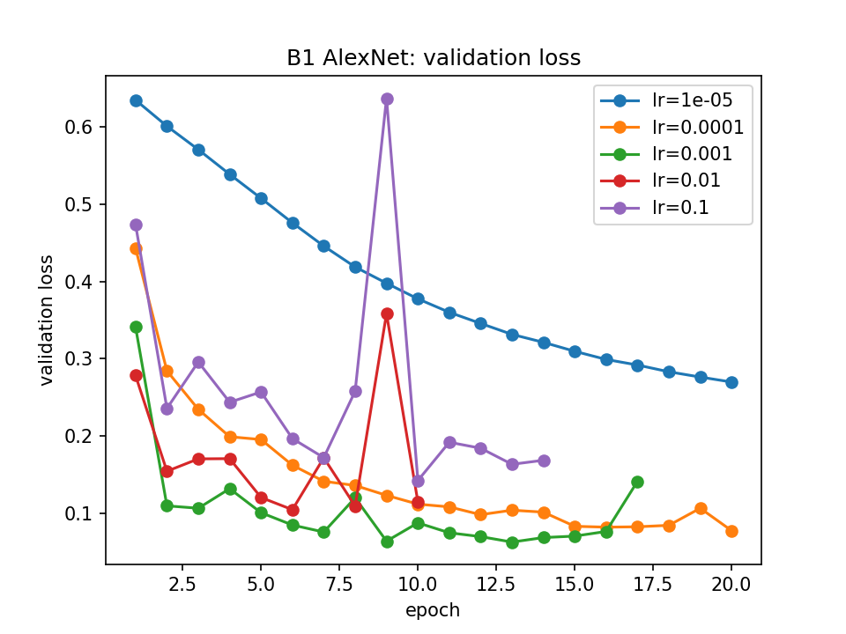 | 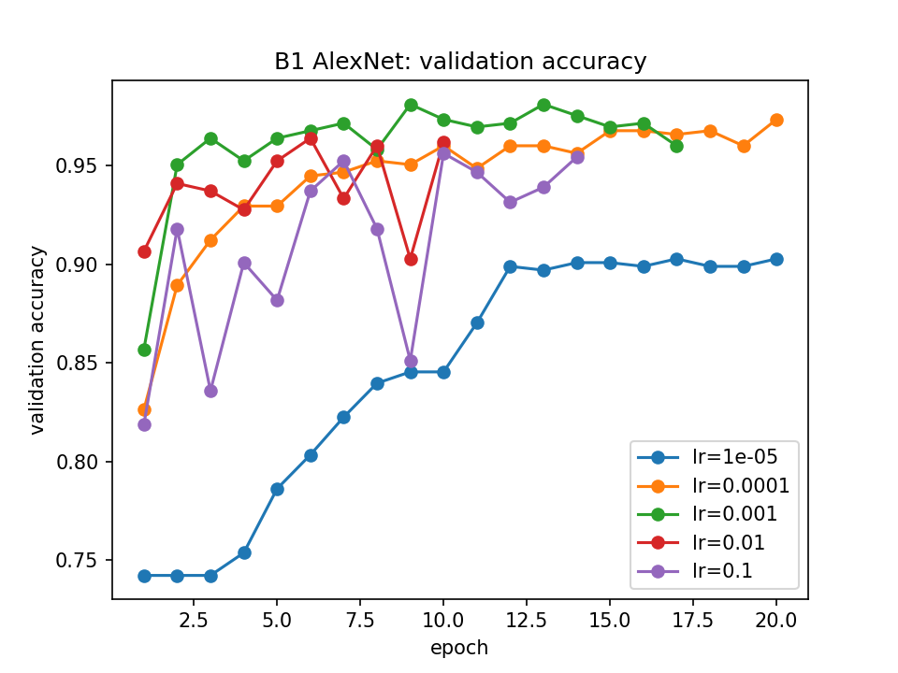
Figure 1. Validation loss and validation accuracy for each learning rate.
A learning rate of 0.001 was selected because it has the lowest validation error, 1.91%, which is only 10 wrong images out of 524. It also has the lowest validation loss and the highest specificity, so the choice is clear.
The curves show how the learning rate affects convergence. With 1e-5 the loss goes down very slowly and is still falling at epoch 20, so the model has not converged. For the first 3 epochs its accuracy stays at 0.742, which is just the share of pneumonia images, meaning it predicts pneumonia for everything. With 1e-4 the loss falls steadily but the best epoch is still the last one, so it would probably improve with more epochs. With 0.001 the loss drops quickly, reaches its lowest point at epoch 13 and then stops improving, so it has converged. With 0.01 and 0.1 training is unstable, with large jumps in the loss, and both settle at a higher loss. A learning rate that is too small learns too slowly, while one that is too large keeps overshooting the minimum.
Accuracy alone is not enough here because the classes are imbalanced. A model that always predicts pneumonia already gets about 74% accuracy, even though it never recognises a normal X-ray, and this is exactly what the 1e-5 model did at the start. The two kinds of mistakes also matter differently: missing a pneumonia case is dangerous, while a false alarm leads to unnecessary follow-up. Sensitivity measures how many pneumonia cases are caught and specificity measures how many normal cases are correctly identified, so together they show what the model is actually getting wrong.
On the test set the model gets an accuracy of 0.857, a sensitivity of 0.992 and a specificity of 0.632. Only 3 of the 390 pneumonia cases are missed, but 86 of the 234 normal cases are labelled as pneumonia. The test error is much higher than the validation error, mostly because the test set has a different mix of classes and almost all of the test mistakes are normal X-rays predicted as pneumonia.

B2. VGG-like network: batch size
Table 2. VGG results on the validation set, learning rate 0.001.
Batch size | Best epoch | Val loss | Val error | Sensitivity | Specificity
16 | 8 | 0.0759 | 0.0229 | 0.977 | 0.978
32 | 15 | 0.0732 | 0.0305 | 0.972 | 0.963
64 | 6 | 0.0969 | 0.0248 | 0.985 | 0.948
128 | 10 | 0.0917 | 0.0286 | 0.990 | 0.919
256 | 11 | 0.1170 | 0.0401 | 0.972 | 0.926

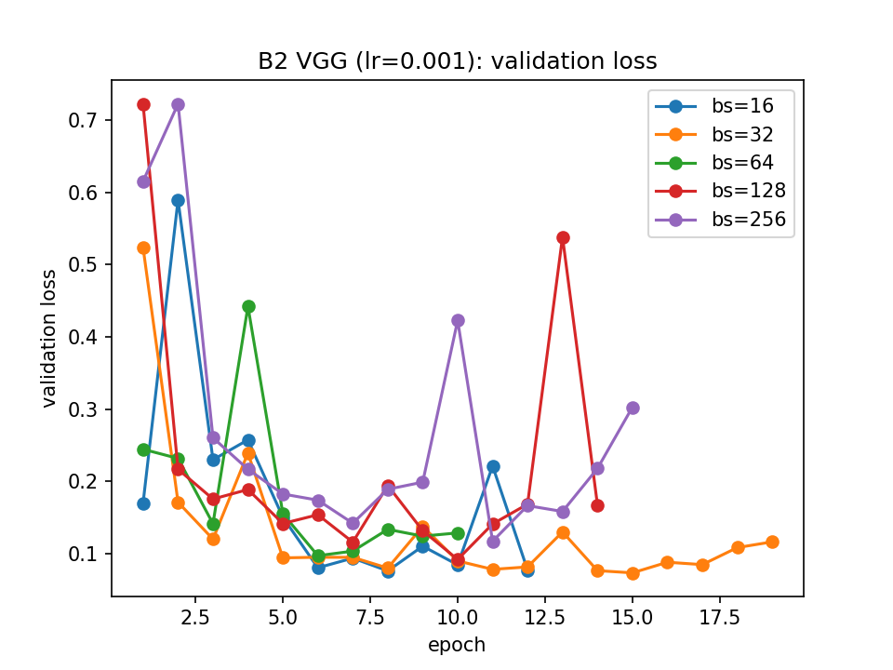 | 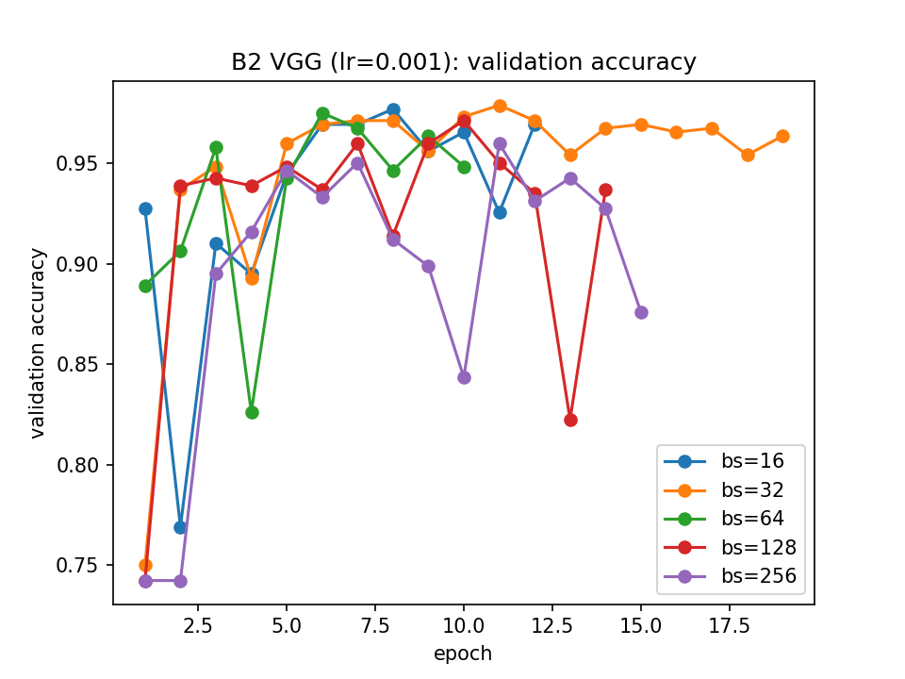
Figure 2. Validation loss and validation accuracy for each batch size.
A batch size of 16 was selected because it has the lowest validation error, 2.29%, and also the highest specificity.
The main reason small batches do better here is the number of updates. With 4,708 training images, a batch size of 16 gives 295 weight updates per epoch, while 256 gives only 19. Since every run uses the same learning rate and at most 20 epochs, the large batches simply get far fewer chances to improve. This shows in the curves: with batch sizes 128 and 256 the accuracy is stuck at 0.742 for the first one or two epochs, while batch size 16 is already above 92% after one epoch. Small batches also give noisier gradients, which makes the curves jumpier but can act as a form of regularisation. Batch size 256 has the worst error and loss. The differences between 16, 32, 64 and 128 are small though, only a few images, so they are fairly close.
On the test set the model gets an accuracy of 0.910, a sensitivity of 0.987 and a specificity of 0.782. It misses 5 pneumonia cases and labels 51 normal cases as pneumonia.

B3. ResNet-like network and comparison
The ResNet was trained with the learning rate from B1 and the batch size from B2. Its best epoch was 7. On the test set it gets an accuracy of 0.869, a sensitivity of 0.997 and a specificity of 0.654, missing only 1 pneumonia case but labelling 81 normal cases as pneumonia.
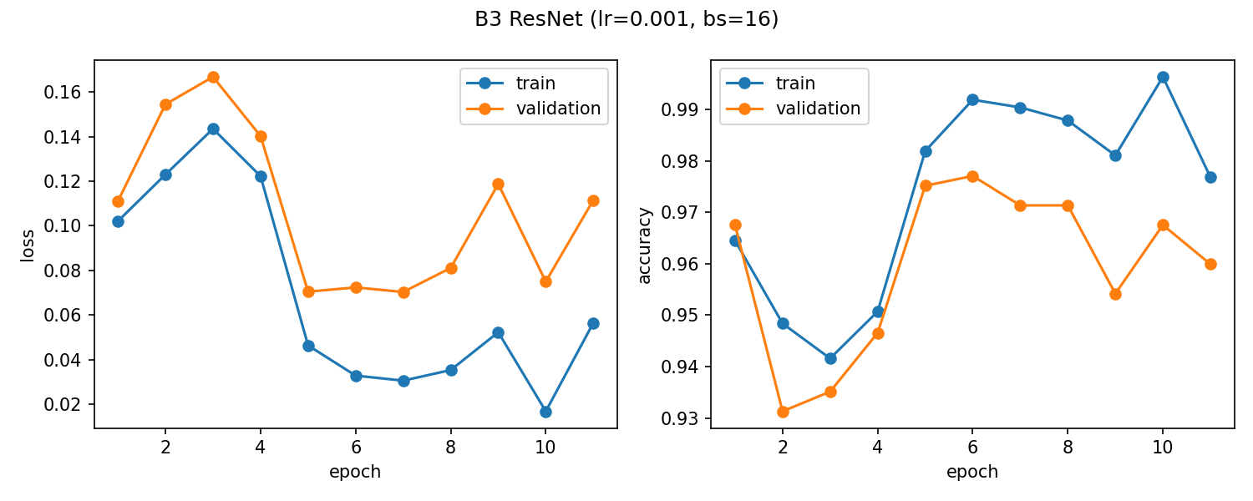
Figure 3. ResNet training and validation loss and accuracy.
Table 3. Comparison of the three models on the test set.
Model | Accuracy | Sensitivity | Specificity | Error | Parameters | MFLOPs
B1 AlexNet | 0.857 | 0.992 | 0.632 | 0.143 | 99,569 | 39.06
B2 VGG | 0.910 | 0.987 | 0.782 | 0.090 | 18,185 | 19.46
B3 ResNet | 0.869 | 0.997 | 0.654 | 0.131 | 77,169 | 25.30

FLOPs were counted for one 64×64 image using 2·D1·F²·D2·H2·W2 for each convolution and 2·in·out for each fully connected layer.
AlexNet is simple and its large 5×5 filters cover a wide area early on. However, it has the most parameters, and about two thirds of them are in a single fully connected layer, which makes it more likely to overfit. Its 5×5 convolutions also make it the most expensive to run, and it has the lowest test accuracy and specificity.
VGG uses pairs of small 3×3 convolutions, which cover the same area as a 5×5 filter with fewer weights and an extra ReLU, and it uses global average pooling instead of large fully connected layers. As a result it has about 5.5 times fewer parameters and half the FLOPs of AlexNet, but still gets the best accuracy and specificity. Its downside is that it is quite narrow, and a plain stack like this becomes hard to train if it is made much deeper.
ResNet's shortcut connections give the gradients an easier path through the network, so it trains quickly and could be made deeper without problems. It has the highest sensitivity, missing only one pneumonia case. However, it has about 4 times more parameters than VGG, it overfits more, with a much higher test loss than validation loss, and with only three blocks it does not really benefit from its depth.
All three models have very high sensitivity but much lower specificity, so they tend to predict pneumonia too often. This is likely because most of the training images are pneumonia and the test set has a different mix. The comparison is also not completely fair, since AlexNet used a different batch size, the learning rate was only tuned on AlexNet, and each model was trained with a single seed.

B4. Grad-CAM
Five pneumonia X-rays were picked at random from the test set using seed 42. Grad-CAM from Captum was applied to the last convolutional layer of AlexNet and VGG and to the last residual block of ResNet. Each heatmap was resized to 64×64 and overlaid on the X-ray.
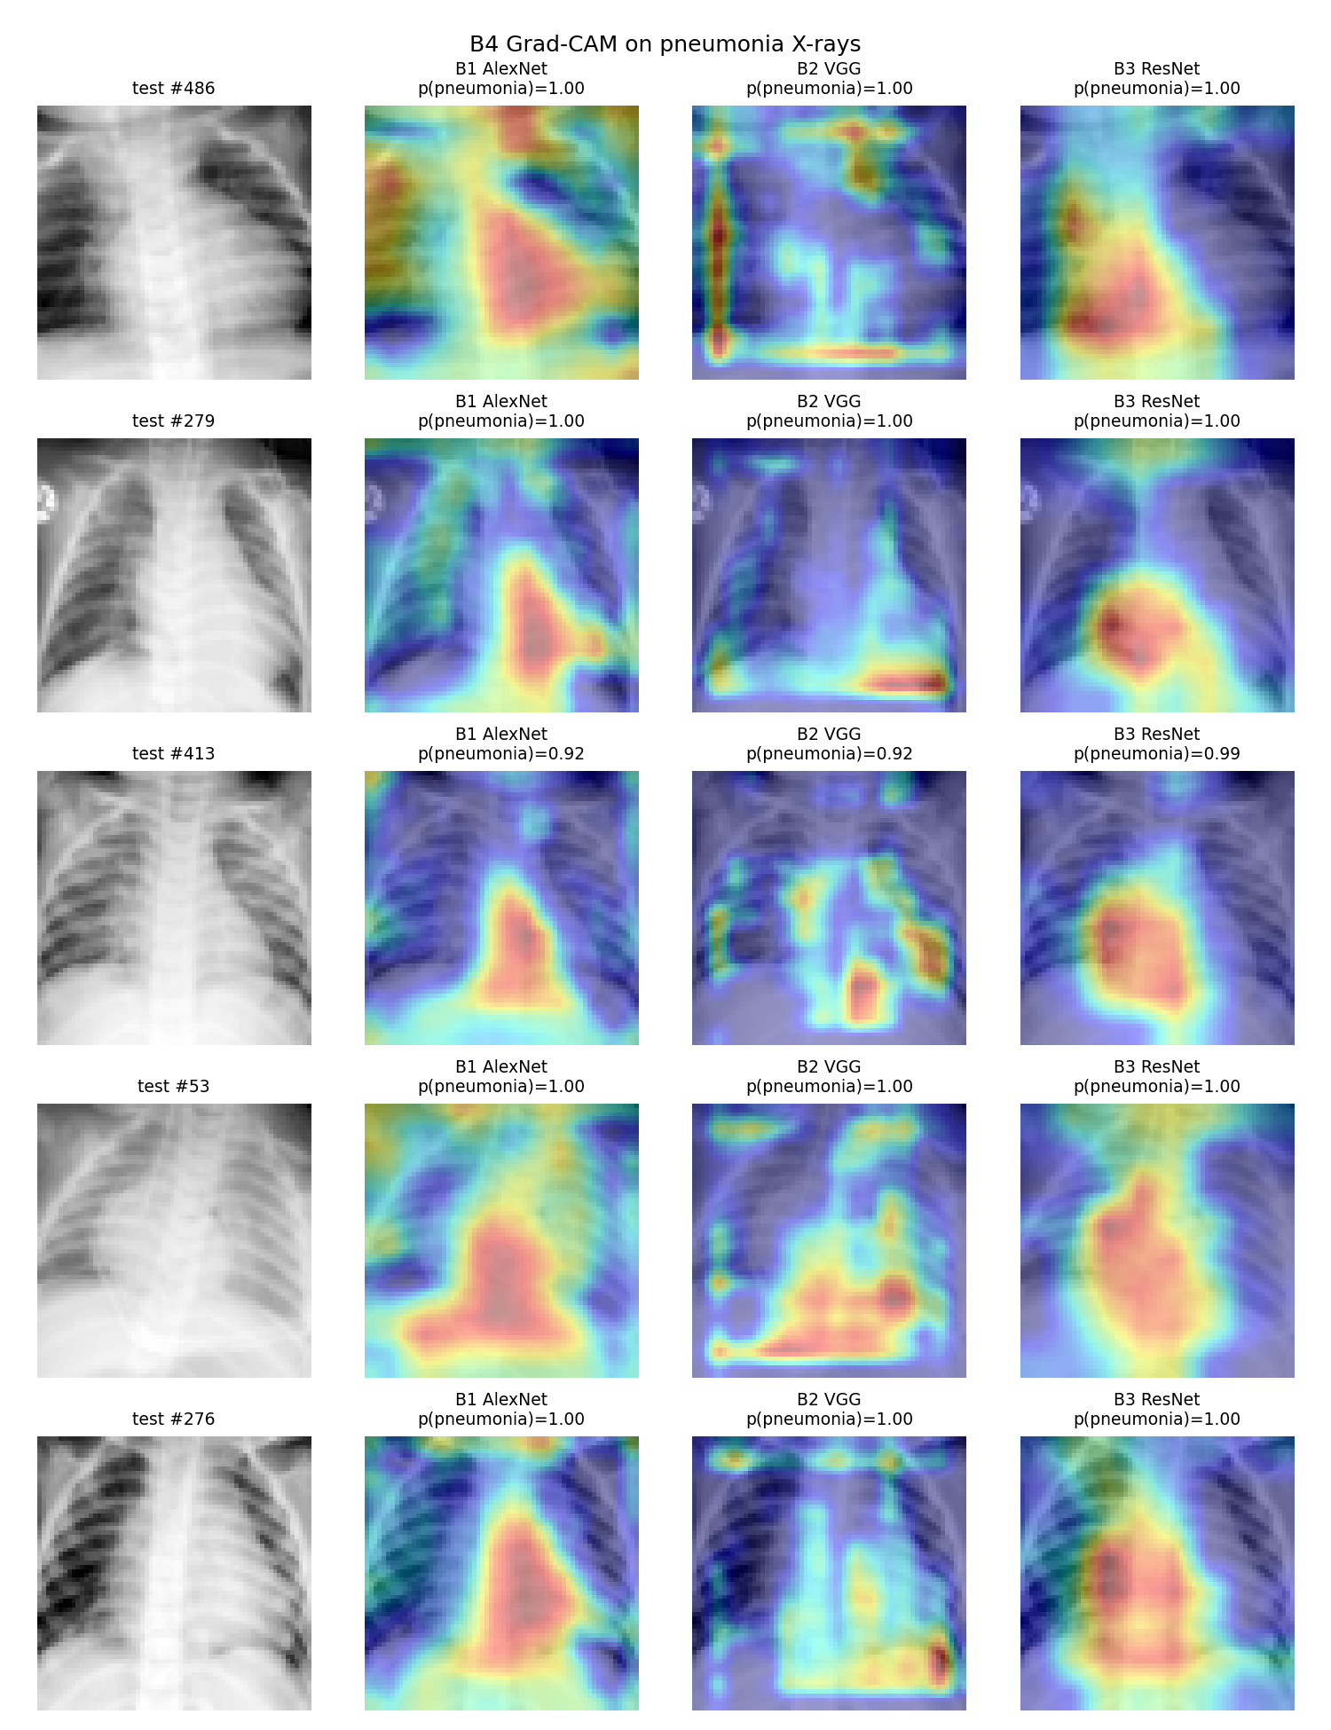
Figure 4. Grad-CAM heatmaps for the three models on five pneumonia test images.
All three models are confident that these images show pneumonia, but they focus on different areas. AlexNet produces one large blob over the centre and lower part of the chest, around the heart, and it often spreads to the edges of the image. ResNet gives the smoothest maps, also mostly over the centre of the chest, but its heatmap is very coarse, so it cannot point to small patches. VGG gives sharper and more scattered spots. Some of them land on cloudy areas inside the lungs, such as in image 413, but several are on the borders of the image, which have nothing to do with the disease.
Overall, none of the models consistently highlights the white, cloudy patches that indicate pneumonia. VGG comes closest on some images, while AlexNet and ResNet mainly look at the middle of the chest. Grad-CAM also has its own limits: the heatmaps are low resolution, they only show where the model looked rather than what it found, and five images are too few to draw strong conclusions.

