**___________________________________**

**ISO ONLINE ART TOOL - FINAL**

**Ava Nelson / IST659-M401**

**Background**

An online art forum is flourishing with creatives and new users on a daily basis. Unfortunately, limitations of the forum format (new threads pushing slower threads off the top pages, non-user friendly shop directories, etc) make it difficult to connect patrons with artists who suit their needs, as well as connecting artists to patrons when they have new shop listings. Many artists already maintain private “ping lists” to notify patrons who have expressed interest in their work before, but this practice does not assist those who are new in the forum and desire to build their audience. There is demand to create an online database tool which can keep records of artists, their shop listings, and potential patrons and help to facilitate greater sales in this marketplace.

**Description**

A database designed to facilitate an online tool that, for artists, can retrieve a list of usernames for patrons looking for any combination of keywords/filters.

For patrons, this tool can return a list of shop cards or artist names that feature artwork with characteristics they are in the market for.

___________________________________

**CONCEPTUAL MODEL**

**Unrefined Representative Example of Data**

The data will be reworked/reorganized into a more cohesive database.

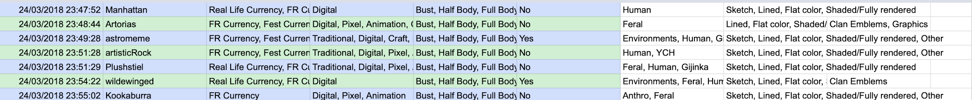

**Conceptual ERD**

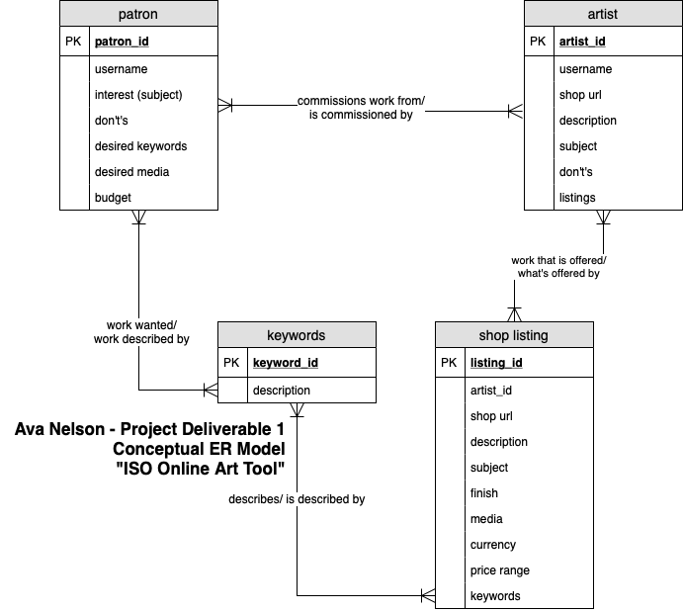

**Conceptual Glossary**

**“Patron”**

*> patron_id: id for patron based upon the forum site’s account id of this person.*

**Username:** written username of patron

**Interest (subject):** artwork subject matter desired (character, environment, graphics, etc)

**Don’t’s:** topics there is no interest in (NSFW/gore/mecha/etc)

**Desired Keywords**: further subject-related filters (colored, realistic, cartoon, animal, human, etc)

**Desired Media:** wanted art medium (traditional, digital, vector, drawing, etc)

**Budget:** Price range for spending ($0-$20, $20-$50, etc)

**“Artist”**

*>artist_id: id for artist based upon the forum site’s account id of this person.*

**Username:** written username of patron

**Shop URL:** http:// url link to artist’s shop page

**Description:** Flavortext describing the nature of their artwork.

**Subject:** offered subject matter (character, environment, graphics, etc)

**Don’t’s:** topics artist does not do art for (NSFW/gore/mecha/etc)

**Listings:** list of the specific “art styles” the artist offers.

**“Shop Listing”**

*>listing_id: surrogate id generated to house each artwork listing.*

**Artist_id:** id for artist based upon the forum site’s account id (from “Artist”)

**Shop URL:** http:// url link to artist’s shop page (from “Artist”)

**Description:** Flavortext describing the nature of this listing

**Subject:** offered subject matter for this listing (character, environment, graphics, etc)

**Finish:** level of artwork completion offered for this listing (sketch, lineart, colored, etc)

**Media:** offered art medium for this listing (traditional, digital vector, drawing, etc)

**Currency:** type of currency accepted for this listing (RLC, premium site coin, basic coin)

**Price Range:** cost of this listing ($0-$20, $20-$50, etc)

**Keywords:** further subject-related filers to identify this listing (colored, realistic, cartoon, animal, human, graphics, typography, etc)

**“Keywords”**

*>keyword_id: surrogate id generated to house each offered keyword.*

Description: name of keyword to accompany the id.

___________________________________

**LOGICAL MODEL**

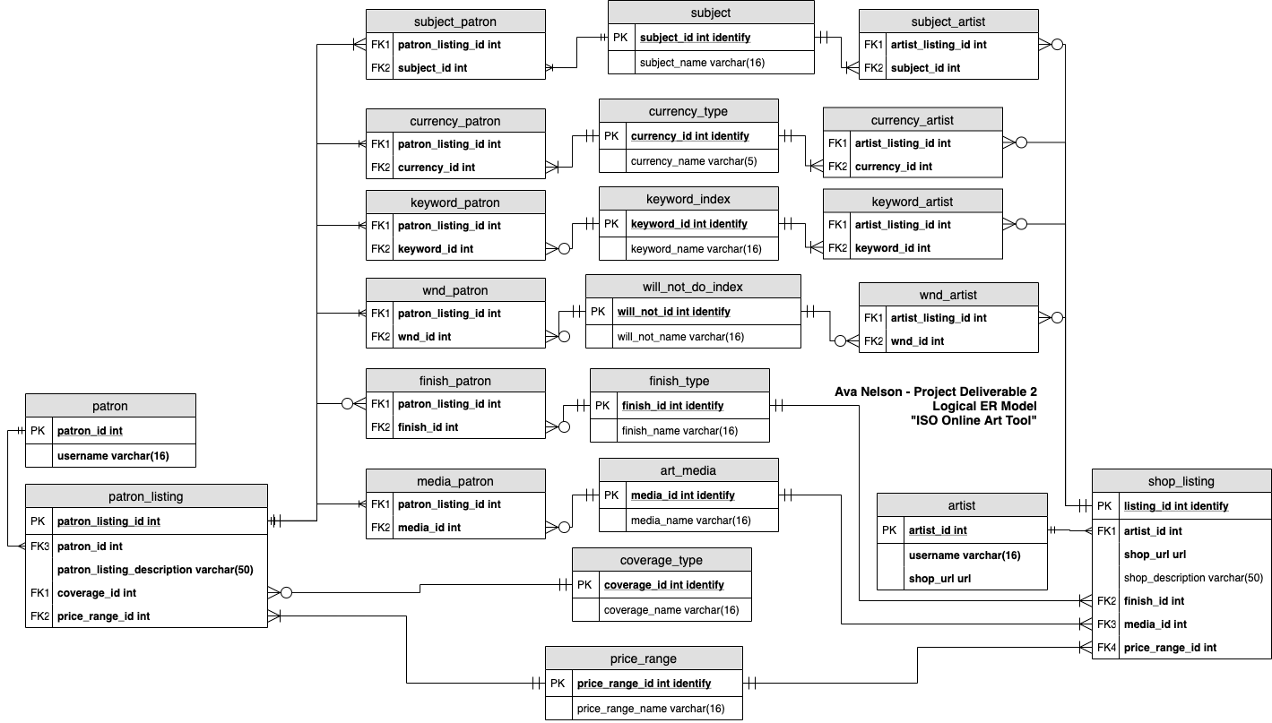

**Logical Glossary (22 Tables in Total)**

**“patron”**

*> patron_id: INT. id for patron based upon the forum site’s account id of this person.*

**Username:** VARCHAR(16) written username of patron. R

**“patron_listing”**

*> patron_listing_id INT IDENTIFY: Surrogate ID*

**patron_id:** INT. Links to patron. R

**patron_listing_description:** VARCHAR(50). Description of search.

**coverage_id:** INT. Links to a weak associative tag table, coverage_type. R

**price_range_id:** INT. Links to a weak associative tag table, price_range. R

**“artist”**

*>artist_id: INT. id for artist based upon the forum site’s account id of this person.*

**Username:** VARCHAR(16) written username of patron. R

**Shop_url:** URL(or equivalent data type). Link to the forum shop. R

**“shop_listing”**

*> listing_id: INT IDENTIFY. Surrogate ID*

**artist_id:** INT id for artist based on forum account’s id. I would like for this field to autofill from the “artist” PK. R

**Shop_url:** URL(or equivalent data type). Link to the forum shop. I would also like for this field to autofill from the “artist” table. R

Shop_description: VARCHAR(50) written description of this art listing.

**finish_id:** INT. Links to a weak associative tag table, finish_type. R

**media_id:** INT. Links to a weak associative tag table, art_media. R

**price_range_id:** INT. Links to a weak associative tag table, price_range. R

**Weak Associative Tables**

**“subject”**

*>subject_id: INT IDENTIFY. surrogate id generated to house each subject.*

**subject_name**: VARCHAR(16) name of keyword to accompany the id.

**Subject Name Examples:**

-Gijinka

-Human

-Creature

-Anthro

-Environments

-YCH

-Adoptable

-Other

**“finish_type”**

*>finish_id: INT IDENTIFY. surrogate id generated to house each finish classification.*

**finish_name**: VARCHAR(16) name of keyword to accompany the id.

**Finish Examples:**

-Sketch

-Lines

-Flat Color

-Shaded/Rendered

-Other

**“art_media”**

*>media_id: INT IDENTIFY. surrogate id generated to house each art media.*

**media_name**: VARCHAR(16) name of art medium to accompany the id.

**Art Media Examples:**

-Traditional - Painting

-Traditional - Drawing

-Digital - Painting

-Digital - Drawing

-Digital - Vector

-Digital - Pixel

-3D/Craft

-Animation

-Graphics/Typography

-Other

**“currency_type”**

*>currency_id: INT IDENTIFY. surrogate id generated to house each currency type category.*

**currency_name**: VARCHAR(5) name of currency type to accompany the id.

**Currency Type Examples:**

-RLC (real life currency)

-Basic IGC (In-Game Currency)

-Premium IGC (In-Game Currency)

-Festival IGC (In-Game-Currency)

-Other

**“price_range”**

*>price_range_id: INT IDENTIFY. surrogate id generated to house each subject.*

**price_range_name**: VARCHAR(16) written price range to accompany the id.

**Price Range Examples:**

-$0-$20

-$20-$50

-$50-$100

-$100+

**“keyword_index”**

*>keyword_id: INT IDENTIFY. surrogate id generated to house each keyword.*

**keyword_name**: VARCHAR(16) name of keyword to accompany the id.

**Keyword Name Examples:**

-Bust

-½ Body

-Full Body

-Reference Sheet

-Emblems

-Realism

-Stylized

-Abstract

-Other

**“will_not_do_index”**

*>will_not_id: INT IDENTIFY. surrogate id generated to house each subject.*

**will_not_name**: VARCHAR(16) name of “Will Not Do” to accompany the id.

**Will Not Do Examples:**

-NSFW

-Gore

-Mechanical

-Excessive Detail

-Humans

-Creatures

**“subject_patron”**

*>no primary key*

**patron_listing_id**: INT associated patron_listing_id. FK

**subject_id**: INT associated subject_id. FK

**“currency_patron”**

*>no primary key*

**patron_listing_id**: INT associated patron_listing_id. FK

**currency_id**: INT associated currency_id. FK

**“keyword_patron”**

*>no primary key*

**patron_listing_id**: INT associated patron_listing_id. FK

**keyword_id**: INT associated keyword_id. FK

**“wnd_patron”**

*>no primary key*

**patron_listing_id**: INT associated patron_listing_id. FK

**wnd_id**: INT associated will_not_id. FK

**“finish_patron”**

*>no primary key*

**patron_listing_id**: INT associated patron_listing_id. FK

**finish_id**: INT associated finish_id. FK

**“media_patron”**

*>no primary key*

**patron_listing_id**: INT associated patron_listing_id. FK

**media_id**: INT associated media_id. FK

**“subject_artist”**

*>no primary key*

**listing_id**: INT associated shop_listing_id. FK

**subject_id**: INT associated subject_id. FK

**“currency_artist”**

*>no primary key*

**listing_id**: INT associated listing_id. FK

**currency_id**: INT associated currency_id. FK

**“keyword_artist”**

*>no primary key*

**listing_id**: INT associated listing_id. FK

**keyword_id**: INT associated keyword_id. FK

**“wnd_artist”**

*>no primary key*

**listing_id**: INT associated listing_id. FK

**wnd_id**: INT associated will_not_id. FK

**___________________________________**

**PART 2**

**PHYSICAL DATABASE DESIGN**

See logical model for visual of the database. See end of document for SQL Server code.

___________________________________

**DATA CREATION**

See end of document for SQL Server code.

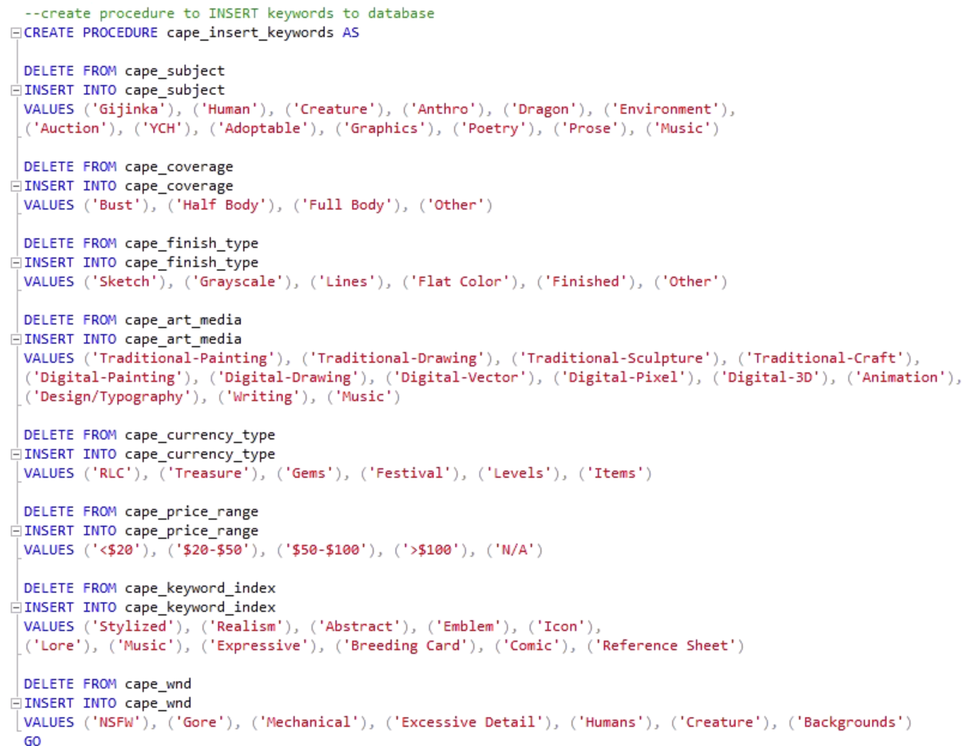

___________________________________

**DATA MANIPULATION**

See end of document for SQL Server code.

**Update Statement**

If a username needs to be updated in the database.

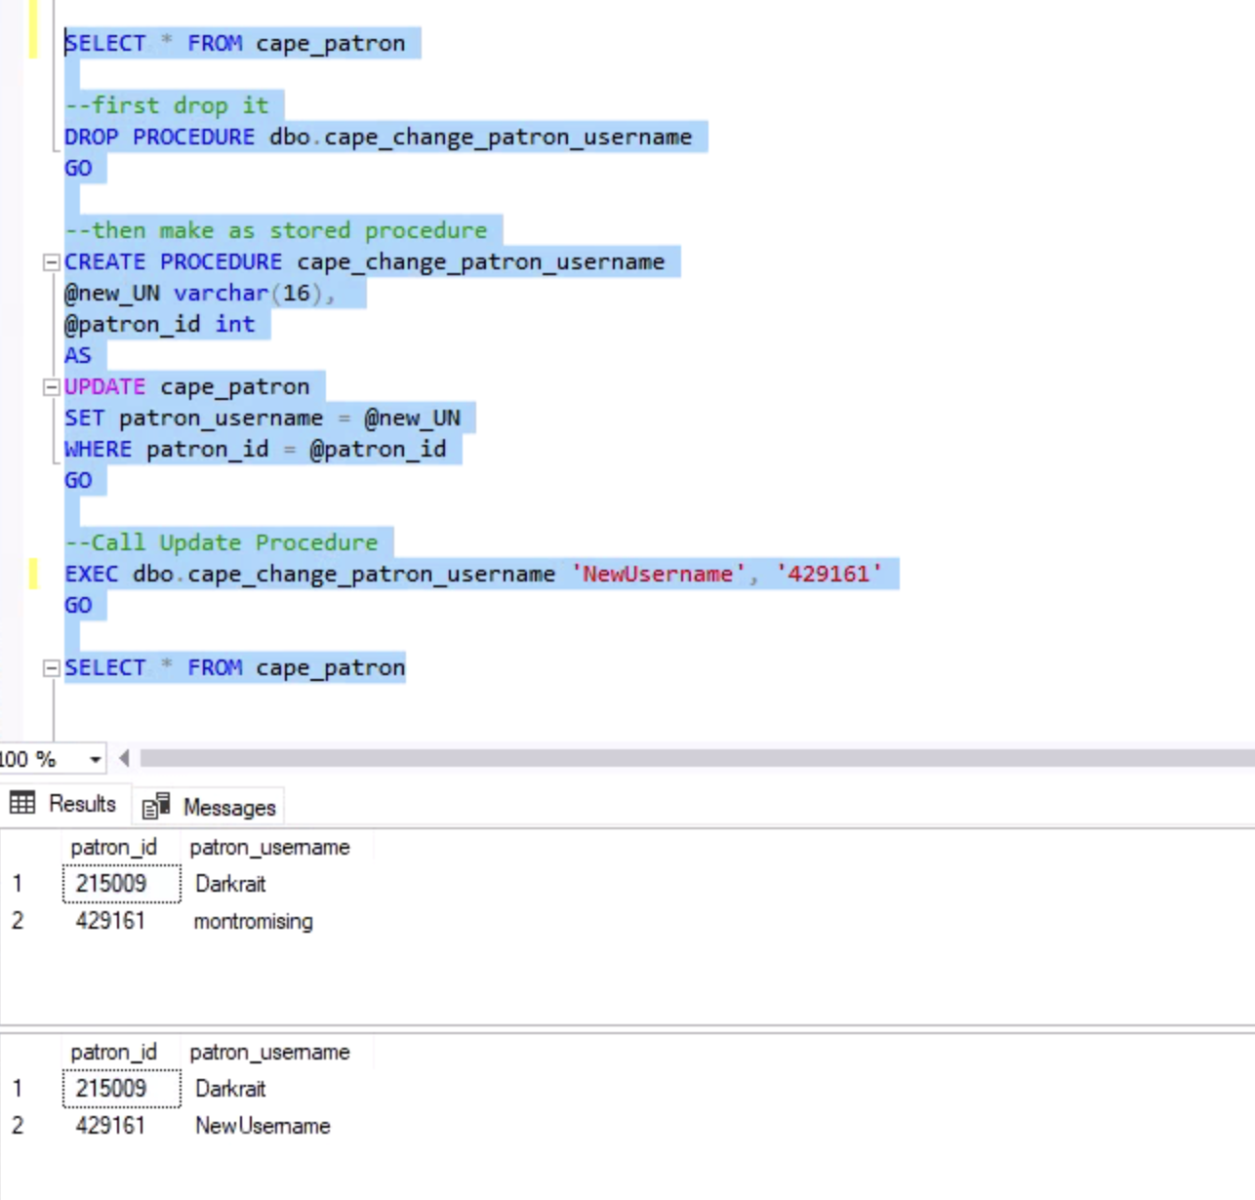

**Delete Statement**

If a user listing from the patron tables needs to be removed from the database.

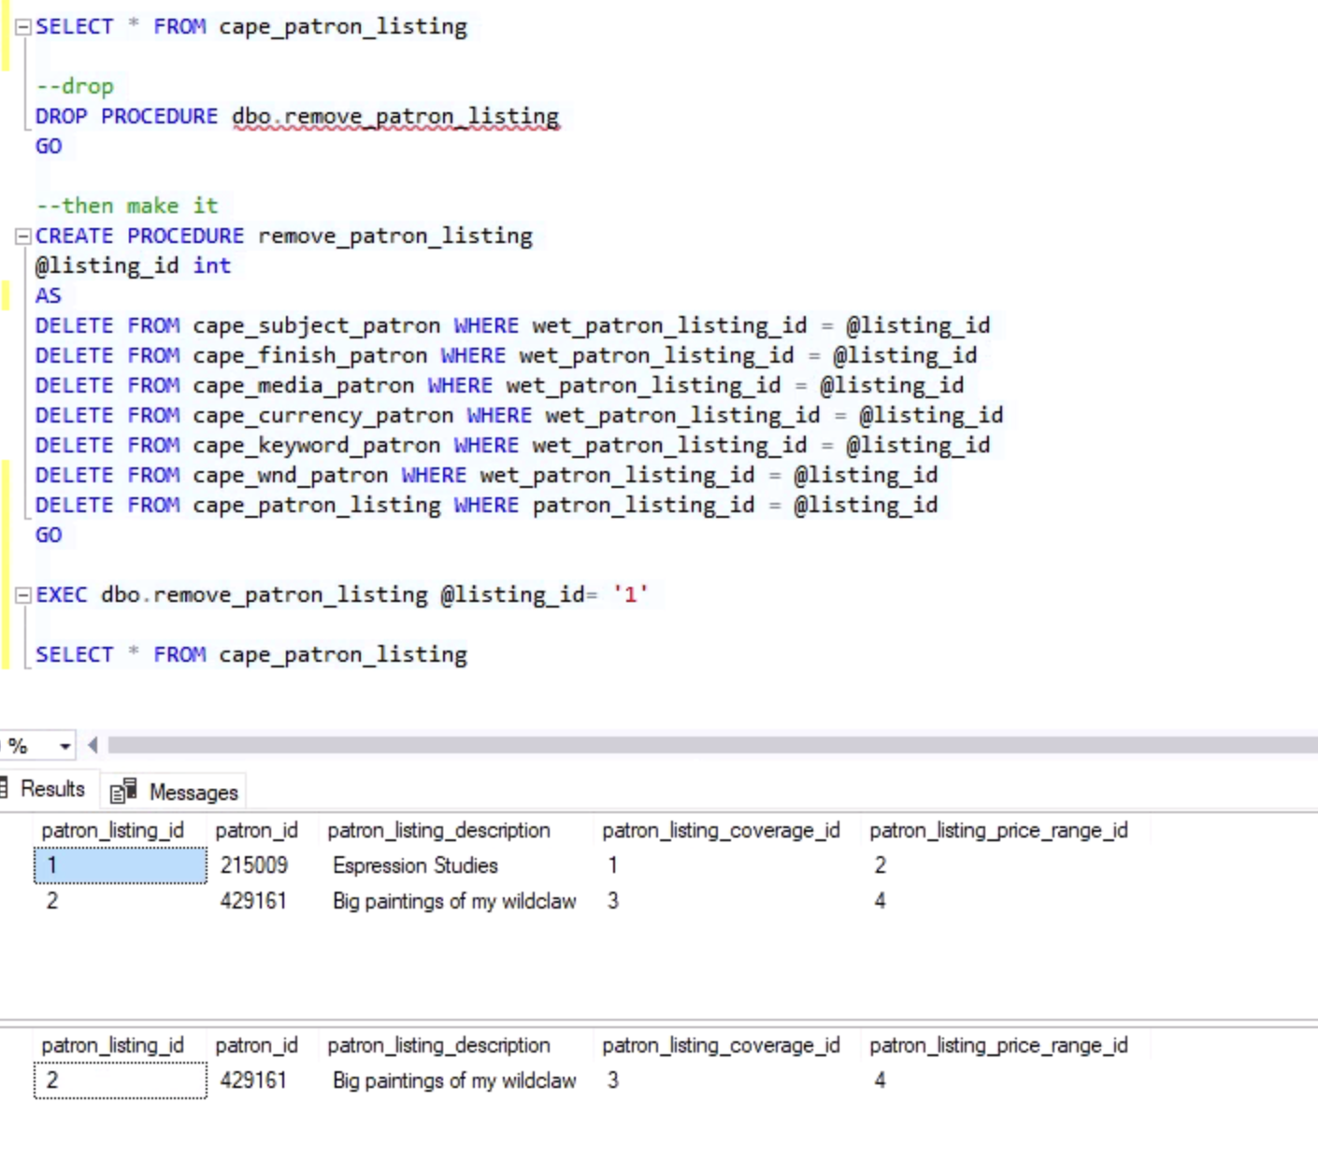

___________________________________

**ANSWERING DATA QUESTIONS**

See end of document for SQL Server code.

**Question: “I want to find the artists who accept Treasure and RLC as payment methods”**

Create a select statement searching for this criteria.

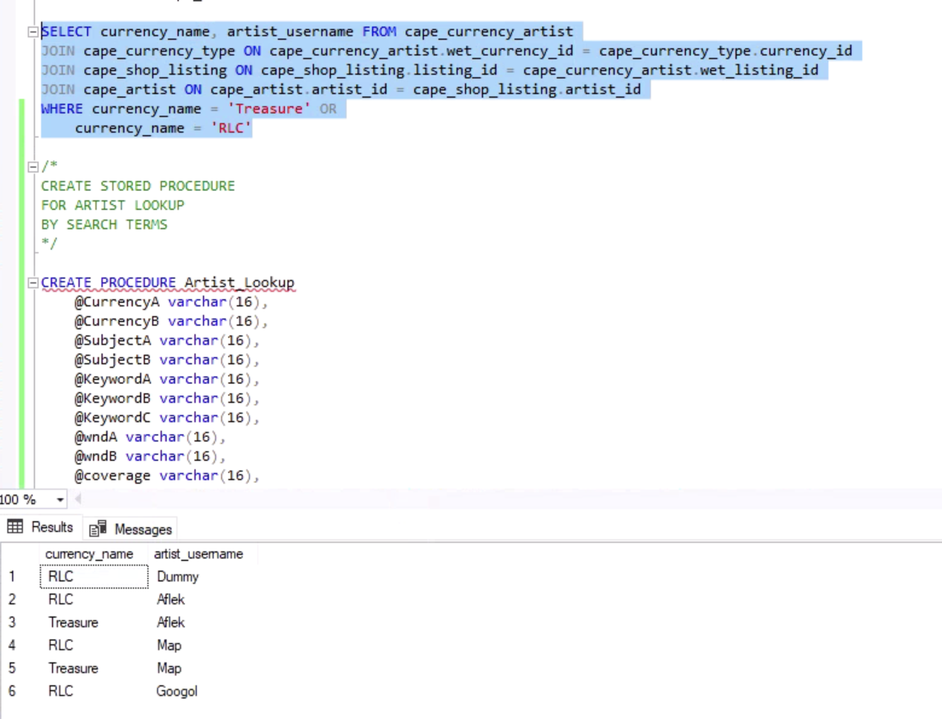

**Question: “I want to find an artist that satisfies a range of criteria across multiple tables.”**

Create a stored procedure that can search across all artist-related tables in the database and return the usernames that satisfy selected parameters.

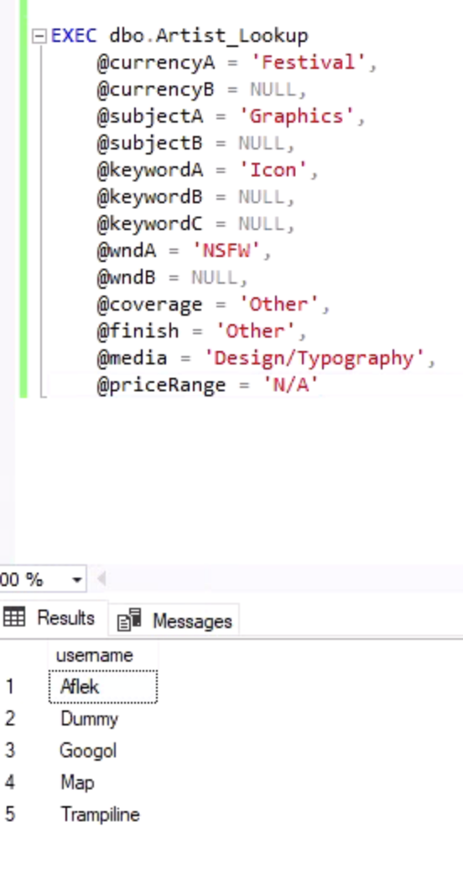

___________________________________

**IMPLEMENTATION**

Google Sheets & Forms as a vehicle for data entry, along with future plans.

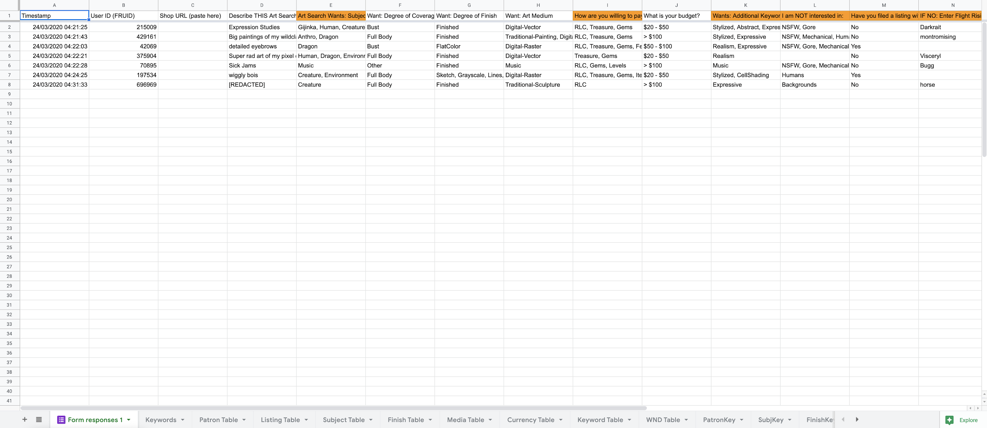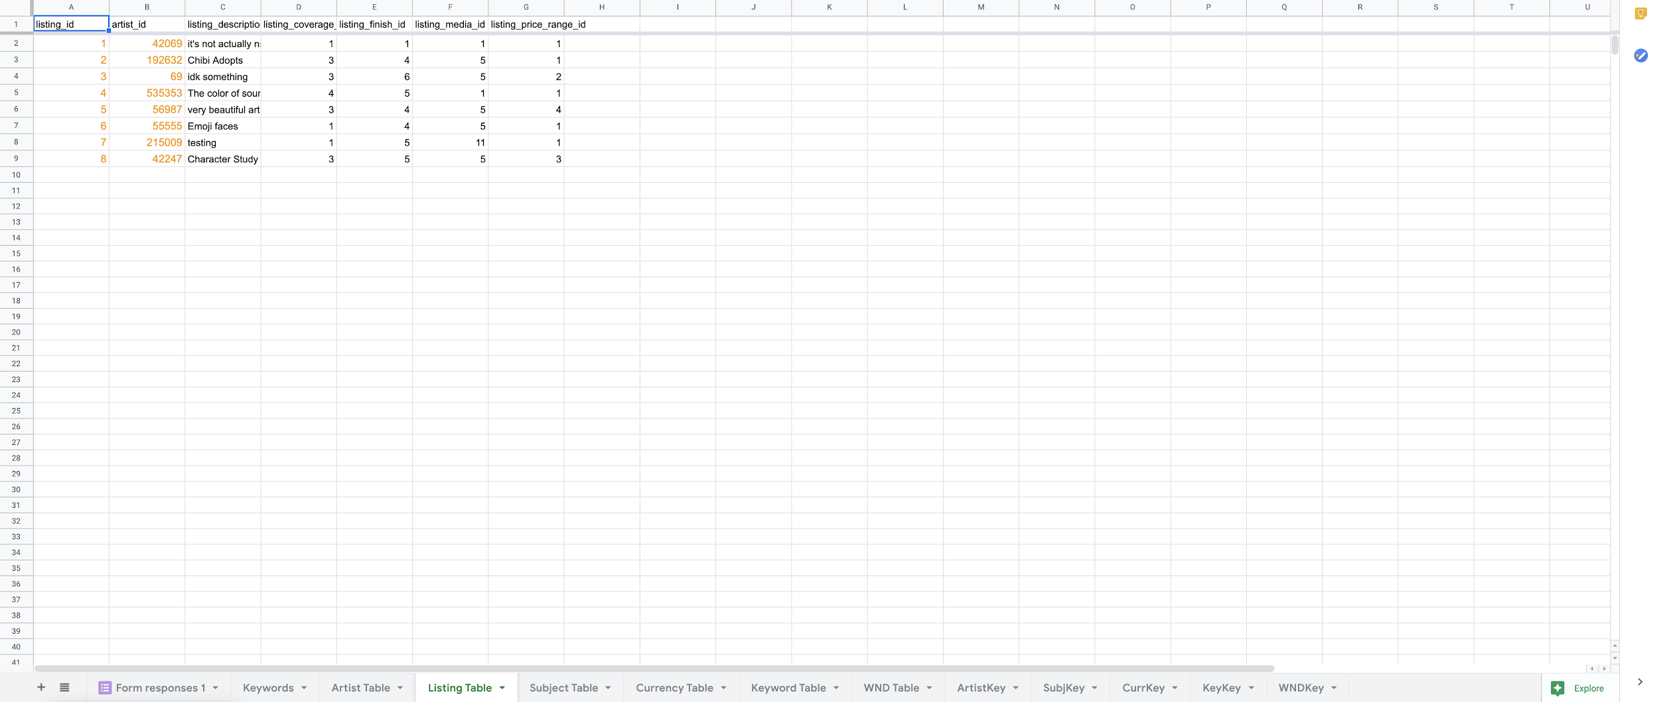

See above screenshots for the automated spreadsheets prepared to receive form entries and disperse user input into raw data. The raw data is organized into tables that mirror the database structure for ease of data import. If you would like to view the sheets yourself: [artist](https://docs.google.com/spreadsheets/d/1CPVSaBg5S-ynbVgATv6koI7aeUKLdKlsfPf-W0Ku32w/edit?usp=sharing) / [patron](https://docs.google.com/spreadsheets/d/1UOlDb2viTZuZw-AYnODeRfm_DV2yLxJ5rFOz3b750M8/edit?usp=sharing)

**Data Input**

Users will fill out provided forms to populate the database. The sheets as shown above will then translate the form responses into raw data that the database can use. Users will then be able to interact with the database on a web-hosted front end to run queries to return searches based on desired search terms.

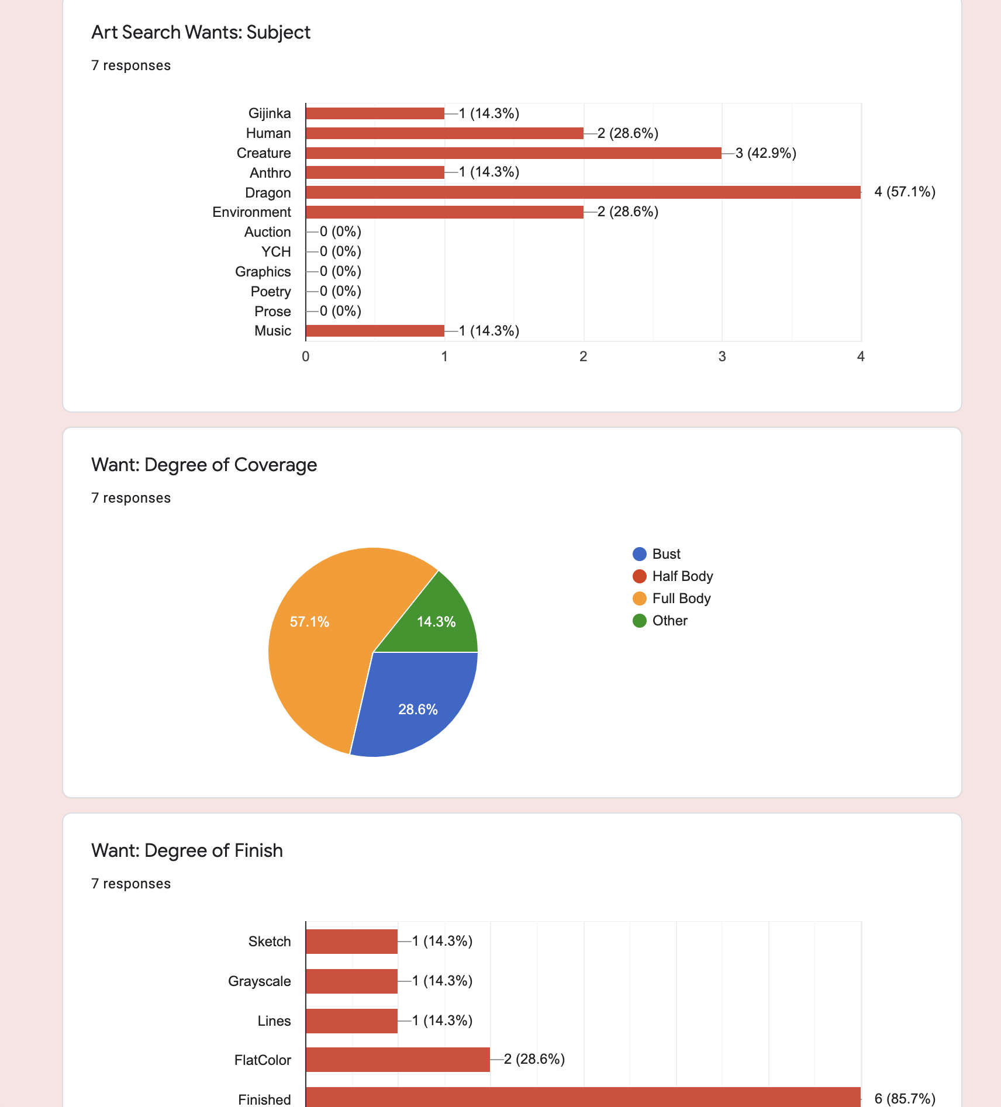

**Future Plans**

I plan to convert the SQL Server Code to MySQL and connect the data entry sheets to the database to automate dbms data population. Then through use of java I will build a front end for users to run queries of the database and thus make this tool usable.

___________________________________

**REFLECTION**

I did not necessarily come into this project with any set expectations, as I have had very little database experience before this class. This project felt like an intimidating task that I really had no idea how to approach “smartly”, but over the course of the class I feel like I have been able to break it down into bite sized pieces and made it into something manageable. I look forward to the challenge of bringing this tool to the web and really bringing the database to life.

If I had to do this project again, I would look at a problem that is less modular in nature so as to make creation and implementation a simpler process. The chosen problem has many moving pieces associated with it, which in the end required quite a few more tables than I had wanted to entertain.

This has been a very insightful look into how computers process and organize information, which will prove useful as I move ahead with my career as an information professional.

**___________________________________**

**SQL SERVER CODE**

**--Physical Database Design**

/*

REMOVE

ALL

TABLES

*/

DROP TABLE cape_wnd_artist

DROP TABLE cape_wnd_patron

DROP TABLE cape_keyword_artist

DROP TABLE cape_keyword_patron

DROP TABLE cape_currency_artist

DROP TABLE cape_currency_patron

DROP TABLE cape_media_patron

DROP TABLE cape_finish_patron

DROP TABLE cape_subject_artist

DROP TABLE cape_subject_patron

DROP TABLE cape_patron_listing

DROP TABLE cape_shop_listing

DROP TABLE cape_artist

DROP TABLE cape_patron

DROP TABLE cape_wnd

DROP TABLE cape_keyword_index

DROP TABLE cape_price_range

DROP TABLE cape_currency_type

DROP TABLE cape_art_media

DROP TABLE cape_finish_type

DROP TABLE cape_coverage

DROP TABLE cape_subject

GO

/*

CREATE

ALL

TABLES

*/

--subject tag table

CREATE TABLE cape_subject (

subject_id int identity primary key,

subject_name varchar(16) not null )

GO

--coverage tag table

CREATE TABLE cape_coverage (

coverage_id int identity primary key,

coverage_name varchar(16) not null )

GO

--finish type tag table

CREATE TABLE cape_finish_type (

finish_id int identity primary key,

finish_name varchar(16) not null )

GO

--art media type table

CREATE TABLE cape_art_media (

media_id int identity primary key,

media_name varchar(25) not null )

GO

--currency type table

CREATE TABLE cape_currency_type (

currency_id int identity primary key,

currency_name varchar(16) not null )

GO

--price range table

CREATE TABLE cape_price_range (

price_range_id int identity primary key,

price_range_name varchar(16) not null )

GO

--keyword index table

CREATE TABLE cape_keyword_index (

keyword_id int identity primary key,

keyword_name varchar(16) not null )

GO

--will not do table

CREATE TABLE cape_wnd (

wnd_id int identity primary key,

wnd_name varchar(16) not null)

GO

--patron table

CREATE TABLE cape_patron (

patron_id int primary key,

patron_username varchar(16) not null )

GO

--artist table

CREATE TABLE cape_artist (

artist_id int primary key,

artist_username varchar(16) not null,

shop_url nvarchar(2083),

shop_description varchar(50))

GO

--shop listing table

CREATE TABLE cape_shop_listing (

listing_id int identity primary key,

artist_id int not null,

shop_url nvarchar(2083) not null,

listing_description varchar(50),

--listing_subject_id int not null,

listing_coverage_id int not null,

listing_finish_id int not null,

listing_media_id int not null,

--listing_currency_id int not null,

listing_price_range_id int not null,

--listing_keyword_id int not null,

--listing_wnd_id int

--shop listing table constraints

--CONSTRAINT FK1_cape_shop_listing FOREIGN KEY (listing_subject_id)REFERENCES cape_subject (subject_id),

CONSTRAINT FK9_cape_shop_listing FOREIGN KEY (listing_coverage_id)REFERENCES cape_coverage (coverage_id),

CONSTRAINT FK2_cape_shop_listing FOREIGN KEY (listing_finish_id)REFERENCES cape_finish_type (finish_id),

CONSTRAINT FK3_cape_shop_listing FOREIGN KEY (listing_media_id)REFERENCES cape_art_media (media_id),

--CONSTRAINT FK4_cape_shop_listing FOREIGN KEY (listing_currency_id)REFERENCES cape_currency_type (currency_id),

CONSTRAINT FK5_cape_shop_listing FOREIGN KEY (listing_price_range_id)REFERENCES cape_price_range (price_range_id),

--CONSTRAINT FK6_cape_shop_listing FOREIGN KEY (listing_keyword_id)REFERENCES cape_keyword_index (keyword_id),

--CONSTRAINT FK7_cape_shop_listing FOREIGN KEY (listing_wnd_id)REFERENCES cape_wnd (wnd_id),

CONSTRAINT FK8_cape_shop_listing FOREIGN KEY (artist_id) REFERENCES cape_artist(artist_id))

GO

--patron listing table

CREATE TABLE cape_patron_listing (

patron_listing_id int identity primary key,

patron_id int not null,

patron_listing_description varchar(50),

--listing_subject_id int not null,

patron_listing_coverage_id int not null,

--listing_finish_id int not null,

--listing_media_id int not null,

--listing_currency_id int not null,

patron_listing_price_range_id int not null,

--listing_keyword_id int not null,

--listing_wnd_id int

--shop listing table constraints

--CONSTRAINT FK1_cape_shop_listing FOREIGN KEY (listing_subject_id)REFERENCES cape_subject (subject_id),

CONSTRAINT FK9_cape_patron_listing FOREIGN KEY (patron_listing_coverage_id)REFERENCES cape_coverage (coverage_id),

--CONSTRAINT FK2_cape_shop_listing FOREIGN KEY (listing_finish_id)REFERENCES cape_finish_type (finish_id),

--CONSTRAINT FK3_cape_shop_listing FOREIGN KEY (listing_media_id)REFERENCES cape_art_media (media_id),

--CONSTRAINT FK4_cape_shop_listing FOREIGN KEY (listing_currency_id)REFERENCES cape_currency_type (currency_id),

CONSTRAINT FK5_cape_patron_listing FOREIGN KEY (patron_listing_price_range_id)REFERENCES cape_price_range (price_range_id),

--CONSTRAINT FK6_cape_shop_listing FOREIGN KEY (listing_keyword_id)REFERENCES cape_keyword_index (keyword_id),

--CONSTRAINT FK7_cape_shop_listing FOREIGN KEY (listing_wnd_id)REFERENCES cape_wnd (wnd_id),

CONSTRAINT FK8_cape_patron_listing FOREIGN KEY (patron_id) REFERENCES cape_patron(patron_id))

GO

/*

WEAK ENTITY TABLES

*/

--subject/patron table

CREATE TABLE cape_subject_patron (

wet_patron_listing_id int not null,

wet_subject_id int not null

--WET subject/patron table constraints

CONSTRAINT FK1_cape_subject_patron FOREIGN KEY (wet_subject_id)REFERENCES cape_subject (subject_id),

CONSTRAINT FK2_cape_subject_patron FOREIGN KEY (wet_patron_listing_id)REFERENCES cape_patron_listing (patron_listing_id))

GO

--subject/artist table

CREATE TABLE cape_subject_artist (

wet_listing_id int not null,

wet_subject_id int not null

--WET subject/artist table constraints

CONSTRAINT FK1_cape_subject_artist FOREIGN KEY (wet_subject_id)REFERENCES cape_subject (subject_id),

CONSTRAINT FK2_cape_subject_artist FOREIGN KEY (wet_listing_id)REFERENCES cape_shop_listing (listing_id))

GO

--finish/patron table

CREATE TABLE cape_finish_patron (

wet_patron_listing_id int not null,

wet_finish_id int not null

--WET subject/patron table constraints

CONSTRAINT FK1_cape_finish_patron FOREIGN KEY (wet_finish_id)REFERENCES cape_subject (subject_id),

CONSTRAINT FK2_cape_finish_patron FOREIGN KEY (wet_patron_listing_id)REFERENCES cape_patron_listing (patron_listing_id))

GO

--subject/patron table

CREATE TABLE cape_media_patron (

wet_patron_listing_id int not null,

wet_media_id int not null

--WET subject/patron table constraints

CONSTRAINT FK1_cape_media_patron FOREIGN KEY (wet_media_id)REFERENCES cape_subject (subject_id),

CONSTRAINT FK2_cape_media_patron FOREIGN KEY (wet_patron_listing_id)REFERENCES cape_patron_listing (patron_listing_id))

GO

--currency/patron table

CREATE TABLE cape_currency_patron (

wet_patron_listing_id int not null,

wet_currency_id int not null

--WET currency/patron table constraints

CONSTRAINT FK1_cape_currency_patron FOREIGN KEY (wet_currency_id)REFERENCES cape_currency_type (currency_id),

CONSTRAINT FK2_cape_currency_patron FOREIGN KEY (wet_patron_listing_id)REFERENCES cape_patron_listing (patron_listing_id))

GO

--currency/artist table

CREATE TABLE cape_currency_artist (

wet_listing_id int not null,

wet_currency_id int not null

--WET currency/artist table constraints

CONSTRAINT FK1_cape_currency_artist FOREIGN KEY (wet_currency_id)REFERENCES cape_currency_type (currency_id),

CONSTRAINT FK2_cape_currency_artist FOREIGN KEY (wet_listing_id)REFERENCES cape_shop_listing (listing_id))

GO

--keyword/patron table

CREATE TABLE cape_keyword_patron (

wet_patron_listing_id int not null,

wet_keyword_id int not null

--WET keyword/patron table constraints

CONSTRAINT FK1_cape_keyword_patron FOREIGN KEY (wet_keyword_id)REFERENCES cape_keyword_index (keyword_id),

CONSTRAINT FK2_cape_keyword_patron FOREIGN KEY (wet_patron_listing_id)REFERENCES cape_patron_listing (patron_listing_id))

GO

--keyword/artist table

CREATE TABLE cape_keyword_artist (

wet_listing_id int not null,

wet_keyword_id int not null

--WET keyword/artist table constraints

CONSTRAINT FK1_cape_keyword_artist FOREIGN KEY (wet_keyword_id)REFERENCES cape_keyword_index (keyword_id),

CONSTRAINT FK2_cape_keyword_artist FOREIGN KEY (wet_listing_id)REFERENCES cape_shop_listing (listing_id))

GO

--Will Not Draw/patron table

CREATE TABLE cape_wnd_patron (

wet_patron_listing_id int not null,

wet_wnd_id int not null

--WET wnd/patron table constraints

CONSTRAINT FK1_cape_wnd_patron FOREIGN KEY (wet_wnd_id)REFERENCES cape_wnd (wnd_id),

CONSTRAINT FK2_cape_wnd_patron FOREIGN KEY (wet_patron_listing_id)REFERENCES cape_patron_listing (patron_listing_id))

GO

--Will Not Draw/artist table

CREATE TABLE cape_wnd_artist (

wet_listing_id int not null,

wet_wnd_id int not null

--WET wnd/artist table constraints

CONSTRAINT FK1_cape_wnd_artist FOREIGN KEY (wet_wnd_id)REFERENCES cape_wnd (wnd_id),

CONSTRAINT FK2_cape_wnd_artist FOREIGN KEY (wet_listing_id)REFERENCES cape_shop_listing (listing_id))

GO

**--Data Creation - Insert Keywords**

/*

INSERT KEYWORDS

INTO

SUPPORT TABLES

*/

--drop stored procedure

DROP PROCEDURE dbo.cape_insert_keywords

GO

--create procedure to INSERT keywords to database

CREATE PROCEDURE cape_insert_keywords AS

DELETE FROM cape_subject

INSERT INTO cape_subject

VALUES ('Gijinka'), ('Human'), ('Creature'), ('Anthro'), ('Dragon'), ('Environment'),

('Auction'), ('YCH'), ('Adoptable'), ('Graphics'), ('Poetry'), ('Prose'), ('Music')

DELETE FROM cape_coverage

INSERT INTO cape_coverage

VALUES ('Bust'), ('Half Body'), ('Full Body'), ('Other')

DELETE FROM cape_finish_type

INSERT INTO cape_finish_type

VALUES ('Sketch'), ('Grayscale'), ('Lines'), ('Flat Color'), ('Finished'), ('Other')

DELETE FROM cape_art_media

INSERT INTO cape_art_media

VALUES ('Traditional-Painting'), ('Traditional-Drawing'), ('Traditional-Sculpture'), ('Traditional-Craft'),

('Digital-Painting'), ('Digital-Drawing'), ('Digital-Vector'), ('Digital-Pixel'), ('Digital-3D'), ('Animation'),

('Design/Typography'), ('Writing'), ('Music')

DELETE FROM cape_currency_type

INSERT INTO cape_currency_type

VALUES ('RLC'), ('Treasure'), ('Gems'), ('Festival'), ('Levels'), ('Items')

DELETE FROM cape_price_range

INSERT INTO cape_price_range

VALUES ('<$20'), ('$20-$50'), ('$50-$100'), ('>$100'), ('N/A')

DELETE FROM cape_keyword_index

INSERT INTO cape_keyword_index

VALUES ('Stylized'), ('Realism'), ('Abstract'), ('Emblem'), ('Icon'),

('Lore'), ('Music'), ('Expressive'), ('Breeding Card'), ('Comic'), ('Reference Sheet')

DELETE FROM cape_wnd

INSERT INTO cape_wnd

VALUES ('NSFW'), ('Gore'), ('Mechanical'), ('Excessive Detail'), ('Humans'), ('Creature'), ('Backgrounds')

GO

--then execute procedure

EXEC dbo.cape_insert_keywords

**--Data Creation - Insert Listings**

/*

FIRST MAKE SURE

ALL TABLES

ARE EMPTY

*/

--Artist Tables

DELETE FROM cape_wnd_artist

DELETE FROM cape_keyword_artist

DELETE FROM cape_currency_artist

DELETE FROM cape_subject_artist

DELETE FROM cape_shop_listing

DELETE FROM cape_artist

--Patron Tables

DELETE FROM cape_wnd_patron

DELETE FROM cape_keyword_patron

DELETE FROM cape_currency_patron

DELETE FROM cape_media_patron

DELETE FROM cape_finish_patron

DELETE FROM cape_subject_patron

DELETE FROM cape_patron_listing

DELETE FROM cape_patron

--Reseed Listing Tables

DBCC CHECKIDENT (cape_shop_listing, RESEED, 0)

DBCC CHECKIDENT (cape_patron_listing, RESEED, 0)

/*

ARTIST ENTRY

ONE*/

INSERT INTO cape_artist (artist_id, artist_username, shop_url, shop_description)

VALUES ('42069', 'Dummy', 'https://matias.ma/nsfw/', 'This is my shop')

INSERT INTO cape_shop_listing

(artist_id, shop_url, listing_description, listing_coverage_id,

listing_finish_id, listing_media_id, listing_price_range_id)

VALUES ('42069', 'https://matias.ma/nsfw/', 'its not actually nsfw.', '1', '1', '1', '1')

GO

--insert weak associative values

INSERT INTO cape_subject_artist (wet_listing_id, wet_subject_id)

VALUES ('1', '1')

INSERT INTO cape_currency_artist (wet_listing_id, wet_currency_id)

VALUES ('1', '1')

INSERT INTO cape_keyword_artist (wet_listing_id, wet_keyword_id)

VALUES ('1', '1')

INSERT INTO cape_wnd_artist (wet_listing_id, wet_wnd_id)

VALUES ('1', '1')

GO

/*

ARTIST ENTRY

TWO*/

INSERT INTO cape_artist (artist_id, artist_username, shop_url, shop_description)

VALUES ('192632', 'Aflek', 'https://www1.flightrising.com/forums/adopt/2055721/1/', 'Insect Designs')

INSERT INTO cape_shop_listing

(artist_id, shop_url, listing_description, listing_coverage_id,

listing_finish_id, listing_media_id, listing_price_range_id)

VALUES ('192632', 'https://www1.flightrising.com/forums/adopt/2055721/1', 'Chibi Adopts', '3', '4', '5', '1')

GO

--insert weak associative values

INSERT INTO cape_subject_artist (wet_listing_id, wet_subject_id)

VALUES ('2', '9')

INSERT INTO cape_currency_artist (wet_listing_id, wet_currency_id)

VALUES ('2', '1'), ('2', '2'), ('2', '3'), ('2', '6')

INSERT INTO cape_keyword_artist (wet_listing_id, wet_keyword_id)

VALUES ('2', '1')

INSERT INTO cape_wnd_artist (wet_listing_id, wet_wnd_id)

VALUES ('2', '1'), ('2', '2'), ('2','3'), ('2','4'),('2','5'), ('2','6'), ('2','7')

GO

/*

ARTIST ENTRY

THREE*/

INSERT INTO cape_artist (artist_id, artist_username, shop_url, shop_description)

VALUES ('69', 'Map', 'https://www.etsy.com/', 'Mapalicious Maps')

INSERT INTO cape_shop_listing

(artist_id, shop_url, listing_description, listing_coverage_id,

listing_finish_id, listing_media_id, listing_price_range_id)

VALUES ('69', 'https://www.etsy.com/', NULL, '3', '6', '6', '2')

GO

--insert weak associative values

INSERT INTO cape_subject_artist (wet_listing_id, wet_subject_id)

VALUES ('3', '3'), ('3', '5')

INSERT INTO cape_currency_artist (wet_listing_id, wet_currency_id)

VALUES ('3', '1'), ('3', '2'), ('3', '3')

INSERT INTO cape_keyword_artist (wet_listing_id, wet_keyword_id)

VALUES ('3', '1'), ('3', '2')

INSERT INTO cape_wnd_artist (wet_listing_id, wet_wnd_id)

VALUES ('3', '1'), ('3', '2'), ('3','3'), ('3','7')

GO

/*

ARTIST ENTRY

FOUR*/

INSERT INTO cape_artist (artist_id, artist_username, shop_url, shop_description)

VALUES ('535353', 'Trampiline', 'https://www.tumblr.com/dashboard', ':)')

INSERT INTO cape_shop_listing

(artist_id, shop_url, listing_description, listing_coverage_id,

listing_finish_id, listing_media_id, listing_price_range_id)

VALUES ('535353', 'https://www.tumblr.com/dashboard', 'The color of sound', '4', '5', '1', '1')

GO

--insert weak associative values

INSERT INTO cape_subject_artist (wet_listing_id, wet_subject_id)

VALUES ('4', '10')

INSERT INTO cape_currency_artist (wet_listing_id, wet_currency_id)

VALUES ('4', '3')

INSERT INTO cape_keyword_artist (wet_listing_id, wet_keyword_id)

VALUES ('4', '3'), ('4', '4'), ('4', '8')

INSERT INTO cape_wnd_artist (wet_listing_id, wet_wnd_id)

VALUES ('4', '2'), ('4', '3'), ('4','7')

GO

/*

ARTIST ENTRY

FIVE*/

INSERT INTO cape_artist (artist_id, artist_username, shop_url, shop_description)

VALUES ('56987', 'Googol', 'http://www.google.com/', 'I rule the internet and like it')

INSERT INTO cape_shop_listing

(artist_id, shop_url, listing_description, listing_coverage_id,

listing_finish_id, listing_media_id, listing_price_range_id)

VALUES ('56987', 'http://www.google.com/', 'very beautiful art. the most beautiful.',

'3', '4', '5', '4')

GO

--insert weak associative values

INSERT INTO cape_subject_artist (wet_listing_id, wet_subject_id)

VALUES ('5', '2'), ('5', '5')

INSERT INTO cape_currency_artist (wet_listing_id, wet_currency_id)

VALUES ('5', '1'), ('5', '4'), ('5', '6')

INSERT INTO cape_keyword_artist (wet_listing_id, wet_keyword_id)

VALUES ('5', '1'), ('5', '3'), ('5', '11')

INSERT INTO cape_wnd_artist (wet_listing_id, wet_wnd_id)

VALUES ('5', '2'), ('5', '4')

GO

SELECT * FROM cape_shop_listing

/*

PATRON ENTRY

ONE*/

INSERT INTO cape_patron (patron_id, patron_username)

VALUES ('215009', 'Darkrait')

INSERT INTO cape_patron_listing

(patron_id, patron_listing_description, patron_listing_coverage_id,

patron_listing_price_range_id)

VALUES ('215009', 'Espression Studies',

'1', '2')

GO

--insert weak associative values

INSERT INTO cape_subject_patron (wet_patron_listing_id, wet_subject_id)

VALUES ('1', '1'), ('1', '2'), ('1', '3'), ('1','5')

INSERT INTO cape_finish_patron (wet_patron_listing_id, wet_finish_id)

VALUES ('1', '1')

INSERT INTO cape_media_patron (wet_patron_listing_id, wet_media_id)

VALUES ('1','1')

INSERT INTO cape_currency_patron (wet_patron_listing_id, wet_currency_id)

VALUES ('1', '1'), ('1', '2'), ('1', '3')

INSERT INTO cape_keyword_patron (wet_patron_listing_id, wet_keyword_id)

VALUES ('1', '1'), ('1', '3'), ('1', '8')

INSERT INTO cape_wnd_patron (wet_patron_listing_id, wet_wnd_id)

VALUES ('1', '1'), ('1', '2')

GO

/*

PATRON ENTRY

TWO*/

INSERT INTO cape_patron (patron_id, patron_username)

VALUES ('429161', 'montromising')

INSERT INTO cape_patron_listing

(patron_id, patron_listing_description, patron_listing_coverage_id,

patron_listing_price_range_id)

VALUES ('429161', 'Big paintings of my wildclaw',

'3', '4')

GO

--insert weak associative values

INSERT INTO cape_subject_patron (wet_patron_listing_id, wet_subject_id)

VALUES ('2', '4'), ('2', '5')

INSERT INTO cape_finish_patron (wet_patron_listing_id, wet_finish_id)

VALUES ('2', '2')

INSERT INTO cape_media_patron (wet_patron_listing_id, wet_media_id)

VALUES ('2','2')

INSERT INTO cape_currency_patron (wet_patron_listing_id, wet_currency_id)

VALUES ('2', '1'), ('2', '2'), ('2', '3')

INSERT INTO cape_keyword_patron (wet_patron_listing_id, wet_keyword_id)

VALUES ('2', '1'), ('2', '8')

INSERT INTO cape_wnd_patron (wet_patron_listing_id, wet_wnd_id)

VALUES ('2', '1'), ('2', '3'), ('2','5')

GO

SELECT * FROM cape_patron_listing

SELECT * FROM cape_shop_listing

/*

IF A

PATRON USERNAME

NEEDS UPDATING

*/

SELECT * FROM cape_patron

--first drop it

DROP PROCEDURE dbo.cape_change_patron_username

GO

--then make as stored procedure

CREATE PROCEDURE cape_change_patron_username

@new_UN varchar(16),

@patron_id int

AS

UPDATE cape_patron

SET patron_username = @new_UN

WHERE patron_id = @patron_id

GO

--Call Update Procedure

EXEC dbo.cape_change_patron_username 'NewUsername', '429161'

GO

SELECT * FROM cape_patron

/*

IF AN

ARTIST USERNAME

NEEDS UPDATING

*/

--first drop it

DROP PROCEDURE dbo.cape_change_artist_username

GO

--then make as stored procedure

CREATE PROCEDURE cape_change_artist_username

@new_UN varchar(16),

@artist_id int

AS

UPDATE cape_artist

SET artist_username = @new_UN

WHERE artist_id = @artist_id

GO

/*

IF A

SHOP LISTING

NEEDS DELETING

*/

--drop

DROP PROCEDURE dbo.remove_shop_listing

GO

--then make it

CREATE PROCEDURE remove_shop_listing

@listing_id int

AS

DELETE FROM cape_shop_listing WHERE listing_id = @listing_id

DELETE FROM cape_subject_artist WHERE wet_listing_id = @listing_id

DELETE FROM cape_currency_artist WHERE wet_listing_id = @listing_id

DELETE FROM cape_keyword_artist WHERE wet_listing_id = @listing_id

DELETE FROM cape_wnd_artist WHERE wet_listing_id = @listing_id

GO

/*

IF A

PATRON LISTING

NEEDS DELETING

*/

SELECT * FROM cape_patron_listing

--drop

DROP PROCEDURE dbo.remove_patron_listing

GO

--then make it

CREATE PROCEDURE remove_patron_listing

@listing_id int

AS

DELETE FROM cape_subject_patron WHERE wet_patron_listing_id = @listing_id

DELETE FROM cape_finish_patron WHERE wet_patron_listing_id = @listing_id

DELETE FROM cape_media_patron WHERE wet_patron_listing_id = @listing_id

DELETE FROM cape_currency_patron WHERE wet_patron_listing_id = @listing_id

DELETE FROM cape_keyword_patron WHERE wet_patron_listing_id = @listing_id

DELETE FROM cape_wnd_patron WHERE wet_patron_listing_id = @listing_id

DELETE FROM cape_patron_listing WHERE patron_listing_id = @listing_id

GO

EXEC dbo.remove_patron_listing @listing_id= '1'

SELECT * FROM cape_patron_listing

**--Answering Data Questions**

SELECT currency_name, artist_username FROM cape_currency_artist

JOIN cape_currency_type ON cape_currency_artist.wet_currency_id = cape_currency_type.currency_id

JOIN cape_shop_listing ON cape_shop_listing.listing_id = cape_currency_artist.wet_listing_id

JOIN cape_artist ON cape_artist.artist_id = cape_shop_listing.artist_id

WHERE currency_name = 'Treasure' OR

currency_name = 'RLC'

/*

CREATE STORED PROCEDURE

FOR ARTIST LOOKUP

BY SEARCH TERMS

*/

CREATE PROCEDURE Artist_Lookup

@CurrencyA varchar(16),

@CurrencyB varchar(16),

@SubjectA varchar(16),

@SubjectB varchar(16),

@KeywordA varchar(16),

@KeywordB varchar(16),

@KeywordC varchar(16),

@wndA varchar(16),

@wndB varchar(16),

@coverage varchar(16),

@finish varchar(16),

@media varchar(16),

@priceRange varchar(16)

AS

--Make a Multiple Select statement

--Select from Weak Associative Tables

SELECT artist_username AS username FROM cape_currency_artist

JOIN cape_currency_type ON cape_currency_artist.wet_currency_id = cape_currency_type.currency_id

JOIN cape_shop_listing ON cape_shop_listing.listing_id = cape_currency_artist.wet_listing_id

JOIN cape_artist ON cape_artist.artist_id = cape_shop_listing.artist_id

WHERE currency_name = @currencyA OR

currency_name = @currencyB

UNION

SELECT artist_username AS username FROM cape_subject_artist

JOIN cape_subject ON cape_subject_artist.wet_subject_id = cape_subject.subject_id

JOIN cape_shop_listing ON cape_shop_listing.listing_id = cape_subject_artist.wet_listing_id

JOIN cape_artist ON cape_artist.artist_id = cape_shop_listing.artist_id

WHERE subject_name = @subjectA OR

subject_name = @subjectB

UNION

SELECT artist_username AS username FROM cape_keyword_artist

JOIN cape_keyword_index ON cape_keyword_artist.wet_keyword_id = cape_keyword_index.keyword_id

JOIN cape_shop_listing ON cape_shop_listing.listing_id = cape_keyword_artist.wet_listing_id

JOIN cape_artist ON cape_artist.artist_id = cape_shop_listing.artist_id

WHERE keyword_name = @keywordA OR

keyword_name = @keywordB OR

keyword_name = @keywordC

UNION

SELECT artist_username AS username FROM cape_wnd_artist

JOIN cape_wnd ON cape_wnd_artist.wet_wnd_id = cape_wnd.wnd_id

JOIN cape_shop_listing ON cape_shop_listing.listing_id = cape_wnd_artist.wet_listing_id

JOIN cape_artist ON cape_artist.artist_id = cape_shop_listing.artist_id

WHERE wnd_name = @wndA OR

wnd_name = @wndB

UNION

--Define selections for direct Listing Table

SELECT artist_username AS username FROM cape_shop_listing

JOIN cape_coverage ON cape_shop_listing.listing_coverage_id = cape_coverage.coverage_id

JOIN cape_finish_type ON cape_shop_listing.listing_finish_id = cape_finish_type.finish_id

JOIN cape_art_media ON cape_shop_listing.listing_media_id = cape_art_media.media_id

JOIN cape_price_range ON cape_shop_listing.listing_price_range_id = cape_price_range.price_range_id

JOIN cape_artist ON cape_artist.artist_id = cape_shop_listing.artist_id

WHERE coverage_name = @coverage OR

finish_name = @finish OR

media_name = @media OR

price_range_name = @priceRange

GO

EXEC dbo.Artist_Lookup

@currencyA = 'Festival',

@currencyB = NULL,

@subjectA = 'Graphics',

@subjectB = NULL,

@keywordA = 'Icon',

@keywordB = NULL,

@keywordC = NULL,

@wndA = 'NSFW',

@wndB = NULL,

@coverage = 'Other',

@finish = 'Other',

@media = 'Design/Typography',

@priceRange = 'N/A'