Pickups Prediction Accuracy Report
This document contains the results of applying the moving window extrapolation method for the prediction of pickups for future dates for each lot separately. This method was used because the data cannot be used for pickups prediction, it already assumes that a chassie loan was performed. The future pickups prediction problem answers a different question entirely - whether there will be a pickup or not. This method used a comb of last values of sums of pickups from a lot, and extrapolates using an automatic algorithm that optimizes the least error extrapolation model (linear, quadratic or cubic).
The results shows the extrapolated (predicted) value on to of the real value in Blue and Green, and the error rate of each sample in Red in another coordinates set. Each LOTs results are shown in a separate sub-section of this document

Pickup Prediction Results for LOT LAXAIM

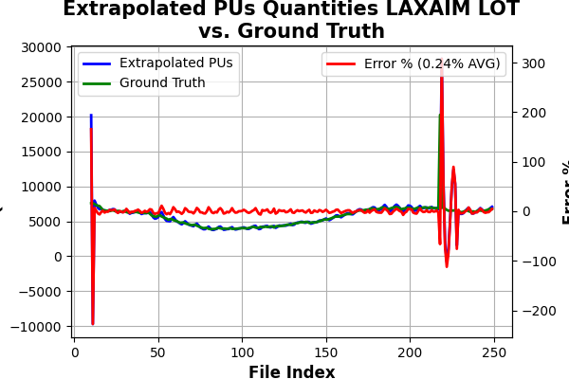

Pickup Prediction Results for LOT LAXCSN

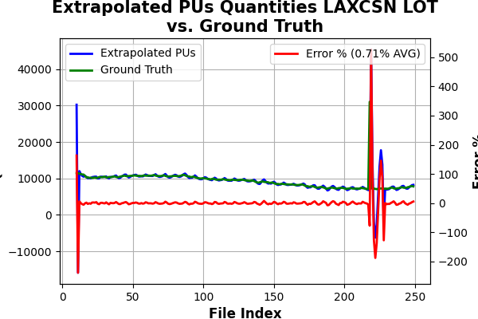

Pickup Prediction Results for LOT CHIIIC

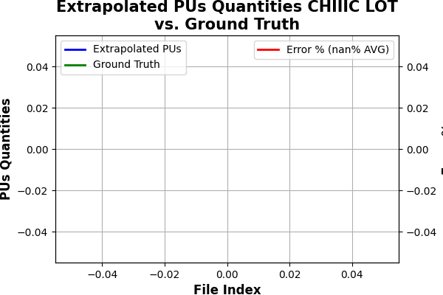

Pickup Prediction Results for LOT WBCT

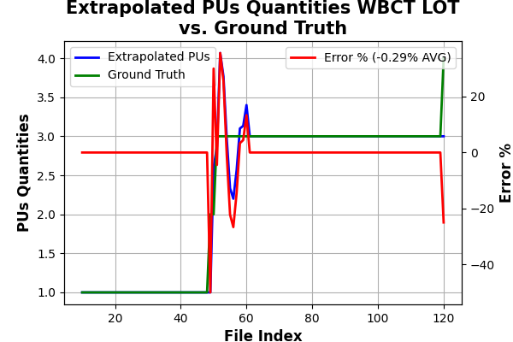

Pickup Prediction Results for LOT LAXICE

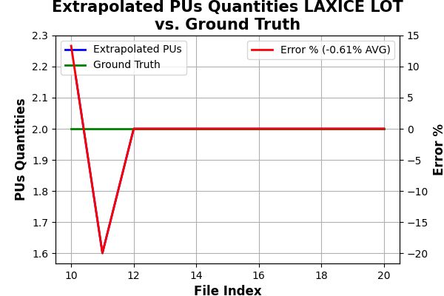

Pickup Prediction Results for LOT SAVCMP

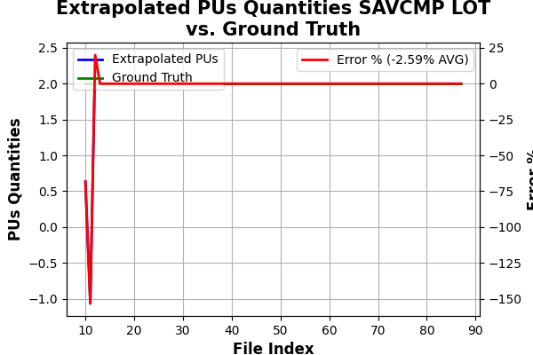

Pickup Prediction Results for LOT OAKSTE

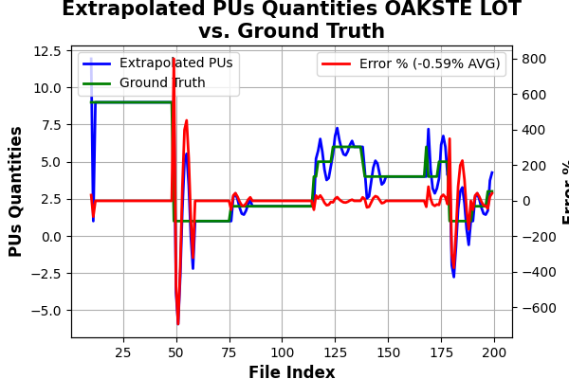

Pickup Prediction Results for LOT TACTHG

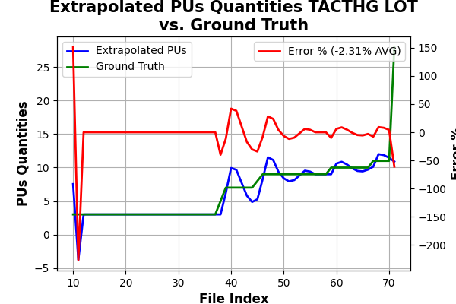

Pickup Prediction Results for LOT LAXBAC

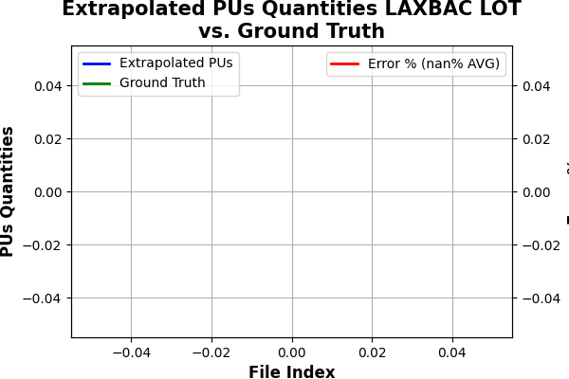

Pickup Prediction Results for LOT ORFMRS

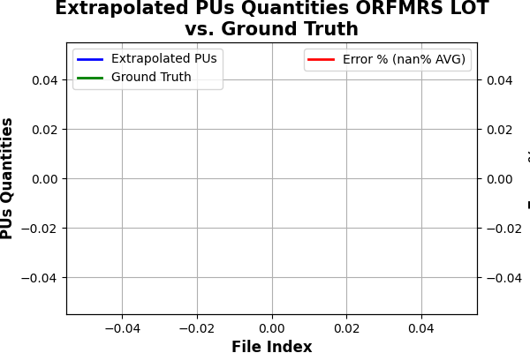

Pickup Prediction Results for LOT SEASPK

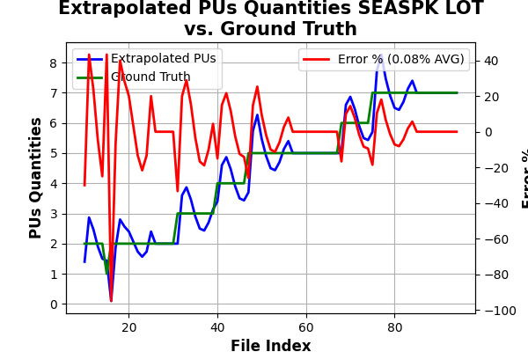

Pickup Prediction Results for LOT LT03JA

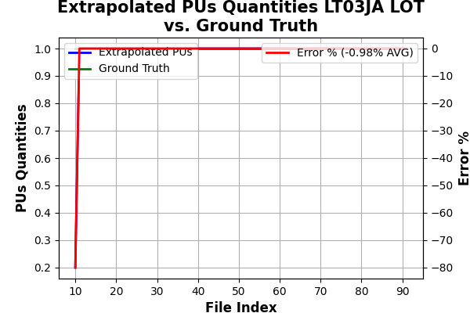

Pickup Prediction Results for LOT SBTAMO

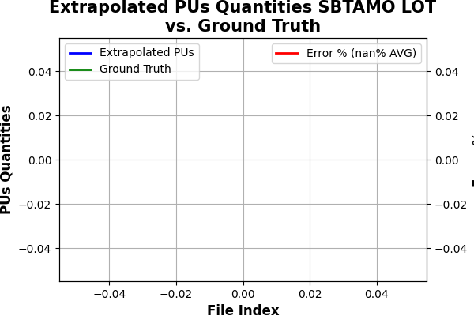

Pickup Prediction Results for LOT HOUCMC

