Flash Firmware to LCD Tutorial for Windows (Current Monitoring System (Ver.C 1.06)

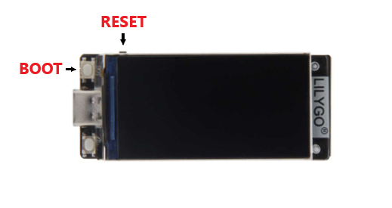

- Unplug LCD screen from PCB board
- Hold Down BOOT Button
- Plug in your PC's USB-C cable into LCD Screen
- Release BOOT Button
- Click Flash.bat file to flash firmware

