IBM SkillBuild National Cybersecurity Bootcamp
THREATLENS
Detect Smishing. Understand Threats. Stay Safe.

Project Title | THREATLENS
Project Tagline | Detect Smishing. Understand Threats. Stay Safe.
Project Type | Rule-Based SMS Phishing Detection Dashboard
Name | Avni
Course | B.Tech Computer Science and Engineering
Institution | Raj Kumar Goel Institute of Technology and Management
Academic Year | 2026–2027
Roll no | 2503330100036
Submission Date | 21-10-2026

1. Introduction
Smishing — SMS-based phishing — is one of the fastest-growing forms of cybercrime. Attackers send text messages that impersonate banks, delivery companies, government agencies, and popular brands to trick recipients into clicking malicious links, disclosing passwords, or transferring money. Unlike email phishing, smishing is harder to filter because most mobile users do not have SMS spam scanners, and short messages create a false sense of urgency with little context to evaluate.
ThreatLens was built to address this gap in a beginner-accessible way. Rather than relying on black-box machine learning or expensive API services, it uses transparent, explainable rule-based logic. Every detection decision is shown to the user in plain English, making it both a practical tool and an educational resource.
DEPLOYED WEBSITE LINK : https://cyber-security-bob-project-jx9a77lzdsr6zapzw2d5vv.streamlit.app/

2. Objectives
The primary objectives of this project are:
- To provide a practical, educational tool that helps non-technical users identify phishing attempts.
- To implement real detection logic using rule-based pattern matching without requiring paid APIs or machine learning.
- To build a modern, professional cybersecurity dashboard with a live statistics panel that updates in real time.
- To keep the entire application in a single Python file so beginners can read and understand all the code.
- To ensure complete user privacy — no messages or URLs are transmitted to any external server.

3. Technology Stack
ThreatLens uses only Python standard library modules plus Streamlit, which is installable with a single pip command. No database, no API keys, and no internet connection are required at runtime.
Component | Technology / Module | Purpose
Web Framework | Streamlit | Builds the entire UI with Python — no HTML/JS needed
Pattern Matching | re (Python standard library) | Regex for URL extraction, phone numbers, IP detection, ALL CAPS
Timestamps | datetime (Python standard library) | Records the time of each scan
State Management | st.session_state + st.rerun() | Persists scan counters and last result across reruns

4. System Architecture
The entire application is contained in a single file: app.py. The code is organised into five logical layers that execute in sequence on every scan:
- Layer 1 — Page Configuration & Styling: The Streamlit page is configured first (required by Streamlit), followed by all custom CSS injected via st.markdown. This creates the deep-navy dark theme with cyan and blue accents.
- Layer 2 — Session State Initialisation: The init_state() function sets up five persistent counters (total_scans, safe_scans, high_risk_scans, suspicious_scans, last_result) the first time the app loads. These counters survive page reruns within the same browser session.
- Layer 3 — Detection Engine: Seven pure Python functions implement all threat detection logic. They take string input and return scores, reasons, and brand sets. No network calls are made.
- Layer 4 — User Interface: Streamlit widgets (text areas, buttons, select boxes, columns) collect user input and trigger scans. Results are stored in session state and displayed on rerun.
- Layer 5 — Results Display: The last scan result is read from session state and rendered as styled HTML cards using st.markdown with unsafe_allow_html=True.

4.1 Data Flow
User Input → analyse_text() → extract_urls() → analyse_url() → run_scan() → Score + Category → UI Output
The run_scan() function is the master coordinator. It calls analyse_text() first (which returns detected reasons, a text score, and a set of already-seen brand names), then iterates over any URLs found in the message and passes the seen_brands set to analyse_url() to prevent double-counting. Finally it caps the combined score at 100 and classifies the result.

4.2 Key Functions
Function | Return Value | Description
init_state() | None | Sets up session state counters on first load only
extract_urls(text) | list[str] | Uses regex to pull all http/https URLs from a text string
analyse_text(message) | tuple(reasons, score, seen_brands) | Scores message text; returns flagged reasons, score (max 75), and brand set
analyse_url(url, seen_brands) | tuple(reasons, score) | Scores a single URL; skips brands already flagged in text (max score 50)
run_scan(message, extra_url) | dict | Master function — combines text + URL analysis, caps total at 100, classifies risk
get_safety_actions(category) | list[str] | Returns a tailored list of recommended actions per risk level
metric_card(label, value) | None | Renders a styled HTML dashboard metric card via st.markdown

5. Detection Engine
The detection engine is the core of ThreatLens. It is purely rule-based — there is no machine learning, no cloud lookup, and no training data. All rules are hard-coded lists of patterns derived from publicly documented phishing techniques.

5.1 Text Analysis Signals
The analyse_text() function checks the message body against nine categories of phishing signals. Each category has a fixed point value and an individual keyword list.
Signal | Points | Detection Method
Urgency Language | +15 | Keyword list: 'urgent', 'act now', 'within 24 hours', 'account locked', etc.
Credential / OTP Requests | +25 | Keyword list: 'otp', 'password', 'verification code', 'enter your code', etc.
Payment Demands | +20 | Keyword list: 'pay now', 'outstanding balance', 'bitcoin', 'wire transfer', etc.
Reward / Prize Lures | +20 | Keyword list: 'you have won', 'claim your prize', 'selected winner', etc.
Threat Language | +20 | Keyword list: 'legal action', 'arrested', 'account suspended', 'deactivated', etc.
Phone Number Present | +10 | Regex pattern matching 8+ digit phone numbers with optional country code
Spoofed Brand Name | +10 | 15 brand names checked: PayPal, Amazon, Netflix, Apple, Google, Chase, FedEx, IRS, etc.
ALL CAPS Words | +5 | Regex: any word with 4+ consecutive uppercase letters (e.g. URGENT, CLICK)
Excessive Exclamation Marks | +5 | 3 or more '!' characters in the message body

5.3 Scoring and Risk Classification
Scores from text analysis are capped at 75 points. Scores from each URL are independently capped at 50 points. The combined total is capped at 100. This prevents a single very suspicious message from overwhelming the scale and ensures proportional scoring across all signal types.
- Score 0–24 (Low Risk): Message appears safe. Three general safety tips are displayed.
- Score 25–59 (Suspicious): Caution advised. Five targeted warnings are displayed.
- Score 60–100 (High Risk): Very likely phishing. Six urgent actions are displayed.
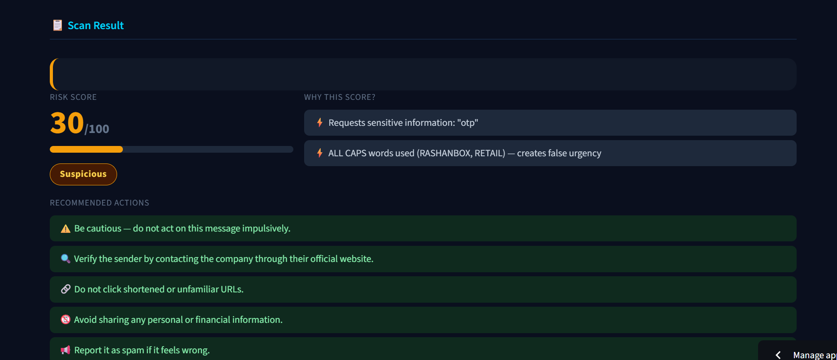

5.4 Bug Found and Fixed — Brand Double-Counting
During automated logic testing, a scoring inflation bug was discovered. When a brand name such as 'fedex' appeared in both the message text and the URL, it was counted twice — +10 for the text analysis hit and +20 for the URL analysis hit — inflating the risk score by 20 points. This caused the Payment Demand test case to score 65 and be wrongly classified as High Risk instead of 45 (Suspicious).
The fix: analyse_text() was modified to return a third value — a Python set called seen_brands. The analyse_url() function was updated to accept this set and skip any brand already recorded by the text analysis. All five automated test cases pass after the fix with the correct classifications.

6. Features Implemented
- Premium Dark Theme: The application uses a deep navy (#0a0f1e) background, cyan-to-blue gradient title, dark card surfaces, and colour-coded risk indicators — all implemented through custom CSS injected into the Streamlit page.
- Live Dashboard Cards: Four metric cards display Total Scans, Safe Scans, High-Risk Detections, and Suspicious Activities. These update in real time after every scan using st.session_state and st.rerun().
- SMS Scanner: A multi-line text area accepts any pasted message. The full text is analysed against all nine signal categories.
- URL Scanner: An optional standalone text input accepts a URL to be analysed independently from the message text.
- Sample Messages: A dropdown menu provides five pre-loaded examples — two High Risk phishing messages, one Suspicious payment demand, and two Low Risk safe messages — so users can test the scanner immediately.
- Risk Score Display: The result panel shows a large numeric score (0–100), a colour-coded horizontal progress bar, and a risk badge (green for Low Risk, amber for Suspicious, red for High Risk).
- Detection Reasons: Every triggered signal is listed in plain English so users understand exactly why a message received its score.
- Safety Recommendations: A tailored action list is shown per risk level. High Risk messages receive six urgent actions including instructions to delete the message and change passwords. Suspicious messages receive five precautionary steps. Low Risk messages receive three general tips.
- Clear Button: Resets all inputs, clears the result panel, and resets the sample selector to the default option in one click.
- Privacy by Design: Zero network calls are made at runtime. No user input is stored, transmitted, or logged. The application can run entirely offline after installation.
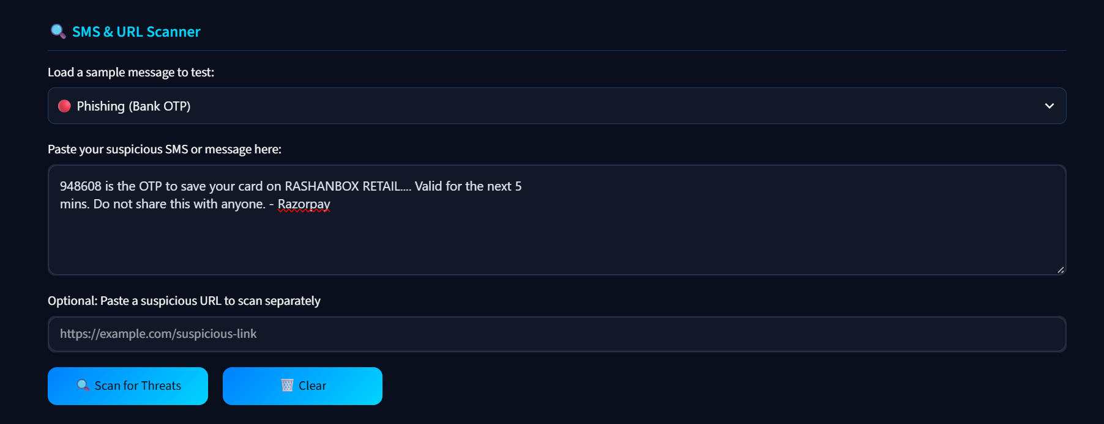
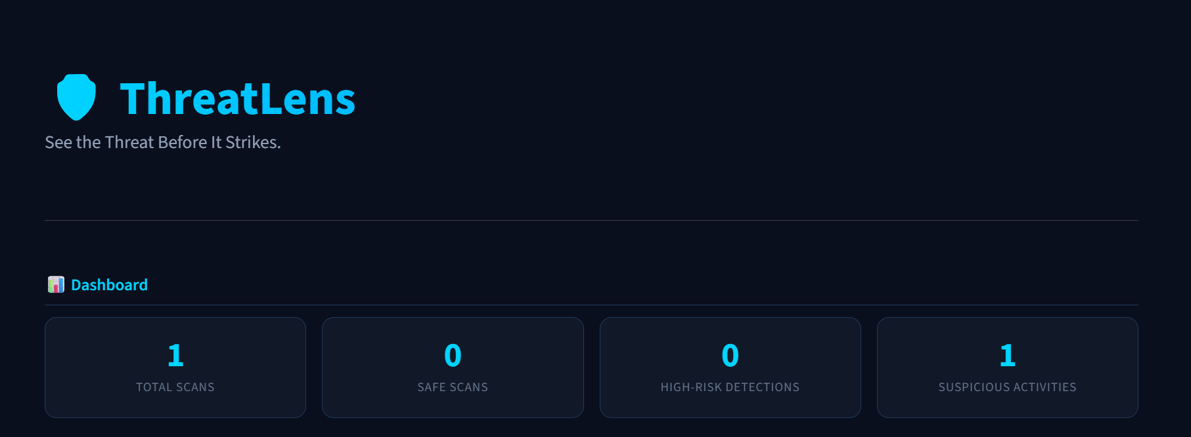

8. Limitations
- Rule-based evasion: A sophisticated attacker who avoids all keyword lists can craft a message that scores 0. The system cannot detect novel or obfuscated phishing that falls outside its known patterns.
- Brand false positives: The brand detection uses simple substring matching. A legitimate message from Chase Bank that mentions 'chase' will trigger the brand flag and add 10 points, even though the message is safe. This is an accepted trade-off for simplicity.
- No state persistence: Session state resets when the browser tab is closed or the Streamlit server is restarted. Scan history and counters do not survive across sessions.
- Structural URL scanning only: The URL analyser checks structure and domain patterns. It does not visit, resolve, or fetch the URL content, so redirect chains and cloaked pages are not detected.
- English-only: All keyword lists are in English. Phishing messages in other languages will not trigger text-based rules, though URL structural checks still apply.

9. Future Scope
The following improvements could extend ThreatLens into a more comprehensive tool:
- Machine Learning Classifier: Train a Naive Bayes or logistic regression classifier on a public SMS spam dataset (such as the UCI SMS Spam Collection) and integrate it alongside the rule-based engine for improved accuracy on novel messages.
- Live URL Reputation Lookup: Integrate free threat intelligence APIs such as VirusTotal or Google Safe Browsing to check URLs against known malicious domains.
- Persistent Scan History: Store scan results in a local SQLite database so statistics survive server restarts and users can review past scans.
- Multi-Language Support: Add keyword lists for other languages (Spanish, French, Hindi, etc.) to detect phishing in non-English messages.
- Browser Extension: Build a lightweight browser extension version that scans SMS messages directly in web-based messaging clients without requiring the user to copy and paste.
- Exportable Reports: Allow users to download a PDF summary of each scan result for reporting or evidence purposes.

10. How to Run the Application
- Prerequisites: Python 3.9 or later must be installed. Download from python.org if not already installed.
- Step 1 — Open PowerShell: Press Win + R, type powershell, press Enter. Navigate to the project folder: cd C:\Users\dell\Desktop\threatlen
- Step 2 — Install Streamlit: pip install streamlit (takes 1–3 minutes the first time)
- Step 3 — Run the application: streamlit run app.py
- Step 4 — Access the dashboard: The browser opens automatically at http://localhost:8501
- Step 5 — Stop the server: Press Ctrl + C in the PowerShell window
- Or simply, Publicly deployed website URL is provided in the project report (both in introduction part and conclusion part) as well as in the git hub repositry.

11. Conclusion
ThreatLens successfully delivers a fully functional, privacy-first cybersecurity dashboard in a single Python file of 663 lines. The project demonstrates that effective, explainable threat detection can be built with pure rule-based logic — no paid APIs, no machine learning, and no external data collection required.
The application is beginner-friendly by design: every function is documented with docstrings, every detection rule is explained in plain English within the user interface, and the codebase is structured to be read from top to bottom. The detection engine covers 15 distinct phishing signal categories across both message text and URL structure, returning a transparent, reasoned risk score rather than a black-box verdict.
All five automated logic tests pass. One real scoring bug — brand double-counting — was identified and fixed during development. The application runs successfully on Python 3.14 with Streamlit and has been verified to be free of syntax errors and invalid escape sequences.
While rule-based detection has known limitations compared to machine learning approaches, this version provides a strong, transparent foundation that can be extended with ML classifiers, live threat intelligence APIs, and persistent storage in future iterations.
DEPLOYED WEBSITE LINK: https://cyber-security-bob-project-jx9a77lzdsr6zapzw2d5vv.streamlit.app/

References
- Streamlit Documentation — https://docs.streamlit.io
- Python re Module Documentation — https://docs.python.org/3/library/re.html
- FTC Smishing Guidance — https://consumer.ftc.gov/articles/how-recognize-and-report-spam-text-messages
- CISA Phishing Awareness — https://www.cisa.gov/phishing
- UCI SMS Spam Collection Dataset — https://archive.ics.uci.edu/dataset/228/sms+spam+collection

