Network Intrusion Detection Using Cyber-Security

Project Id: 09
Member 1:
Name : Avni Srivastava
Class Roll No : 35
University Roll No : 2028683
Section and Group : P(G1)

Member 2:
Name : Jigyasa Rana
Class Roll No : 8
University Roll No : 2028439
Section and Group : P(G1)

- Contents:

1.Problem Description………………. 3
2.Dataset Description………………...4
3.Flow diagram………………………7
4.Modules for Project Implementation.……………8
  - Modules Used……8
  - Platform Used……9
5.Machine Learning model used………10
6.Evaluation metrics used….11
7.Results and Visualizations …13
8.Conclusion and Future Scope….16
9.References………17

- Problem Description:

Network intrusion detection is the process of identifying unauthorized or malicious activities occurring within a computer network. With the rapid increase in cyber threats such as hacking, malware attacks, and data breaches, securing network systems has become a critical requirement. Manual monitoring of large-scale network traffic is inefficient and unreliable, making automated detection systems essential.

This project aims to develop a Machine Learning-based Network Intrusion Detection System using a dataset containing network traffic features such as protocol type, packet size, connection duration, bytes sent/received, traffic flags, and error rate. The dataset is preprocessed by handling missing values, scaling features, and performing exploratory data analysis.

The system is designed for real-world applications in sectors like banking, healthcare, cloud services, and enterprise networks, where early detection of suspicious activity is crucial for preventing cyber attacks and ensuring secure communication.

- Dataset Description

The dataset used in this project is a synthetically generated network traffic dataset created using Python libraries such as pandas, NumPy, and random. The dataset simulates real-world network activity to analyze and detect malicious behavior.

- Dataset Size:
• Total records: 3000
• Each row represents a “network traffic instance”

- Features (Attributes)

Feature Name | Description
Timestamp | Date and time of network activity
Source_IP | IP address of sender
Destination_IP | IP address of receiver
Source_Port | Source port number
Destination_Port | Destination port  (e.g., 21, 22, 80, 443)
Protocol | Type of protocol (TCP, UDP, ICMP)
Packet_Size | Size of packet in bytes
Connection_Duration | Duration of connection
Packets_Per_Second | Traffic rate
Error_Rate | Fraction of errors in transmission
Login_Attempts | Number of login attempts
Bytes_Sent | Data sent (bytes)
Bytes_Received | Data received (bytes)
Traffic_Flag | Type of traffic (Normal, Suspicious, DoS, Probe)
MAC_Address | Device MAC address

- Target Variable:

Column | Description
Label | Binary classification output

- 0 → Normal Traffic
- 1 → Malicious Traffic
Label Creation Logic
The target label is generated based on specific conditions:
- High packet size + high error rate
- Excessive login attempts
- High bytes sent with suspicious flag
- Traffic marked as DoS
If any of these conditions are met → Label = 1 (Malicious)
Otherwise → Label = 0 (Normal)
Handling Missing Values
To simulate real-world data:
- Missing values are intentionally introduced:
  - 8% in numerical features (Packet_Size, Bytes, etc.)
  - 5% in categorical features (MAC, IP)
  - 3% in Timestamp
  - 6% in Error-related features
Processed Dataset
After preprocessing:
- Selected important features:
  - Traffic_Flag
  - Login_Attempts
  - Connection_Duration
  - Packets_Per_Second
  - Error_Rate
  - Packet_Size
- Final dataset used for modeling: Processed_data.csv
Dataset Purpose
This dataset is used to:
- Detect network intrusions
- Classify traffic as normal or malicious
- Train machine learning models like:
  - KNN
  - Logistic Regression
  - Decision Tree
  - Random Forest

- Flowchart:

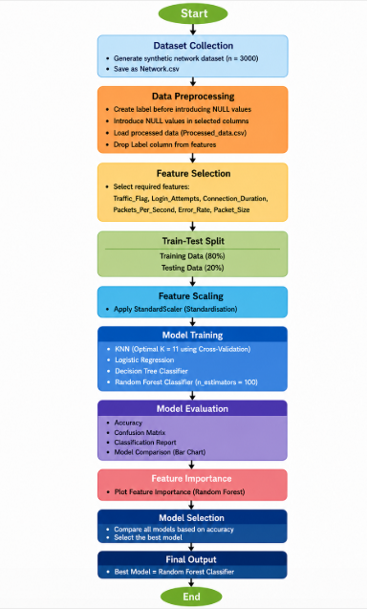

- Modules for Project Implementation

- Modules Used
- Pandas – Used for data manipulation
  - pd.read_csv() → load dataset
  - df.drop() → remove columns
  - df.to_csv() → save data
- NumPy – Used for numerical operations
  - np.random() → generate random values
- Matplotlib – Used for visualization
  - plt.plot() → line graph
  - plt.bar() → bar chart
  - plt.show() → display output
- Seaborn – Used for advanced graphs
  - sns.heatmap() → heatmaps
- Scikit-learn (sklearn) – Used for ML models
  - train_test_split() → split data
  - StandardScaler() → scaling
  - KNeighborsClassifier() → KNN
  - LogisticRegression() → LR
  - DecisionTreeClassifier() → DT
  - RandomForestClassifier() → RF
  - accuracy_score() → accuracy
  - confusion_matrix() → evaluation
  - classification_report() → metrics

6.Random & Datetime – Used for dataset creation
  - random.randint() → random values
  - datetime, timedelta → timestamps

- Platform Used
- Jupyter Notebook
Used for writing, executing code step-by-step, visualization, and easy analysis of results.

- Models Used(Applied/ Planned):

1. K-Nearest Neighbors (KNN)
KNN is used as a distance-based classification algorithm. The optimal value of K is selected using the Elbow Method and Cross-Validation. It classifies network traffic based on similarity with nearby data points, making it effective for detecting patterns in intrusion data.

2. Logistic Regression
Logistic Regression is used as a baseline classification model. It predicts whether a network activity is normal or malicious by estimating probabilities using a logistic function. It is simple, efficient, and useful for binary classification tasks.

3. Decision Tree Classifier
Decision Tree builds a tree-like structure to classify network traffic based on feature conditions. It is highly interpretable and performs well in capturing non-linear relationships in intrusion patterns.

4. Random Forest Classifier
Random Forest is an ensemble learning method that combines multiple decision trees to improve accuracy and reduce overfitting. It provides highly reliable predictions for intrusion detection by aggregating multiple models.

- Evaluation metrics used:

1. Accuracy Score
Accuracy measures the proportion of correctly classified network traffic samples out of total samples. It provides an overall performance measure for each model.

2. Confusion Matrix
The confusion matrix shows the number of correct and incorrect predictions for both normal and malicious classes, helping to analyze model errors in detail.

3. Precision
Precision indicates how many predicted intrusion cases are actually correct. It is important to reduce false alarms in network security systems.

4. Recall
Recall measures how many actual intrusion cases were correctly detected. High recall is crucial for identifying cyber attacks effectively.

5. F1-Score
F1-score is the harmonic mean of precision and recall, providing a balanced evaluation of model performance, especially in imbalanced datasets.

6. Classification Report
The classification report provides a complete summary of precision, recall, F1-score, and support for each class, allowing comparison between different models

- Results and Visualizations:

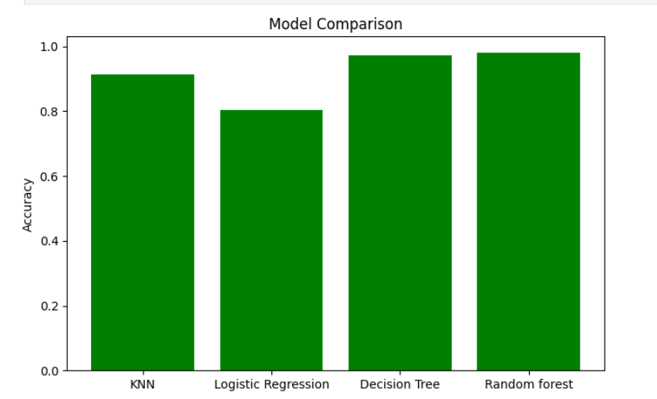

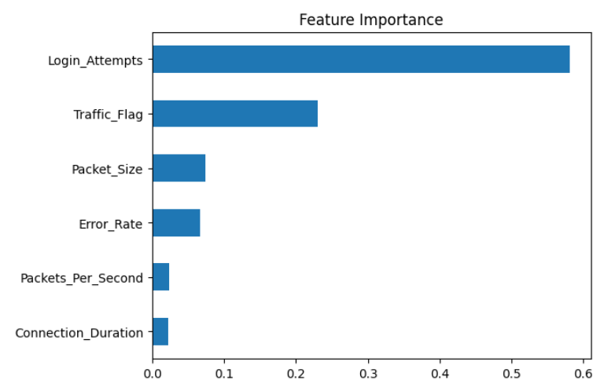
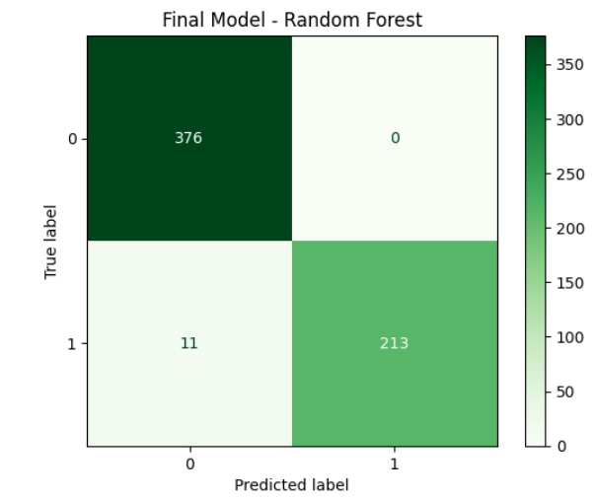

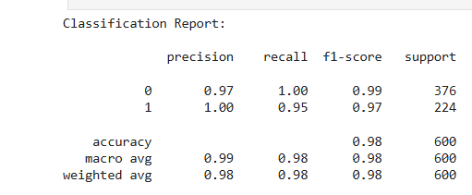

- Conclusion and Future Scope:

- Conclusion:

In this project, a network traffic dataset was generated and analyzed to detect malicious activities. Multiple machine learning models such as KNN, Logistic Regression, Decision Tree, and Random Forest were applied and compared. Based on performance, Random Forest achieved the highest accuracy, making it the best model for this task. The project demonstrates how machine learning can effectively identify network intrusions.

- Future Scope:

- Use real-world network datasets for better accuracy
- Apply deep learning models for improved detection
- Develop a real-time intrusion detection system
- Enhance feature engineering for better performance
- Deploy the model into a web or security application

- References:

Books and Link Sources:
- Introduction to Machine Learning with Python – Scikit-learn Algorithms
- Machine Learning – Oxford higher education
- Scikit-learn – https://scikit-learn.org/stable/
- Kaggle – https://www.kaggle.com/datasets
- NumPy Documentation – https://numpy.org

