Synopsis

Network Intrusion Detection for Cyber Security

Problem Id: 9

Student Name: Avni Srivastava
University Roll number: 2028683
Section: P

Student Name: Jigyasa Rana
University Roll number: 2028439
Section: P

- Problem Description:
Network intrusion detection is the process of identifying unauthorized or malicious activities occurring within a computer network. With the rapid growth of cyber threats such as hacking attempts, denial-of-service attacks, malware transmission, and data breaches, ensuring network security has become increasingly important. Manual monitoring of large volumes of network traffic data is inefficient and prone to errors.
This project aims to develop a Machine Learning-based Network Intrusion Detection System using a raw, real-world-like dataset containing multiple network traffic features such as IP Address, MAC Address, Protocol Type, Packet Size, Connection Duration, Bytes Sent, Bytes Received, Traffic Flags, and Error Rate. The dataset intentionally includes missing values, variations, and raw attributes to perform preprocessing tasks like data cleaning, handling null values, feature analysis, and visualization before model training.Multiple machine learning models such as K-Nearest Neighbors (KNN), Logistic Regression, Decision Tree, and Random Forest are applied to classify network traffic as normal or malicious.
In real-life scenarios, intrusion detection systems are widely used in banking networks, healthcare systems, cloud platforms, corporate infrastructures, and government organizations to monitor traffic behavior, detect cyber-attacks early, and maintain secure and reliable communication systems
- Steps of Implementation:
The implementation of the proposed Network Intrusion Detection System follows a structured Machine Learning pipeline to identify malicious network activities efficiently.

1.Dataset Simulation:
A realistic network traffic dataset is created containing multiple raw features such as IP
Address, MAC Address, Source Host, Packet Size, Protocol Type, Bytes Sent, Bytes Received, Traffic Flag, Connection Duration, and Error Rate. The dataset intentionally includes missing values, noise, and irregular patterns to simulate real-world network conditions.

2.Data Organisation and Preprocessing:
The generated data is structured into a tabular dataset and labeled as Normal or Attack traffic to enable supervised learning. Data preprocessing techniques are applied, including handling missing values, removing irrelevant features (like IP and MAC address), detecting outliers, encoding categorical features, and performing exploratory data analysis.

3.Dataset Splitting:
The dataset is divided into training (80%) and testing (20%) sets to evaluate model performance on unseen data.

4.Feature Scaling:
StandardScaler is applied to normalize all feature values so that each parameter contributes equally during model training, especially for distance-based algorithms like KNN.

5.Optimal K Selection (Elbow Method):
Different values of K are tested, and an Elbow Plot is used to determine the optimal number of neighbors for accurate classification in KNN.

6.Model Training:
Multiple machine learning models are trained using the processed dataset:
- K-Nearest Neighbors (KNN)
- Logistic Regression
- Decision Tree
- Random Forest

7.Prediction and Classification:
The trained model predicts whether incoming network traffic belongs to normal behavior or intrusion activity.

8. Performance Evaluation and Visualization:
Model performance is analyzed using multiple evaluation metrics:
- Accuracy Score
- Confusion Matrix
- Classification Report (Precision, Recall, F1-score)
Visualizations such as confusion matrices, elbow plots, and comparison graphs are used to interpret classification effectiveness.

9. Model Comparison and Selection:
All models are compared based on evaluation metrics. Random Forest is selected as the best-performing model due to its higher accuracy and balanced performance.

10. Model Testing:
The final model is tested on unseen data to verify its real-world performance. Testing includes:
- Samples from the test dataset
- Manual normal and attack samples
. This ensures that the model can generalize well and make reliable predictions.
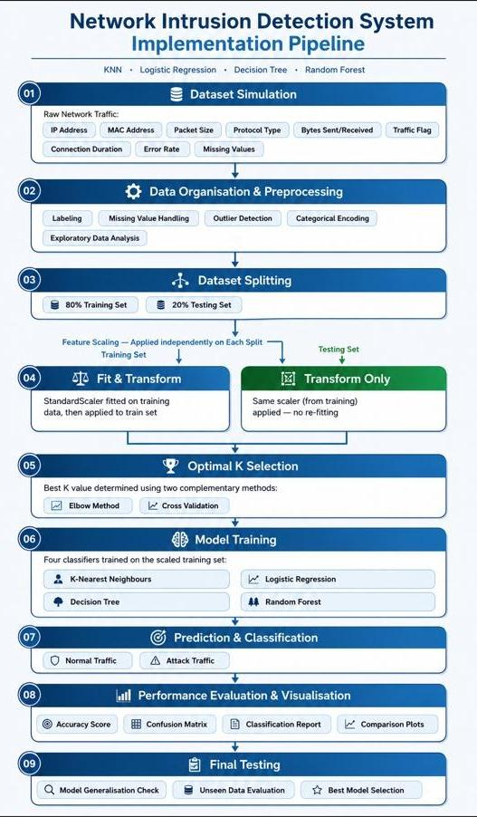
• Expected Modules/ Libraries to be used :

Libraries and modules used are:
- NumPy: Used for numerical computations and data manipulation.
- Pandas: Used for data handling, structuring, and analysis.
- Scikit-learn (sklearn): Machine learning library providing algorithms and preprocessing tools.
Modules used:
- StandardScaler (sklearn.preprocessing) – Normalizes feature values for better model performance, especially for distance-based algorithms like KNN.
- train_test_split (sklearn.model_selection) – Splits dataset into training and testing data.
- cross_val_score (sklearn.model_selection) – Performs cross-validation for reliable model evaluation and optimal K selection.
- KNeighborsClassifier (sklearn.neighbors) – Implements KNN classification algorithm.
- LogisticRegression (sklearn.linear_model) – Used for probabilistic classification.
- DecisionTreeClassifier (sklearn.tree) – Tree-based classification model.
- RandomForestClassifier (sklearn.ensemble) – Ensemble model for improved accuracy and robustness.
- sklearn.metrics – Computes accuracy, precision, recall, F1-score, and confusion matrix.
- Matplotlib / Seaborn: Used for visualization of results and model comparison.

• Expected Evaluation metrics and Plots to be used:

- Accuracy – Measures overall prediction correctness.
- Precision – Measures correctness of positive predictions.
- Recall – Measures ability to detect intrusion cases.
- F1-score – Balances precision and recall.
- Confusion Matrix – Shows correct and incorrect classifications.
- Elbow Plot – Helps select optimal K value for KNN.
- Cross-validation Plot (K vs Accuracy) – Helps select optimal K more reliably.
- Scatter Plot – Visualizes feature distribution for normal vs attack traffic.
- Confusion Matrix Visualization (multiple models) – Helps compare model performance.
This combination helps both quantitative evaluation and visual interpretation of model performance.

• Required topics from the subject:

- Data Preprocessing:
Preparing, cleaning, encoding, and scaling data improves model performance.
- Supervised Learning:
Used to classify network traffic into normal or attack categories based on labeled data.
- Machine Learning Algorithms:
  - KNN (distance-based)
  - Logistic Regression (probabilistic)
  - Decision Tree (rule-based)
  - Random Forest (ensemble learning)
- Model Evaluation:
Uses multiple metrics to measure accuracy, reliability, and performance of models.
- Model Validation (Cross-Validation):
Ensures model generalization by evaluating performance across multiple data splits

• Platform Required:

- Jupyter Notebook – For writing and running Python code to create the dataset and implement the ML model.
- Microsoft Excel / Google Sheets – Useful for viewing, organizing, and inspecting the generated dataset.
- Microsoft Word / Google Docs – Used for writing and formatting the project synopsis and documentation.
• Books and Link Sources:

- Introduction to Machine Learning with Python – Scikit‑learn Algorithms
- Machine Learning – Oxford higher education
- Scikit‑learn – https://scikit-learn.org/stable/
- Kaggle – https://www.kaggle.com/datasets
- NumPy Documentation – https://numpy.org

