Network Intrusion Detection Using Cyber-Security

Project Id: 09
Member 1:
Name : Avni Srivastava
Class Roll No : 35
University Roll No : 2028683
Section and Group : P(G1)

Member 2:
Name : Jigyasa Rana
Class Roll No : 8
University Roll No : 2028439
Section and Group : P(G1)

- Contents:

1.Problem Description………………………………….. 3

2.Architecture ………………………………………… 4

3.Models model….…………………………………… 5

4.Evaluation metrics used ………………………… 6

5.Preliminary Results and Visualizations…………………. 8

6.References……………………………………………….11

- Problem Description:

Network intrusion detection is the process of identifying unauthorized or malicious activities occurring within a computer network. With the rapid increase in cyber threats such as hacking, malware attacks, and data breaches, securing network systems has become a critical requirement. Manual monitoring of large-scale network traffic is inefficient and unreliable, making automated detection systems essential.

This project aims to develop a Machine Learning-based Network Intrusion Detection System using a dataset containing network traffic features such as protocol type, packet size, connection duration, bytes sent/received, traffic flags, and error rate. The dataset is preprocessed by handling missing values, scaling features, and performing exploratory data analysis.

The system is designed for real-world applications in sectors like banking, healthcare, cloud services, and enterprise networks, where early detection of suspicious activity is crucial for preventing cyber attacks and ensuring secure communication.
- Architecture:

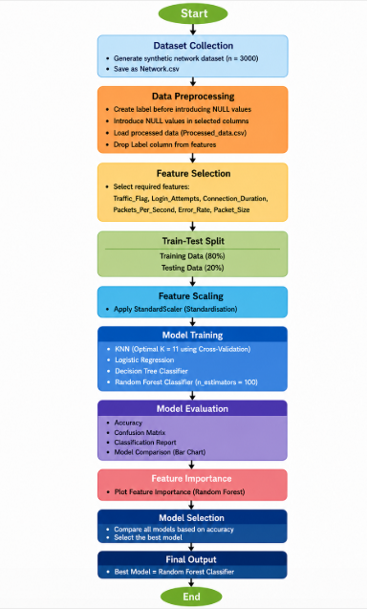

- Models Used(Applied/ Planned):

1. K-Nearest Neighbors (KNN)
KNN is used as a distance-based classification algorithm. The optimal value of K is selected using the Elbow Method and Cross-Validation. It classifies network traffic based on similarity with nearby data points, making it effective for detecting patterns in intrusion data.

2. Logistic Regression
Logistic Regression is used as a baseline classification model. It predicts whether a network activity is normal or malicious by estimating probabilities using a logistic function. It is simple, efficient, and useful for binary classification tasks.

3. Decision Tree Classifier
Decision Tree builds a tree-like structure to classify network traffic based on feature conditions. It is highly interpretable and performs well in capturing non-linear relationships in intrusion patterns.

4. Random Forest Classifier
Random Forest is an ensemble learning method that combines multiple decision trees to improve accuracy and reduce overfitting. It provides highly reliable predictions for intrusion detection by aggregating multiple models.

- Evaluation metrics used:

1. Accuracy Score
Accuracy measures the proportion of correctly classified network traffic samples out of total samples. It provides an overall performance measure for each model.

2. Confusion Matrix
The confusion matrix shows the number of correct and incorrect predictions for both normal and malicious classes, helping to analyze model errors in detail.

3. Precision
Precision indicates how many predicted intrusion cases are actually correct. It is important to reduce false alarms in network security systems.

4. Recall
Recall measures how many actual intrusion cases were correctly detected. High recall is crucial for identifying cyber attacks effectively.

5. F1-Score
F1-score is the harmonic mean of precision and recall, providing a balanced evaluation of model performance, especially in imbalanced datasets.

6. Classification Report
The classification report provides a complete summary of precision, recall, F1-score, and support for each class, allowing comparison between different models

- Preliminary Results and Visualizations:
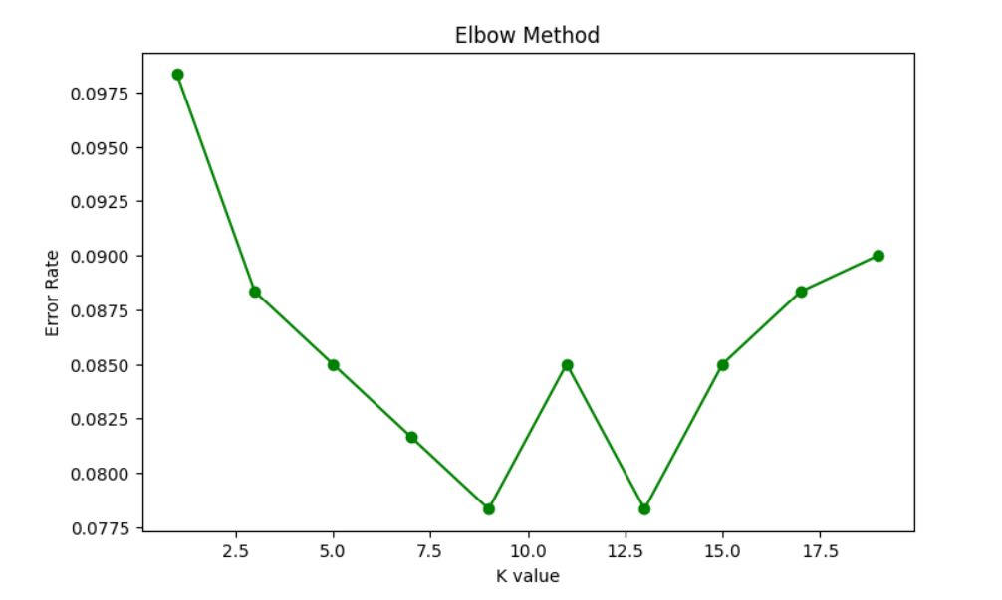


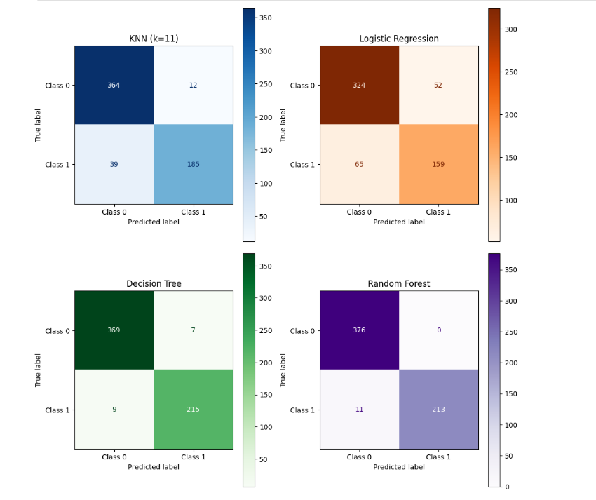
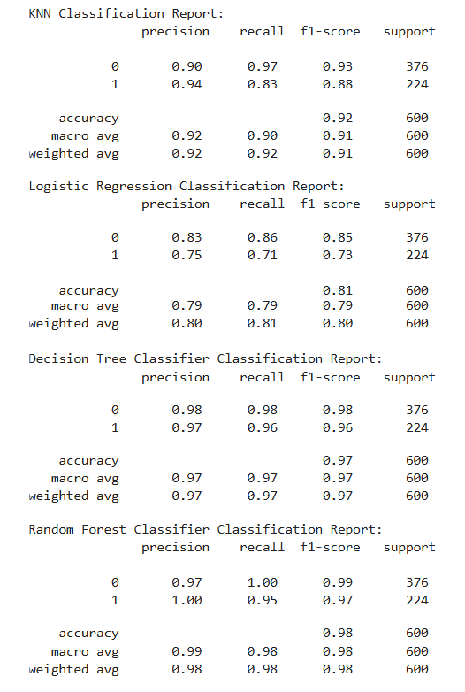

- References:

Books and Link Sources:
- Introduction to Machine Learning with Python – Scikit-learn Algorithms
- Machine Learning – Oxford higher education
- Scikit-learn – https://scikit-learn.org/stable/
- Kaggle – https://www.kaggle.com/datasets
- NumPy Documentation – https://numpy.org

