REQUIREMENTS:

- Need a Database for data storage
- Creation of a form to store interested students’ data
- On Coaching navbar, show upcoming webinar and ‘see our previous webinars’ on YouTube section.
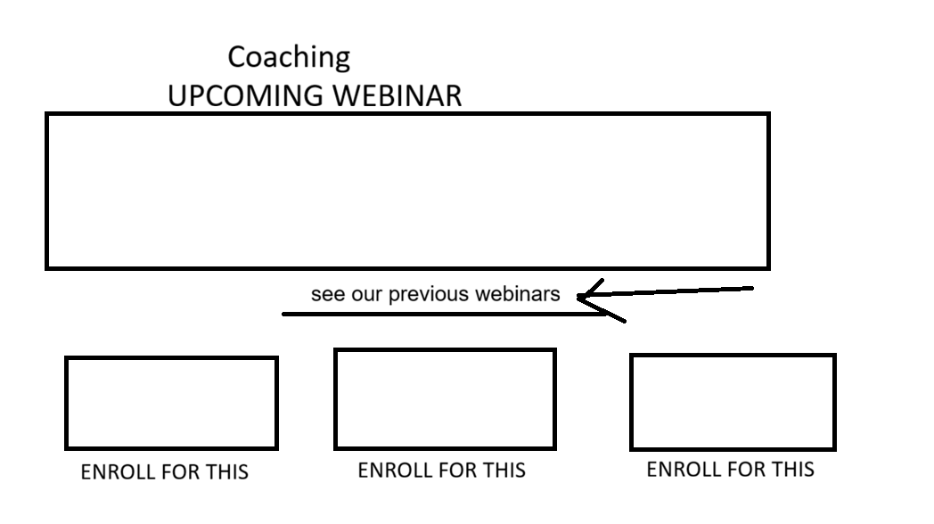
- We will create multiple subsections about “Enroll” for this upcoming course.

