AgriScope — Agricultural Market Price Analyzer
Exploratory Data Analysis (EDA) & Machine Learning Modeling Notebook
Author: Avnish Kumar (Roll No: 2400320100331)
Department of Computer Science & Engineering | ABES Engineering College, Ghaziabad
Project Guide: Prof. Poonam Jaswani | Academic Year: 2026–2027
1. Environment Setup & Data Ingestion
This notebook documents the exploratory data analysis, domain cleaning, micro-climate weather integration, and machine learning benchmarking for Indian wholesale agricultural mandi prices. We load 1,118,899 raw transaction records from AGMARKNET spanning 15 August 2024 to 14 August 2025.
import os, pandas as pd, numpy as np, lightgbm as lgb
from sklearn.metrics import mean_absolute_error, mean_squared_error, mean_absolute_percentage_error
df = pd.read_csv('agmarknet_india_historical_prices_2024_2025.csv')
df['Price Date'] = pd.to_datetime(df['Price Date'], dayfirst=True)
df = df.drop(columns=['Sl no.']) # Drop arbitrary row serial index

2. Data Integrity Engineering & Domain Bounds Validation
In agricultural wholesale economics, domain consistency mandates: Min Price <= Modal Price <= Max Price. We enforce two sequential validation rules:
• Rule 1 (Min <= Max): Dropped 470 records where reported minimum exceeded maximum (1,118,429 rows remaining). • Rule 2 (Modal within [Min, Max]): Eliminated 730 records where the clearing modal price violated the reported interval (1,117,699 clean rows remaining).
3. Strategic Crop Selection & Mandi Density Filtering
We focus on 3 crops spanning the agricultural volatility spectrum: Wheat (MSP-backed durable grain), Maize (feed/industrial coarse cereal), and Brinjal (highly perishable vegetable). For each crop, the top 5 mandis with >80% trading continuity are retained, creating a balanced 15-series panel aggregated to daily medians (5,005 modeling observations).
4. Exploratory Data Analysis & Visualizations (Deliverable 3)
To understand market inertia, price cycles, and volatility regimes, we analyze the visualised trends generated by our interactive dashboard and data pipeline.
4.1 Visualisation 1: Historical Price Trajectory & Moving Averages (Trend Decomposition)
We plot daily modal clearing prices alongside 7-day and 30-day moving averages for Brinjal at Asansol Mandi to observe volatility and structural price regimes.
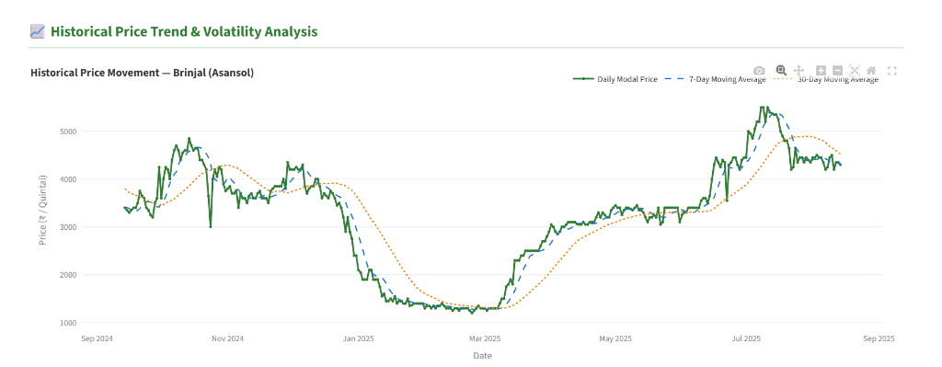
Figure 1: Daily modal wholesale price trends with 7-day and 30-day moving averages for Brinjal at Asansol Mandi.
Analysis: The time-series reveals three distinct market phases: (1) Winter Glut (Jan–Feb 2025): Prices crash to ₹1,200/quintal due to massive harvest arrivals with zero cold storage; (2) Heatwave Recovery (Apr–May 2025): Gradual climb to ₹3,500 due to temperature-induced yield reduction; (3) Monsoon Supply Shock (Jul 2025): Abrupt spike over ₹5,500 caused by road flooding, truck disruption, and harvest damage.
4.2 Visualisation 2: Inter-Mandi Price Spread & Spatial Arbitrage Opportunity
Comparing latest modal prices across regional mandis exposes significant price variations and market fragmentation across neighboring market yards.
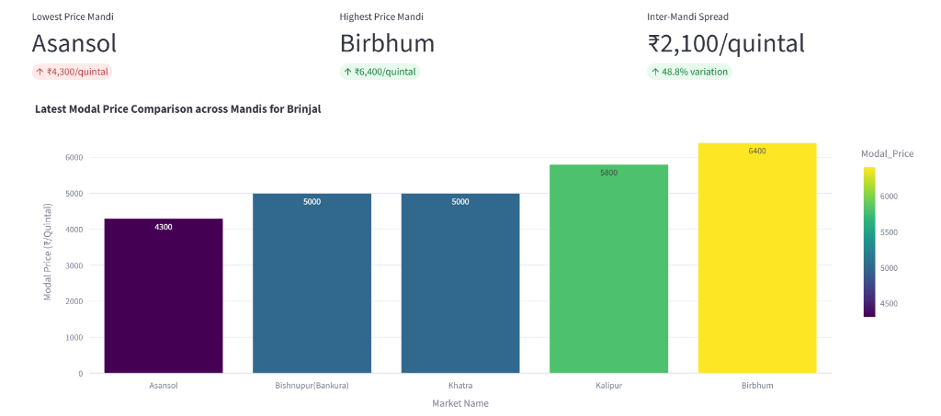
Figure 2: Latest wholesale modal price comparison across Brinjal mandis, highlighting lowest (Asansol), highest (Birbhum), and the ₹2,100/quintal price spread.
Analysis: On the latest common date, Brinjal cleared at ₹4,300/quintal in Asansol but ₹6,400/quintal in Birbhum—a 48.8% price spread (₹2,100 difference) between markets only ~110 km apart. This proves major spatial arbitrage potential for farmers and traders using the dashboard to select optimal selling destinations.
4.3 Visualisation 3: Micro-Climate Historical Weather & Extreme Rain Patterns
We integrated hyper-local daily weather retrieved via the Open-Meteo Historical Archive API across 13 physical market coordinates (4,745 daily meteorological records).
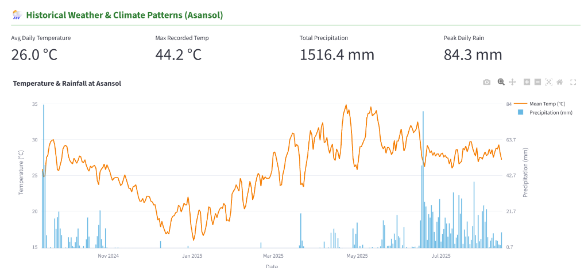
Figure 3: Daily mean temperature curve (°C) and precipitation bars (mm) for Asansol Mandi (Total Rain: 1,516.4 mm; Peak Day Rain: 84.3 mm; Max Temp: 44.2 °C).
Analysis: Peak monsoon downpours (84.3 mm peak rain) directly coincide with the July price surge to ₹5,500. Flooded rural roads halt transport trucks, drastically restricting daily mandi arrivals. Weather serves as an empirical early-warning indicator for supply chain breakdown.
5. Anti-Leakage Feature Engineering (The shift(1) Principle)
A fatal pitfall in time-series machine learning is target leakage from rolling windows. If today's target y_t is included in today's 7-day rolling mean, the model trivially inverts the mean to cheat during training. We enforce a strict safeguard: every rolling window is shifted by 1 day (shift(1)) so predictors depend strictly on past data (t-1). We derive Lag_1, 7, 14, 30, 7/30-day rolling means and volatilities, calendar attributes, and weather metrics.
6. Machine Learning Benchmarks & Chronological Evaluation
Evaluation enforced a strict chronological 56-day hold-out period (20 June 2025 to 14 August 2025; Train: 4,166 rows, Test: 839 rows). Zero random shuffling was permitted.
6.1 Visualisation 4: Academic Model Benchmark Scorecard
We compare the performance of Seasonal Naive Baseline, LightGBM (Price-Only), LightGBM (Price + Weather), and classical SARIMA.
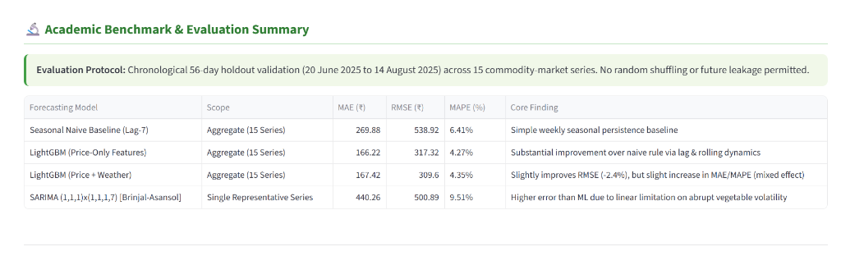
Figure 4: Academic model evaluation scorecard comparing Seasonal Naive, LightGBM, and SARIMA.
Quantitative Findings & The Weather Paradox: • LightGBM vs Baseline: LightGBM (Price-Only) achieves MAE ₹166.22, RMSE ₹317.32, and MAPE 4.27%—a 38.4% error reduction over the Seasonal Naive baseline (MAE ₹269.88, MAPE 6.41%). • The Weather Paradox: Adding weather reduces RMSE from ₹317.32 to ₹309.60 (-2.4%), proving weather dampens extreme error spikes during storm days, while adding slight parameter noise on calm days (MAE ₹167.42). • SARIMA Failure: SARIMA attained 9.51% MAPE on Brinjal—Asansol because linear equations cannot adapt to non-linear monsoon price shocks.
6.2 Visualisation 5: LightGBM Feature Importance Ranking
Feature importance decomposition reveals the dominant decision drivers across the gradient-boosted tree ensemble.
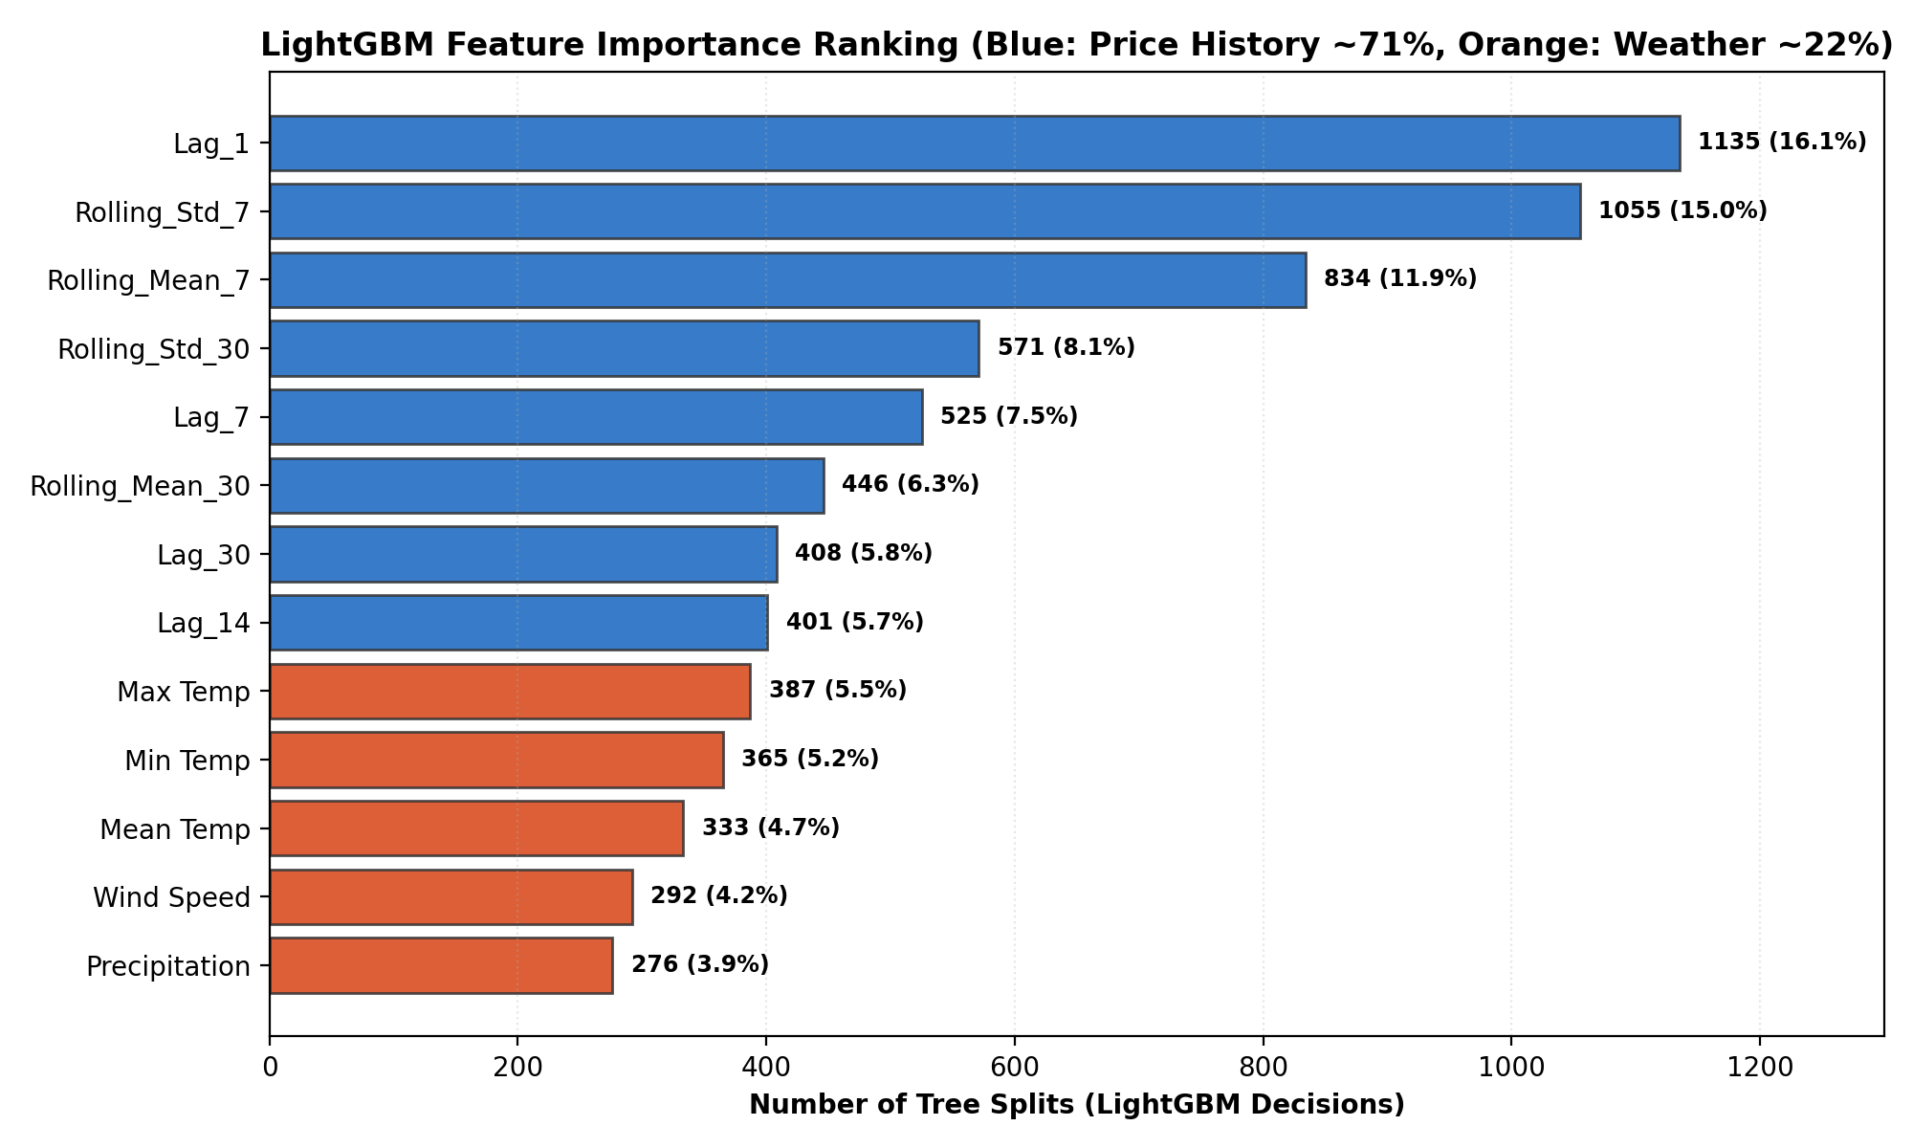
Figure 5: LightGBM feature importance decomposition by number of tree splits (Price history: ~71%, Micro-climate weather: ~22%, Calendar: ~7%).
Analysis: Autoregressive price memory and short-term volatility (Rolling_Std_7 with 1,055 splits) dominate tree decision branching. Micro-climate weather features account for 22% of total splits, acting as secondary supply-shock indicators.
7. Interactive Streamlit Dashboard Deployment (app.py)
The complete production pipeline is operationalized into an interactive Streamlit dashboard (app.py). The application supports dynamic commodity/mandi dropdown selection, 1-to-30 day recursive multi-step forecasting, Plotly moving average charts, cross-mandi spatial comparison, and live academic evaluation scorecards.
Summary: The complete pipeline connects raw government mandi records, Open-Meteo micro-climate weather, leak-free feature engineering, and validated gradient boosting into a production dashboard suitable for farmers, traders, and agricultural economists.

