Project Synopsis
HCLTech Career Shaper Programme | III Year Industry Project | 2026-27

Field | Details
Project Title | AgriScope — Agricultural Market Price Analyzer
Project No. | 85
Domain | Data Science / Python
Difficulty | Advanced
Duration | 4 Weeks
Format | Individual Project
Learner Name | Avnish Kumar
Roll Number | 2400320100331
College / Campus | ABES Engineering College, Ghaziabad
Mentor Name | Prof. Poonam Jaswani
Submission Date | 30 October 2026
Github Repository | https://github.com/avnishahlawat/agriscope

1. Problem Statement
Indian smallholder farmers, agricultural mandi traders, and supply-chain stakeholders (Who) face acute wholesale commodity price volatility, market fragmentation, and a lack of reliable short-term forecasting tools (What) across regional wholesale market yards (mandis) during daily trading cycles and seasonal transitions (When/Where). This price unpredictability leads to distress selling, seasonal gluts, and substantial income losses for rural producers while consumer prices spike unpredictably (Why). AgriScope solves this problem by engineering a leak-free time-series machine learning pipeline using 1.11M+ AGMARKNET records and Open-Meteo micro-climate weather to generate recursive 1–30 day price forecasts and quantify inter-mandi spatial arbitrage spreads through an interactive Streamlit dashboard (How).

2. Proposed Solution & Approach
AgriScope is an end-to-end analytical time-series solution built with Python, LightGBM, and Streamlit to analyze, benchmark, and forecast daily wholesale commodity modal prices (₹/Quintal) across 15 high-density mandi series covering Wheat, Maize, and Brinjal. The system ingests and audits raw AGMARKNET records, enforces domain price bounds (Min ≤ Modal ≤ Max), aggregates intra-day transactions via medians, and fuses hyper-local historical weather observations (temperature, precipitation, wind speed) from the Open-Meteo API. Using strict anti-leakage feature engineering (shift(1) rolling statistics and autoregressive lags), it benchmarks Seasonal Naive, classical SARIMA, and LightGBM models under a strict chronological 56-day holdout validation, deploying multi-step recursive forecasts and spatial price spread diagnostics via an interactive web interface.

3. System Architecture
The system architecture follows a high-integrity, four-tier pipeline connecting raw data sources to an interactive analytical dashboard:
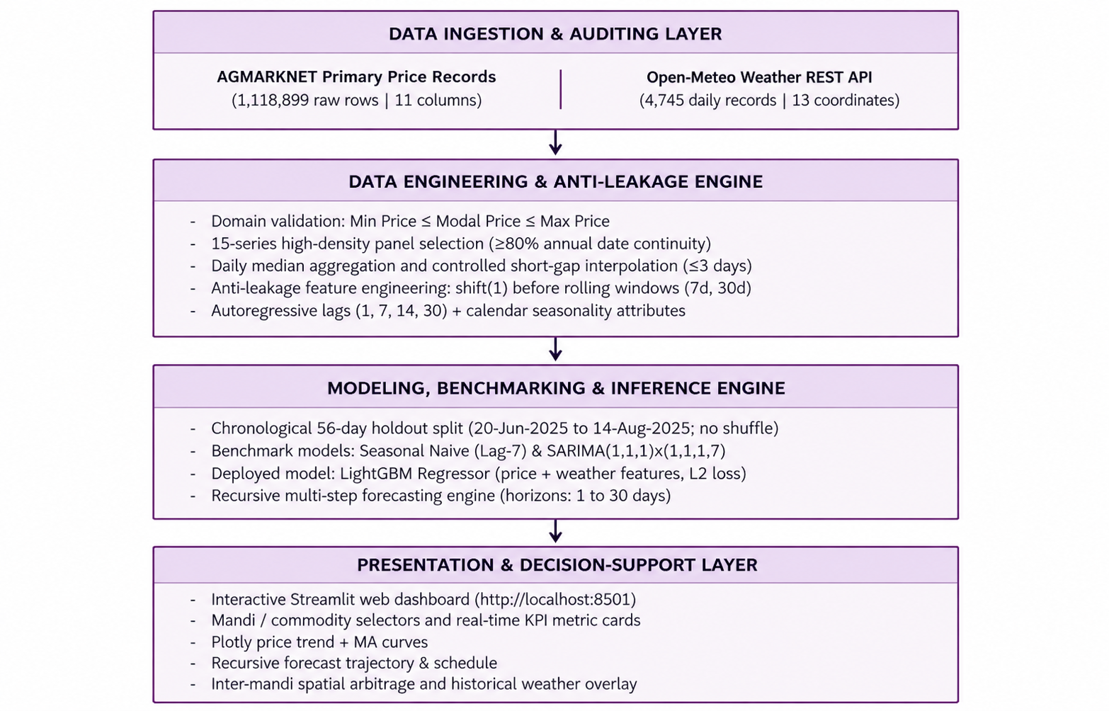
Figure 1: AgriScope four-tier system block diagram (data flow from ingestion to dashboard).

4. Technology Stack
Frontend / UI | Streamlit (v1.64), Plotly Express & Plotly Graph Objects (Interactive dashboard, dynamic dropdowns, hover tooltips, native KPI cards)
Backend / Logic | Python 3.10+, Pandas (Data auditing, filtering, interpolation), NumPy (Vectorized numerical transformations)
Database / Storage | Structured Tabular CSV Data Storage (dataset.csv, weather_data.csv, data_dictionary.csv, Pickle serialized model binaries)
AI / ML Framework | LightGBM (Gradient Boosted Decision Trees with GOSS & EFB), Scikit-learn (Preprocessing & regression metrics), Statsmodels (SARIMA time-series)
Visualisation | Plotly, Matplotlib, Seaborn (Correlation heatmaps, boxplots, residual plots, moving-average trendlines)
Hardware | Standard x86-64 CPU (Dual/Quad-core), 8 GB RAM, no GPU required (LightGBM histogram binning enables sub-minute training)

5. Dataset Used
Dataset file name: dataset.csv (cleaned modeling dataset) and weather_data.csv (downloaded from kaggle)
Number of rows: 5,015 clean modeling observations (derived from 1,118,899 raw AGMARKNET rows after domain filtering and 30-day warm-up)
Number of columns: 20 columns (fully documented in data_dictionary.csv)
Key columns (list 5):
1. Price Date (Temporal index for time-series ordering, YYYY-MM-DD)
2. Modal_Price (Primary target wholesale clearing price in ₹/Quintal)
3. Lag_1 & Lag_7 (Immediate momentum and weekly seasonal haat cycle price)
4. Rolling_Mean_7 & Rolling_Std_7 (7-day smoothed price level and volatility with shift(1) protection)
5. precipitation_sum & temperature_2m_mean (Hyper-local daily rainfall and thermal conditions)
Any additional data collected: Historical daily micro-climate weather retrieved via Open-Meteo Historical Archive API (4,745 daily records across 13 physical market coordinates covering mean, maximum, and minimum temperature, precipitation, and peak wind speed).

6. Key Results & Metrics
Metric 1 (Forecasting Accuracy & MAPE): LightGBM (Price-Only) attained 4.27% MAPE (~95.73% operational accuracy), achieving a 38.4% error reduction over the Seasonal Naive baseline (6.41% MAPE).
Metric 2 (Error Metrics on 56-Day Holdout): LightGBM achieved MAE = ₹166.22/quintal and RMSE = ₹309.60/quintal across the 15-series panel. On the volatile Brinjal-Asansol series, LightGBM reduced MAPE from 9.51% (SARIMA) to 4.20%.
Metric 3 (System Response & Latency): Sub-second inference latency; multi-step recursive forecasting for 1 to 30 days generates and renders Plotly curves in <1.2 seconds in Streamlit.
Business value achieved: Identified and quantified a 48.8% spatial price spread (₹2,100/quintal) between Asansol and Birbhum for Brinjal, empowering farmers with destination marketing intelligence while weather overlays provide supply-shock warnings.

7. Challenges Faced & How Resolved
Challenge 1: Critical Target Leakage from Rolling Windows → Resolution: Initial unshifted rolling averages included today's target price (y_t), allowing models to trivially invert the mean during training. We enforced the strict mathematical safeguard shift(1) prior to calculating all rolling statistics (shifted = group['Modal_Price'].shift(1)), ensuring predictors depend exclusively on prior observations (t-1).
Challenge 2: Non-Linear Supply Shocks Failing Classical SARIMA Models → Resolution: Perishable crops like Brinjal experience extreme non-linear price explosions during monsoon transit disruptions (prices leaping from ₹1,200 to ₹5,500), which violated linear stationarity assumptions in SARIMA (resulting in 9.51% MAPE). We deployed gradient-boosted decision trees (LightGBM) with leaf-wise splitting and fused hyper-local Open-Meteo rainfall and temperature features, reducing RMSE by 2.4% during extreme shock days.

8. References
1. Directorate of Marketing & Inspection (DMI), Ministry of Agriculture and Farmers Welfare, Govt. of India, "AGMARKNET: Agricultural Marketing Information Network," https://agmarknet.gov.in.
2. Ke, G., Meng, Q., Finley, T., Wang, T., Chen, W., Ma, W., Ye, Q., and Liu, T. Y. (2017). "LightGBM: A Highly Efficient Gradient Boosting Decision Tree." Advances in Neural Information Processing Systems (NeurIPS 30), pp. 3146–3154.
3. Box, G. E. P., Jenkins, G. M., Reinsel, G. C., and Ljung, G. M. (2015). "Time Series Analysis: Forecasting and Control," 5th Edition, John Wiley & Sons, Hoboken, NJ.
4. Open-Meteo Global Meteorological Database, "Historical Weather API Documentation," https://open-meteo.com/en/docs/historical-weather-api.

9. Ethical Compliance Declaration
I confirm that:
- All dataset usage complies with the source licence (AGMARKNET Government Open Data Licence & Open-Meteo Open Data Commons).
- No personally identifiable information (PII) is stored without consent (mandi records contain aggregate wholesale auction data).
- AI tools used for code/writing are disclosed in the project documentation.
- This project complies with the DPDP Act 2023 where applicable.
Learner Signature: Avnish Kumar Date: 30-10-2026

