Small Shop Supplier Reorder Assistant: Project Proposal
Nov 6, 2026 · @Lavnish
My project is a small menu-driven C++ program for a local shop owner. It keeps a list of the products the shop sells, along with the supplier for each one. At any time, it can tell the owner which products are running low, how many to order, roughly what the order will cost, and which supplier to phone.

Submission details
Item | Detail
Course | CAP455 (Object-Oriented Programming using C++)
Assessment | CA1, Phase 1
Roll number | A17
Student | Lavnish Kumar Singh
School | School of Computer Science and Engineering, Lovely Professional University, Phagwara, Punjab
Section | [Section]
Faculty | [Faculty name]
Project title | Small Shop Supplier Reorder Assistant
Main class | Product
Unique key | productCode
File name | A17_CAP455_CA1_SmallShopSupplierReorderAssistant
Syllabus used | Unit I (Principles of OOP and C++ essentials) and Unit II (Handling pointers, arrays and string) only

1. Introduction and background
Almost every street in India has a small kirana or general store. These shops sell a few dozen to a few hundred everyday items, and they buy most of that stock from a handful of local wholesalers. In most of them, one person is the owner, the cashier and the buyer at the same time.
Reordering in these shops usually happens from memory. The owner sees a shelf getting empty, remembers which wholesaler supplies that item, looks for the phone number and places the order. On a normal day this works. On a busy day, during a festival, or when someone else is minding the shop, things get missed.
The common problems are:
- A fast-selling item like rice, sugar or cooking oil runs out before anyone notices, and customers go to the next shop.
- A slow-selling item gets ordered again too soon, so money stays stuck on the shelf.
- Supplier numbers are spread across notebooks and phones, so time is wasted finding whom to call.
- The owner has no idea how much cash the next round of orders will need until the bills arrive.
Shops have a simple rule for this called the reorder point. Every product gets a stock level at which it should be reordered, and a fixed quantity to order each time. When the stock drops to that level, you reorder. No forecasting is needed. You only need an accurate list of products with their stock, reorder level, order quantity and supplier.
My project builds that list as a C++ program. It is small, it runs on any computer with a C++ compiler, and it maps well onto Units I and II of CAP455. Each product is an object with private data and checked setters, and the whole stock list is an array of those objects.

2. Problem statement
A small shop owner has no quick, reliable way to answer three questions:
- Which products have dropped low enough that I need to reorder them?
- How many of each should I order, and what will it cost in total?
- Which supplier do I call for each one, and on what number?
The information is there, but it lives in the owner's head, in notebooks and in phone contacts. Nobody checks it for mistakes, such as a phone number with a missing digit, a negative stock figure, or the same item written twice under slightly different names.
So the problem I am solving is this: keep one checked list of products and suppliers with no duplicates, and build a reorder list from it whenever the owner asks. In Phase 1 the list is kept in memory while the program runs. The program has to:
- accept a new product only when every field is valid,
- refuse a product whose code is already in the list,
- let the owner view the list and search it by code, and
- show which products need reordering, with the quantity, estimated cost and supplier contact for each.

3. Objectives
What the program should do in Phase 1
- Store up to 50 products in memory. Each product has a code, name, supplier name, supplier phone, current stock, reorder level, reorder quantity and unit cost.
- Add a product through the menu, checking each field as it is typed and asking again if it is wrong.
- Never allow two products with the same code. Upper and lower case count as the same, so rc-101 and RC-101 are one product.
- Show all products, search one product by its code, and show a short summary.
- Show a reorder list of every product whose stock is at or below its reorder level, with the quantity to order, the estimated cost, the supplier to call and the total.
What I want to learn and show from Units I and II
- Design a real class with private data, setters that check their input, and inline getters.
- Use static data members and static member functions for limits, a shared counter and input checks.
- Use a friend function and a friend class, with a clear reason for each.
- Keep objects in an array of objects and search it using pointers, pointer arithmetic and a null pointer.
- Use the this pointer, reference variables, and call by value, by reference and by address.
- Use the standard C++ string class and its modifiers for all text handling.

4. Scope
Included in Phase 1
- One shop, one user (the owner), and a simple console menu.
- Up to 50 products kept in memory while the program is running.
- Adding a product with full input checking (Create).
- Viewing all products, searching by code, the reorder list and a summary (Read).
- A unique product code, with no duplicates and no difference between upper and lower case.
- Supplier name and phone stored with each product.
- Tests for normal, invalid and boundary inputs.
Not included in Phase 1
- Changing a product after it is added, or removing it. Later phases will decide this based on their brief.
- Billing, GST, sales records, logins and any graphical screens.
Why this topic fits the rules. It is not a library, hospital or IPL type system. It solves a real buying problem for a small business, it has one clear main class (Product), and it has one natural unique key (productCode).

5. Proposed system and features
The program shows a menu, does what the owner picks, and comes back to the menu until the owner chooses Exit.
Option | Feature | What the owner sees
1 | Add product | Asked for each field one by one. A wrong value gets a clear message and the same question again. A code that already exists is refused straight away. Leaving a field blank cancels the add.
2 | View all products | A neat table of every product. Products that need reordering are marked *REORDER*.
3 | Search by code | The matching product, or "No product found". Case and extra spaces are ignored.
4 | Reorder list | Every product at or below its reorder level, with the quantity to order, the estimated cost, and the supplier's name and phone. The number of items and the total cost are shown at the end.
5 | Summary | How many products are stored out of 50, how many have been added in total, and how many need reordering.
6 | Load demo products | Adds five sample products for the demo. Running it a second time shows all five being refused as duplicates.
0 | Exit | Closes the program.
A quick example. With the five demo products loaded, the reorder list shows Basmati Rice 5kg: 8 in stock, reorder level 10, so order 20 at Rs. 410 each, which comes to Rs. 8,200. It also lists Sugar 1kg (Rs. 1,320) and Bath Soap Pack of 4 (Rs. 1,500). The total is Rs. 11,020, and each line shows the supplier's name and number. That one screen answers all three questions from the problem statement.

6. Entities, main class and unique key
The main class is Product, and its unique key is productCode. A second class, ProductStore, holds all the products. An enumeration, AddResult, tells the menu how an add attempt went.
Part | Type | Job
Product | Main entity class | One item the shop sells, plus the supplier it is bought from. It owns its data and the rules for checking that data.
ProductStore | Class, and a friend of Product | Holds the array of 50 Product objects. Adds, finds and lists products, and builds the reorder list.
AddResult | Enumeration | ADD_OK, ADD_INVALID, ADD_DUPLICATE or ADD_FULL.
displayProduct() | Friend function | Prints one product as a row of the table, reading its private fields.
Helper functions | User-defined functions | trim, toUpperCase, parseInt and parseMoney, used to check input.
Why Product is the main class. Every question the owner asks is about a product: is it running low, how many should I order, whom do I call? The reorder decision depends only on the product's own numbers (stock, reorder level and reorder quantity). So the supplier's name and phone are simply stored inside each product.
Why productCode is the unique key. Product names are long, and people write them differently ("Basmati Rice 5kg" or "basmati rice 5 kg"), so a name can't reliably identify a product. A short code like RC-101 is what shops already put on shelf labels, and it is quick to type and compare. Before the code is stored or compared, the program removes extra spaces and converts it to capital letters. That way rc-101, RC-101 and Rc-101 all mean the same product, and it can never be stored twice.

7. Data dictionary
Class Product (kept in memory in ProductStore::items[50])
# | Field | C++ type | Size or range | Rule | Example
1 | productCode | string | 3 to 10 characters | Unique key. Letters, digits or - only. Must start with a letter or digit. Spaces trimmed, stored in capitals, must not already exist. | RC-101
2 | name | string | 1 to 40 characters | Printable characters only, not blank | Basmati Rice 5kg
3 | supplierName | string | 1 to 40 characters | Same rule as name | Sharma Traders
4 | supplierPhone | string | exactly 10 characters | Digits only. Kept as text because we never do maths on it, and 10 digits can be bigger than the largest int. | 9876543210
5 | currentStock | int | 0 to 100000 | Whole number | 8
6 | reorderLevel | int | 0 to 100000 | Whole number. Reorder when stock is at or below this. | 10
7 | reorderQty | int | 1 to 100000 | Whole number, at least 1 | 20
8 | unitCost | double | 0.01 to 1000000.00 | More than 0, at most 2 decimal places | 410.00
Static members of Product (one copy shared by the whole class)
Member | Type | Meaning
totalAdded | static int, private | How many products have been added. Only ProductStore, as a friend, can change it.
MAX_PRODUCTS | static const int | 50, the size of the array
CODE_MIN_LEN, CODE_MAX_LEN | static const int | 3 and 10
TEXT_MAX_LEN | static const int | 40
PHONE_LEN | static const int | 10
QTY_MAX | static const int | 100000
Values worked out, not stored
Function | Formula | Meaning
needsReorder() | currentStock <= reorderLevel | Time to reorder this product
reorderCost() | reorderQty * unitCost | Rough cost of one order
Class ProductStore. items is an array of 50 Product objects, and slots 0 to count - 1 are in use. count is an int from 0 to 50. It is the number of products stored, and also the position where the next product will go.

8. System design
The design uses two classes. ProductStore owns an array of up to 50 Product objects, and every add and search goes through it. Product keeps its fields private and offers setters that check their input, inline getters, and static checking functions. ProductStore is a friend class of Product so it can update the private static counter totalAdded. displayProduct() is a friend function that prints a product's private fields.
Design choices and why I made them
- Every data member starts blank, and setAll() fills them. The line Product items[50]; creates 50 objects at once. Each data member has a starting value in the class (int currentStock = 0;, and strings start empty), so all 50 objects begin blank and isValid() says none of them is a real product yet. Constructors belong to a later unit, so instead the class has setAll(), which fills every field by calling each setter in turn and returns true only if every value was valid.
- Setters return bool. That way the caller knows whether the value was accepted. Each setter's parameter has the same name as the data member, so I use this-> to say which one I mean.
- findByCode() returns a pointer. "Not found" is a normal answer, and returning nullptr says that cleanly without making a fake product. The pointer also points at the real object in the array, not a copy.
- The checking functions are static. A rule like isValidCode() doesn't depend on any particular object, so I can check the input before creating or storing anything.

8.1 UML class diagram
Figure 1 shows the data and functions of Product and ProductStore, the AddResult enumeration and the two friend links. Underlined members are static, and «inline» marks inline functions.
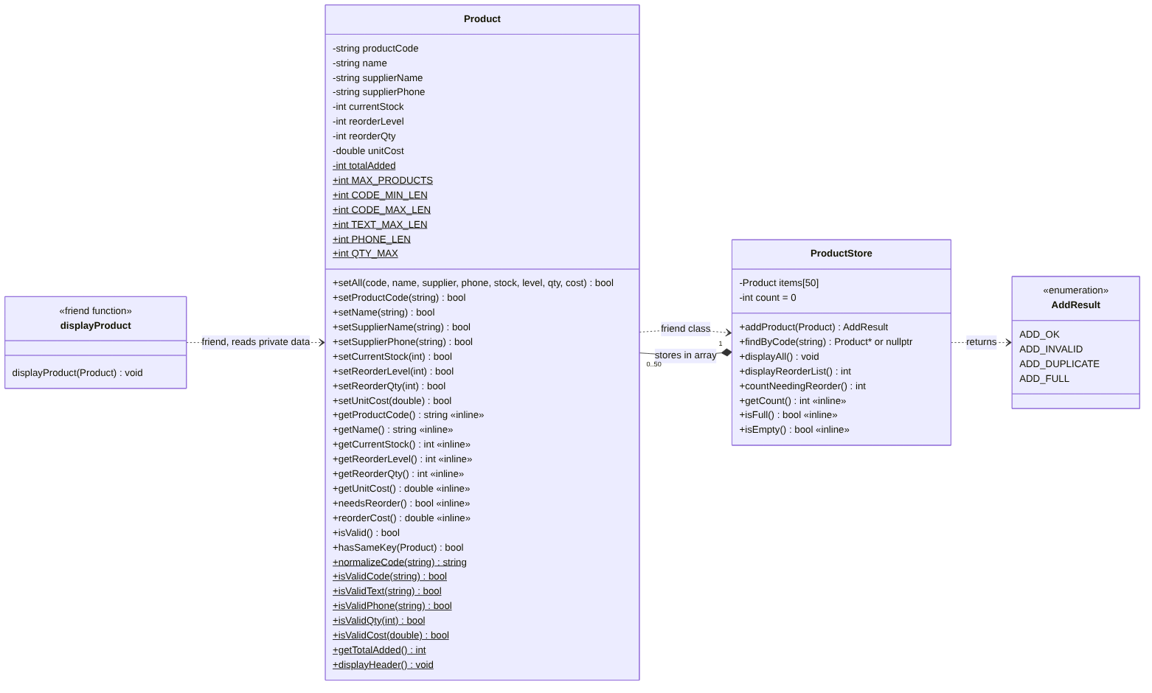
Figure 1. UML class diagram

8.2 Flowchart: main menu
Figure 2 shows the main loop. The menu keeps coming back until the owner picks 0, and each option runs one Create or Read action.
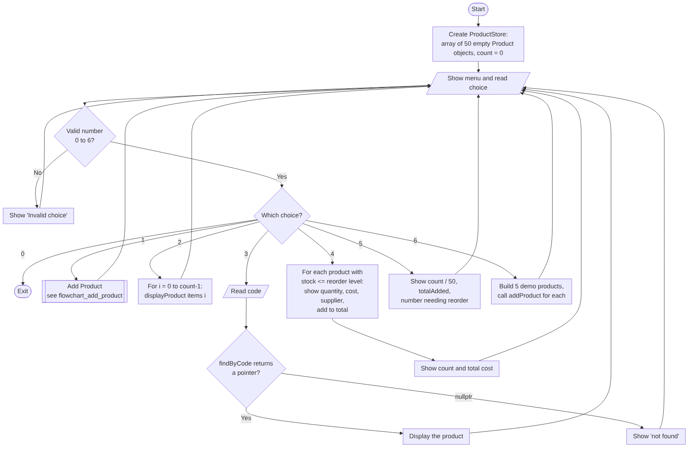
Figure 2. Flowchart of the main menu

8.3 Flowchart: Add Product
Figure 3 shows how a product gets added. The code is checked first, both for its format and for duplicates, so the owner doesn't type seven more fields only to be told the code is taken. After that, every field is checked as it is typed. A blank entry cancels the add. The store checks everything once more before copying the product into the array.
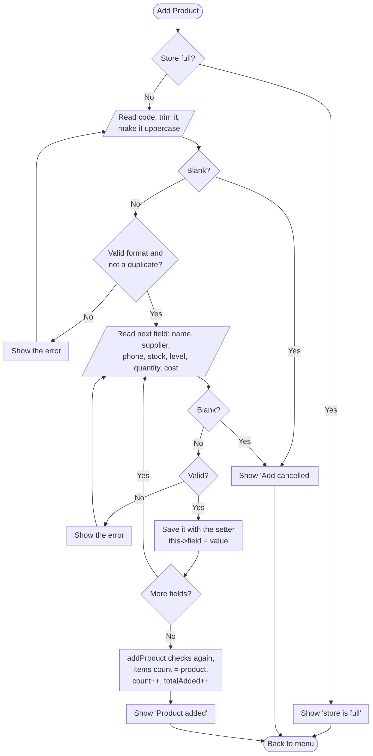
Figure 3. Flowchart of Add Product, with input checks and the duplicate key check

9. Input checking and duplicate keys
A product goes into the array only when every field is valid and its code is new. I check this in three places, so the rule holds no matter how the data arrives:
- In the menu, while typing. Every value is read as a full line using getline() and checked straight away. If it is wrong, the owner sees what is wrong and gets the same question again. A blank line cancels the add, so a half-filled product is never saved.
- In the setters of Product. Each setter calls its static check (for example Product::isValidPhone()) and refuses a bad value. setAll() also goes through these setters.
- In ProductStore::addProduct(). Before copying a product into the array, the store checks isValid(), then looks for a duplicate code, then checks if the array is full. It returns ADD_INVALID, ADD_DUPLICATE, ADD_FULL or ADD_OK.
Why I read numbers as strings. With cin >> number, typing abc puts cin into a failed state, and the menu can get stuck in a loop. Typing 12abc quietly stores 12. So I read the whole line as a string and check each character myself in parseInt() and parseMoney(). This rejects abc, 12abc, 1.5 and -5 with a clear message, and cin keeps working normally.
How duplicate codes are stopped
- Product::normalizeCode() trims the typed code and turns it into capitals.
- ProductStore::findByCode() moves a pointer through the used part of the array and compares codes.
- If it finds a match, the menu prints "Duplicate: product RC-101 already exists" and asks for another code before any other field.
- addProduct() checks again before storing, so the rule also holds for the demo loader and the test program.
What the owner types | What happens
Code AB, RC 101, RC_101 or -RC1 | Refused: wrong length or characters
Code rc-101 when RC-101 is already stored | Refused: duplicate
A name with only spaces, or 41 characters long | Refused: blank or too long
Phone 98765 or 98765abcde | Refused: not 10 digits
Stock abc, -5 or 100001 | Refused: not a whole number from 0 to 100000
Reorder quantity 0 | Refused: must be at least 1
Cost 0, -410 or 4.555 | Refused: must be above 0, with at most 2 decimals
A 51st product | Refused: the store is full

10. C++ concepts used from Units I and II
Everything in this project comes from Unit I and Unit II of the CAP455 syllabus. The table shows where each topic is used and why. Figures 4 to 6 show the main ideas as pictures.
Topic | Unit | Where I use it | Why
Procedural vs object-oriented | I | Whole design (see section 11) | Keeps data and its rules together
Input/output streams | I | cin, cout, getline, setw, setprecision | Menu, input and neat tables
Classes and objects | I | Product, ProductStore | One object per product
Enumeration | I | enum AddResult | Named results instead of 0, 1, 2, 3
Static data member | I | Product::totalAdded | One counter shared by all products
Static const members | I | MAX_PRODUCTS, CODE_MAX_LEN, QTY_MAX | Limits belong to the class, not to one object
Static member functions | I | isValidCode(), isValidPhone(), normalizeCode() | Check input before any object exists
User-defined functions | I | trim, parseInt, parseMoney, menu functions | Small parts that are easy to test
Inline functions | I | Getters, needsReorder(), reorderCost(), isDigitChar() | Very small functions called often
Friend function | I | displayProduct(const Product&) | Prints private fields without being a member
Friend class | I | friend class ProductStore; | Only the store may change the private counter
Reference variables | I, II | parseInt(..., int& value), addProductMenu(ProductStore&) | Function changes the caller's own variable
Call by value | I | isValidQty(int), setCurrentStock(int) | Small values are cheap to copy
Call by address | I | findByCode() gives back a const Product* | Caller gets the address of the real object
this pointer | II | Every setter: this->name = trim(name); | Separates the member from a parameter with the same name
Array of objects | II | Product items[50], Product demo[5] | Holds all the products
Pointer to objects | II | const Product* p = &items[i]; | Works on an object inside the array
Pointer arithmetic | II | ptr = items; end = items + count; ptr++ | Walks the array in findByCode()
Null pointer assignment | II | return nullptr; and if (found == nullptr) | A safe way to say "not found"
string class and modifiers | II | erase(), append(), insert(), substr(), length() | All text fields and checks

10.1 Array of objects and pointers
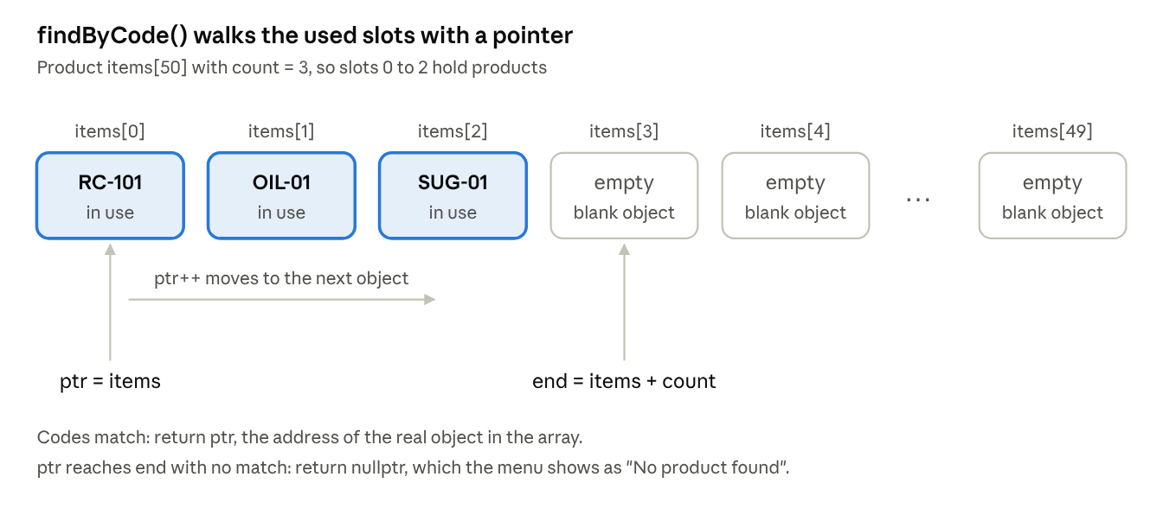
Figure 4. Array of objects, pointer arithmetic and nullptr in findByCode()
The array always holds 50 objects, because Product items[50] creates them all at the start, each one blank. Only the first count slots hold real products. findByCode() starts a pointer at items, moves it one object at a time with ptr++, and stops at items + count. It returns the pointer if the codes match, and nullptr if nothing matches.

10.2 Static member, friend class and friend function
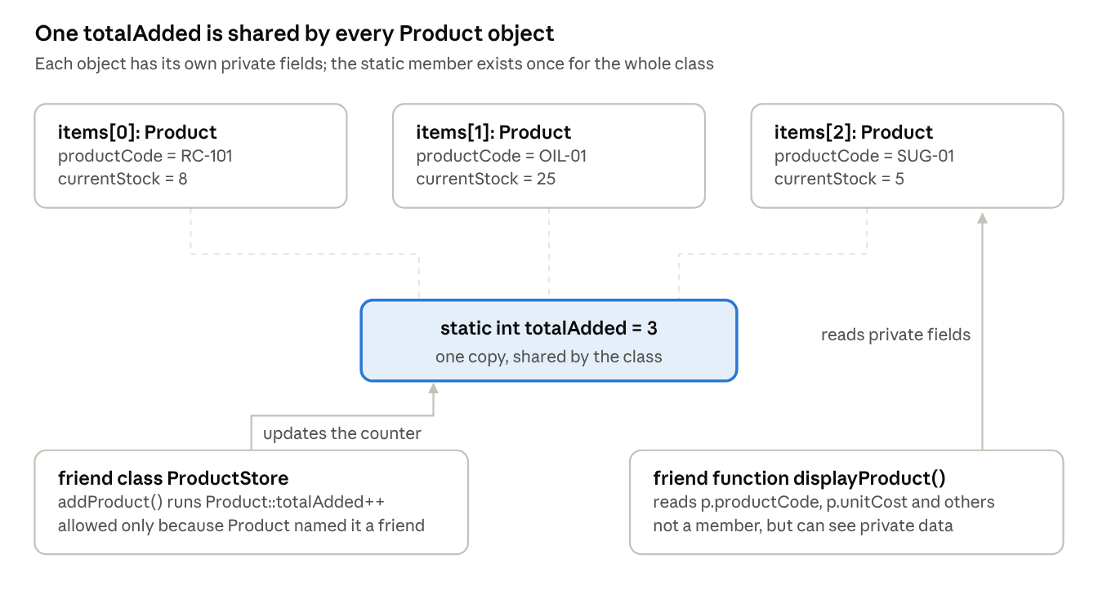
Figure 5. Static data member, friend class and friend function
Every Product object has its own private fields, but totalAdded exists only once for the whole class. It is private, so normal code can't change it. ProductStore can, because Product declares it a friend class. That way the counter goes up only when a product is really stored. displayProduct() isn't a member of Product, but as a friend function it can still read the private fields to print them.

10.3 Call by value, reference and address, and the this pointer
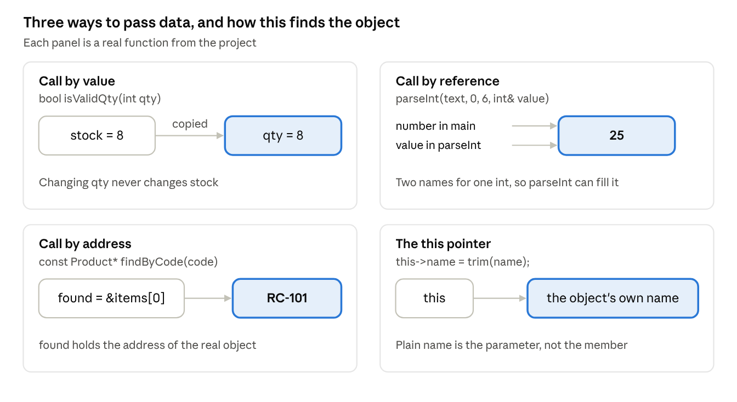
Figure 6. Call by value, by reference and by address, and the this pointer
I pass small numbers by value because a copy costs nothing and keeps the caller's variable safe. I use a reference when a function has to hand back a result, such as parseInt() filling in the number. findByCode() gives back an address, so the caller works on the real product in the array. Inside a setter, this points to the object being changed, so this->name is the member and plain name is the parameter.

11. Procedural vs object-oriented approach
I chose an object-oriented design because each product's data and rules stay in one place, and the private data can only be changed through checked setters.
Point | Procedural way | Object-oriented way (my project)
How data is kept | Eight separate arrays: codes[50], names[50], stocks[50] and so on | One array of objects: Product items[50]
Who can change it | Any function can write stocks[i] = -5; | Fields are private. Only setters, which check the value, can change them.
Where the rules are | Repeated in every function that reads input | Written once, as static functions in Product
Adding a new field | Every function that uses the arrays has to change | Only the class changes
Keeping a record together | Easy to update names[i] and forget stocks[i] | One object is one complete record
In a procedural version, one wrong index can quietly join one product's name with another product's stock. In my version, a product goes into the array as one complete object that has already been checked, and the class itself makes sure a stored product is valid.

12. Tools, folder layout and version control
Compiler. The code is standard C++. It compiles with no warnings on g++ and clang++, and it also works in Code::Blocks or Dev-C++ on Windows. It needs no extra libraries. I compile with -std=c++11 only because of nullptr.
How to build and run
g++ -std=c++11 -Wall -o reorder src/main.cpp src/Product.cpp src/ProductStore.cpp src/Utils.cpp
g++ -std=c++11 -Wall -Isrc -o test_phase1 tests/test_phase1.cpp src/Product.cpp src/ProductStore.cpp src/Utils.cpp
Folder layout
Folder | What is inside
/docs | This proposal, the data dictionary, the UML diagram, the flowcharts and my design notes
/src | Product.h/.cpp, ProductStore.h/.cpp, Utils.h/.cpp, main.cpp
/data | Sample products and ready-made input for the demo (normal, invalid, boundary)
/tests | The test program, the table of test cases and saved outputs
README.md | How to build and run, and the features in each phase
Version control. I keep the project in my own Git repository and commit at each real step: setting up the folders, the Product class, ProductStore, the menu, the tests and sample data, and the documents. Every phase builds on the one before and takes the faculty's feedback into account. Files are named A17_CAP455_CA1_SmallShopSupplierReorderAssistant.

13. Testing plan
I test the program with normal, invalid and boundary cases, both with a test program and by running full menu sessions. The test program tests/test_phase1.cpp runs 57 checks, and all 57 pass. Three input files in /data replay complete menu sessions, and their outputs are saved in /tests as proof.
Type | Example cases | Expected result
Normal | Add RC-101 with correct fields. Add oil-01. Search rc-101. Reorder list with the 5 demo products. | Added. Saved as OIL-01. Found. 3 items, total Rs. 11,020.
Invalid | Menu choice 9 or abc. Code RC_101. Duplicate rc-101. Phone 98765. Stock abc. Quantity 0. Cost 4.555. Search XYZ-999. | A clear message and the same question again. Duplicate refused. "No product found".
Boundary | Codes of 3 and 10 characters (accepted) and 2 and 11 (refused). Names of 40 and 41 characters. Stock 0, 100000 and 100001. Stock equal to the reorder level. Cost 0.01. 50 products, then a 51st. | The limits are accepted and one step past them is refused. Equal stock needs reordering. The 51st product is refused.
Empty list | View all and reorder list before adding anything | "No products added yet" and "Nothing to order"
The test program needs no typing and gives the same result every time, on any compiler. I run it again after every change, and later phases will add to it.

14. Phase plan
Each phase builds on the last one and is submitted with updated code, documents and tests. Only Phase 1 is fixed right now. The later phases will follow the brief given for each one.
Phase | Assessment | Work | Status
1 | CA1 | Product class with static, inline and friend members, an array of objects, pointers, this and string. Create and Read in memory, with input checks and no duplicate keys. | Built and tested
2 | Next CA | As given in the Phase 2 brief, plus fixes from CA1 feedback | Waiting for the brief
3 | Later CA | As given in the Phase 3 brief | Waiting for the brief
What I submit for Phase 1: this approved proposal, the data dictionary, the UML diagram, the flowcharts, the source code, the README, sample data and tests, along with the viva and a live demo.

15. Expected outcomes and limitations
What I expect at the end of Phase 1
- A working program that answers, on one screen, what to reorder, how much, what it will cost and whom to call.
- A product list that cannot hold wrong values or repeated codes.
- Clear examples of every Phase 1 topic: static, inline, friend, array of objects, pointers, this and string.
- Tested code that later phases can build on instead of starting again.
Limitations of Phase 1
- Products are kept only while the program is running, and are lost when it closes.
- A product can't yet be changed or removed after it is added.
- The list holds at most 50 products, and searching checks them one by one. At this size the search is instant.
- The same supplier's details are stored again for each of its products.

16. Conclusion
This project turns a shop owner's scattered notes into one checked product list with no duplicates, and builds a reorder list from it whenever needed. Phase 1 does Create and Read in memory, around one main class, Product, with productCode as its unique key. It uses only topics from Units I and II of CAP455. I kept the design small enough to explain line by line in the viva, and organised so that later phases can add to it without rewriting what already works.

References
- Lovely Professional University, CAP455 syllabus: Unit I (Principles of OOP and C++ essentials) and Unit II (Handling pointers, arrays and string).
- E. Balagurusamy, Object Oriented Programming with C++, McGraw Hill Education.
- Robert Lafore, Object-Oriented Programming in C++, Pearson Education.
- Bjarne Stroustrup, The C++ Programming Language, Addison-Wesley.
- C++ language and library reference: cppreference.com.

Appendix A: Key source code
These are the main parts of my Phase 1 code, copied from the project as they are. Every line uses only Unit I and Unit II topics. The full code is in the /src folder of the repository.

A.1 The Product class (Product.h)
This is the main entity class. It shows private data members, static data members and static member functions, inline functions, a friend function and a friend class (Unit I), plus string members (Unit II).
#ifndef PRODUCT_H
#define PRODUCT_H
#include <string>
class ProductStore; // forward declaration, needed for the friend class line
class Product {
private:
std::string productCode; // unique key, e.g. "RC-101"
std::string name; // e.g. "Basmati Rice 5kg"
std::string supplierName; // e.g. "Sharma Traders"
std::string supplierPhone; // exactly 10 digits
int currentStock = 0; // units on the shelf now
int reorderLevel = 0; // reorder when stock <= this level
int reorderQty = 0; // units to order each time
double unitCost = 0.0; // purchase price per unit (Rs.)
// Every field starts empty or zero, so a new Product object is "blank"
// until its setters fill it. "Product items[50]" therefore gives 50
// blank objects, and isValid() is false for each of them.
// STATIC DATA MEMBER: only ONE copy exists, shared by all Product objects.
// Counts how many products have been added to the store so far.
// It is private so only Product and its friend ProductStore can change it.
static int totalAdded;
public:
// Class-wide limits (static const = one shared, unchangeable value).
static const int MAX_PRODUCTS = 50;
static const int CODE_MIN_LEN = 3;
static const int CODE_MAX_LEN = 10;
static const int TEXT_MAX_LEN = 40;
static const int PHONE_LEN = 10;
static const int QTY_MAX = 100000;
// Fills every field at once by calling each setter in turn.
// Returns true only if ALL values were valid.
bool setAll(const std::string& productCode, const std::string& name,
const std::string& supplierName, const std::string& supplierPhone,
int currentStock, int reorderLevel, int reorderQty, double unitCost);
// ---- Setters: validate first, then store using this-> ----
bool setProductCode(const std::string& productCode);
bool setName(const std::string& name);
bool setSupplierName(const std::string& supplierName);
bool setSupplierPhone(const std::string& supplierPhone);
bool setCurrentStock(int currentStock);
bool setReorderLevel(int reorderLevel);
bool setReorderQty(int reorderQty);
bool setUnitCost(double unitCost);
// ---- INLINE getters: defined inside the class, so they are inline ----
std::string getProductCode() const { return productCode; }
std::string getName() const { return name; }
std::string getSupplierName() const { return supplierName; }
std::string getSupplierPhone() const { return supplierPhone; }
int getCurrentStock() const { return currentStock; }
int getReorderLevel() const { return reorderLevel; }
int getReorderQty() const { return reorderQty; }
double getUnitCost() const { return unitCost; }
// Business rules: short and called often, so marked inline.
inline bool needsReorder() const { return currentStock <= reorderLevel; }
inline double reorderCost() const { return reorderQty * unitCost; }
// True only when every field holds a valid value.
bool isValid() const;
// Compares this object's key with another object's key using "this".
bool hasSameKey(const Product& other) const;
// ---- STATIC MEMBER FUNCTIONS: called as Product::xyz(), no object needed ----
static std::string normalizeCode(const std::string& rawCode);
static bool isValidCode(const std::string& code);
static bool isValidText(const std::string& text);
static bool isValidPhone(const std::string& phone);
static bool isValidQty(int qty);
static bool isValidCost(double cost);
static int getTotalAdded() { return totalAdded; }
static void displayHeader();
// ---- FRIEND FUNCTION: not a member, but may read private data ----
friend void displayProduct(const Product& p);
// ---- FRIEND CLASS: ProductStore may access private members ----
// Needed so the store can update the private static counter totalAdded
// without making that counter public to the whole program.
friend class ProductStore;
};
// Normal (non-member) declaration of the friend function, so any file
// that includes Product.h can call it.
void displayProduct(const Product& p);
#endif

A.2 Static member, this pointer and friend function (Product.cpp)
The static member is defined once outside the class. The setter uses this-> because its parameter has the same name as the data member. displayProduct() is not a member, but as a friend it reads private fields such as p.unitCost.
int Product::totalAdded = 0; // static member: defined once, here
bool Product::setName(const std::string& name) {
if (!isValidText(name)) return false;
this->name = trim(name);
return true;
}
bool Product::setAll(const std::string& productCode, const std::string& name,
const std::string& supplierName, const std::string& supplierPhone,
int currentStock, int reorderLevel, int reorderQty, double unitCost) {
bool ok = true;
if (!setProductCode(productCode)) ok = false;
if (!setName(name)) ok = false;
if (!setSupplierName(supplierName)) ok = false;
if (!setSupplierPhone(supplierPhone)) ok = false;
if (!setCurrentStock(currentStock)) ok = false;
if (!setReorderLevel(reorderLevel)) ok = false;
if (!setReorderQty(reorderQty)) ok = false;
if (!setUnitCost(unitCost)) ok = false;
return ok;
}
bool Product::hasSameKey(const Product& other) const {
// "this" points to the object this function was called on.
return this->productCode == other.productCode;
}
void displayProduct(const Product& p) {
std::cout << std::left
<< std::setw(11) << p.productCode
<< std::setw(22) << p.name.substr(0, 21)
<< std::right
<< std::setw(7) << p.currentStock
<< std::setw(8) << p.reorderLevel
<< std::setw(8) << p.reorderQty
<< std::setw(11) << std::fixed << std::setprecision(2) << p.unitCost
<< " " << std::left
<< std::setw(18) << p.supplierName.substr(0, 17)
<< p.supplierPhone
<< (p.needsReorder() ? " *REORDER*" : "")
<< "\n";
}

A.3 Array of objects, pointers and the duplicate check (ProductStore.cpp)
addProduct() refuses invalid, duplicate or extra products, and as a friend class it updates the private static counter. findByCode() walks the array of objects with a pointer, using pointer arithmetic, and returns nullptr when nothing matches (Unit II).
AddResult ProductStore::addProduct(const Product& p) {
if (!p.isValid())
return ADD_INVALID;
// ProductStore is a friend class, so it can read p.productCode directly.
if (findByCode(p.productCode) != nullptr)
return ADD_DUPLICATE;
if (isFull())
return ADD_FULL;
items[count] = p; // copy the object into the next free slot
count++;
Product::totalAdded++; // private static member, allowed as friend
return ADD_OK;
}
const Product* ProductStore::findByCode(const std::string& rawCode) const {
std::string key = Product::normalizeCode(rawCode); // "rc-101" -> "RC-101"
const Product* ptr = items; // array name = address of items[0]
const Product* end = items + count; // one past the last USED slot
while (ptr < end) {
if (ptr->getProductCode() == key) // "->" accesses a member through a pointer
return ptr;
ptr++; // pointer arithmetic: move to the next object
}
return nullptr; // not found
}

A.4 String modifiers and call by reference (Utils.cpp)
trim() uses the erase() string modifier. parseInt() checks every character itself and hands the number back through a reference parameter, int& value (Unit I).
std::string trim(const std::string& text) {
std::string result = text; // work on a copy
// erase() is a string modifier: remove spaces from the front...
while (!result.empty() && isSpaceChar(result[0]))
result.erase(0, 1);
// ...and from the back.
while (!result.empty() && isSpaceChar(result[result.length() - 1]))
result.erase(result.length() - 1, 1);
return result;
}
bool parseInt(const std::string& text, int minValue, int maxValue, int& value) {
std::string t = trim(text);
if (t.empty()) return false;
bool negative = false;
int n = t.length();
int i = 0;
if (t[0] == '-' || t[0] == '+') {
negative = (t[0] == '-');
i = 1;
if (n == 1) return false; // just a sign, no digits
}
long result = 0; // long, so we can detect overflow
for (; i < n; ++i) {
if (!isDigitChar(t[i])) return false; // rejects "12abc", "1.5", "1 2"
result = result * 10 + (t[i] - '0');
if (result > 1000000000L) return false;
}
if (negative) result = -result;
if (result < minValue || result > maxValue) return false;
value = result; // write back through the reference
return true;
}

A.5 Menu loop (main.cpp)
The menu reads the choice as a line, checks it with parseInt(), and calls one function per option. The store is passed by reference so every option works on the same products.
int main() {
ProductStore store;
string input;
int choice = -1;
while (true) {
showMenu();
if (!readLine("Enter choice: ", input)) {
cout << "\nInput ended. Exiting.\n";
break;
}
if (!parseInt(input, 0, 6, choice)) {
cout << "Invalid choice. Enter a number from 0 to 6.\n";
continue;
}
if (choice == 0) {
cout << "Goodbye!\n";
break;
}
switch (choice) {
case 1: addProductMenu(store); break;
case 2: cout << "\n"; store.displayAll(); break;
case 3: searchProductMenu(store); break;
case 4: cout << "\n"; store.displayReorderList(); break;
case 5: showSummary(store); break;
case 6: loadDemoProducts(store); break;
}
}
return 0;
}

