Cereal Data as a Scatterplot

Author: Avnish Pandey; Email: [avnishpandey113@live.com](https://d.docs.live.net/399aa50a8ddbb094/Desktop/MyProjects/InformationVisualization/ScatterPlotForCereals/avnishpandey113@live.com);

## Screenshot:

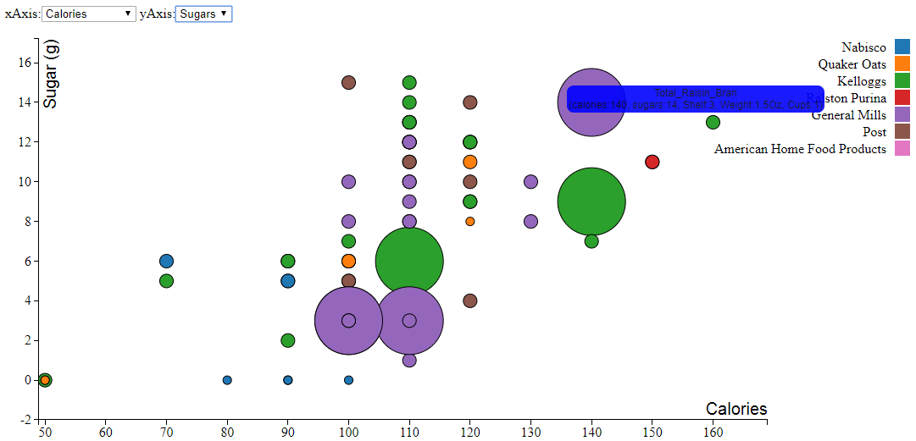

## Instructions for compiling and running program:

Visit: <http://www2.cs.uregina.ca/~akp817/ScatterPlotForCereals/html_pages/ScatterPlot.html>

Files: https://github.com/avnishpandey113/InformationVisualization/ScatterPlotForCereals/

(OR via Xampp)

Xampp Deployment:

Step 1: Install Xampp from <https://www.apachefriends.org/index.html>.

Step 2: Once installed, open Xampp, below screen will pop-up:

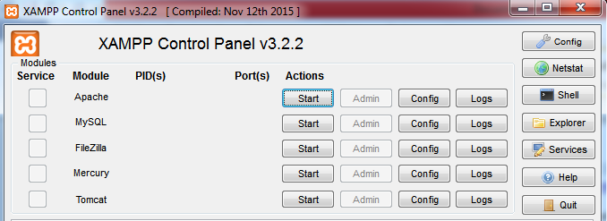

Step 3: Select start in “Actions” column opposite “Apache” module.

Step 4: Apache server will be deployed on your system and the xampp control will look as below:

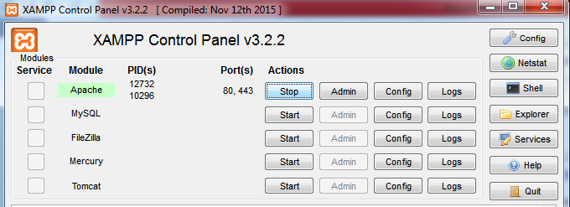

Step 5: Go to location htdocs where xampp is installed is. It’ll look something like this: “drive:\xampp\htdocs”.

Step 6: Extract all files in this folder from zip file into this folder. Now the folder will look like “drive:\xampp\htdocs\ZipFileName\”

Step 7: Open chrome and type [http://localhost/ZipFile/html_pages/html_filename.html](http://localhost/ZipFile/html_pages/html_filename.html%20)  to see the output.

Steps for interacting with the visualization:

1. Using the drop the drop down menu user can choose to encode 8 different attributes on x and y axis (4 on each side respectively).
2. Hovering the mouse over a particular circle will give the value of the point with additional information like its shelf number, weight and cups. The color of the tooltip will show the ‘ type’ of the cereal, whether it’s hot(red) or cold(blue).
3. The user can pre-attentively process the amount of vitamins and minerals in by looking at the size of the circle.
4. The data can be zoomed in and out by double clicking anywhere on the graph. The graph can be dragged as well.
5. The legend on the right side shows different manufacturers with different colors. The user can interact with the legend to view the data points related to selected manufacturer.
6. The missing data was denoted by -1 value in the csv, so it has been handled by not showing that particular data or “N/A” in case of cups.

## Discussion:

1. The visualization represents 15 attributes namely cereal name, it’s manufacturer, type (cold/hot), calories, protein (g), fat (g), sodium (mg), dietary fiber (g), carbohydrates (g), sugars (g), and display shelf (1, 2, or 3, counting from the floor), potassium(mg), vitamins & minerals (0%, 25%, or 100%), weight (in ounces) of one serving, cups per serving for 77 different cereals.

2. For representing this data 6 visual variables were supposed to be used namely Position (x dimension), Position (y dimension), Mark, Size, Brightness and Colour.

3. During the course of this assignment I found out that for encoding the different data types in this dataset position(x&y), mark, size, color were good visual variables whereas brightness was making the visualization hard to be interpreted.

4. **Screenshot for Bad visualization:**

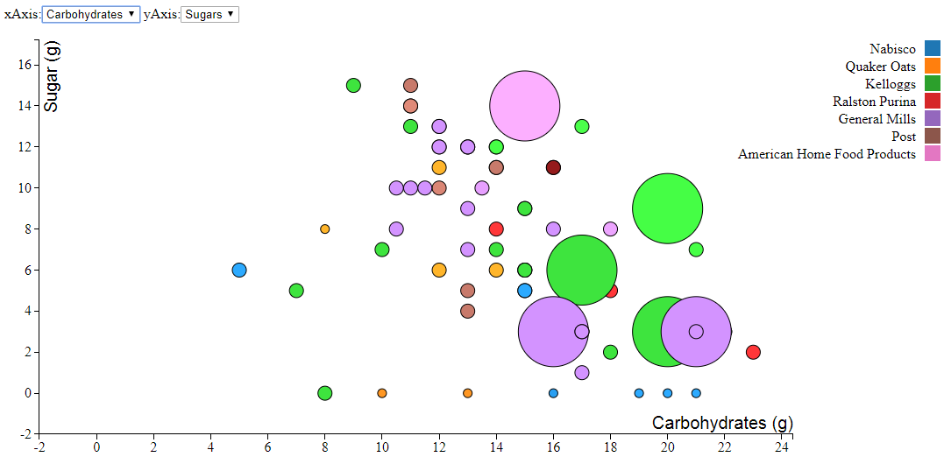

The above visualization is an example of bad data representation for the below reasons:

* The brightness visual variable representing the weight attribute is misleading the user.
* User will not be able to clearly distinguish between manufacturers of the cereal such as light brown may belong to Ralston Purina or Quaker Oats or dark brown may belong to Ralston Purina or Post. There are different hues for violet as well which makes it hard to distinguish whether the cereal is of American Home or General Mills.

5. **Screenshot for good visualization:**

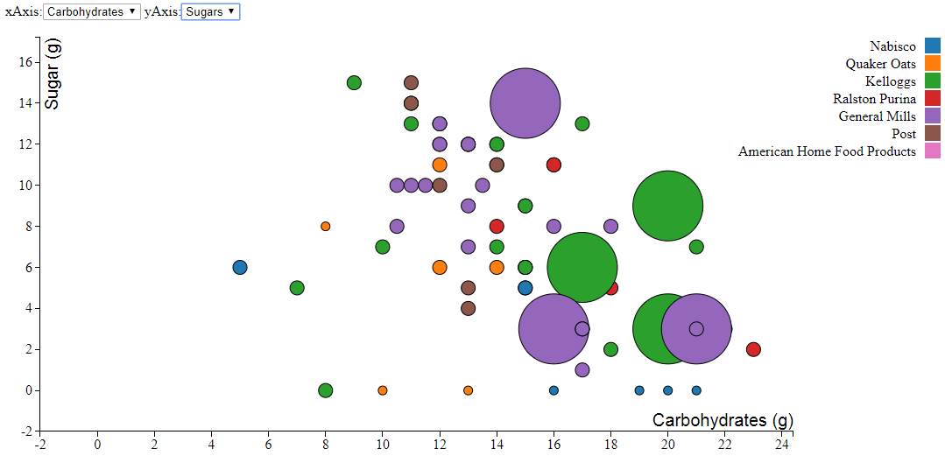

The above visual representation of the data is a good visualization because:

* User will be easily able to differentiate between manufacturers of the cereal because of distinctly colored data points of the cereals.

## References for code:

* <http://www.d3noob.org/2013/01/adding-tooltips-to-d3js-graph.html>
* <http://bl.ocks.org/peterssonjonas/4a0e7cb8d23231243e0e>