Currency Exchange Rate as a Scatterplot

Author: Avnish Pandey; Email: [avnishpandey113@live.com](https://d.docs.live.net/399aa50a8ddbb094/Desktop/MyProjects/InformationVisualization/ScatterPlotForCereals/avnishpandey113@live.com);

## Screenshot:

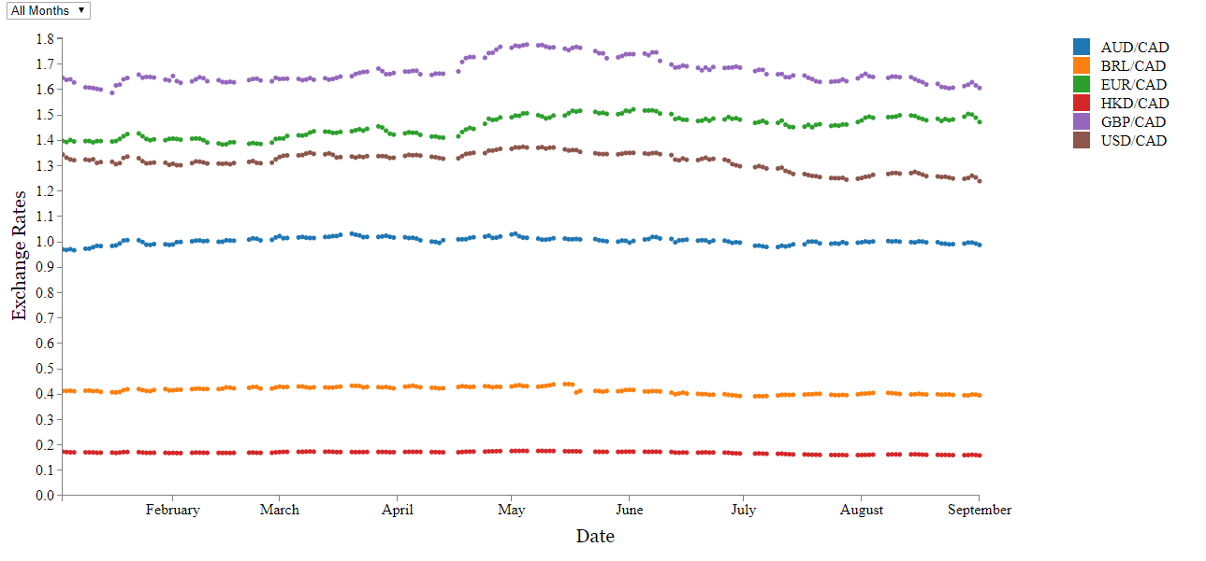

## Instructions for compiling and running program:

Visit: <http://www2.cs.uregina.ca/~akp817/ScatterPlotForCurrencyExchangeRate/html_pages/ScatterPlot.html>

Files: https://github.com/avnishpandey113/InformationVisualization/ScatterPlotForCurrencyExchangeRate/

(OR via Xampp)

Xampp Deployment:

Step 1: Install Xampp from <https://www.apachefriends.org/index.html>.

Step 2: Once installed, open Xampp, below screen will pop-up:

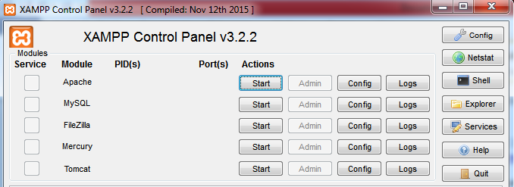

Step 3: Select start in “Actions” column opposite “Apache” module.

Step 4: Apache server will be deployed on your system and the Xampp control will look as below:

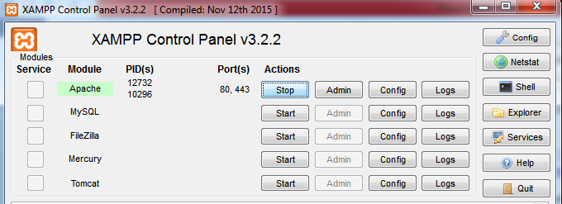

Step 5: Go to location htdocs where xampp is installed is. It’ll look something like this: “drive:\xampp\htdocs”.

Step 6: Extract all files in this folder from zip file into this folder. Now the folder will look like “drive:\xampp\htdocs\ZipFileName\”

Step 7: Open chrome and type [http://localhost/ZipFile/html_pages/html_filename.html](http://localhost/ZipFile/html_pages/html_filename.html%20)  to see the output.

## Critique:

**Explanation of Visualization:**

1. The visualization represents the exchange rate between the Canadian dollar and six other currencies from Jan-2017 till Sept-2017.
2. The visualization is represented in the form of the scatter plot.
3. Different currency exchange rates are represented by different colors.
4. A legend is given on the left side of the screen to make user understand the visualization.
5. The user can interact with the visualization either through legend or the drop-down provided to him.
6. The drop-down will let user select the month for which he needs to visualize the data.
7. The user can select and compare currencies as well by selecting from the legend.
8. Whenever a change occurs in date filter, the x-axis will be adjusted too.
9. Whenever a different currency is selected the scatter plot will plot the same.
10. Whenever the user focuses on a particular data point in the scatter plot, all the data points for that currency becomes highlighted so that the exchange rate trend for that currency becomes apparent.
11. The information regarding the data point on which the user hovers is provided in the tooltip to the user.

**Usefulness of the system with respect to user activities:**

* Activity 1: Finding trends in the data--

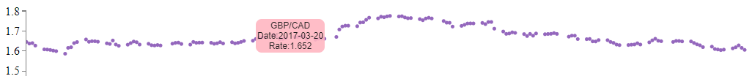The above screenshot demonstrates that the user will easily be able to find trend of the exchange rate of a particular currency over time by hovering over its data points.

* Activity 2: Finding outlier data--

The outlier data or the erroneous data has been handled as part of data processing. The user will be able to find it out by carefully observing the scatter plot as the exchange rates won't be available for those particular days.

* Activity 3: Finding relationships among the data sets--

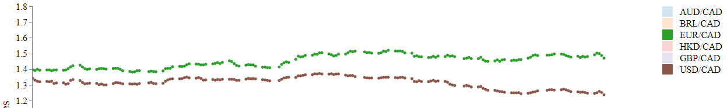

The above screenshot demonstrates that the user will easily be able to find out relationships between the exchange rates of different currencies.

**Data That Pops-Out:**



As per the above screenshot of the visualization, information regarding the data point on which the user hovers pops out in the form of tooltip.

**Is the system also useful for answering other types of questions?--**

Yes the system will help the user to make informed decisions regarding the currency exchange rate. She/he can make exchange rates at appropriate time period to make profit or minimize the loss.

## References for code:

* <http://bl.ocks.org/jfreels/6734823>
* <http://bl.ocks.org/DStruths/9c042e3a6b66048b5bd4>