|  |  |
| --- | --- |
| Bug Id | 01 |
| Title | Selection of Snacks on Checkbox click is not working |
| Assigned To | Dev |
| State | New |
| Area | Snack Application-main selection screen |
| Reporo Steps | 1.Launch Snack Application on Andriod phone/tablet  2.When application launches click on checkboxes from snack list to select either veg or nonveg snacks |
| Expected Result | Checkbox button should be checked |
| Actual Result | Checkbox is not checked but clicking on snack text is checking the checkbox. |
| Screenshot/Recording | <sent separate> |
| Found in build | 1.0 Build |
| Severity | 3-Medium |
| Priority | 3 |
| Linked TestCase | <Test case Id> |
| Machine | Phone -Galaxy Nexus API28,Tablet-Nexus 10 |

Note:Following behaviour is not called in the spec, but is found as issue based on the functionality of application which should be mention in the requirement document.

|  |  |
| --- | --- |
| Bug Id | 02 |
| Title | Duplicate entries of snacks are not restricted |
| Assigned To | Dev |
| State | New |
| Area | Snack Application-Add snack |
| Reporo Steps | 1.Launch Snack Application on Andriod phone/tablet  2.When application launches note down the snack either veg or non-veg from the list  3. Click on ‘+’ icon to add snacks a  4. Add same noted down snack from the list and click ‘Save’  5.Verify the added snack in the list |
| Expected Result | Duplicate snack should not be added |
| Actual Result | Duplicate snack for both veg and nonveg scenarios are added |
| Screenshot/Recording | Screenshots below |
| Found in build | 1.0 Build |
| Severity | 3-Medium |
| Priority | 3 |
| Linked TestCase | <Test case Id> |
| Machine | Phone -Galaxy Nexus API28,Tablet-Nexus 10 |

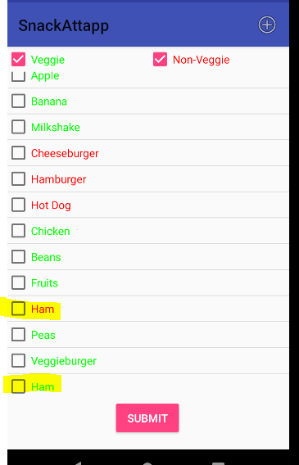

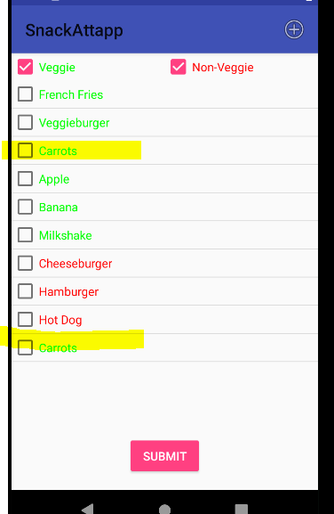

|  |  |
| --- | --- |
| Bug Id | 03 |
| Title | Blank entries are added as snack and also getting submitted |
| Assigned To | Dev |
| State | New |
| Area | Snack Application-Add and main selection screen |
| Reporo Steps | 1.Launch Snack Application on Andriod phone/Tablet  2.When application launches click ‘+’ icon to add snack .  3. Select either veg or non-veg from dropdown  4. Add snack as blank space  5.Click Save  6.Check in the list, blank entry is added for option selected(veg/nonveg)  7.Select the entry and click ‘Submit’ button |
| Expected Result | Blank entry should not be allowed while adding snack |
| Actual Result | Blank entry is getting added and also selection is done for blank entry. |
| Screenshot/Recording | screenshot below |
| Found in build | 1.0 Build |
| Severity | 3-Medium |
| Priority | 3 |
| Linked TestCase | <Test case Id> |
| Machine | Phone -Galaxy Nexus API28,Tablet-Nexus 10 |

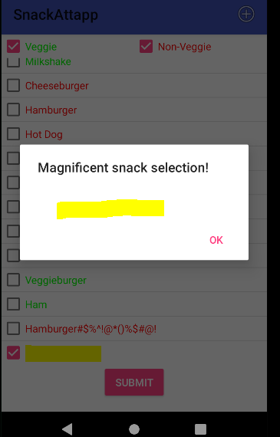

**This might be a bug or not bug depending on requirement document.**

|  |  |
| --- | --- |
| Bug Id | 04 |
| Title | Added snack entries disappears when application is closed and re-open again |
| Assigned To | Dev |
| State | New |
| Area | Snack Application- main selection screen |
| Reporo Steps | 1.Launch Snack Application on Andriod phone/Tablet  2.When application launches click ‘+’ icon to add snack .  3. Select either veg or non-veg from dropdown  4. Add new snack  5.Click Save  6.Check in the list, new entry is added for option selected(veg/nonveg)  7.Close the application  8.Re-open application again  9.Verify the list of snacks |
| Expected Result | Added entry should be available in the snack list |
| Actual Result | Added entry is not available in the snack list |
| Found in build | 1.0 Build |
| Severity | 3-Medium |
| Priority | 3 |
| Linked TestCase | <Test case Id> |
| Machine | Phone -Galaxy Nexus API28,Tablet-Nexus 10 |