* Dependencies:

1. Appium server with configurations as shown below.

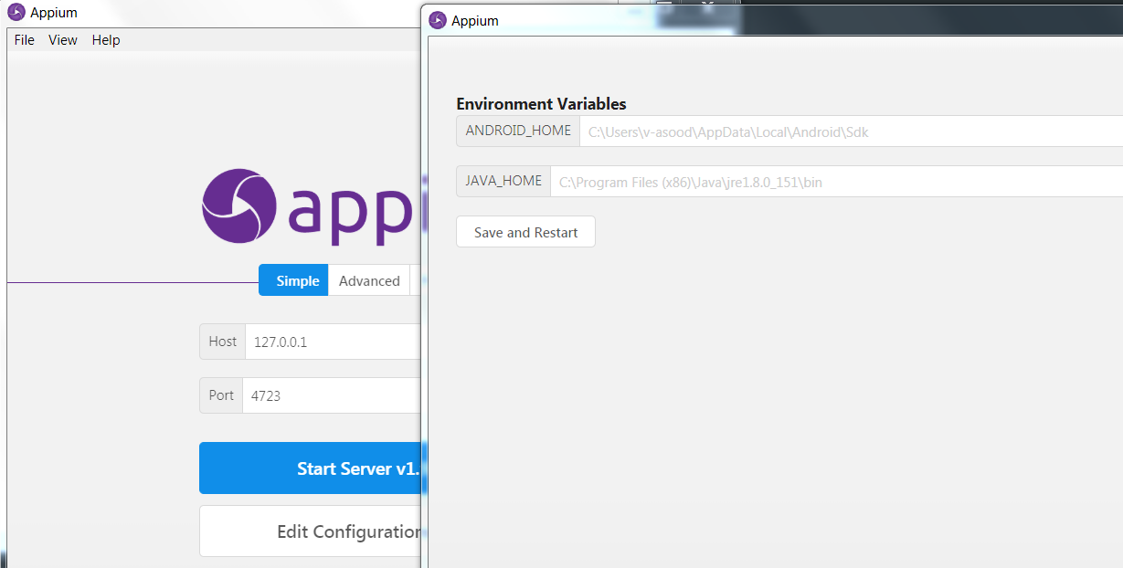

1. Android emulator/ Android device
2. Msbuild to build project
3. Android SDK
4. JAVA SDK

* Test execution settings:

Following settings in TestExecutionSettings.json file

DeviceName: name of the android device where testing will be done

UdId: unique device identifier of the android device where testing will be done

AndroidSdkPath: Path of Android SDK

AppPath:Path of application’s apk to be tested