HOMEWORK ASSIGNMENT #1

Assignment 1-1

- Based on your personal observation, give three examples of good quality in a manufactured good or service and three examples of bad quality.

Good

- Mobile smart Phone manufactures – easy of use of touch screen and will it break easily.
Good – Iphone screens does not break and Samsung’s screen is water proof.
Bad – Local companies screen breaks in 2-3 months
- Laptop Manufactures – how long the battery lasts
Good - Mac book battery last for 9 hours
Bad – Acer Battery last only 4 hours and needs replacement every alternate year.
- Furniture – How long the furniture will last
Good – Ashley Home will last 10 years
Bad – Ikea hard to assemble and last less than a year.

Services
- Car manufacture – Number of time cars engine problems in next five years.
Good – BMW no charge to customers for 4 years
Bad – Kia , you are on your own if car breaks
- Mobile phone service providers – Is signal available everywhere.
Good – ATNT Coverage is everywhere
Bad – Lyca mobile works only in big cities and not in high rise apartments.
- Customer care – How long did it take to ship a product.
Good – Amazon will ship in 2 days
Bad – ebay ships in 1-2 months

2. The Cost of Quality was evaluated by PAF Industries, as follows:

Prevention Monthly cost
Quality training $ 2,000
Reliability consulting 10,000
Pilot production runs 5,000
Systems development 8,000
Total 25,000
Appraisal
Materials inspection 6,000
Supplies inspection 3,000
Reliability testing 5,000
Laboratory testing 25,000
Total 39,000
Internal Failure
Scrap 15,000
Repair 18,000
Rework 12,000
Downtime 6,000
Total 51,000
External failure
Warrantee 14,000
Out-of-warrantee repair & replacement 6,000
Customer complaints 3,000
Product liability 10,000
Transportation 5,000
Total 38,000

Total 153,000

- Calculate separately the prevention and appraisal (and total P&A) costs as a proportion of the failure costs
- Calculate the P, A, and F costs as a proportion of the total costs.
- Make recommendations.

2a . Appraisal = 39000 / (51000 + 38000 ) = 43.8
Prevention = 25000 / ( 51000 + 38000 ) = 28.1

Assignment 1-2

3. Brewerton's Tennessee Sip'n Whiskey provides liquid refreshment to discriminating customers who choose not to pay for revenue stamps. Frank Brewerton wants to know if his organization is maintaining the national average of 2.5% annual increase in productivity. He has the following data:

Last Year This Year
Units of Production 1,000 1,000
Labor (hours) 300 275
Corn Mash (bushel) 50 45
Capital Invested ($) 10,000 11,000
Energy (Btu) 3,000 2,850

a. Show the current year PPM measure for each category
b. Show the current year MFM measure for labor & corn mash, for labor & capital, and for labor & energy
c. Show the current year TPM measure
d. Determine the productivity index for each category.
e. Identity notable contributions to productivity and notable changes.

4. A company has gathered the following financial information for itself and a competing firm. They wish to compare productivity for the two firms (all numbers in 000s).
Firm A Firm B
Labor $ 30,000 $ 16,000
Plant & equipment 200,000 150,000
Energy 17,500 20,500
Materials 200,000 180,000
Sales 1,200,000 900,000

- Compute partial and total factor productivity measures for Firms A and B.
- What is the picture you get of the two firms?
- What would you suggest to the management of Firm B?

Assignment 1-3

5. For the below matrix, compute the:

- Customer requirements absolute weight
- Sum of Technical Characteristics and Technical Score
- Customer Requirements Technical Index weight and factor
- Customer Requirements Technical Absolute weight and factor
- Which design and technical factors should be emphasized? Why?
(Note: ● = 9; o = 3; Δ = 1)
 |  |  | 1 | 2 | 3 | 4 | 5
 |  |  |  |  |  |  |  | 1 2 3 4 5
Customer Requirement | A |  | Δ | ● | Δ |  | ● |  | 2 | 1 | 2
Customer Requirement | B |  | Δ | o |  | o |  |  | 8 | 1 | 1
Customer Requirement | C |  | ● | Δ | ● |  | ● |  | 5 | 5 | 2
Customer Requirement | D |  |  |  | ● | o | Δ |  | 3 | 4 | 2
Customer Requirement | E |  | o | Δ |  | Δ | Δ |  | 2 | 3 | 1
Current Benchmark Score |  |  | 3 | 5 | 9 | 6 | 2 | Competitive Assessment | Importance | Target | Sales Point | Absolute Weight
Sum of Tech. Characteristics
Technical Score
Cust. Req. Tech. Index Weight
Cust. Req. Tech. Index Factor
Cust. Req. Tech. Abs. Weight
Cust. Req. Tech. Abs. Factor
6. The averages for dimensions of service quality were computed by averaging the items for each dimension. Use the following data to determine which dimensions to emphasize
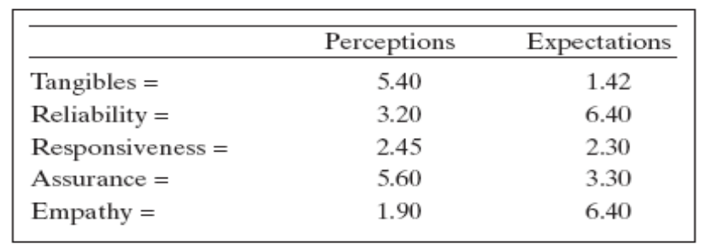

- Using simple differencing, determine which dimensions should be emphasized.
- Use two-dimensional differencing to determine which dimensions should be emphasized.
- Based on your findings, choose the most important dimension and describe how you would develop a process improvement program to address the dimension that needs improvement.

7. Using the Various OC Curves graphic found in BB materials at the Formulas & Tables link, with a sample size of n = 100 and an acceptance number of c = 1, if a good shipment has no more than .05 defective, what is the probability of acceptance? What type of risk is this?

8. Develop an OC curve using the OC Curve Nomogram found in Course Materials at the Formulas & Tables link, a sample size of 100, and the following p values: .01, .02, .03, .05, .07, .09, .11, .13, .15, .17, .19, .21. The maximum acceptance number is c = 3.

9. Interpret the following sampling plan in plain English:

n₁ = 50; c₁ = 2
n₂ = 100; c₂ = 5
r₁ = 4; r₂ = 6

