**IATS ASSIGNMENT: SPECIALITY TOYS**

**Problem Statement:**

Speciality In decided to introduce a new toy called Weather Teddy and target the preholiday season so that they can make good business. Members of the Speciality Inc Management have to take the decision on how many units of new toy must be purchased to meet the anticipated sales demand. Members of the Management suggested to order 15000, 18000, 24000, 28000 units. Since there is no consensus on the order quantity

1. Analyse the stock-out probabilities for various order quantities.
2. Sketch the demand distribution which follows the normal distribution and label the mean and standard deviation
3. Compute the probability of stock-out for the order quantities suggested.
4. Compute the projected profits for order quantities suggested under three scenarios
5. Worst case in which the sales is 10000 units
6. Most likely case in which the sales is 20000 units
7. Best case in which the sales is 30000 units

**Information in the case study :**

1. Suggested order quantities are 15000 , 18000 , 24000 , 28000
2. The cost price of the Teddy is $16/unit
3. The Selling price of the Teddy is $24/unit ( for the inventory available during the holiday season )
4. The Selling price of the Teddy is $5/unit ( for the inventory available left out after the holiday season )
5. The Expected Demand is 20000 units with a probability fo 0.95 and the demand would range between 10000 and 30000.

**Computations & Results :**

* 1. The mean (µ) of the suggested ordered quantities is **20000** units.
  2. Standard Deviation (σ) of the distribution is **5102.13.**
  3. The sketch of distribution is as follows.

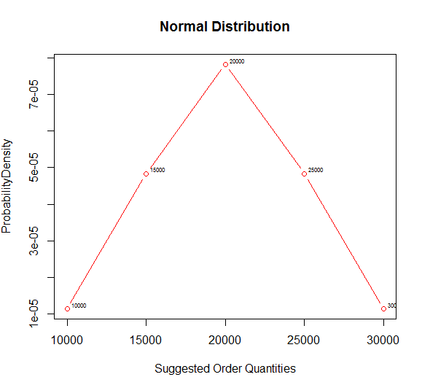

* 1. The suggested stocks and the corresponding probabilities that it would stock-out is as follows

|  |  |
| --- | --- |
| Suggested Stock Order Quantity | Probability of Stock-Out |
| 15000 units | **0.84** |
| 18000 units | **0.65** |
| 24000 units | **0.22** |
| 28000 units | **0.06** |

1. The following is the Profits in the worst, most likely and best case situations.

|  |  |  |  |
| --- | --- | --- | --- |
| Suggested  Order Quantity | Worst Case  (10000 Units) | Most Likely  (20000 Units) | Best Case  (30000 Units) |
| 15000 Units | $25000 | $120000 | $120000 |
| 18000 Units | -$8000 | $144000 | $144000 |
| 24000 Units | -$74000 | $116000 | $192000 |
| 28000 Units | -$118000 | $72000 | $224000 |

**Analysis:**

1. The mean of the distribution is 20000
2. The standard deviation is 5102 which means that the values of the ordered quantities deviates about 5102 on an average from mean.
3. The probabilities of stock-out for each of the suggested stock is indicated in above tables. Since the probability of stock-out in case the management ordered 28000 units is least value, the management must go with ordering 28000. This will ensure that they most probably do not run into the stock-out scenario. Thereby they can make best use of the preholiday seasonal demand.
4. If the management goes with ordering 28000 units , in most likely case, they would make the profit of $72000 and in best case they can achieve maximum profit of $224000 in the season.

**R- Code**

library(calibrate)

orderquantities = c(10000,15000,20000,25000,30000)

#Mean Computation

orderquantities_mean = mean(orderquantities)

print(paste("MEAN of Ordered Quantities <Mu>:" ,orderquantities_mean))

#Probability is given as 95% for the sales between 10K and 30K

zvalue = qnorm(1-(1-0.95)/2)

orderquantities_sd = round(10000/zvalue,2)

print(paste("STANDARD DEVIATION of Ordered Quantities <Sigma>:" ,orderquantities_sd))

#Plotting the Density

densityfuntion = dnorm(orderquantities,orderquantities_mean,orderquantities_sd)

plot(orderquantities, densityfuntion, col="red", xlab="Suggested Order Quantities", ylab="ProbabilityDensity", type = "b" , main="Normal Distribution",lwd=1)

textxy(orderquantities, densityfuntion,orderquantities)

#Computing the Probability of out of stock situation.

print( paste("Suggested Stock | Probability"))

xseq_suggestedstock = c(15000,18000,24000,28000)

for(suggestedstock in xseq_suggestedstock) {

if(suggestedstock < orderquantities_mean) {

probability = round(pnorm(abs((suggestedstock-orderquantities_mean)/StandardDeviation)),2)

}

else {

probability = round(1-pnorm((suggestedstock-orderquantities_mean)/StandardDeviation),2)

}

print( paste(suggestedstock,"|", probability))

}

#Profit Calculation

InitialProfit = 24 - 16

LaterProfit = 5-16

WorstCaseStockSold = 10000

MostLikelyStockSold = 20000

BestCaseStockSold = 30000

print("SuggestedStock | WorstCaseStockSold -> TotalProfitInWorstCase | MostLikelyStockSold -> TotalProfitInMostLikelyCase | BestCaseStockSold -> TotalProfitInBestCase ")

xseq_orderedstock = c(15000,18000,24000,28000)

for(orderedstock in xseq_orderedstock) {

if(orderedstock < WorstCaseStockSold) {

TotalProfitInWorstCase = orderedstock * InitialProfit

} else {

TotalProfitInWorstCase = (WorstCaseStockSold * InitialProfit) + ((orderedstock-WorstCaseStockSold) * LaterProfit)

}

if(orderedstock < MostLikelyStockSold) {

TotalProfitInMostLikelyCase = orderedstock * InitialProfit

} else {

TotalProfitInMostLikelyCase = (MostLikelyStockSold * InitialProfit) + ((orderedstock-MostLikelyStockSold) * LaterProfit)

}

if(orderedstock < BestCaseStockSold) {

TotalProfitInBestCase = orderedstock * InitialProfit

} else {

TotalProfitInBestCase = (BestCaseStockSold * InitialProfit) + ((orderedstock-BestCaseStockSold) * LaterProfit)

}

print( paste(orderedstock,"|",WorstCaseStockSold,"-> $",TotalProfitInWorstCase,"|",MostLikelyStockSold,"-> $",TotalProfitInMostLikelyCase,"|",BestCaseStockSold,"-> $",TotalProfitInBestCase))

}