**Lab 05 was done as a group: Audie Escala, Aaron Volpone**

**Task 0:**

We first identified the ID’s of board of our CC1350.

Collector:



Sensor:



**Task 1 and 2:**

Building and loading the collector and sensor examples.

Since we are using the US BLE mode, we did not need to change any parameters in the config.c file.

Collector csf.c file was modified to read:

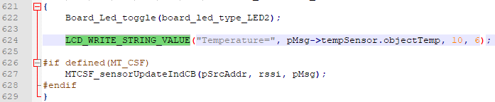

**Task 3:**

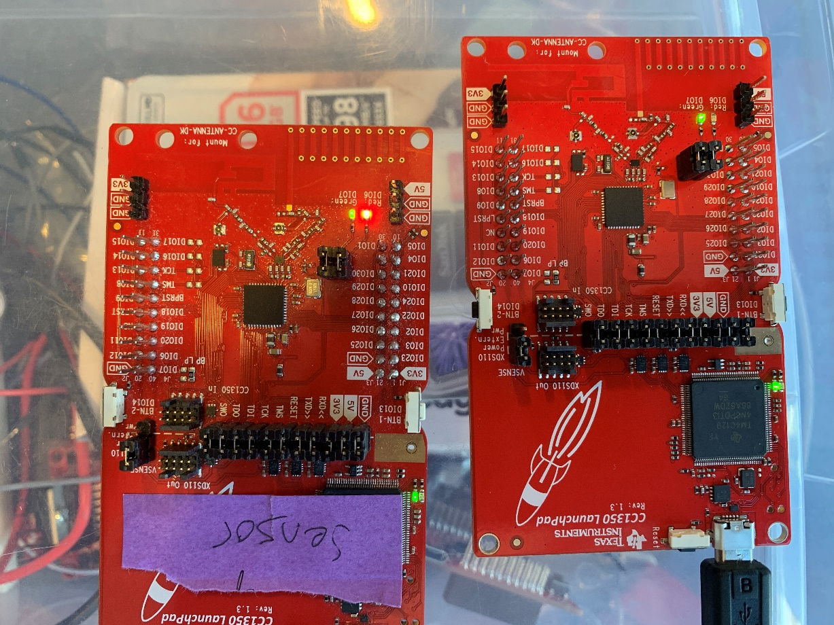

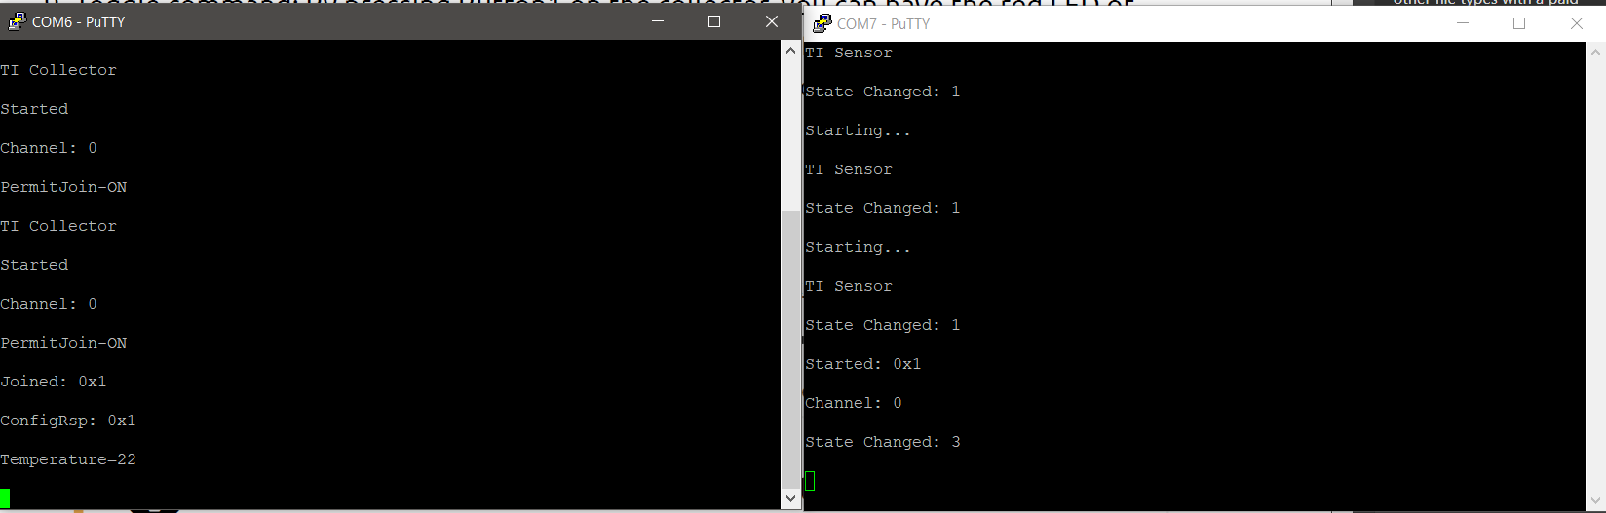

**Task 4:**

Changes to the collector are as follows:

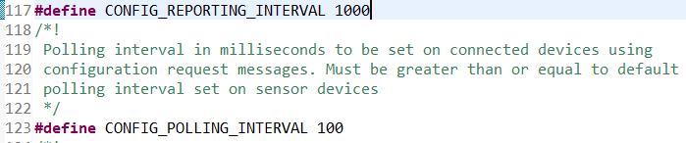

Changes to the sensor are as follows:

