**Task 1:**

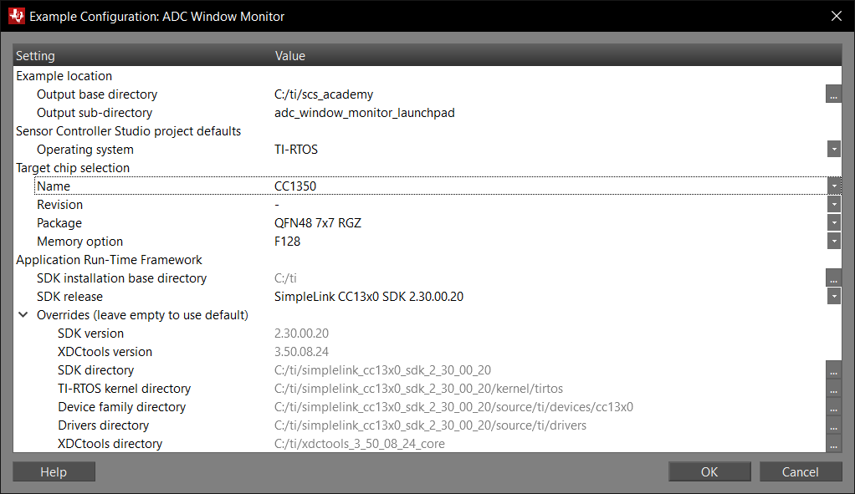

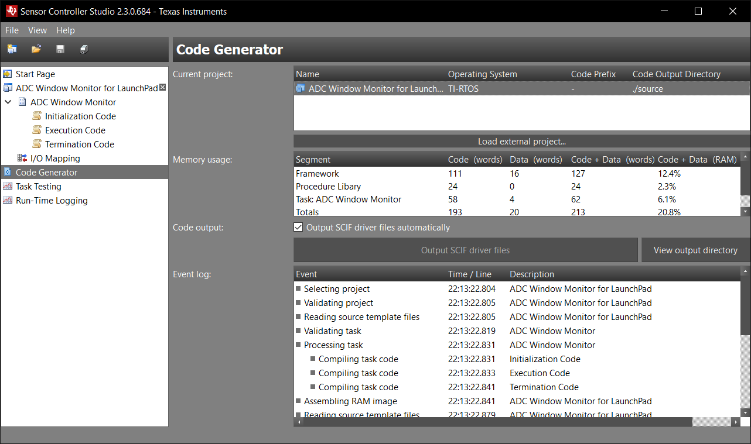

Successfully importing the project into CCS:

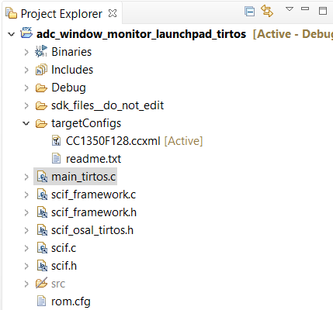

**Task 2:**

The breakpoint when the ADC reads the 3.3V:

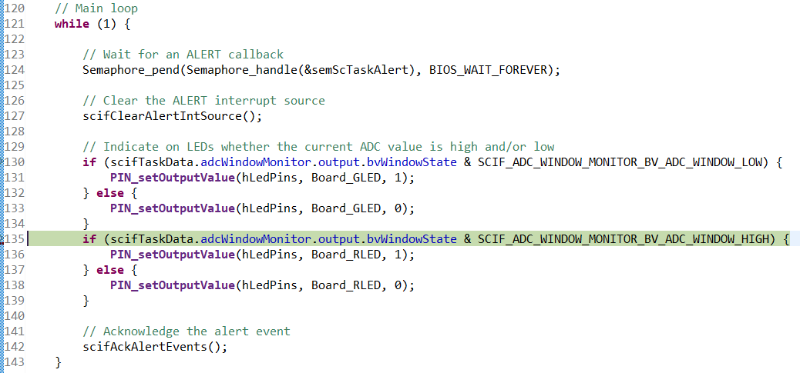

The breakpoint when the ADC reads the GND:

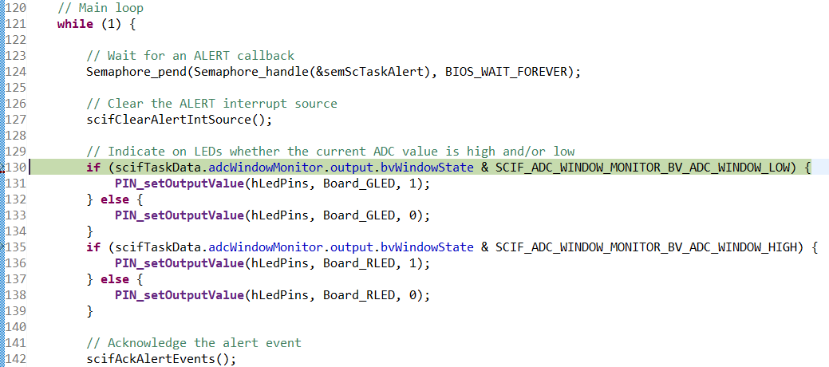

**Task 3:**

In Task Testing:

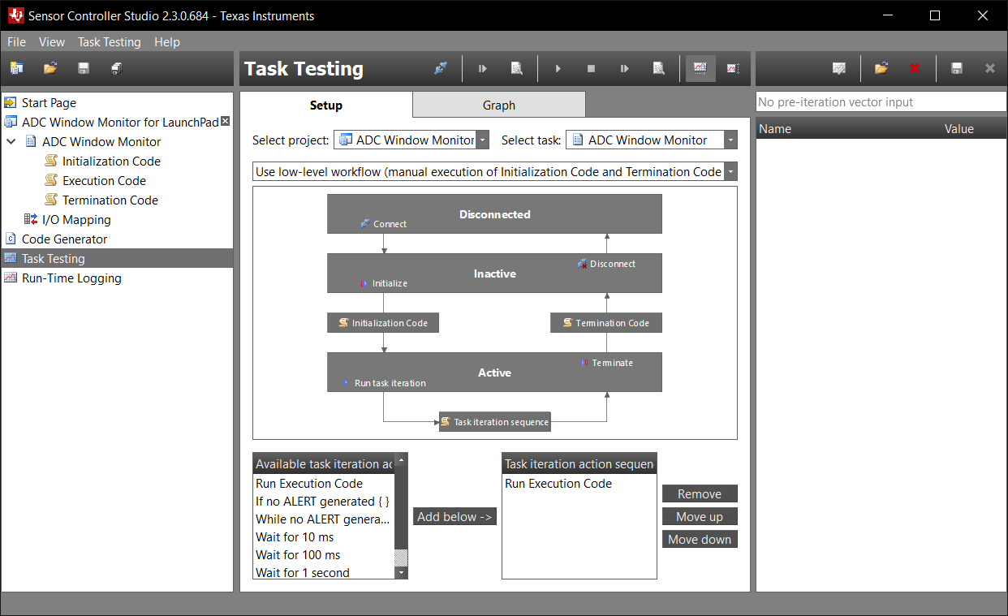

Alternating through the 3.3V and GND pins along with floating wire:

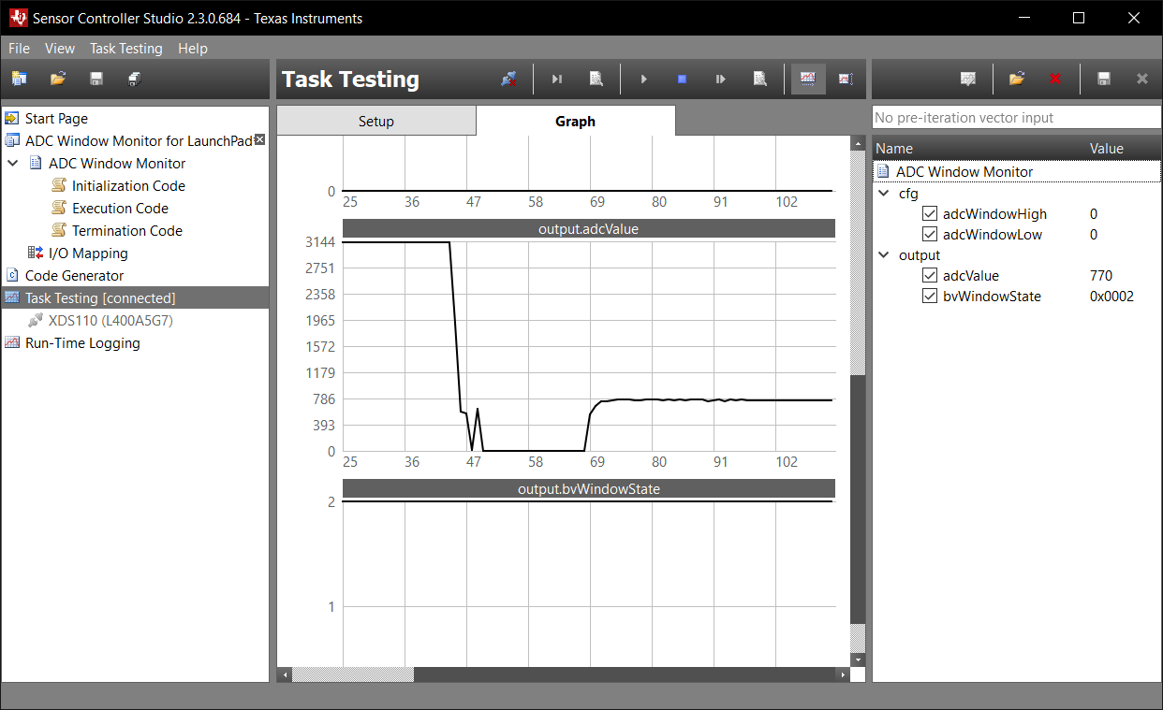

Placing a breakpoint at the ADC:

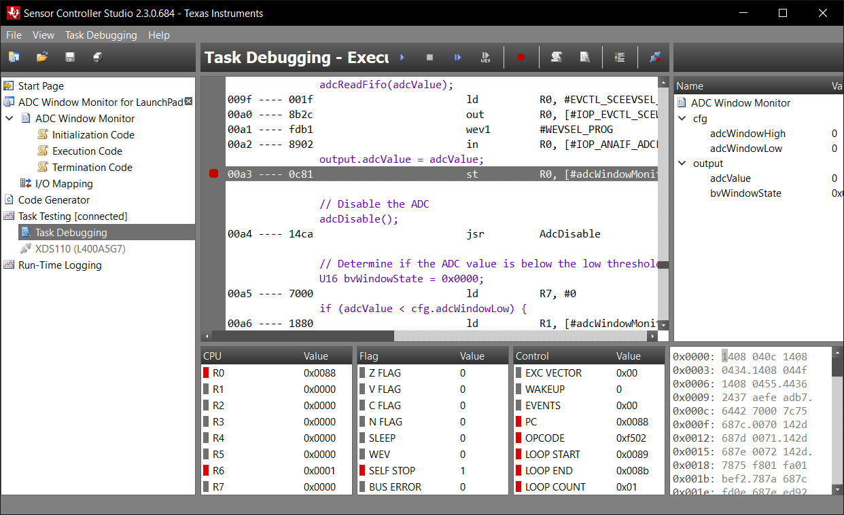

**Task 4:**

The PDF walks through how the main function operates in the project:

**int** **main**(**void**) {

Task_Params taskParams;

// Initialize the board

Board_initGeneral();

**#ifdef** Board_shutDownExtFlash

Board_shutDownExtFlash();

**#endif**

// Configure the OS task

Task_Params_init(&taskParams);

taskParams.stack = myTaskStack;

taskParams.stackSize = **sizeof**(myTaskStack);

taskParams.priority = 3;

Task_construct(&myTask, taskFxn, &taskParams, NULL);

// Create the semaphore used to wait for Sensor Controller ALERT events

Semaphore_Params semParams;

Semaphore_Params_init(&semParams);

semParams.mode = Semaphore_Mode_BINARY;

Semaphore_construct(&semScTaskAlert, 0, &semParams);

// Start TI-RTOS

BIOS_start();

**return** 0;

} // main