**Lab 06 was done as a group: Audie Escala, Aaron Volpone**

**Task 0 and 1:**

Identifying the CC1350 on the SensorTag app and pushing an image to it through UniFlash.

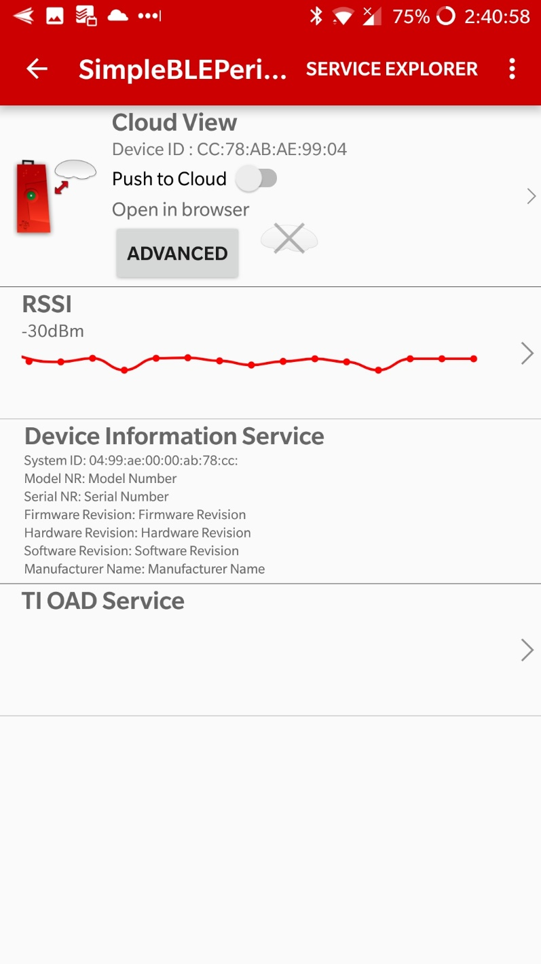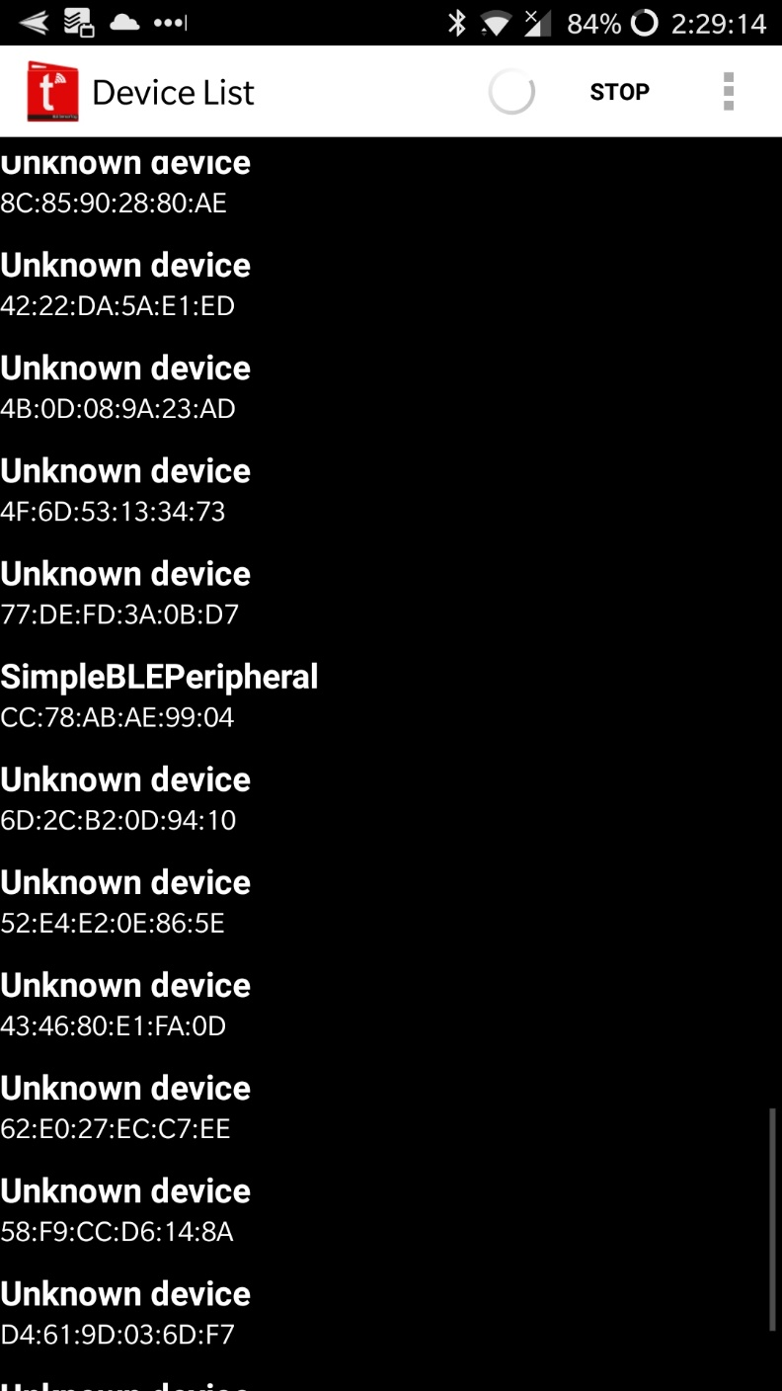

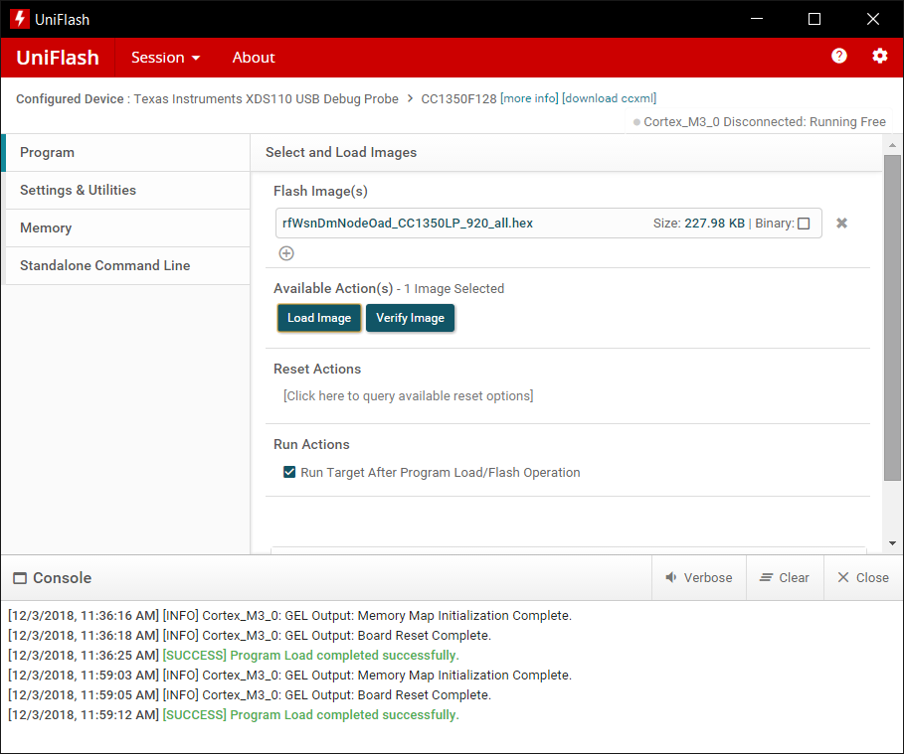

**Task 2 and 3:**

The SensorTag app did not work properly on Android devices, so we opted to flash the concentrator and node images directly to the CC1350 boards by UniFlash. The UART readouts for the concentrator and node are below respectively:

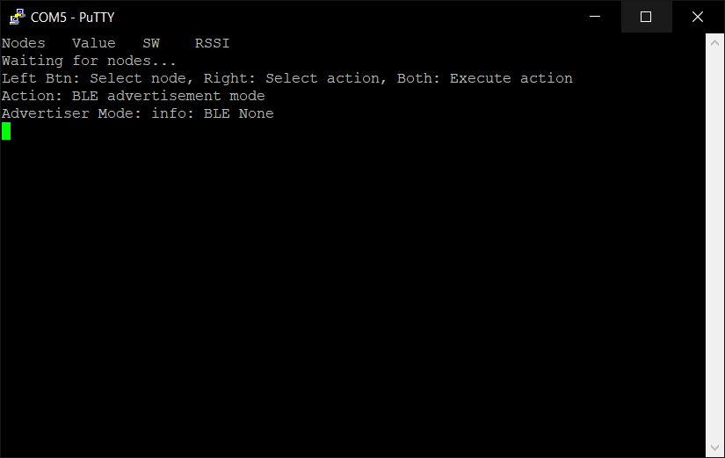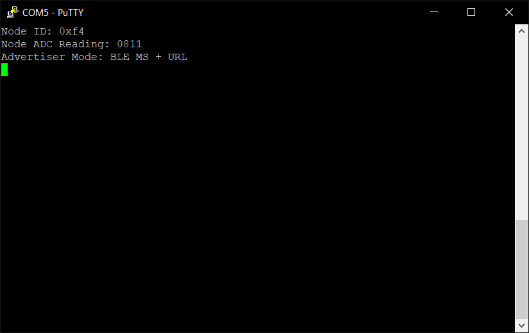

Now the concentrator and node UART readouts below are for when the two CC1350 boards are connected to each other:

