**Task 1:**

Submit a comprehensive commented file of the original code.

Two full oscillations of the function are shown below:

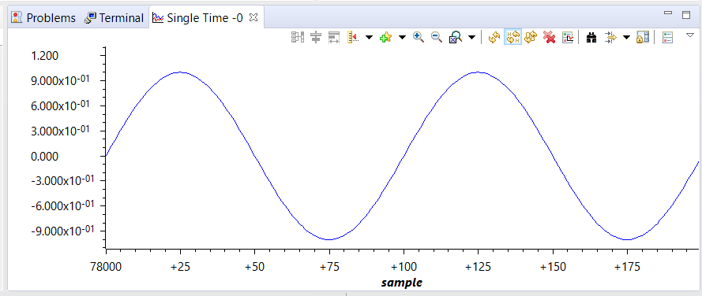

**#include** <stdint.h>

**#include** <stdbool.h>

**#include** <math.h> // lib for math functions

**#include** "inc/hw_memmap.h"

**#include** "inc/hw_types.h"

**#include** "driverlib/fpu.h" // floating point lib

**#include** "driverlib/sysctl.h"

**#include** "driverlib/rom.h"

// define the constant for PI as a floating point number

**#ifndef** M_PI

**#define** M_PI 3.14159265358979323846

**#endif**

// depth of the data buffer for samples

**#define** SERIES_LENGTH 100

// floating point array that holds the series data points

**float** gSeriesData[SERIES_LENGTH];

// the counter for computation

int32_t i32DataCount = 0;

**int** **main**(**void**)

{

// radian variable

**float** fRadians;

// enable FP data onto stack, space is reserved

**FPULazyStackingEnable**();

// floating point unit is enabled

**FPUEnable**();

// ==================================================

// Configure system clock

// CLK = 50MHz = (400MHz PLL / (4 * 2))

// --------------------------------------------------

**SysCtlClockSet**(SYSCTL_SYSDIV_4 | SYSCTL_USE_PLL | SYSCTL_XTAL_16MHZ | SYSCTL_OSC_MAIN);

// define radian with respect to the series length

fRadians = ((2 * M_PI) / SERIES_LENGTH);

// continue to compute while counter is under depth size

**while**(i32DataCount < SERIES_LENGTH)

{

// sin function of given radian value

gSeriesData[i32DataCount] = **sinf**(fRadians * i32DataCount);

// increment counter by 1

i32DataCount++;

}

// loop here forever

**while**(1)

{

}

}

**Task 2:**

Modify the code to implement the below equation to generate a frequency of 5 Hz. Display

the equation for 1 sec.

1.0*sin(2π50t) + 0.5*cos(2π200t)

$$radian=\frac{2π}{λ}=\frac{2πf}{\frac{λ}{T}}$$

Recall that:

$$f=\frac{1}{T}=\frac{1}{\frac{2π}{ω}}$$

Therefore, with ω = 50 and series length = 100 we have:

$$radian=\frac{2π\frac{1}{\frac{2π}{50}}}{\frac{100}{\frac{2π}{50}}}$$

For ω = 200 and series length = 100 we have:

$$radian=\frac{2π\frac{1}{\frac{2π}{200}}}{\frac{100}{\frac{2π}{200}}}$$

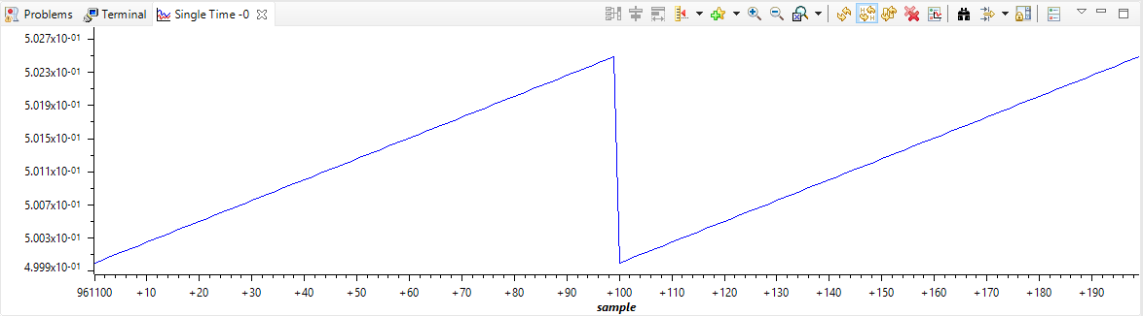

**#include** <stdint.h>

**#include** <stdbool.h>

**#include** <math.h> // lib for math functions

**#include** "inc/hw_memmap.h"

**#include** "inc/hw_types.h"

**#include** "driverlib/fpu.h" // floating point lib

**#include** "driverlib/sysctl.h"

**#include** "driverlib/rom.h"

// define the constant for PI as a floating point number

**#ifndef** M_PI

**#define** M_PI 3.14159265358979323846

**#endif**

// depth of the data buffer for samples

**#define** SERIES_LENGTH 100

// floating point array that holds the series data points

**float** gSeriesData[SERIES_LENGTH];

// the counter for computation

int32_t i32DataCount = 0;

**int** **main**(**void**)

{

// radian variable

**float** fRadians;

**float** fRadians_50;

**float** fRadians_200;

// enable FP data onto stack, space is reserved

**FPULazyStackingEnable**();

// floating point unit is enabled

**FPUEnable**();

// ==================================================

// Configure system clock

// CLK = 50MHz = (400MHz PLL / (4 * 2))

// --------------------------------------------------

**SysCtlClockSet**(SYSCTL_SYSDIV_4 | SYSCTL_USE_PLL | SYSCTL_XTAL_16MHZ | SYSCTL_OSC_MAIN);

// define radian with respect to the series length

/*

* recall that radians can be calculated as:

*

* r = (2pi/wavelength) = (2*pi*f) / (wavelength / period)

*

* f = 1 / T = 1 / (2pi/omega)

*/

// omega value, 50

fRadians_50 = ( ((2 * M_PI) * (1/(2 * M_PI) / 50)) / (SERIES_LENGTH / ((2 * M_PI) / 50)) );

// omega value, 200

fRadians_200 = ( ((2 * M_PI) * (1/(2 * M_PI) / 200)) / (SERIES_LENGTH / ((2 * M_PI) / 200)) );

// continue to compute while counter is under depth size

**while**(i32DataCount < SERIES_LENGTH)

{

// sin function of given radian value

gSeriesData[i32DataCount] = 1.0 * **sinf**(fRadians_50 * i32DataCount) + 0.5 * **cosf**(fRadians_200 * i32DataCount);

// increment counter by 1

i32DataCount++;

}

// loop here forever

**while**(1)

{

}

}