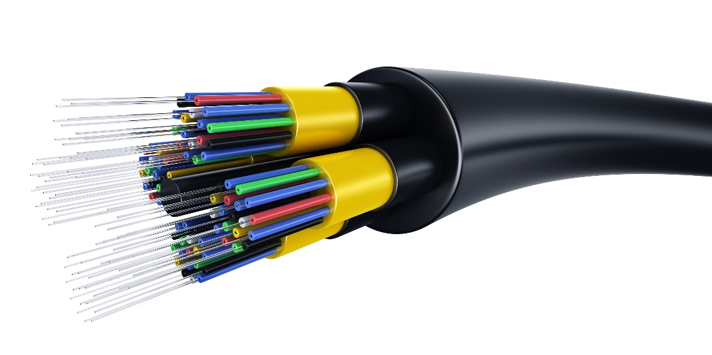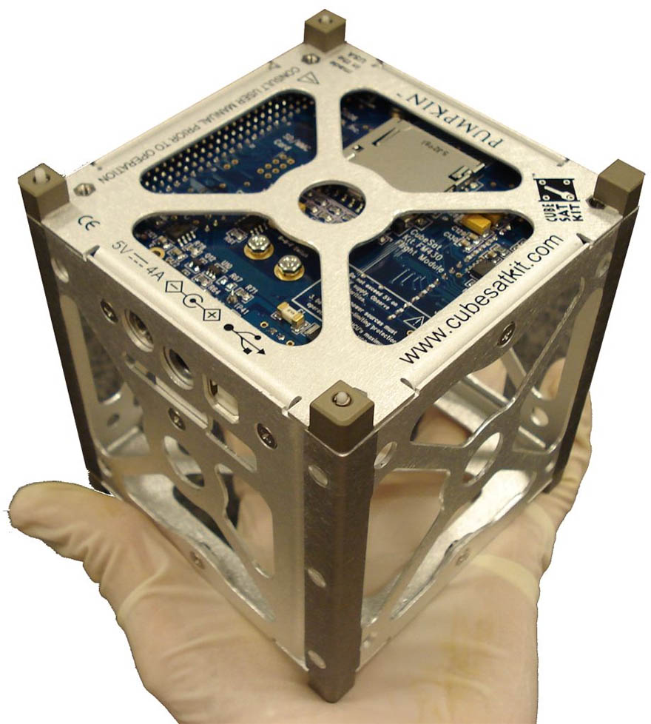

**Fiber Optic Sensor for CubeSat**

Information Technology Solutions

* Easy to operate
* High Sensitivity
* 3D detection capability
* Impossible to hack