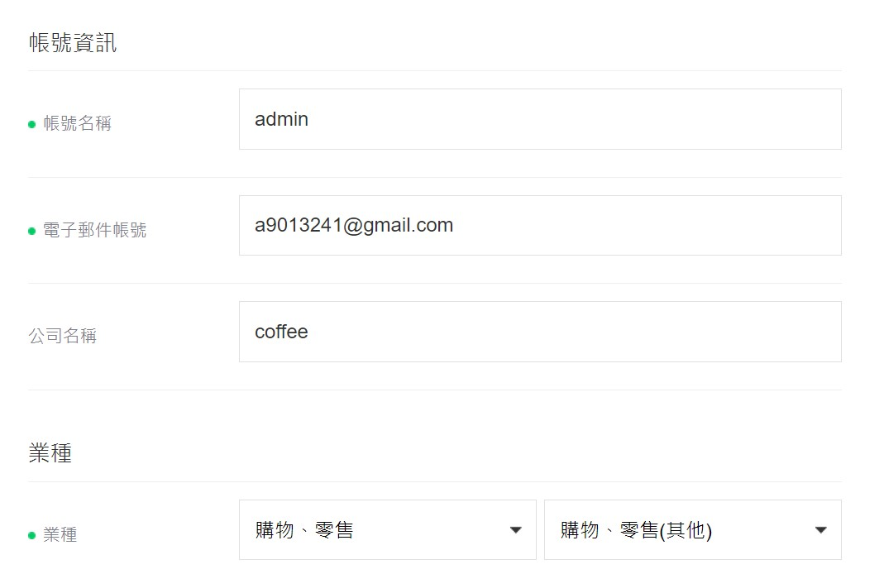

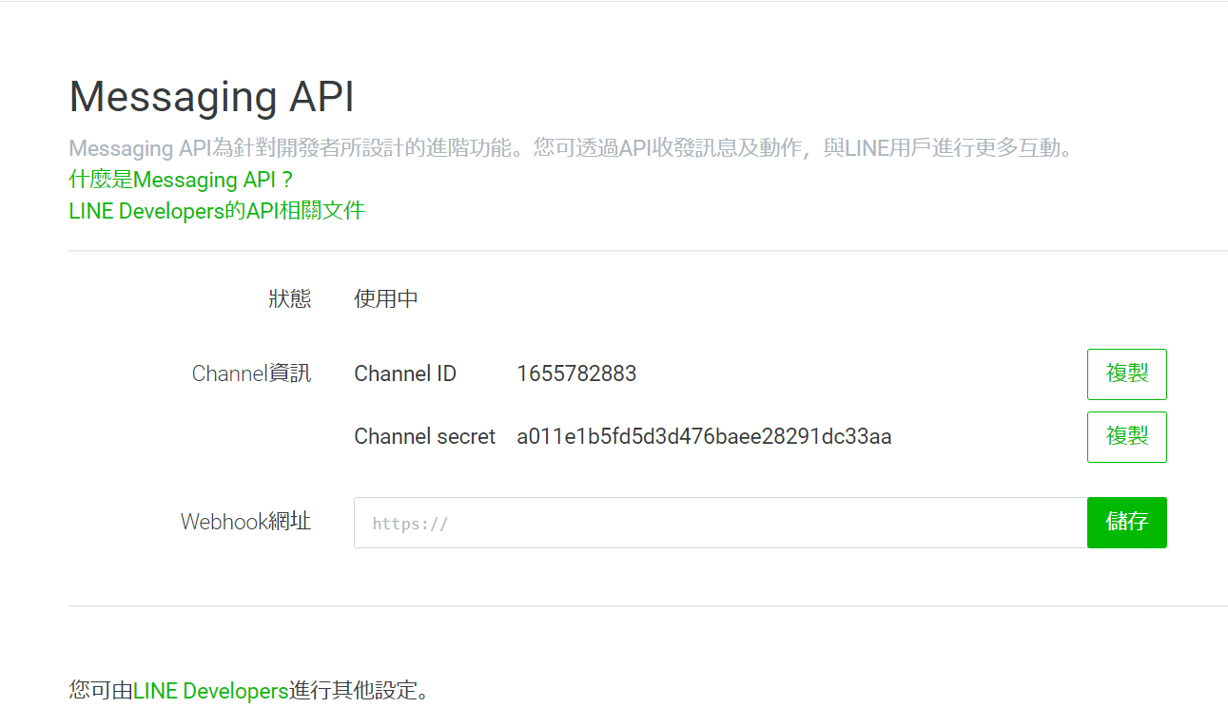

Channel ID 1655782883

Channel secret a011e1b5fd5d3d476baee28291dc33aa