Document | DDElibra Web Services
Author | Simon Dunlavey
Synopsis | Describes the content and use of DDElibra Web Services messages
Scope | LMS systems connected to Arena or other portals
Version | 1.0 – SJD - Original issue  1.1 – SJD – Updated for Arena 1.6  1.2 – SJD – Updated for Arena 1.5.4  1.3 – SJD - Updated for Archives & Museums  1.4 – SJD – Updated to include Indexing Council recommendations from 11/06/2010  1.5 – SJD – Updated for Arena 2.0.0 and to include Indexing Council recommendations from 17/09/2010  1.6 – SJD – Updated for Arena 2.0.0  1.6+ - FLP - Updated for DDElibra Web Services
Software version | ALMA message schema 1.2.9
Date | 21/06/2011

Axiell Library Group

DDElibra Web Services

Contents
1. Overview 8
1.1. Protocol specification 9
2. DDElibra Web Services 10
2.1. Add Patron Address 10
2.2. Add Patron Email Address 11
2.3. Add Patron Message Service 11
2.4. Add Payment Transaction 12
2.5. Add Patron Phone Number 13
2.6. Add Reservation 14
2.7. Change Patron Address 15
2.8. Change Patron Borrower Card 16
2.9. Change Patron Card PIN 17
2.10. Change Patron Email Address 18
2.11. Change Patron Message Service 19
2.12. Change Patron Phone Number 20
2.13. Change Reservation 21
2.14. Check Patron Status 22
2.15. Export Catalogue Records 22
2.16. Get Address Types 23
2.17. Get Catalogue Record Availability 24
2.18. Get Branches 24
2.19. Get Catalogue Record Detail 25
2.20. Get Collections 26
2.21. Get Countries 26
2.22. Get Patron Debts 27
2.23. Get Departments 27
2.24. Get Patron Alternative Cards 28
2.25. Get Patron Loans 29
2.26. Get Locations 29
2.27. Get Media Types 30
2.28. Get Patron Messages 30
2.29. Get Patron Message Services 31
2.30. Get Organisation Hierarchy 33
2.31. Get Organisations 34
2.32. Get Patron Overdue Loans 35
2.33. Get Patron Information 36
2.34. Get Payment Confirmation 37
2.35. Get Patron Payments 39
2.36. Get Payment Service Information 39
2.37. Get Patron Ready Reservations 40
2.38. Get Reservation Branches 41
2.39. Get Reservation Responsible Branches 42
2.40. Get Patron Reservations 43
2.41. Get Similar Catalogue Records 44
2.42. Get Sublocations 45
2.43. Get Version Numbers 46
2.44. Remove Patron Address 47
2.45. Remove Patron Email Address 48
2.46. Remove Patron Message Service 48
2.47. Remove Patron Phone Number 49
2.48. Remove Patron Reservation 50
2.49. Renew Patron Loans 50
2.50. Run Search on Back-end LMS 51
2.51. Update Catalogue 54
3. Common Elements 56
3.1. Element accessionDate 56
3.2. Element address 56
3.3. Element addresses 57
3.4. Element addressType 57
3.5. Element addressTypes 57
3.6. Element agency 58
3.7. Element amount 58
3.8. Element amountInSubunit 58
3.9. Element author 58
3.10. Element authors 59
3.11. Element borrCard 59
3.12. Element borrCards 59
3.13. Element branch 60
3.14. Element branches 60
3.15. Element catalogueRecord 60
3.16. Element catalogueRecords 61
3.17. Element category 61
3.18. Element classificationCode 61
3.19. Element classificationCodes 61
3.20. Element code 61
3.21. Element codes 62
3.22. Element collection 62
3.23. Element collections 62
3.24. Element compositeHolding 63
3.25. Element compositeHoldings 63
3.26. Element contentType 63
3.27. Element contentTypes 64
3.28. Element copyright 64
3.29. Element country 64
3.30. Element countries 65
3.31. Element coverUrl 65
3.32. Element coverUrls 65
3.33. Element debt 65
3.34. Element debts 66
3.35. Element department 66
3.36. Element departments 67
3.37. Element description 67
3.38. Element descriptions 67
3.39. Element detailCatalogueRecord 68
3.40. Element edition 71
3.41. Element emailAddress 71
3.42. Element emailAddresses 71
3.43. Element eventDate 72
3.44. Element eventDates 72
3.45. Element exportCatalogueRecord 72
3.46. Element externalUrl 73
3.47. Element externalUrls 73
3.48. Element facet 74
3.49. Element holding 75
3.50. Element holdings 76
3.51. Element index 77
3.52. Element isbn 79
3.53. Element isbns 80
3.54. Element issn 80
3.55. Element issns 80
3.56. Element language 80
3.57. Element languages 81
3.58. Element languageOriginal 81
3.59. Element linkedCatalogueRecord 81
3.60. Element linkedCatalogueRecords 81
3.61. Element loan 82
3.62. Element loanIsRenewable 83
3.63. Element loans 83
3.64. Element location 83
3.65. Element locations 84
3.66. Element mediaClass 84
3.67. Element mediaClassIcon 84
3.68. Element mediaType 84
3.69. Element mediaTypes 85
3.70. Element message 85
3.71. Element messages 85
3.72. Element messageService 86
3.73. Element messageServices 86
3.74. Element name 87
3.75. Element names 87
3.76. Element nofDays 87
3.77. Element nofRecords 88
3.78. Element nofRecordsFetched 88
3.79. Element nofRecordsRemaining 88
3.80. Element nofRecordsTotal 88
3.81. Element note 89
3.82. Element notes 89
3.83. Element number 89
3.84. Element numbers 89
3.85. Element objectDate 90
3.86. Element objectDates 90
3.87. Element orderid 90
3.88. Element organisation 91
3.89. Element organisations 91
3.90. Element other 91
3.91. Element others 92
3.92. Element patronCard 92
3.93. Element patronCards 92
3.94. Element patronInformation 93
3.95. Element payment 93
3.96. Element payments 94
3.97. Element phoneNumber 94
3.98. Element phoneNumbers 95
3.99. Element provenance 95
3.100. Element publicationYear 96
3.101. Element publisher 96
3.102. Element receiver 96
3.103. Element recordControlNumber 97
3.104. Element recordSorting 98
3.105. Element reservation 98
3.106. Element reservations 100
3.107. Element reservationStatus 100
3.108. Element resourceType 101
3.109. Element responsibility 101
3.110. Element sendMethod 101
3.111. Element sendMethods 102
3.112. Element seriesTitles 102
3.113. Element shelfMark 102
3.114. Element shortname 102
3.115. Element shortnames 103
3.116. Element sms 103
3.117. Element sortAuthor 103
3.118. Element sortPublicationYear 104
3.119. Element sortTitle 104
3.120. Element startNo 104
3.121. Element status 104
3.122. Element stopNo 106
3.123. Element subject 106
3.124. Element subjects 106
3.125. Element subLocation 106
3.126. Element subLocations 107
3.127. Element systemChangeNumber 107
3.128. Element targetAudience 107
3.129. Element title 108
3.130. Element titleMain 108
3.131. Element titleOriginal 108
3.132. Element titles 108
3.133. Element titleSeries 108
3.134. Element uberkey 109
3.135. Element update 109
3.136. Element updates 110
3.137. Element view 110
4. Common Types 112
4.1. Type categoryChoice 112
4.2. Type contentTypeChoice 112
4.3. Type controlNumberType 113
4.4. Type debtTypeChoice 113
4.5. Type holdingStatusChoice 114
4.6. Type lmsSearchTypeChoice 114
4.7. Type mediaClassChoice 114
4.8. Type mediaClassIconChoice 115
4.9. Type messageSendMethod 115
4.10. Type messageServiceType 116
4.11. Type paymentResult 116
4.12. Type paymentTypeChoice 116
4.13. Type recordTypeChoice 116
4.14. Type reservationSource 117
4.15. Type reservationStateType 117
4.16. Type reservationTypeChoice 117
4.17. Type resourceTypeChoice 117
4.18. Type roleType 118
4.19. Type simpleOptionType 119
4.20. Type targetAudienceChoice 119
4.21. Type updateType 119
5. DDElibra specific messages and elements 120
5.1. Add Absent Period 120
5.2. Add Fee 121
5.3. Change Absent Period 122
5.4. Change Patron Preferences 123
5.5. Change Pincode 123
5.6. Get Patron Information Extended 124
5.7. Remove Absent Period 125
5.8. Element absentPeriod 126
5.9. Element absentPeriods 126
5.10. Element patronBlock 126
5.11. Element patronBlocks 127
5.12. Element patronInformationExtended 127
5.13. Element patronPreferences 128

Overview

DDElibra Web Services is a set of services used by Arena or other portals as an interface to communicate with the backend Library Management System (LMS) for both information retrieval and update.

The DDElibra Web Services are defined in an XML Schema, details of which are given below. The root element of the Schema is ‘AlmaMessage’. An instance of an DDElibra Web Services XML message must contain a single ‘AlmaMessage’ element which in turn contains a single child element taken from the list in section 2 below.

The DDElibra Web Services messages are in pairs, each service consisting of a request and a response message. Every response message contains a common status element indicating whether the request was successful or not, with an error message to indicate the reason for failure.

A number of the DDElibra Web Services requests contain ‘branches’ and ‘organisation’ attributes that are used as filters. When configuring Arena the customer can choose to set the site to show a subset of the LIS by setting organisation or branch filters. The values are passed to the LIS and handled according to the LIS business logic. The implementation of the add/change messages are not consistent, some of them only return the actual item (debt, loan, reservation etc.) while others return a list of items. It’s when the message returns a list that the branch and organisation filters are used.

A number of the DDElibra Web Services requests have a ‘pin’ attribute that contains a patron’s PIN which the LMS uses for authentication purposes. For Arena systems that use an external authentication service the ‘pin’ attribute in these requests will contain a predefined agreed text string instead of the PIN. The LMS will need to be aware of this so that it can avoid attempting to validate the contents of the ‘pin’ attribute for patrons that have been externally authenticated.

Section 3 contains details of global child elements used by the services. Any local elements (i.e. elements defined within a parent element) are listed immediately after the element in which they are defined.

Section 4 contains details of global types referenced by the elements. These are used to restrict the content of elements and attributes to a set of enumerated values.

In the diagrams in this document elements and attributes that are mandatory and must appear at least once are shown with solid borders. Optional elements and attributes are shown with dashed borders. The diagrams also contain information on how many times an element can occur – if there is no occurrence information for an element then it can only occur once at most. For example the child element name of the names element must occur at least once and at most four times.

Protocol specification

DDElibra Web Services is REST-based, with the request taking the following form:

http://server:port/path?key1=value1&key2=value2 ...

An example:

http://sundown:8000/alma/patron/loans?borrCard=0212611239&pinCode=0000

The response is returned as XML according to the schema AlmaMessage.xsd. A full list of paths can be found in AlmaMessage.xsd.

Please note that request parameters (keys) are specified in AlmaMessage.xsd for convenience, i.e. the getLoans request above is specified as:

<xs:element name="getLoans">
<xs:complexType>
<xs:attribute name="arenaMemberAgencyCredentials" use="required"/>
<xs:attribute name="borrCard" use="required"/>
<xs:attribute name="pinCode" use="required"/>
<xs:attribute name="organisation" use="optional"/>
<xs:attribute name="branches" use="optional"/>
</xs:complexType>
</xs:element>

in AlmaMessage.xsd. Please note that arenaMemberAgencyCredentials are currently not used in DDElibra.

Dates are returned in the format YYYY-MM-DD.

DDElibra Web Services

Add Patron Address

Add a new address for the patron to the LMS database. The addAddress message contains the new address details. The response message (addAddressResponse) returns a list of all current addresses for the patron.

The type attribute has been interpreted differently by the various LMSs – some have it hard-coded as ‘Home Address’ (e.g. Book-IT, Pallas) and others (e.g. OpenGalaxy) use it to differentiate between the primary (type = 1) and secondary (type = 2) addresses for the patron.

addAddress

diagram | 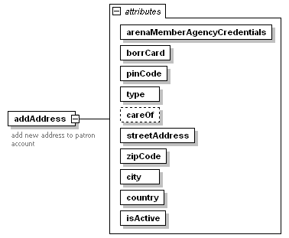
attributes
  Name | Type | Use
  arenaMemberAgencyCredentials |  | required
  borrCard |  | required
  pinCode |  | required
  type |  | required
  careOf |  | optional
  streetAddress |  | required
  zipCode |  | required
  city |  | required
  country |  | required
  isActive | simpleOptionType | required

addAddressResponse

diagram | 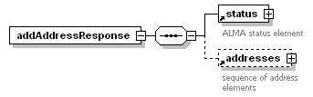
children | status addresses

Add Patron Email Address

Add a new email address for the patron to the LMS database. The addEmailAddress message contains the new email address. The response message (addEmailAddressResponse) returns a list of all current email addresses for the patron.

addEmailAddress

diagram | 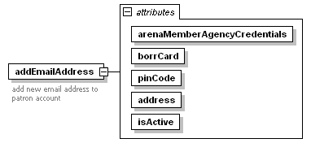
attributes
  Name | Type | Use
  arenaMemberAgencyCredentials |  | required
  borrCard |  | required
  pinCode |  | required
  address |  | required
  isActive | simpleOptionType | required

addEmailAddressResponse

diagram | 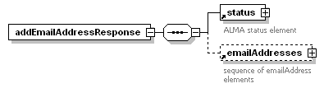
children | status emailAddresses

Add Patron Message Service

Add a new message service for the patron to the LMS database. The addMessageService message contains the new message service details. The serviceType and sendMethod attributes must contain one of the enumerated strings from the messageServiceType and messageSendMethod simple types respectively. The response message (addMessageServiceResponse) returns a list of all current message services for the patron.

addMessageService

diagram | 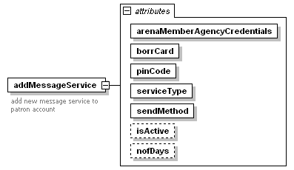
attributes
  Name | Type | Use
  arenaMemberAgencyCredentials |  | required
  borrCard |  | required
  pinCode |  | required
  serviceType | messageServiceType | required
  sendMethod | messageSendMethod | required
  isActive | simpleOptionType | optional
  nofDays |  | optional

addMessageServiceResponse

diagram | 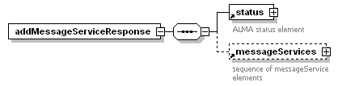
children | status messageServices

Add Payment Transaction

Add details of a completed payment transaction to the LMS database. The addPayment message contains the payment transaction details. The transactionNumber attribute contains the merchant service provider’s (MSP) reference for the transaction and the orderId attribute contains the payment ID from the LMS, as returned in the response to the getPaymentServiceInformation message. The debts element contains a comma separated list of debt ids as returned by the getDebts service. The response message (addPaymentResponse) simply returns the result status.

In a payment sequence this call will be followed by the getPaymentConfirmation service call.

addPayment

diagram | 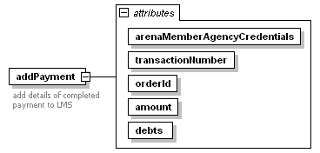
attributes
  Name | Type | Use
  arenaMemberAgencyCredentials |  | required
  transactionNumber |  | required
  orderId |  | required
  amount |  | required
  debts |  | required

addPaymentResponse

diagram | 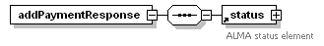
children | status

Add Patron Phone Number

Add a new phone number for the patron to the LMS database. The addPhoneNumber message contains the new phone number. The response message (addPhoneNumberResponse) returns a list of all current phone numbers for the patron.

addPhoneNumber
diagram | 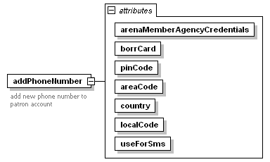
attributes
  Name | Type | Use
  arenaMemberAgencyCredentials |  | required
  borrCard |  | required
  pinCode |  | required
  areaCode |  | required
  country |  | required
  localCode |  | required
  useForSms | simpleOptionType | required

addPhoneNumberResponse

diagram | 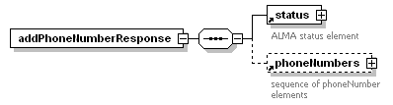
children | status phoneNumbers

Add Reservation

Add a new reservation to the LMS database on behalf of a patron. The addReservation message contains the reservation details – the reservable attribute contains the LMS ID of the title to be reserved. The response message (addReservationResponse) returns an indication of whether the reservation was successful, and if so returns full details of the reservation created on the LMS. If the attempt to add the reservation fails then the reason for the failure is returned in the reservationStatus child element of the reservation element.

addReservation
diagram | 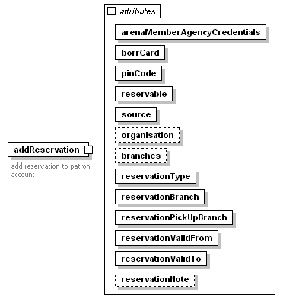
attributes
  Name | Type | Use
  arenaMemberAgencyCredentials |  | required
  borrCard |  | required
  pinCode |  | required
  reservable |  | required
  source | reservationSource | required
  organisation |  | optional
  branches |  | optional
  reservationType | reservationTypeChoice | required
  reservationBranch |  | required
  reservationPickUpBranch |  | required
  reservationValidFrom |  | required
  reservationValidTo |  | required
  reservationNote |  | optional

addReservationResponse

diagram | 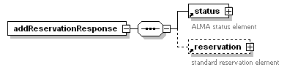
children | status reservation

Change Patron Address

Change an existing address for the patron on the LMS database. The changeAddress message contains the amended address details. The response message (changeAddressResponse) returns a list of all current addresses for the patron.

The type attribute has been interpreted differently by the various LMSs – some have it hard-coded as ‘Home Address’ (e.g. Book-IT, Pallas) and others (e.g. OpenGalaxy) use it to differentiate between the primary (type = 1) and secondary (type = 2) addresses for the patron.

changeAddress

diagram | 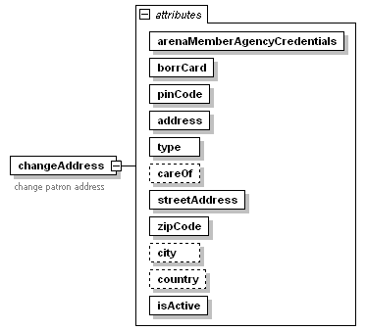
attributes
  Name | Type | Use
  arenaMemberAgencyCredentials |  | required
  borrCard |  | required
  pinCode |  | required
  address |  | required
  type |  | required
  careOf |  | optional
  streetAddress |  | required
  zipCode |  | required
  city |  | optional
  country |  | optional
  isActive | simpleOptionType | required

changeAddressResponse
diagram | 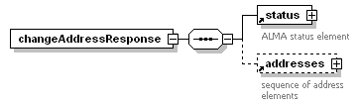
children | status addresses

Change Patron Borrower Card

Change a patron’s borrower card, currently all that can be changed is whether the card is valid or not. The borrCardChange attribute contains the number of the borrower card to change – this may well be different from the number under which the borrower is currently logged in. The response message (changeBorrCardResponse) returns a list of all current borrower cards for the patron.

changeBorrCard

diagram | 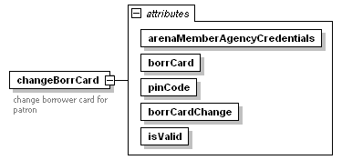
attributes
  Name | Type | Use
  arenaMemberAgencyCredentials |  | required
  borrCard |  | required
  pinCode |  | required
  borrCardChange |  | required
  isValid | simpleOptionType | required

changeBorrCardResponse

diagram | 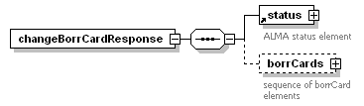
children | status borrCards

Local element borrCards

Contains a sequence of standard borrCard elements. The isAddable attribute indicates whether another borrower card can be added or not.

diagram | 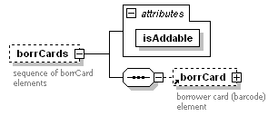
children | borrCard
attributes
  Name | Type | Use
  isAddable | simpleOptionType | required

Change Patron Card PIN

Change the PIN for a patron’s borrower card, the request takes the card number and the old (i.e. current) and new PINs. The response returns just a status element to indicate success or failure.

changeBorrCardPin

diagram | 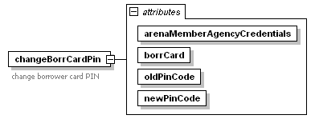
attributes
  Name | Type | Use
  arenaMemberAgencyCredentials |  | required
  borrCard |  | required
  oldPinCode |  | required
  newPinCode |  | required

changeBorrCardPinResponse

diagram | 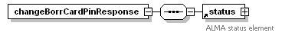
children | status

Change Patron Email Address

Change an existing email address for the patron on the LMS database. The changeEmailAddress message contains the amended email address. The response message (changeEmailAddressResponse) returns a list of all current email addresses for the patron.

changeEmailAddress

diagram | 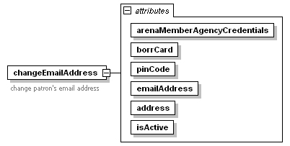
attributes
  Name | Type | Use
  arenaMemberAgencyCredentials |  | required
  borrCard |  | required
  pinCode |  | required
  emailAddress |  | required
  address |  | required
  isActive | simpleOptionType | required

changeEmailAddressResponse

diagram | 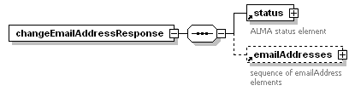
children | status emailAddresses

Change Patron Message Service

Change an existing message service for the patron on the LMS database. The changeMessageService message contains the amended message service details. The serviceType and sendMethod attributes must contain one of the enumerated strings from the messageServiceType and messageSendMethod simple types respectively, these attributes identify the message service to be modified. Only the isactive and nofDays attributes can be changed. The response message (changeMessageServiceResponse) returns a list of all current message services for the patron.

changeMessageService

diagram | 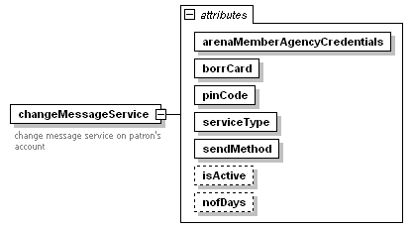
attributes
  Name | Type | Use
  arenaMemberAgencyCredentials |  | required
  borrCard |  | required
  pinCode |  | required
  serviceType | messageServiceType | required
  sendMethod | messageSendMethod | required
  isActive | simpleOptionType | optional
  nofDays |  | optional

changeMessageServiceResponse

diagram | 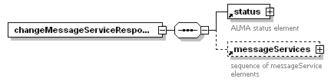
children | status messageServices

Change Patron Phone Number

Change an existing phone number for the patron on the LMS database. The changePhoneNumber message contains the amended phone number. The response message (changePhoneNumberResponse) returns a list of all current phone numbers for the patron.

changePhoneNumber

diagram | 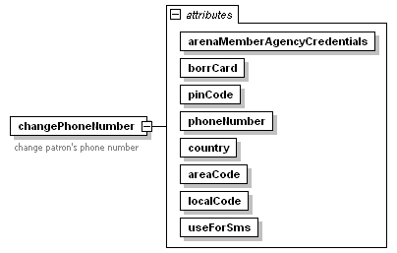
attributes
  Name | Type | Use
  arenaMemberAgencyCredentials |  | required
  borrCard |  | required
  pinCode |  | required
  phoneNumber |  | required
  country |  | required
  areaCode |  | required
  localCode |  | required
  useForSms | simpleOptionType | required

changePhoneNumberResponse

diagram | 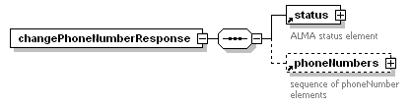
children | status phoneNumbers

Change Reservation

Change a patron’s existing reservation on the LMS database. Note that only the pickup branch and the reservation valid from and valid to dates can be modified. The changeReservation message contains the amended reservation details – the reservation attribute contains the LMS reservation ID. The response message (changeReservationResponse) returns full details of the reservation on the LMS.

changeReservation

diagram | 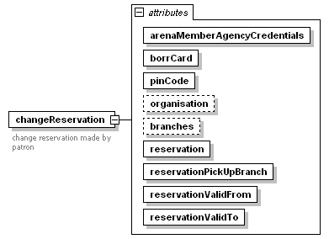
attributes
  Name | Type | Use
  arenaMemberAgencyCredentials |  | required
  borrCard |  | required
  pinCode |  | required
  organisation |  | optional
  branches |  | optional
  reservation |  | required
  reservationPickUpBranch |  | required
  reservationValidFrom |  | required
  reservationValidTo |  | required

changeReservationResponse

diagram | 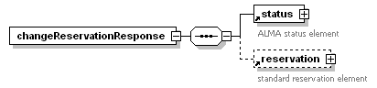
children | status reservation

Check Patron Status

Check the patron’s current status. The checkPatronStatus message contains the borrower number and PIN code – The response message (checkPatronStatusResponse) simply returns the status.

checkPatronStatus

diagram | 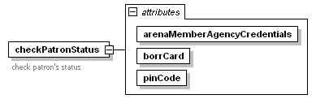
attributes
  Name | Type | Use
  arenaMemberAgencyCredentials |  | required
  borrCard |  | required
  pinCode |  | required

checkPatronStatusResponse

diagram | 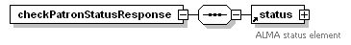
children | status

Export Catalogue Records

The exportCatalogueRecords message requests the export of one or more catalogue records from the LMS database. The attributes nofRecords and startNo contain the number of records to export and the first record required respectively. If attribute nofRecords is 1 then the catalogueRecordKey attribute contains the LMS ID of the required record. The response message (exportCatalogueRecordsResponse) contains control information about the number of records in the response, the first and last record numbers and the number of records remaining to be exported. The exported records are in instances of the exportCatalogueRecord element.

exportCatalogueRecords

diagram | 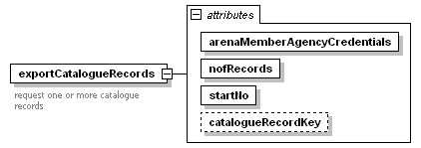
attributes
  Name | Type | Use
  arenaMemberAgencyCredentials |  | required
  nofRecords |  | required
  startNo |  | required
  catalogueRecordKey |  | optional

exportCatalogueRecordsResponse

diagram | 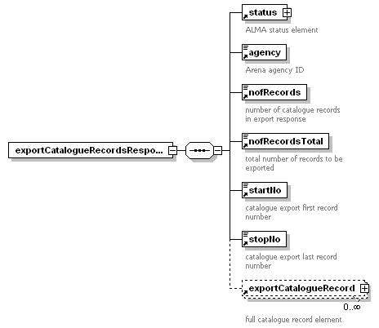
children | status agency nofRecords nofRecordsTotal startNo stopNo exportCatalogueRecord

Get Address Types

The getAddressTypes message requests details of the address types that are available on the LMS. The response message (getAddressTypesResponse) should contain details (i.e. the name) of all address types in all languages used by Arena.

getAddressTypes

diagram | 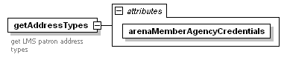
attributes
  Name | Type | Use
  arenaMemberAgencyCredentials |  | required

getAddressTypesResponse

diagram | 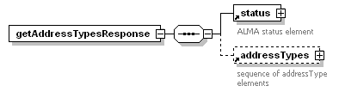
children | status addressTypes

Get Catalogue Record Availability

The getAvailability message requests a check on the availability of items (copies) associated with one or more specified catalogue records. The keys of the required records are given as a comma separated list in the catalogueRecordKey attribute. The response message (getAvailabilityResponse) returns the availability status of the catalogue record. A catalogue record is considered to be available if there is at least one copy available within the limits set by the optional organisation and branch filters.

getAvailability

diagram | 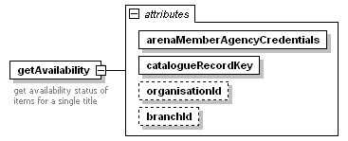
attributes
  Name | Type | Use
  arenaMemberAgencyCredentials |  | required
  catalogueRecordKey |  | required
  organisationId |  | optional
  branchId |  | optional

getAvailabilityResponse

diagram | 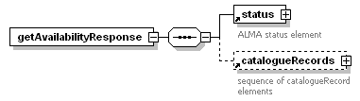
children | status catalogueRecords

Get Branches

The getBranches message requests details of all the branches that are known to the LMS. The response message (getBranchesResponse) should contain details (name, short name, code) of all branches in all languages used by Arena.

getBranches

diagram | 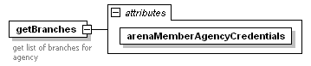
attributes
  Name | Type | Use
  arenaMemberAgencyCredentials |  | required

getBranchesResponse

diagram | 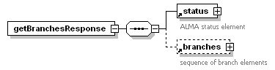
children | status branches

Get Catalogue Record Detail

The getCatalogueRecordDetail message requests full details (including holdings and any linked catalogue records) of the specified catalogue record. The response message (getCatalogueRecordDetailResponse) returns full catalogue record details, including the holdings (in a hierarchical structure) within the limits set by the optional organisation, branch and department filters.

getCatalogueRecordDetail

diagram | 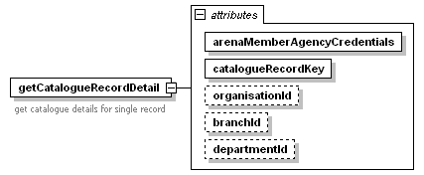
attributes
  Name | Type | Use
  arenaMemberAgencyCredentials |  | required
  catalogueRecordKey |  | required
  organisationId |  | optional
  branchId |  | optional
  departmentId |  | optional

getCatalogueRecordDetailResponse

diagram | 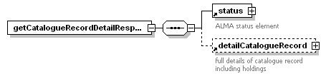
children | status detailCatalogueRecord

Get Collections

The getCollections message requests details of all the item collections that are known to the LMS. The response message (getCollectionsResponse) should contain details (name, shortname, code) of all collections in all languages used by Arena.

getCollections

diagram | 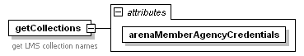
attributes
  Name | Type | Use
  arenaMemberAgencyCredentials |  | required

getCollectionsResponse

diagram | 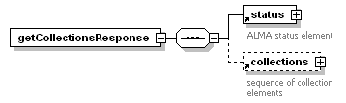
children | status collections

Get Countries

The getCountries message requests details of all the countries that are known to the LMS. The response message (getCountriesResponse) returns the country id and code and should contain the country name of all countries in all languages used by Arena.

getCountries

diagram | 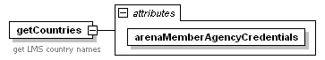
attributes
  Name | Type | Use
  arenaMemberAgencyCredentials |  | required

getCountriesResponse

diagram | 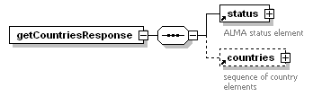
children | status countries

Get Patron Debts

The getDebts message requests details of a patron’s current outstanding debts. These are returned in the response message getDebtsResponse.

This message is the first step in a payment transaction, when it will be followed by the getPaymentServiceInformation message.

getDebts

diagram | 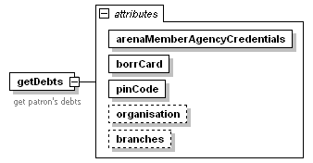
attributes
  Name | Type | Use
  arenaMemberAgencyCredentials |  | required
  borrCard |  | required
  pinCode |  | required
  organisation |  | optional
  branches |  | optional

getDebtsResponse

diagram | 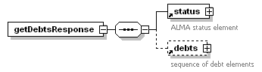
children | status debts

Get Departments

The getDepartments message requests details of all the departments that are known to the LMS. The response message (getDepartmentsResponse) should contain details (name, shortname, code) of all departments in all languages used by Arena.

getDepartments

diagram | 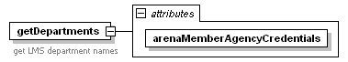
attributes
  Name | Type | Use
  arenaMemberAgencyCredentials |  | required

getDepartmentsResponse

diagram | 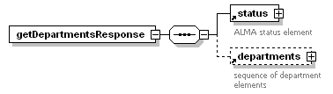
children | status departments

Get Patron Alternative Cards

The getPatronAlternativeCards message requests details of all the cards registered to a patron. The request message contains the details (card number and PIN) for a single card. The response messages contains details of all cards associated with the same patron as the card passed in the request message.

getPatronAlternativeCards

diagram | 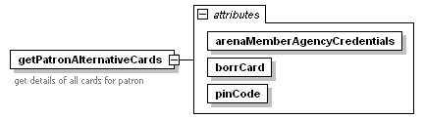
attributes
  Name | Type | Use
  arenaMemberAgencyCredentials |  | required
  borrCard |  | required
  pinCode |  | required

getPatronAlternativeCardsResponse

diagram | 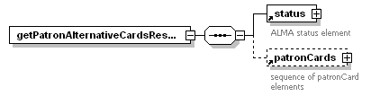
children | status patronCards

Get Patron Loans

The getLoans message requests details of all the loans that a patron currently has. These are returned in the response message getLoansResponse. The use of the organisation and branch filters is LMS dependent.

getLoans

diagram | 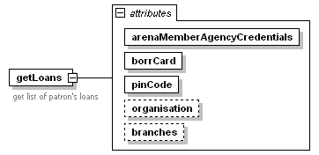
attributes
  Name | Type | Use
  arenaMemberAgencyCredentials |  | required
  borrCard |  | required
  pinCode |  | required
  organisation |  | optional
  branches |  | optional

getLoansResponse

diagram | 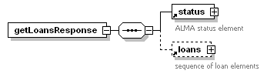
children | status loans

Get Locations

The getLocations message requests details of all the locations that are known to the LMS. The response message (getLocationsResponse) should contain details (name, shortname, code) of all locations in all languages used by Arena.

getLocations

diagram | 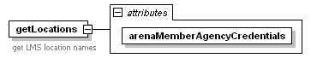
attributes
  Name | Type | Use
  arenaMemberAgencyCredentials |  | required

getLocationsResponse

diagram | 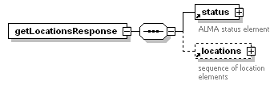
children | status locations

Get Media Types

The getMediaTypes message requests details of all the media types that are known to the LMS. The response message (getMediaTypesResponse) should contain the names of all media types in all languages used by Arena.

getMediaTypes

diagram | 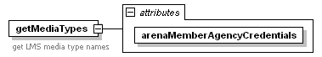
attributes
  Name | Type | Use
  arenaMemberAgencyCredentials |  | required

getMediaTypesResponse

diagram | 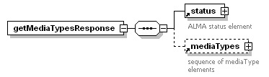
children | status mediaTypes

Get Patron Messages

The getMessages message requests a list of current messages for the patron. The response message (getMessagesResponse) returns a list of all current patron messages within the limits set by the optional organisation and branch filters.

getMessages

diagram | 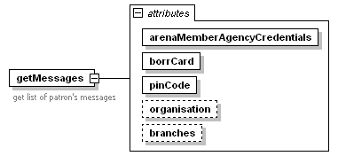
attributes
  Name | Type | Use
  arenaMemberAgencyCredentials |  | required
  borrCard |  | required
  pinCode |  | required
  organisation |  | optional
  branches |  | optional

getMessagesResponse

diagram | 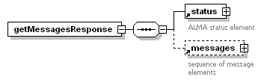
children | status messages

Get Patron Message Services

The getMessages message requests a list of message services for which the patron is currently registered. These are returned by in the response message getMessageServicesResponse.

getMessageServices

diagram | 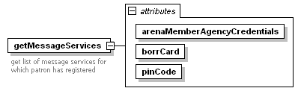
attributes
  Name | Type | Use
  arenaMemberAgencyCredentials |  | required
  borrCard |  | required
  pinCode |  | required

getMessageServicesResponse

diagram | 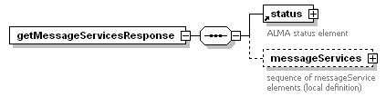
children | status messageServices

Local element messageServices

diagram | 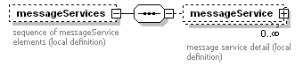
children | messageService

Local element messageService

The showNofDays attribute indicates whether the nofDays value is to be displayed for this service or not.

diagram | 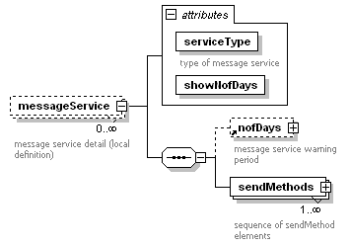
children | nofDays sendMethods
attributes
  Name | Type | Use
  serviceType | messageServiceType | required
  showNofDays | simpleOptionType | required

Local element sendMethods

diagram | 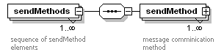
children | sendMethod

Local element sendMethod

diagram | 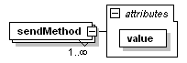
attributes
  Name | Type | Use
  value | messageSendMethod | required

Get Organisation Hierarchy

The getOrganisationHierarchy message requests the structure of the LMS organisation hierarchy. This is returned as a multi-level list in the response message getOrganisationHierarchyResponse. The structure is a list of departments within lists of branches within lists of organisations.

getOrganisationHierarchy

diagram | 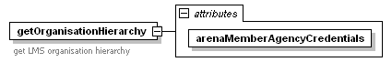
attributes
  Name | Type | Use
  arenaMemberAgencyCredentials |  | required

getOrganisationHierarchyResponse

diagram | 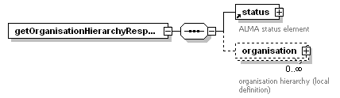
children | status organisation

Local element organisation

diagram | 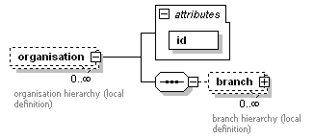
children | branch
attributes
  Name | Type | Use
  id |  | required

Local element branch

diagram | 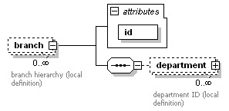
children | department
attributes
  Name | Type | Use
  id |  | required

Local element department

diagram | 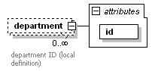
attributes
  Name | Type | Use
  id |  | required

Get Organisations

The getOrganisations message requests details of all the organisations that are known to the LMS. The response message (getOrganisationsResponse) should contain the details of all organisations within the LMS in all languages used by Arena.

getOrganisations

diagram | 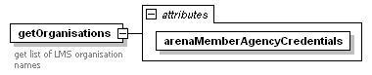
attributes
  Name | Type | Use
  arenaMemberAgencyCredentials |  | required

getOrganisationsResponse

diagram | 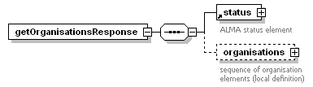
children | status organisations

Local element organisations

diagram | 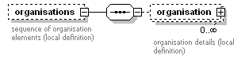
children | organisation

Local element organisation

diagram | 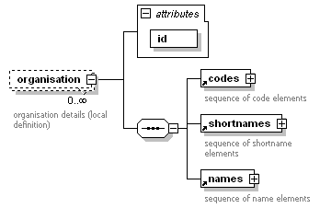
children | codes shortnames names
attributes
  Name | Type | Use
  id |  | required

Get Patron Overdue Loans

The getOverdueLoans message requests details of all the loans that a patron has that are currently overdue. These are returned in the response message getOverdueLoansResponse. The use of the organisation and branch filters is LMS dependent.

getOverdueLoans

diagram | 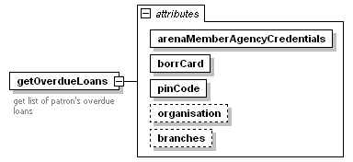
attributes
  Name | Type | Use
  arenaMemberAgencyCredentials |  | required
  borrCard |  | required
  pinCode |  | required
  organisation |  | optional
  branches |  | optional

getOverdueLoansResponse

diagram | 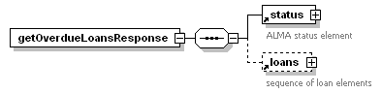
children | status loans

Get Patron Information

The getPatronInformation message requests full details held on the LMS for the specified patron. This is returned in the getPatronInformationResponse message. The information returned includes addresses, email addresses, phone numbers, borrower cards and message services. It does not include information on the patron’s loans or account.

getPatronInformation

diagram | 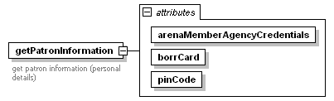
attributes
  Name | Type | Use
  arenaMemberAgencyCredentials |  | required
  borrCard |  | required
  pinCode |  | required

getPatronInformationResponse

diagram | 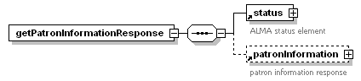
children | status patronInformation

Get Payment Confirmation

Check that a completed payment transaction has been added to the LMS. This message should be invoked immediately after the addPayment message. The transactionNumber attribute contains the merchant service provider’s (MSP) reference for the transaction and the orderId attribute contains the payment ID from the LMS, as returned in the response to the getPaymentServiceInformation message. The response message (getPaymentConfirmationResponse) returns payment details from the LMS that are associated with the MSPs transaction number.

getPaymentConfirmation

diagram | 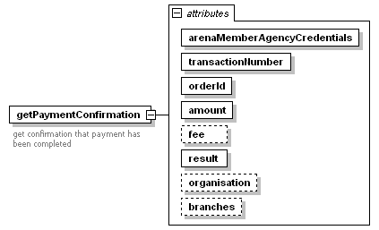
attributes
  Name | Type | Use
  arenaMemberAgencyCredentials |  | required
  transactionNumber |  | required
  orderId |  | required
  amount |  | required
  fee |  | optional
  result | paymentResult | required
  organisation |  | optional
  branches |  | optional

getPaymentConfirmationResponse

diagram | 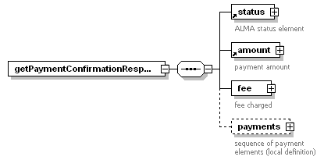
children | status amount fee payments

Local element fee

diagram | 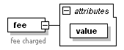
attributes
  Name | Type | Use
  value |  | required

Local element payments

diagram | 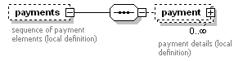
children | payment

Local element payment

diagram | 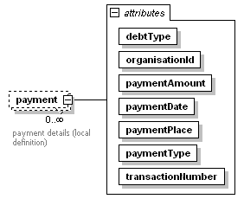
attributes
  Name | Type | Use
  debtType | debtTypeChoice | required
  organisationId |  | required
  paymentAmount |  | required
  paymentDate |  | required
  paymentPlace |  | required
  paymentType | paymentTypeChoice | required
  transactionNumber |  | required

Get Patron Payments

The getPayments message requests details of all payments that a patron has made. These are returned in the response message getPaymentsResponse subject to the optional organisation, branches, from date and to date filters. The use of the organisation and branch filters is LMS dependent.

getPayments

diagram | 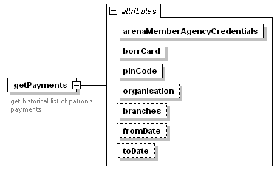
attributes
  Name | Type | Use
  arenaMemberAgencyCredentials |  | required
  borrCard |  | required
  pinCode |  | required
  organisation |  | optional
  branches |  | optional
  fromDate |  | optional
  toDate |  | optional

getPaymentsResponse

diagram | 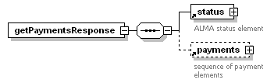
children | status payments

Get Payment Service Information

This message forms part of the payment sequence. Following a successful getDebts service call the getPaymentServiceInformation call is used to retrieve the information from the LMS needed to complete the payment. The information in the response message getPaymentServiceInformationResponse includes the LMS reference for the payment (the orderId element) and the creditors details (the receiver element)

In a payment sequence this call will be followed by the addPayment service call.

getPaymentServiceInformation

diagram | 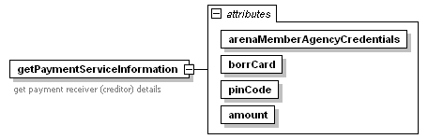
attributes
  Name | Type | Use
  arenaMemberAgencyCredentials |  | required
  borrCard |  | required
  pinCode |  | required
  amount |  | required

getPaymentServiceInformationResponse

diagram | 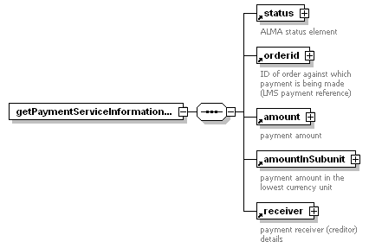
children | status orderid amount amountInSubunit receiver

Get Patron Ready Reservations

The getReadyReservations message requests a list of reservations for the patron that are available for collection. These are returned in the response message (getReadyReservationsResponse) within the limits set by the optional organisation and branch filters.

getReadyReservations

diagram | 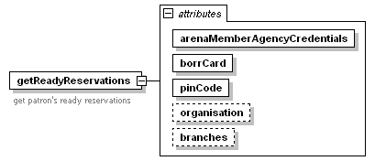
attributes
  Name | Type | Use
  arenaMemberAgencyCredentials |  | required
  borrCard |  | required
  pinCode |  | required
  organisation |  | optional
  branches |  | optional

getReadyReservationsResponse

diagram | 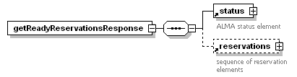
children | status reservations

Get Reservation Branches

The getReservationBranches message requests a list of branches that can be used as reservation pickup branches. These are returned in the response message (getReservationBranchesResponse) within the limits set by the optional organisation and branch filters. The information is returned as a multi-level list of branches within lists of organisations. All names etc. should be presented in all languages used by Arena.

getReservationBranches

diagram | 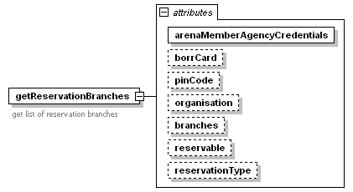
attributes
  Name | Type | Use
  arenaMemberAgencyCredentials |  | required
  borrCard |  | optional
  pinCode |  | optional
  organisation |  | optional
  branches |  | optional
  reservable |  | optional
  reservationType | reservationTypeChoice | optional

getReservationBranchesResponse

diagram | 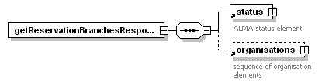
children | status organisations

Get Reservation Responsible Branches

This service is not currently used by Arena.

getReservationResponsibleBranches

diagram | 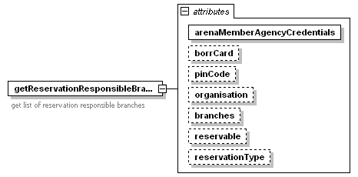
attributes
  Name | Type | Use
  arenaMemberAgencyCredentials |  | required
  borrCard |  | optional
  pinCode |  | optional
  organisation |  | optional
  branches |  | optional
  reservable |  | optional
  reservationType | reservationTypeChoice | optional

getReservationResponsibleBranchesResponse

diagram | 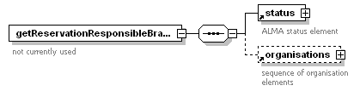
children | status organisations

Get Patron Reservations

The getReservations message requests details of all the reservations that a patron currently has. These are returned in the response message getReservationsResponse. The use of the organisation and branch filters is LMS dependent.

getReservations

diagram | 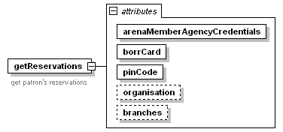
attributes
  Name | Type | Use
  arenaMemberAgencyCredentials |  | required
  borrCard |  | required
  pinCode |  | required
  organisation |  | optional
  branches |  | optional

getReservationsResponse

diagram
children | status reservations

Get Similar Catalogue Records

The getSimilarCatalogueRecords message requests the LMS to return the catalogue ID of records that are similar to the catalogue ID passed as a parameter. The implementation of this call is LMS dependent. Some systems have explicit links to other catalogue records in the catalogue data and will probably choose to return these records in response to this call. Other systems do not and may choose to return records with e.g. the same series title instead.

getSimilarCatalogueRecords

diagram | 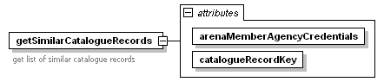
attributes
  Name | Type | Use
  arenaMemberAgencyCredentials |  | required
  catalogueRecordKey |  | required

getSimilarCatalogueRecordsResponse

diagram | 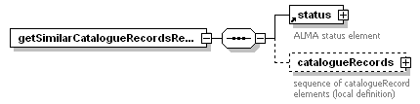
children | status catalogueRecords

Local element catalogueRecords

diagram | 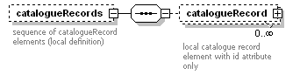
children | catalogueRecord

Local element catalogueRecord

diagram | 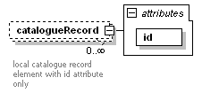
attributes
  Name | Type | Use
  id |  | required

Get Sublocations

The getSubLocations message requests details of all the sublocations that are known to the LMS. The response message (getSubLocationsResponse) should contain details (name, shortname, code) of all locations in all languages used by Arena.

getSubLocations

diagram | 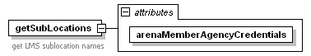
attributes
  Name | Type | Use
  arenaMemberAgencyCredentials |  | required

getSubLocationsResponse

diagram | 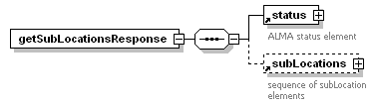
children | status subLocations

Get Version Numbers

Retrieve the version numbers of the ALMA adapter and LMS system being used, and the version number of the supported ALMA schema. The versions element also contains an optional information attribute which can be used for extra information from the LMS.

getVersions

diagram | 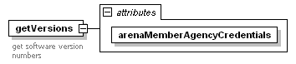
attributes
  Name | Type | Use
  arenaMemberAgencyCredentials |  | required

getVersionsResponse

diagram | 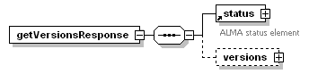
children | status versions

local element versions

diagram | 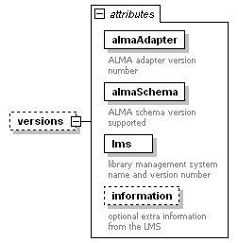
attributes
  Name | Type | Use | Description
  almaAdapter | xs:string | required | ALMA adapter version number
  almaSchema | xs:string | required | supported ALMA schema version number
  lms | xs:string | required | LMS name and version number
  information | xs:string | optional | Extra information from the LMS

Remove Patron Address

Remove an existing address for the patron from the LMS database. The removeAddress message contains the address ID (attribute address) to be removed. The response message (removeAddressResponse) returns a list of all current addresses for the patron.

removeAddress

diagram | 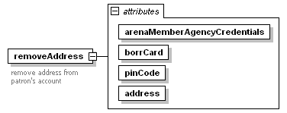
attributes
  Name | Type | Use
  arenaMemberAgencyCredentials |  | required
  borrCard |  | required
  pinCode |  | required
  address |  | required

removeAddressResponse

diagram | 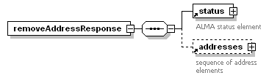
children | status addresses

Remove Patron Email Address

Remove an existing email address for the patron from the LMS database. The removeEmailAddress message contains the email address ID (attribute emailAddress) to be removed. The response message (removeEmailAddressResponse) returns a list of all current email addresses for the patron.

removeEmailAddress

diagram | 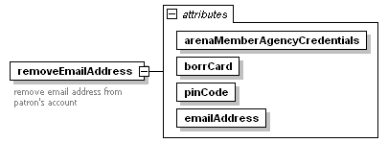
attributes
  Name | Type | Use
  arenaMemberAgencyCredentials |  | required
  borrCard |  | required
  pinCode |  | required
  emailAddress |  | required

removeEmailAddressResponse

diagram | 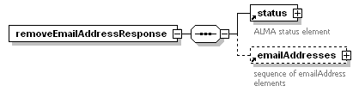
children | status emailAddresses

Remove Patron Message Service

Remove an existing message service for the patron from the LMS database. The message service to be removed is determined by the serviceType and sendMethod attributes in the removeMessageService message. The response message (removeMessageServiceResponse) returns a list of all current message services for the patron.

removeMessageService

diagram | 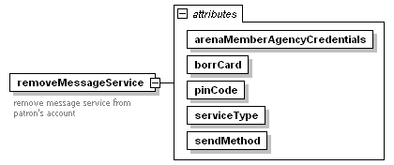
attributes
  Name | Type | Use
  arenaMemberAgencyCredentials |  | required
  borrCard |  | required
  pinCode |  | required
  serviceType | messageServiceType | required
  sendMethod | messageSendMethod | required

removeMessageServiceResponse

diagram | 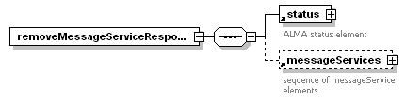
children | status messageServices

Remove Patron Phone Number

Remove an existing phone number for the patron from the LMS database. The removePhoneNumber message contains the phone number ID (attribute phoneNumber) to be removed. The response message (removePhoneNumberResponse) returns a list of all current phone numbers for the patron.

removePhoneNumber

diagram | 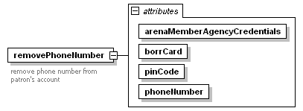
attributes
  Name | Type | Use
  arenaMemberAgencyCredentials |  | required
  borrCard |  | required
  pinCode |  | required
  phoneNumber |  | required

removePhoneNumberResponse

diagram | 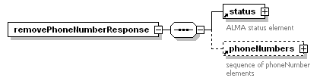
children | status phoneNumbers

Remove Patron Reservation

Remove an existing reservation for the patron from the LMS database. The removeReservation message contains the reservation ID (attribute reservation) to be removed. The response message (removeReservationResponse) returns status information only, it does not return a list of all current reservations for the patron.

removeReservation

diagram | 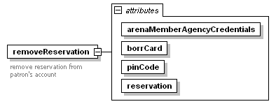
attributes
  Name | Type | Use
  arenaMemberAgencyCredentials |  | required
  borrCard |  | required
  pinCode |  | required
  reservation |  | required

removeReservationResponse

diagram | 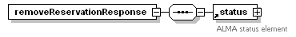
children | status

Renew Patron Loans

The renewLoan message requests the LMS to renew the patron’s loans as passed in the loans attribute – this contains a comma separated list of loan ids. The response message renewLoanResponse returns details of the patron’s current loans. The use of the organisation and branch filters is LMS dependent.

renewLoan

diagram | 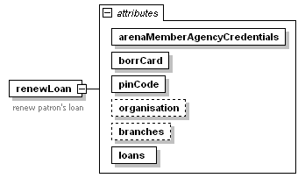
attributes
  Name | Type | Use
  arenaMemberAgencyCredentials |  | required
  borrCard |  | required
  pinCode |  | required
  organisation |  | optional
  branches |  | optional
  loans |  | required

renewLoanResponse

diagram | 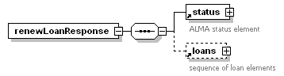
children | status loans

Run Search on Back-end LMS

Using the Arena index gives very good results in most cases, but sometimes a customer wants to pinpoint the search in more detail for specific presentation. This can be done by sending a search to the back-end in the native search syntax. The LMS returns a set of title ids and these are used to pick up the presentation data from the Arena index.

The runLmsSearch message passes details of a catalogue search query to be run on the LMS system. Results are returned as a sequence of catalogue record ids in the runLmsSearchResponse message. The use of the organisation and branch filters is LMS dependent.

There are currently three variants of LMS search supported. Which type of search is being requested is determined by the value of the seachType attribute. The details of the search to be executed are in the searchText attribute.

- Native – Run a search using the native LMS search syntax.

- Full text – Run a search using the full text search syntax supported by the Intertext module used by BOOK-IT and DDElibra.

- Named lists - Most (if not all) of the Arena LMS systems have the functionality to create various lists of catalogue records to present to the users. This search passes a list reference to the LMS.

To initiate a search, Arena will send a runLmsSearch message with the searchText and searchType attributes containing details of the search to be run. The nofRecords attribute will contain the maximum number of records to be returned by the LMS and the startNo attribute will contain the number of the first record to be returned to Arena.

Assuming the search is successful the LMS will respond with a runLmsSearchResponse message with a sequence of catalogue record ids in the catalogueRecords element. The nofRecords element will contain the number of catalogue record ids returned in the message. This cannot be more than Arena requested (it may of course be less if the search only returned a small number of records). The nofRecordsTotal element will contain the total number of records that the search returned on the LMS (so that Arena will know if it has to request more records for display), and the startNo and stopNo elements will contain the index of the first and last records returned.

So if Arena initiates a new search and wants a maximum of 10 records returned then the runLmsSearch message will have a nofRecords attribute of ‘10’ and a startNo attribute of ‘1’. If when the search is run on the LMS it results in a list of 20 records then the LMS will send a runLmsSearchResponse message with nofRecords set to ’10, nofRecordsTotal set to ’20, startNo set to ‘1’ and stopNo set to 10. The catalogueRecords element will contain the ids of the first 10 records. To retrieve the next 10 records Arena will send the same runLmsSearch message as before, but this time with the startNo attribute set to ‘11’.

runLmsSearch

diagram | 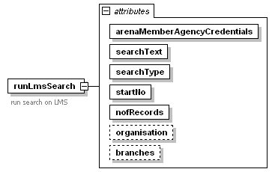
attributes
  Name | Type | Use
  arenaMemberAgencyCredentials | xs:string | required
  searchText | xs:string | required
  searchType | lmsSearchTypeChoice | required
  startNo | xs:int | required
  nofRecords | xs:int | required
  organisation
  branches

runLmsSearchResponse

diagram | 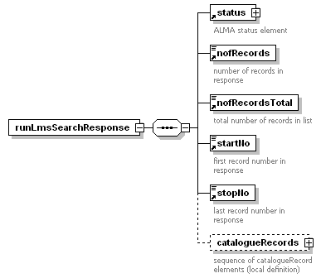
children | status nofRecords nofRecordsTotal startNo stopNo catalogueRecords

Local element catalogueRecords

diagram
children | catalogueRecord

Local element catalogueRecord

diagram
attributes
  Name | Type | Use
  id |  | required

Update Catalogue

Request the next set of catalogue updates from the LMS. The nofRecords attribute contains the number of records requested and this is the maximum number of records that should be returned in the updateCatalogueResponse message.

The use of the systemChangeNumber attribute is LMS dependent but it must contain a string assigned by the LMS to identify the current set of updates. The system change number is maintained by the LMS.

In normal use Arena will send an updateCatalogue request containing the system change number from the last updateCatalogueResponse message that it received from the LMS - this indicates that Arena has successfully processed the set of updates with that system change number.

For a clean installation Arena will send the first ever updateCatalogue request with no system change number at all (it's an optional element in the updateCatalogue message).

In rare cases when Arena has failed to process a set of updates for some reason then Arena will send a repeat updateCatalogue request with a system change number that is the same as a previous request. In this case the LMS should send a repeat of the set of updates that failed with the same system change number.

For example, suppose the LMS is using a sequential number as the system change number.

- The LMS sends an update response to Arena with change number = 2.
- Arena processes the updates and sends a new request with change number = 2.
- The LMS responds to this with a new set of updates with change number = 3.
- Arena fails to process these updates for some reason. Arena will send the next request with change number = 2, expecting to get a repeat of the previous set of updates with change number = 3.
- The LMS should respond to this request with a repeat of the previous response with change number = 3.

If the LMS cannot repeat a response for whatever reason (e.g. the LMS doesn't maintain a history of catalogue updates) then the LMS should continue with the normal sequence of updates - note however that this will mean that the Arena and LMS catalogues are now out of step and they will need to be re-synchronised by some other means.

Note that it is not an error if there are no updates available to satisfy the request. Under these circumstances a response message with a status of ‘ok’, a nofRecords attribute of 0, a normal systemChangeNumber attribute and an empty updates element should be returned.

updateCatalogue

diagram | 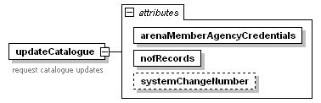
attributes
  Name | Type | Use
  arenaMemberAgencyCredentials |  | required
  nofRecords |  | required
  systemChangeNumber |  | optional

updateCatalogueResponse

diagram | 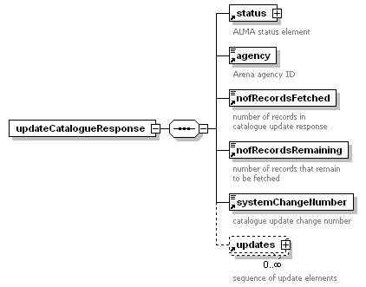
children | status agency nofRecordsFetched nofRecordsRemaining systemChangeNumber updates

Common Elements

This section lists child elements defined at the root schema level and that are available for use throughout the schema.

Element accessionDate

The date that the first copy was added to a title.

diagram | 
type | xs:date

Element address

A standard street address. The use of the id and type attributes is LMS dependent. The careOf attribute would be used e.g. for the name of a parent or guardian when the address is for a minor.

diagram | 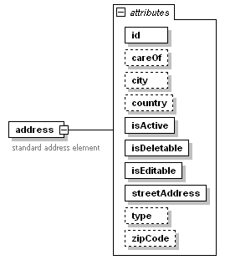
attributes
  Name | Type | Use
  id |  | required
  careOf |  | optional
  city |  | optional
  country |  | optional
  isActive | simpleOptionType | required
  isDeletable | simpleOptionType | required
  isEditable | simpleOptionType | required
  streetAddress |  | required
  type |  | optional
  zipCode |  | optional

Element addresses

A sequence of address elements. The isAddable attribute indicates whether another address can be added or not.
diagram | 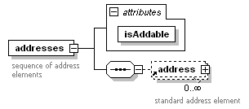
children | address
attributes
  Name | Type | Use
  isAddable | simpleOptionType | required

Element addressType

Standard address type. The addressTypeId attribute is LMS dependent and holds the unique ID assigned by the LMS to this type of address. The names element contains the labels given to the address types, e.g. ‘primary’, ‘active’ etc.

diagram | 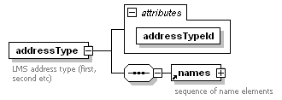
children | names
attributes
  Name | Type | Use
  addressTypeId |  | required

Element addressTypes

A sequence of addressType elements.

diagram | 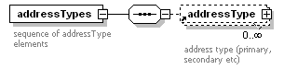
children | addressType

Element agency

An Arena agency ID

diagram | 
type | xs:string

Element amount

A monetary amount – attribute value contains the amount.

diagram | 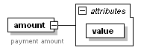
attributes
  Name | Type | Use
  value |  | required

Element amountInSubunit

A monetary amount expressed as a number of the lowest currency unit in the currency being used.

diagram | 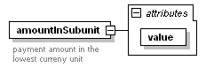
attributes
  Name | Type | Use
  value |  | required

Element author

Catalogue author text. Attribute value contains the author’s name and attribute role contains the author’s role, e.g. ‘illustrator’, ‘editor’ etc.

diagram | 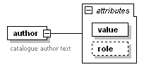
attributes
  Name | Type | Use | Default
  value | xs:string | required
  role | roleType | optional | author

Element authors

A sequence of author elements.

diagram | 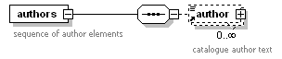
children | author

Element borrCard

Holds the borrower (patron) barcode number in the cardNumber attribute.

diagram | 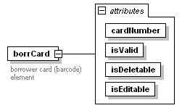
attributes
  Name | Type | Use
  cardNumber |  | required
  isValid | simpleOptionType | required
  isDeletable | simpleOptionType | required
  isEditable | simpleOptionType | required

Element borrCards

A sequence of borrCard elements. The isAddable attribute indicates whether another borrCard element can be added or not.

diagram | 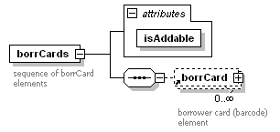
children | borrCard
attributes
  Name | Type | Use
  isAddable | simpleOptionType | required

Element branch

Standard branch element. The id attribute contains the LMS unique branch ID. Elements codes, shortnames, and names should contain the information indicated by the element name in all languages used by Arena.

diagram | 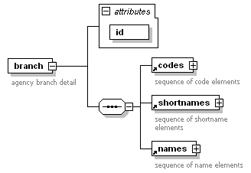
children | codes shortnames names
attributes
  Name | Type | Use
  id |  | required

Element branches

A sequence of branch elements.

diagram | 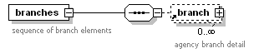
children | branch

Element catalogueRecord

Contains attributes with the LMS unique catalogue record ID and an indication of whether there are available copies.

diagram | 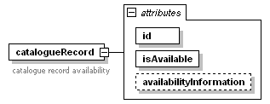
attributes
  Name | Type | Use
  id |  | required
  isAvailable | simpleOptionType | required
  availabilityInformation | holdingStatusChoice | optional

Element catalogueRecords

A sequence of catalogueRecord elements.
diagram | 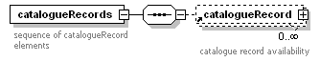
children | catalogueRecord

Element category

Contains the category type of a catalogue record. Element category is of type categoryChoice which restricts the allowed values for this element.

diagram | 
type | categoryChoice

Element classificationCode

Contains a catalogue record classification code, e.g. Dewey classmark.

diagram | 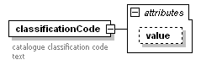
attributes
  Name | Type | Use
  value | xs:string

Element classificationCodes

A sequence of classificationCode elements.

diagram | 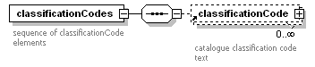
children | classificationCode

Element code

Standard code element, used in several places to hold a code for entities such as branches, organisations etc. The language attribute contains the language code used in the current instance of the element. The code elements usually occur in a sequence, with one instance for each language used in Arena.

diagram | 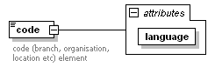
attributes
  Name | Type | Use
  language | derived by: xs:string | required

Element codes

A sequence of code elements.

diagram | 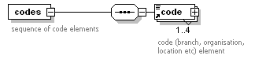
children | code

Element collection

Standard collection element. The id attribute contains the LMS unique collection ID. Elements codes, shortnames, and names should contain the information indicated by the element name in all languages used by Arena.

diagram | 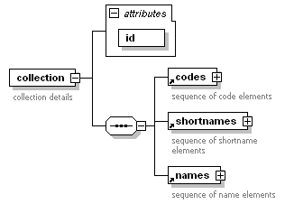
children | codes shortnames names
attributes
  Name | Type | Use
  id |  | required

Element collections

A sequence of collection elements.
diagram | 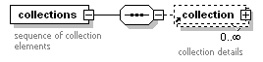
children | collection

Element compositeHolding

Used to list holdings of copies by the getCatalogueRecordDetailResponse message. The optional value attribute can be used to hold an LMS specific description of this level of holdings. Multi-level holdings schemes are supported as this element must contain either another compositeHolding element or the holdings themselves in a holdings element.

diagram | 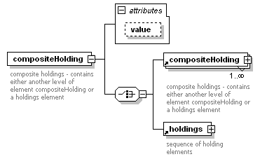
children | compositeHolding holdings
attributes
  Name | Type | Use
  value | xs:string | optional

Element compositeHoldings

A sequence of compositeHolding elements.

diagram | 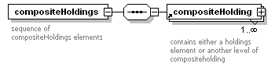
children | compositeHolding

Element contentType

Contains the content type of a catalogue record. Element contentType is of type contentTypeChoice which restricts the allowed values for this element.

diagram | 
type | contentTypeChoice

Element contentTypes

A sequence of contentType elements.

diagram | 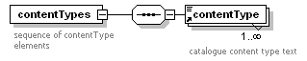
children | contentType

Element copyright

This element is used in the detailCatalogueRecord element to hold a statement of copyright or other rights information.

diagram | 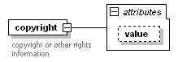
attributes
  Name | Type | Use
  value | xs:string | optional

Element country

Standard country element that contains country details. Attribute countryId contains the LMS unique ID for the country. Attribute code contains the standard code for the country. The names element contains the country name in all languages used by Arena.

diagram | 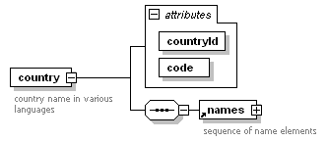
children | names
attributes
  Name | Type | Use
  countryId |  | required
  code |  | required

Element countries

A sequence of country elements.

diagram | 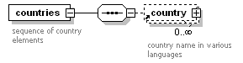
children | country

Element coverUrl

Contains the URL for the cover image of a catalogue record. The raw URL text is in the value attribute.

diagram | 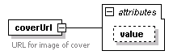
attributes
  Name | Type | Use
  linkText | xs:string | optional
  value | xs:string

Element coverUrls

A sequence of coverUrl elements.

diagram | 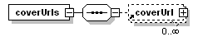
children | coverUrl

Element debt

A standard debt element. Attribute debtId is the LMS unique ID for the debt, debtDate is the date the debt was incurred, debtType (of type debtTypeChoice) describes the type of debt, debtAmount and debtAmountFormatted are the debt amount without and with a currency indicator respectively, and organisationId is the organisation that owns the debt.

diagram | 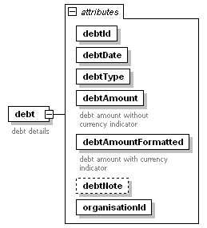
attributes
  Name | Type | Use
  debtId |  | required
  debtDate |  | required
  debtType | debtTypeChoice | required
  debtAmount |  | required
  debtAmountFormatted |  | required
  debtNote |  | optional
  organisationId |  | required

Element debts

A sequence of debt elements. The totalDebtAmountFormatted attribute is the total amount with a currency indicator for all debts in the sequence.

diagram | 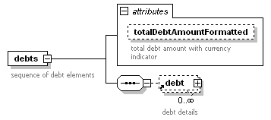
children | debt
attributes
  Name | Type | Use
  totalDebtAmountFormatted |  | optional

Element department

Standard department element. The id attribute contains the LMS unique department ID. Elements codes, shortnames, and names should contain the information indicated by the element name in all languages used by Arena.

diagram | 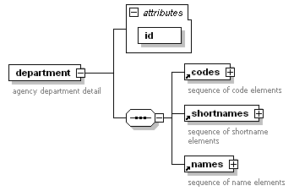
children | codes shortnames names
attributes
  Name | Type | Use
  id |  | required

Element departments

A sequence of department elements.

diagram | 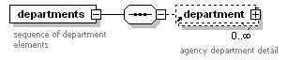
children | department

Element description

Physical description text for a catalogue record from MARC tag 300, e.g. size, pagination etc.

diagram | 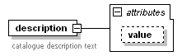
attributes
  Name | Type | Use
  value | xs:string

Element descriptions

A sequence of description elements.

diagram | 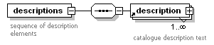
children | description

Element detailCatalogueRecord

Contains full details of a catalogue record, including holdings. The various attributes are described in the table below. The child elements are described under the individual element definitions. Note the choice between the compositeHoldings and holdings elements, an instance of the detailCatalogueRecord element can contain either one or the other of these child elements.

The use of the isbns and issns elements in detailCatalogueRecord is now deprecated. The numbers element should be used instead.

diagram | 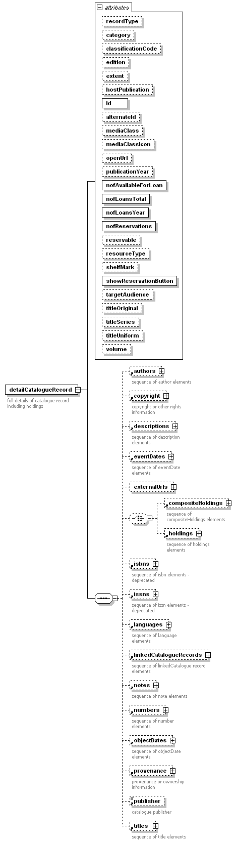
children | authors copyright descriptions eventDates externalUrls compositeHoldings holdings isbns issns languages linkedCatalogueRecords notes numbers objectDates provenance publisher titles
attributes
  Name | Type | Use | Description
  recordType | recordTypeChoice | optional | see recordTypeChoice definition, default value is ‘catalogue’
  category | categoryChoice | optional | see categoryChoice definition
  classificationCode |  | optional | classification text, from e.g. MARC tags 80, 82 etc
  edition |  | optional | edition text, from e.g. MARC tag 250
  extent |  | optional | LMS specific (Book-IT: number of pages)
  hostPublication |  | optional | LMS specific (Book-IT: used for host publication when catalogue record is for an article)
  id | xs:string | required | LMS catalogue record ID
  mediaClass | mediaClassChoice | optional | see mediaClassChoice definition
  mediaClassIcon | mediaClassIconChoice | optional | see mediaClassIconChoice definition
  openUrl |  | optional | URL of catalogue record
  publicationYear | xs:string | optional | year of publication
  nofAvailableForLoan | xs:int | required | available copy count
  nofLoansTotal | xs:int | required | total loan count
  nofLoansYear | xs:int | required | count of loans this year
  nofReservations | xs:int | required | reservation count
  reservable | xs:string | optional | catalogue ID
  resourceType | resourceTypeChoice | optional | see resourceTypeChoice definition
  shelfMark | xs:string | optional | main shelf mark
  showReservationButton | simpleOptionType | required | display reservation button indicator
  targetAudience | targetAudienceChoice | optional | see targetAudienceChoice definition
  titleOriginal | xs:string | optional | original title text
  titleSeries | xs:string | optional | series title text (tag 440, 490)
  titleUniform | xs:string | optional | uniform title text (tag 240)
  volume | xs:string | optional | volume information (tag 245)

Local element externalUrl

External URL text from MARC tag 856. The global externalUrl element can’t be used here because of a difference in attribute names. Attribute url contains the raw URL and attribute linkText contains the link text to be displayed.

diagram | 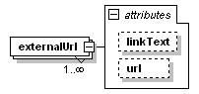
attributes
  Name | Type | Use
  url | xs:string | optional
  linkText | xs:string | optional

Local element externalUrls

A sequence of local externalUrl elements. The global externalUrls element can’t be used here because of a difference in attribute names.

diagram | 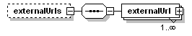
children | externalUrl

Element edition

Contains catalogue edition text from MARC tag 250.

diagram | 
type | xs:string

Element emailAddress

Standard email address element. The id attribute is the LMS unique id for this e-mail address. The email address is in the address attribute. The isActive, isDeletable and isEditable attributes indicate whether the address is active, can be deleted and can be edited respectively, and there is an optional note element.

diagram | 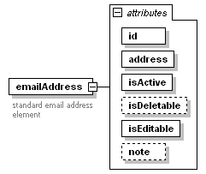
attributes
  Name | Type | Use
  id |  | required
  address |  | required
  isActive | simpleOptionType | required
  isDeletable | simpleOptionType | optional
  isEditable | simpleOptionType | required
  note |  | optional

Element emailAddresses

A sequence of emailAddress elements. The isAddable attribute indicates whether another e-mail address can be added or not.
diagram | 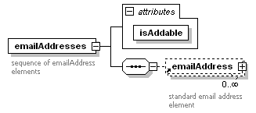
children | emailAddress
attributes
  Name | Type | Use
  isAddable | simpleOptionType | required

Element eventDate

This is a standard date range element. It contains starting and ending dates and a text attribute to describe its use. The starting and ending date elements are full dates in the form ‘YYYY-MM-DD’. Note that dates before 1st January 1 AD (CE) cannot be used in the startDate and endDate attributes of this element.

diagram | 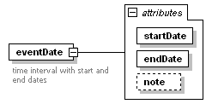
attributes
  Name | Type | Use
  startDate | xs:date | required
  endDate | xs:date | required
  note | xs:string | optional

Element eventDates

Element eventDates contains a sequence of eventDate elements. It is used in the detailCatalogueRecord element, and in the index and view elements of the exportCatalogueRecord element.

diagram | 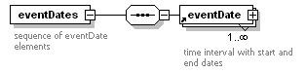
children | eventDate

Element exportCatalogueRecord

This element is used by the exportCatalogueRecords and updateCatalogue services. The id attribute contains the LMS unique key for the catalogue record.

The newTitle attribute is a ‘Yes’ or ‘No’ choice. It should normally contain ‘Yes’ to indicate that this title can be returned by new stock searches, i.e. a search that looks for new titles that have been added to the LMS since a given date. Setting newTitle to ‘No’ means that this title can never be returned by new stock searches. This may be appropriate under certain circumstances, e.g. if the title is for a reprint or is a known duplicate of an already existing title. This attribute is optional and if it is omitted then a value of ‘Yes’ will be assumed.

The facet, index, uberkey, and view child elements contain the information from the catalogue needed to create these parts of the Arena catalogue record display.

diagram | 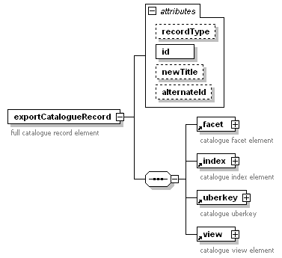
children | facet index uberkey view
attributes
  Name | Type | Use | Description
  recordType | recordTypeChoice | optional | see recordTypeChoice definition, default value is ‘catalogue’
  id | xs:string | required | record ID
  newTitle | simpleOptionType |  | ‘No’ if title is not included in ‘new’ searches
  alternateId | xs:string | optional | alternate record ID

Element externalUrl

A standard URL element. The raw URL text is in the value attribute and the linkText attribute contains the link text to be displayed.

diagram | 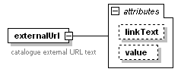
attributes
  Name | Type | Use
  linkText | xs:string | optional
  value | xs:string | optional

Element externalUrls

A sequence of externalUrl elements.

diagram | 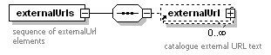
children | externalUrl

Element facet

This element is used by the exportCatalogueRecords and updateCatalogue services. It contains the information from the catalogue needed to create the Arena catalogue record facet displays.

diagram | 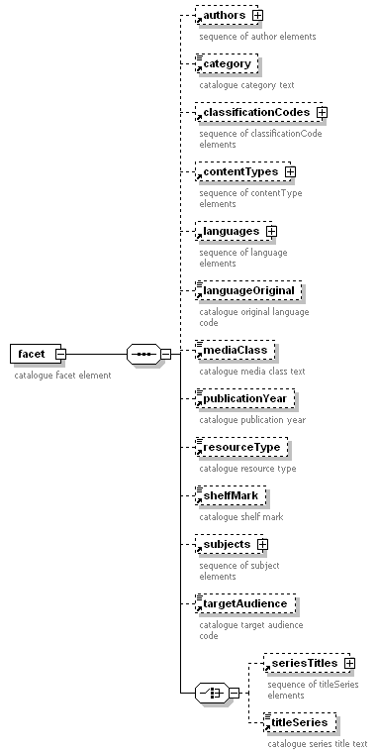
children | authors category classificationCodes contentTypes languages languageOriginal mediaClass publicationYear resourceType seriesTitles shelfMark subjects targetAudience titleSeries

Element holding

Standard copy holdings element. The attributes are described in the table below.
diagram | 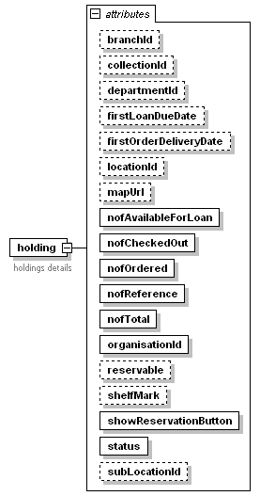
attributes
  Name | Type | Use | Description
  branchId | xs:string | optional | LMS branch ID
  collectionId | xs:string | optional | LMS collection ID
  departmentId | xs:string | optional | LMS department ID
  firstLoanDueDate | xs:string | optional | earliest due date of items on loan
  firstOrderDeliveryDate | xs:string | optional | earliest delivery date of orders
  locationId | xs:string | optional | LMS location ID
  mapUrl | xs:string | optional | URL of map showing location
  nofAvailableForLoan | xs:int | required | available copies count
  nofCheckedOut | xs:int | required | count of copies on loan
  nofOrdered | xs:int | required | count of copies on order
  nofReference | xs:int | required | reference copy count
  nofTotal | xs:int | required | total copy count
  organisationId | xs:string | required | LMS organisation ID
  reservable | xs:string | optional | reservable copy ID
  shelfMark | xs:string | optional | shelf mark
  showReservationButton | simpleOptionType | required | display reservation button indicator
  status | holdingStatusChoice | required | see: holdingStatusChoice definition
  subLocationId | xs:string | optional | LMS sublocation ID

Element holdings

A sequence of holding elements.
diagram | 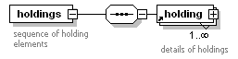
children | holding

Element index

This element is used by the exportCatalogueRecords and updateCatalogue services. It contains the information from the catalogue used to index the catalogue record. The information in this element therefore determines the terms that can be used to search for the record.

Use of ‘isbns’ and ‘issns’ in the ‘index’ element is now deprecated. The ‘numbers’ element should now be used instead, with an appropriate setting for the ‘type’ attribute.

diagram | 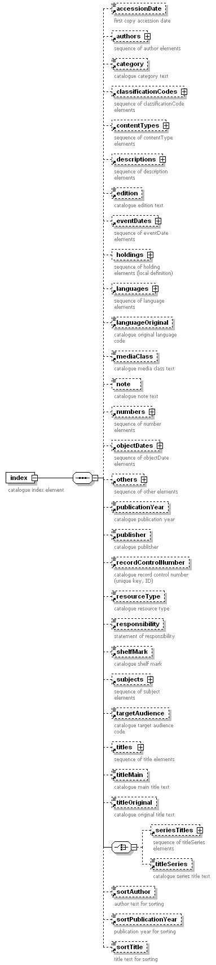
children | accessionDate authors category classificationCodes contentTypes descriptions edition eventDates holdings languages languageOriginal mediaClass note numbers objectDates others publicationYear publisher recordControlNumber resourceType responsibility seriesTitles shelfMark sortAuthor sortPublicationYear sortTitle subjects targetAudience titles titleMain titleOriginal titleSeries

Local element holding

A local holding element containing only organisation, branch and department ID attributes.

diagram | 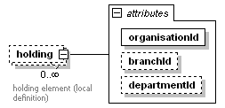
attributes
  Name | Type | Use
  organisationId |  | required
  branchId
  departmentId

Local element holdings

A sequence of local holding elements.

diagram | 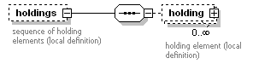
children | holding

Local element note

diagram | 
type | xs:string

Element isbn

Contains an ISBN from MARC tag 020. Use of this element is now deprecated. Where possible the ‘number’ element should be used instead, with an appropriate setting for the ‘type’ attribute.

diagram | 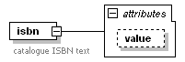
attributes
  Name | Type | Use
  value | xs:string

Element isbns

A sequence of isbn elements. Use of this element is now deprecated. Where possible the ‘numbers’ element should be used instead.

diagram | 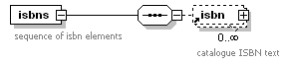
children | isbn

Element issn

Contains an ISSN from MARC tag 022. Use of this element is now deprecated. Where possible the ‘number’ element should be used instead, with an appropriate setting for the ‘type’ attribute.

diagram | 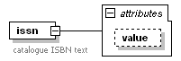
attributes
  Name | Type | Use
  value | xs:string

Element issns

A sequence of issn elements. Use of this element is now deprecated. Where possible the ‘number’ element should be used instead.

diagram | 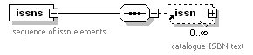
children | issn

Element language

Contains a standard language code, e.g. ‘swe’.

diagram | 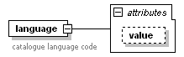
attributes
  Name | Type | Use
  value | xs:string

Element languages

A sequence of language elements.

diagram | 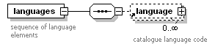
children | language

Element languageOriginal

Contains the original language code for a work which has been translated.

diagram | 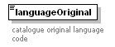
type | xs:string

Element linkedCatalogueRecord

Used by the detailCatalogueRecord element to hold the LMS ID of catalogue records that are linked to the current record.

diagram | 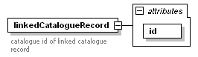
attributes
  Name | Type | Use
  id |  | required

Element linkedCatalogueRecords

A sequence of linkedCatalogueRecord elements.

diagram | 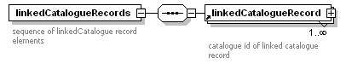
children | linkedCatalogueRecord

Element loan

Contains details of a single item that is currently on loan. The remainingRenewals attribute contains the number of times that the item can currently be renewed. The note element was added primarily to allow detailed information for loans of periodicals to be displayed.

diagram | 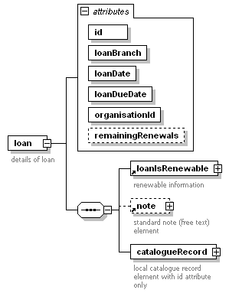
children | loanIsRenewable note catalogueRecord
attributes
  Name | Type | Use
  id |  | required
  loanBranch |  | required
  loanDate |  | required
  loanDueDate |  | required
  organisationId |  | required
  remainingRenewals | xs:nonNegativeInteger | optional

Local element catalogueRecord

A local definition of the catalogueRecord element that contains only a catalogue ID.

diagram | 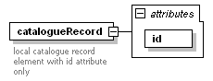
attributes
  Name | Type | Use
  id |  | required

Element loanIsRenewable

Indicates whether the loan can be renewed or not, with an optional message that contains the reason why the loan cannot be renewed.

diagram | 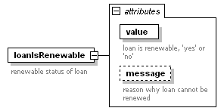
attributes
  Name | Type | Use
  value | simpleOptionType | required
  message | derived by: xs:string | optional

Element loans

A sequence of loan elements.

diagram | 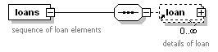
children | loan

Element location

Standard location element. The id attribute contains the LMS unique location ID. Elements codes and names should contain the information indicated by the element name in all languages used by Arena.

diagram | 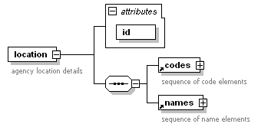
children | codes names
attributes
  Name | Type | Use
  id |  | required

Element locations

A sequence of location elements.

diagram | 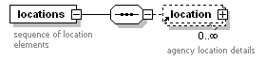
children | location

Element mediaClass

Contains the media class text (e.g. book, cassette etc.) for a catalogue record. See the definition of the mediaClassChoice type for a list of allowed values.

diagram | 
type | mediaClassChoice

Element mediaClassIcon

Contains the media class icon text (e.g. book, cassette etc.) for a catalogue record. See the definition of the mediaClassIconChoice type for a list of allowed values.

diagram | 
type | mediaClassIconChoice

Element mediaType

Used by the getMediaTypesResponse message. The mediaTypeId attribute contains the unique LMS ID for the media type. The names element should contain the name of the media type in all languages used by Arena.

diagram | 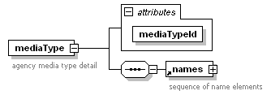
children | names
attributes
  Name | Type | Use
  mediaTypeId |  | required

Element mediaTypes

A sequence of mediaType elements.

diagram | 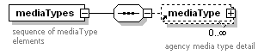
children | mediaType

Element message

A standard patron message element.

diagram | 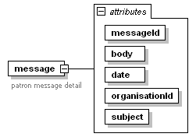
attributes
  Name | Type | Use | Description
  messageId |  | required | LMS unique message ID
  body |  | required | message text
  date |  | required | date message sent
  organisationId |  | required | owning organisation
  subject |  | required | message subject

Element messages

A sequence of message elements.

diagram | 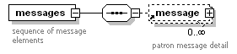
children | message

Element messageService

A standard message service element. Attributes isActive, isDeletable and isEditable are all of type simpleOptionType and indicate whether the message service is active, can be deleted or can be edited respectively. Attribute serviceType indicates the type of service being described – see the definition of the type messageServiceType for the possible values for this attribute. Some message services relate to events (e.g. the due date warning message service relates to a loan becoming overdue) and the optional nofDays element contains the number of days before the event occurs that the message should be sent. The sendmethods element contains a sequence of communications methods that can be used for this message service.

diagram | 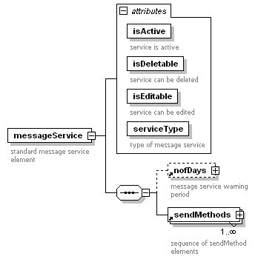
children | nofDays sendMethods
attributes
  Name | Type | Use
  isActive | simpleOptionType | required
  isDeletable | simpleOptionType | required
  isEditable | simpleOptionType | required
  serviceType | messageServiceType | required

Element messageServices

A sequence of messageService elements. The isAddable attribute indicates whether another message service can be added or not.

diagram | 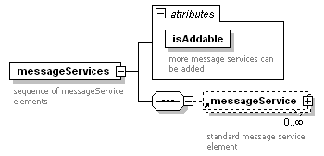
children | messageService
attributes
  Name | Type | Use
  isAddable | simpleOptionType | required

Element name

A standard name element used to hold the name of a branch, organisation, department etc in a specific language.

diagram | 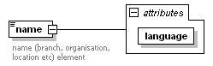
attributes
  Name | Type | Use
  language | derived by: xs:string | required

Element names

A sequence of name elements normally used to hold the name of a branch, organisation, department etc in all languages used by Arena.

diagram | 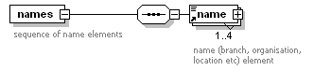
children | name

Element nofDays

Used to hold a time period specified as a number of days.

diagram | 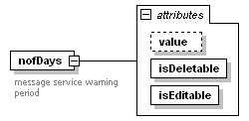
attributes
  Name | Type | Use
  value |  | optional
  isDeletable | simpleOptionType | required
  isEditable | simpleOptionType | required

Element nofRecords

A child element used to hold the number of records in the current message.

diagram | 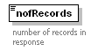
type | xs:int

Element nofRecordsFetched

A child element of updateCatalogueResponse where it is used to hold the number of records in the export.

diagram | 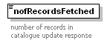
type | xs:int

Element nofRecordsRemaining

A child element of updateCatalogueResponse where it is used to hold the number of records that still remain to be imported into Arena.

diagram | 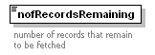
type | xs:int

Element nofRecordsTotal

A child element used to hold the total number of records retrieved by the LMS.

diagram | 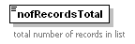
type | xs:int

Element note

A standard note element used for free text.

diagram | 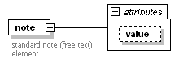
attributes
  Name | Type | Use
  value | xs:string

Element notes

A sequence of note elements.

diagram | 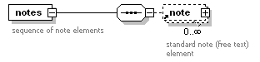
children | note

Element number

Used in the getCatalogueDetailResponse, exportCatalogueRecordsResponse and updateCatalogueResponse messages where it holds a control number (e.g. ISBN, ISSN, manufacturer’s number etc.) associated with a catalogue record. The optional type attribute contains a text string identifying the type of number.

diagram | 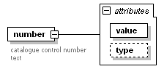
attributes
  Name | Type | Use | Default
  value | xs:string | required
  type | controlNumberType | optional | unknown

Element numbers

A sequence of number elements.

diagram | 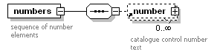
children | number

Element objectDate

This is a standard date range element. It contains starting and ending dates and a text attribute to describe its use. The starting and ending date elements contain the year only in the form ‘YYYY’. Note that years before 1 AD (CE) are held in the startDate and endDate attributes as negative numbers.

diagram | 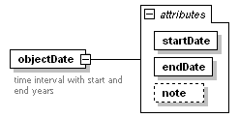
attributes
  Name | Type | Use
  startDate | xs:gYear | required
  endDate | xs:gYear | required
  note | xs:string | optional

Element objectDates

Element objectDates contains a sequence of objectDate elements. It is used in the detailCatalogueRecord element, and in the index and view elements of the exportCatalogueRecord element.

diagram | 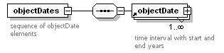
children | objectDate

Element orderid

The orderid element holds the LMS unique ID for a payment being made against a patron’s debts. It is returned by the getPaymentServiceInformationResponse message.

diagram | 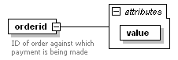
attributes
  Name | Type | Use
  value |  | required

Element organisation

Standard organisation element. The id attribute contains the LMS unique organisation ID. Elements codes, shortnames, and names should contain the information indicated by the element name in all languages used by Arena.

diagram | 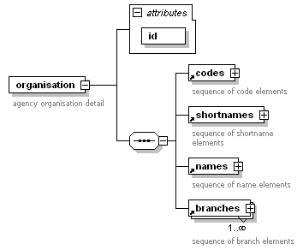
children | codes shortnames names branches
attributes
  Name | Type | Use
  id |  | required

Element organisations

A sequence of organisation elements.

diagram | 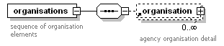
children | organisation

Element other

The other element is used by the messages exportCatalogueRecordsResponse and updateCatalogueResponse to hold catalogue data that doesn’t fit into any of the other elements. Prime candidates for this are the MARC notes tags (5XX series).

diagram | 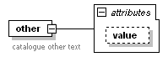
attributes
  Name | Type | Use
  value | xs:string

Element others

A sequence of other elements.

diagram | 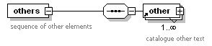
children | other

Element patronCard

A standard patron card element containing the card number, PIN and a flag to indicate whether the card is currently valid for use or not.

diagram | 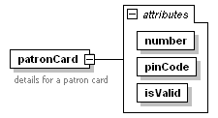
attributes
  Name | Type | Use
  number | xs:string | required
  pinCode | xs:string | required
  isValid | simpleOptionType | required

Element patronCards

A sequence of patronCard elements. This element is used by the getPatronAlternativeCardsResponse message.

diagram | 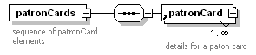
children | patronCard

Element patronInformation

This is the element used by the getPatronInformationResponse message to return detailed patron information.

Attribute patronId is the unique LMS ID for the patron.

diagram | 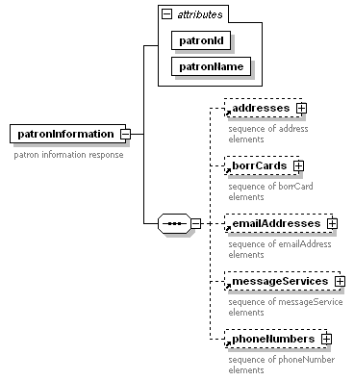
children | addresses borrCards emailAddresses messageServices phoneNumbers
attributes
  Name | Type | Use
  patronId |  | required
  patronName |  | required

Element payment

Used by the getPaymentsResponse message to return all details on the LMS for a payment that a patron has made.

diagram | 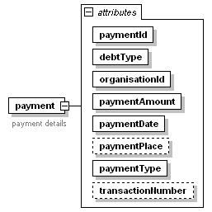
attributes
  Name | Type | Use | Description
  paymentId |  | required | LMS unique payment ID
  debtType | debtTypeChoice | required | see debtTypeChoice definition
  organisationId |  | required | Arena organisation ID
  paymentAmount |  | required | amount of payment
  paymentDate |  | required
  paymentPlace |  | optional
  paymentType | paymentTypeChoice | required | see paymentTypeChoice definition
  transactionNumber |  | optional | MSP transaction number

Element payments

A sequence of payment elements.

diagram | 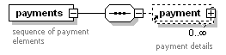
children | payment

Element phoneNumber

Standard phone number element containing country and area codes and the local phone number.

diagram | 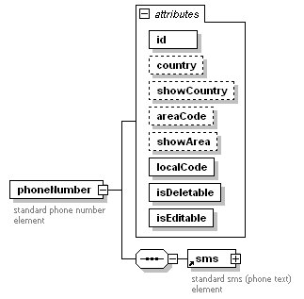
children | sms
attributes
  Name | Type | Use
  id |  | required
  country |  | optional
  showCountry | simpleOptionType | optional
  areaCode |  | optional
  showArea | simpleOptionType | optional
  localCode |  | required
  isDeletable | simpleOptionType | required
  isEditable | simpleOptionType | required

Element phoneNumbers

A sequence of phoneNumber elements. The isAddable attribute indicates whether another phone number can be added or not.

diagram | 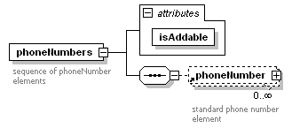
children | phoneNumber
attributes
  Name | Type | Use
  isAddable | simpleOptionType | required

Element provenance

This element is used in the detailCatalogueRecord element to hold a statement of provenance or other ownership information.

diagram | 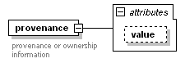
attributes
  Name | Type | Use
  value | xs:string | optional

Element publicationYear

Used by the exportCatalogueRecordsResponse and updateCatalogueResponse messages to hold the publication year from MARC tag 260.

diagram | 
type | xs:string

Element publisher

Used by the messages getCatalogueRecordDetailResponse, exportCatalogueRecordsResponse and updateCatalogueResponse to hold the publisher information from MARC tag 260.

diagram | 
type | xs:string

Element receiver

This element is used by the getPaymentServiceInformationResponse message. It holds details of the organisation to whom payment is due.

diagram | 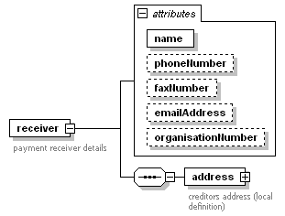
children | address
attributes
  Name | Type | Use
  name |  | required
  phoneNumber |  | optional
  faxNumber |  | optional
  emailAddress |  | optional
  organisationNumber |  | optional

Local element address

A local address element used to hold the creditor’s address.
diagram | 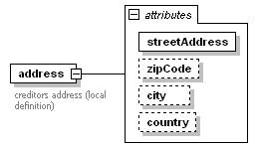
attributes
  Name | Type | Use
  streetAddress |  | required
  zipCode |  | optional
  city |  | optional
  country |  | optional

Element recordControlNumber

This element is used in the index, uberkey and view elements of the messages exportCatalogueRecordsResponse and updateCatalogueResponse messages to hold the record control number from MARC tag 001.

diagram | 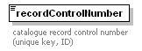
type | xs:string

Element recordSorting

Used by the exportCatalogueRecordsResponse and updateCatalogueResponse messages to hold information used to sort lists of catalogue records. This element is used as the secondary sort key when sorting by title. The content of this element is LMS specific.

diagram | 
type | xs:string

Element reservation

The standard reservation element – see table below for a description of the attributes. The group and groupSequenceNo attributes are intended to be used for a future implementation of reservation groups. The note element is intended primarily to allow detailed information for periodical reservations to be displayed.

diagram | 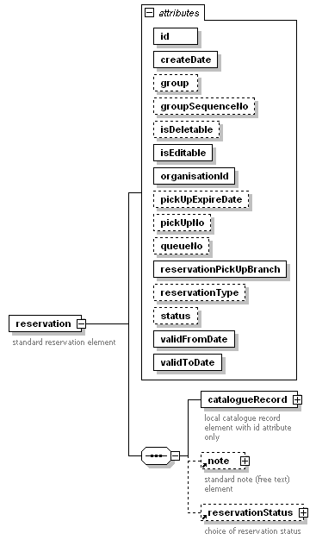
children | catalogueRecord note reservationStatus
attributes
  Name | Type | Use | Description
  id |  | required | LMS unique reservation ID
  createDate |  | required | date reservation created
  group |  | optional | reservation group
  groupSequenceNo |  | optional | sequence within group
  isDeletable | simpleOptionType | optional | reservation can be deleted
  isEditable | simpleOptionType | required | reservation can be edited
  organisationId |  | required | Arena organisation ID
  pickUpExpireDate |  | optional | date until which the item can be collected
  pickUpNo |  | optional | self-service pickup number
  queueNo |  | optional | position in reservation queue
  reservationPickUpBranch |  | required | branch at which to collect item
  reservationType | reservationTypeChoice | optional | see reservationTypeChoice
  status | reservationStateType | optional | see reservationStateType
  validFromDate |  | required | date reservation starts
  validToDate |  | required | date reservation expires

Local element catalogueRecord

A local definition of catalogueRecord containing catalogue record ID only.

diagram
attributes
  Name | Type | Use
  id |  | required

Element reservations

A sequence of reservation elements.

diagram | 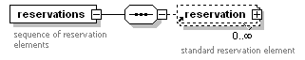
children | reservation

Element reservationStatus

Indicates the status of a reservation – the value attribute may contain either ‘reservationOk’ or ‘reservationNotOk’. The optional key attribute contains a reason for the reservation being denied.

diagram | 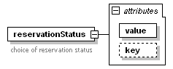
attributes
  Name | Type | Use
  value | derived by: xs:string | required
  key | derived by: xs:string | optional

Valid values for the attribute key

type | restriction of xs:string
facets
  Kind | Value | Meaning
  enumeration | reservationAlreadyFilled | title already reserved and ready for collection
   | reservationAlreadyReserved | title already reserved
   | reservationDenied | general failure message
   | reservationInvalidExpireDate | expiry date is invalid
   | reservationLoanOnCopy | patron already has this title on loan
   | reservationNoExpiry | no expiry date given
   | reservationNoHolding | no reservable copies in the accessible branches
   | reservationNoItemsAvailable | no available items match the title
   | reservationNoPeriodicalPermission | patron has no rights to reserve periodicals
   | reservationNoPermission | patron has no rights to place reservations
   | reservationNotForLoan | item not for loan
   | reservationOnShelf | item is available on shelf for loan
   | reservationPatronBlocked | patron’s card is blocked
   | reservationPatronMaxReservations | max number of reservations reached
   | reservationPatronUnderAged | patron is under age to reserve title

Element resourceType

Used by the exportCatalogueRecordsResponse and updateCatalogueResponse messages to indicate the type of resource to which the record refers. See the definition of resourceTypeChoice for a list of allowed values.

diagram | 
type | resourceTypeChoice

Element responsibility

This element is used as a child element of the exportCatalogue index and view elements. It contains the statement of responsibility from MARC 21 tag 245 subfield $c. This usually contains the author name in normal (i.e. non-inverted) form.

diagram | 
type | xs:string

Element sendMethod

Used as a child element of the messageService element. The sendMethod element selects a communication method for a message service. See the definition of the messageSendMethod type for a list of valid values.

diagram | 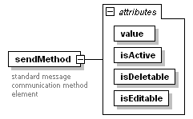
attributes
  Name | Type | Use
  value | messageSendMethod | required
  isActive | simpleOptionType | required
  isDeletable | simpleOptionType | required
  isEditable | simpleOptionType | required

Element sendMethods

A sequence of sendMethod elements. A message service may have more than one communication method.

diagram | 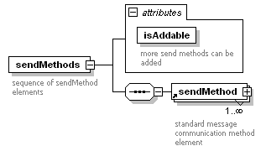
children | sendMethod
attributes
  Name | Type | Use
  isAddable | simpleOptionType | required

Element seriesTitles

A sequence of titleSeries elements. Used by the exportCatalogueRecord facet, index and view elements..

diagram | 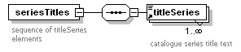
children | titleSeries

Element shelfMark

Used by the exportCatalogueRecordsResponse and updateCatalogueResponse messages to contain the primary shelf mark for a catalogue record. The use of this element is LMS dependent as in most systems the shelf mark is an attribute of the item not the catalogue record.

diagram | 
type | xs:string

Element shortname

A standard short name element used to hold the short name of a branch, organisation, department etc in a specific language.

diagram | 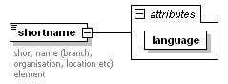
attributes
  Name | Type | Use
  language | derived by: xs:string | required

Element shortnames

A sequence of shortname elements normally used to hold the short name of a branch, organisation, department etc in all languages used by Arena.

diagram | 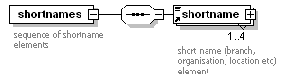
children | shortname

Element sms

A child of the phoneNumber element that contains an indication of whether the phone number can be used for SMS (text messaging) or not.

diagram | 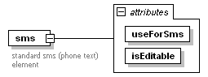
attributes
  Name | Type | Use
  useForSms | simpleOptionType | required
  isEditable | simpleOptionType | required

Element sortAuthor

A child element of the exportCatalogueRecord index element. It contains the version of the main author text to be used in sorting result lists.

diagram | 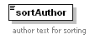
type | xs:string

Element sortPublicationYear

A child element of the exportCatalogueRecord index element. It contains the version of the publication year to be used in sorting result lists.

diagram | 
type | xs:string

Element sortTitle

A child element of the exportCatalogueRecord index element. It contains the version of the main title text to be used in sorting result lists.

diagram | 
type | xs:string

Element startNo

A child element of exportCatalogueRecordsResponse used to hold the sequence number of the first record in the current response message.

diagram | 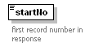
type | xs:int

Element status

The standard status element is present in all ALMA response messages. The value attribute contains an indication of whether the request was successful or not, and the key attribute contains a short explanatory message giving the reason for failure.

diagram | 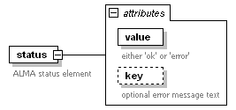
attributes
  Name | Type | Use
  value | derived by: xs:string | required
  key | derived by: xs:string | optional

Valid values for the attribute value

type | restriction of xs:string
facets
  Kind | Value
  enumeration | error
  enumeration | ok

Valid values for the attribute key. Note that the value ‘noRecieverInformationFound’ is spelled incorrectly. The correct value ‘noReceiverInformationFound’ has been added to the list. The incorrect version has been retained for backwards compatibility and will be removed in a future version.

type | restriction of xs:string
facets
  Kind | Value
  enumeration | addressNotFound
  enumeration | addressOfTypeExists
  enumeration | blockedBorrCard
  enumeration | borrCardNotFound
  enumeration | catalogueRecordNotFound
  enumeration | databaseError
  enumeration | emailAddressNotFound
  enumeration | expiredAccount
  enumeration | expiredAccountCard
  enumeration | invalidAccountCard
  enumeration | invalidAddressType
  enumeration | invalidAmount
  enumeration | invalidBorrCard
  enumeration | invalidCountry
  enumeration | invalidDateFormat
  enumeration | invalidMessageService
  enumeration | invalidPatron
  enumeration | invalidPinCode
  enumeration | invalidQuery
  enumeration | invalidUser
  enumeration | loanNotFound
  enumeration | moduleNotAvailable
  enumeration | noAccountFound
  enumeration | noRecieverInformationFound *
  enumeration | noReceiverInformationFound
  enumeration | phoneNumberNotFound
  enumeration | reservationNotFound
  enumeration | unsupportedMethodCall

Element stopNo

A child used to hold the sequence number of the last record in the current response message.

diagram | 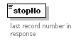
type | xs:int

Element subject

The subject element is used by the messages exportCatalogueRecordsResponse and updateCatalogueResponse to hold catalogue data containing subject information from the MARC 6XX series of tags.

diagram | 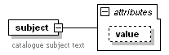
attributes
  Name | Type | Use
  value | xs:string

Element subjects

A sequence of subject elements.

diagram | 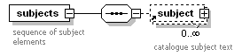
children | subject

Element subLocation

Standard sublocation element. The id attribute contains the LMS unique sublocation ID. Elements codes, shortnames and names should contain the information indicated by the element name in all languages used by Arena.

diagram | 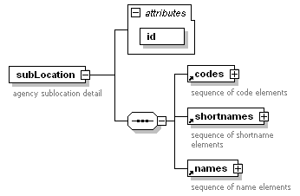
children | codes shortnames names
attributes
  Name | Type | Use
  id |  | required

Element subLocations

A sequence of subLocation elements.

diagram | 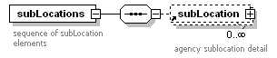
children | subLocation

Element systemChangeNumber

Used in the updateCatalogue service. It associates an identifier with a set of catalogue update records. The use of this element is LMS specific

diagram | 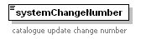
type | xs:string

Element targetAudience

This element is used by the messages exportCatalogueRecordsResponse and updateCatalogueResponse to hold the code for the target audience of the work to which the catalogue record refers. See the definition of the targetAudienceChoice type for more details.

diagram | 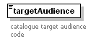
type | targetAudienceChoice

Element title

Contains catalogue title text.

diagram | 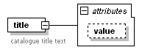
attributes
  Name | Type | Use
  value | xs:string

Element titleMain

Contains the main title for a catalogue record from MARC tag 245.

diagram | 
type | xs:string

Element titleOriginal

Contains the original title for a work which is a translation.

diagram | 
type | xs:string

Element titles

A sequence of title elements.

diagram | 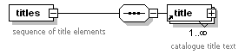
children | title

Element titleSeries

Contains the series title (MARC tags 440, 490 or 830) for a catalogue record.

diagram | 
type | xs:string

Element uberkey

This element is used by the exportCatalogueRecords and updateCatalogue services. It contains the information from the catalogue used to create the uberkey for the catalogue record.

diagram | 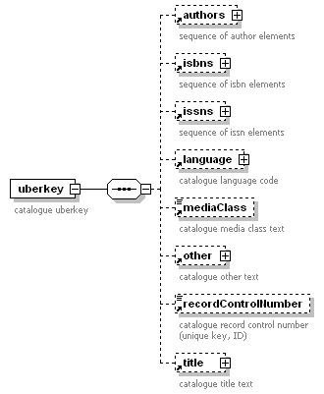
children | authors isbns issns language mediaClass other recordControlNumber title

Element update

This element is used by the updateCatalogue service. It contains complete details of a single catalogue record. The date attribute contains the date of the update and the type attribute contains the update type (see the definition of updateType). The exportCatalogueRecord element contains the details of the catalogue record.

diagram | 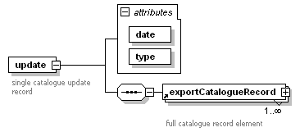
children | exportCatalogueRecord
attributes
  Name | Type | Use
  date |  | required
  type | updateType | required

Element updates

A sequence of update elements.

diagram | 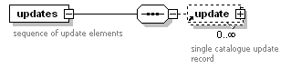
children | update

Element view

This element is used by the exportCatalogueRecords and updateCatalogue services. It contains the information used to create the catalogue record displays in Arena.

The use of the isbns and issns elements in view is now deprecated. The numbers element should be used instead.

diagram | 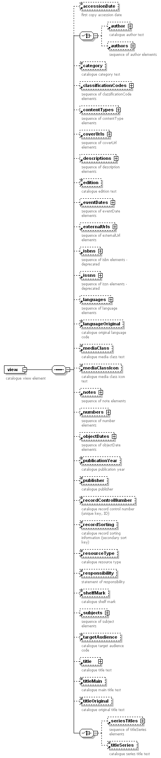
children | accessionDate author authors category classificationCodes contentTypes coverUrls descriptions edition eventDates externalUrls isbns issns languages languageOriginal mediaClass mediaClassIcon notes numbers objectDates publicationYear publisher recordControlNumber recordSorting resourceType responsibility seriesTitles shelfMark subjects targetAudience title titleMain titleOriginal titleSeries

Common Types

Type categoryChoice

Used for the category of a catalogue record.

type | restriction of xs:Name
facets
  Kind | Value
  enumeration | fictionCategory
  enumeration | nonFictionCategory

Type contentTypeChoice

Lists the possible choices for the content type of a catalogue record. Note that the values ‘catalog’ and ‘speach’ are spelled incorrectly. The correct values ‘catalogue’ and ‘speech’ have been added to the list. The incorrect versions have been retained for backwards compatibility and will be removed in a future version.

type | restriction of xs:Name
facets
  Kind | Value
  enumeration | abstractSummary
  enumeration | bibliography
  enumeration | calendar
  enumeration | comicGraphicNovel
  enumeration | catalog *
  enumeration | catalogue
  enumeration | dictionary
  enumeration | directory
  enumeration | discography
  enumeration | drama
  enumeration | encyclopedia
  enumeration | essay
  enumeration | filmography
  enumeration | handbook
  enumeration | humorSatire
  enumeration | index
  enumeration | lawReportDigest
  enumeration | legalArticle
  enumeration | legalCaseNotes
  enumeration | legislation
  enumeration | letter
  enumeration | mixedForm
  enumeration | novel
  enumeration | offprint
  enumeration | patentDocument
  enumeration | poetry
  enumeration | programmedText
  enumeration | review
  enumeration | shortStory
  enumeration | speach *
  enumeration | speech
  enumeration | standardSpecification
  enumeration | statistics
  enumeration | surveyLiterature
  enumeration | thesis
  enumeration | technicalReport
  enumeration | treaty
  enumeration | yearbook

Type controlNumberType

Lists the possible choices for the type attribute of the number element.

type | restriction of xs:Name
facets
  Kind | Value |  | Description
  enumeration | ean |  | international article number
  enumeration | isan |  | international standard audiovisual number
  enumeration | isbn |  | international standard book number
  enumeration | ismn |  | international standard music number
  enumeration | isrc |  | international standard recording code
  enumeration | issn |  | international standard serial number
  enumeration | istc |  | international standard text code
  enumeration | iswc |  | international standard musical work code
  enumeration | lcn |  | library of congress number
  enumeration | nbn |  | national bibliography number
  enumeration | sici |  | serial item and contribution identifier
  enumeration | upc |  | universal product code
  enumeration | unknown |  | unknown number type

Type debtTypeChoice

Lists the possible choices for a type of debt.

type | restriction of xs:Name
facets
  Kind | Value
  enumeration | deleteReservationFeeDebt
  enumeration | emailReminderFeeDebt
  enumeration | illFeeDebt
  enumeration | illReservationFeeDebt
  enumeration | loanFeeDebt
  enumeration | messageFeeDebt
  enumeration | otherFeeDebt
  enumeration | overdueFeeDebt
  enumeration | overdueFeeInvoiceDebt
  enumeration | photocopyFeeDebt
  enumeration | renewFeeDebt
  enumeration | replacementFeeDebt
  enumeration | reservationFeeDebt
  enumeration | reservationPickupFeeDebt
  enumeration | smsIllFeeDebt
  enumeration | smsRecall1FeeDebt
  enumeration | smsRecall2FeeDebt
  enumeration | smsRecall3FeeDebt
  enumeration | smsRecall4FeeDebt
  enumeration | smsRecall5FeeDebt
  enumeration | smsReminderFeeDebt
  enumeration | smsReservationFeeDebt

Type holdingStatusChoice

Lists the possible choices for the status of a catalogue holding.

type | restriction of xs:Name
facets
  Kind | Value
  enumeration | availableForLoan
  enumeration | checkedOut
  enumeration | inAcquisition
  enumeration | inProduction
  enumeration | internetAccessible
  enumeration | nonAvailableForLoan
  enumeration | notAvailable
  enumeration | noHolding
  enumeration | noReservableCopies
  enumeration | onLoan
  enumeration | openLoan
  enumeration | ordered
  enumeration | overdueLoan
  enumeration | periodical
  enumeration | quarantined
  enumeration | referenceOnly
  enumeration | returnedToday

Type lmsSearchTypeChoice

Lists the possible choices for the type of back-end search to be run on the LMS.

type | restriction of xs:Name
facets
  Kind | Value
  enumeration | fullText
  enumeration | namedList
  enumeration | native

Type mediaClassChoice

Lists the possible choices for the media class of a catalogue record.

type | restriction of xs:Name
facets
  Kind | Value
  enumeration | article
  enumeration | blueray
  enumeration | book
  enumeration | braille
  enumeration | cassette
  enumeration | cd
  enumeration | cdBook
  enumeration | cdAndBook
  enumeration | daisy
  enumeration | data
  enumeration | dissertation
  enumeration | document
  enumeration | dvd
  enumeration | eBook
  enumeration | eMusic
  enumeration | ePeriodical
  enumeration | internet
  enumeration | map
  enumeration | microFilm
  enumeration | music
  enumeration | newspaper
  enumeration | otherMaterial
  enumeration | periodical
  enumeration | picture
  enumeration | serial
  enumeration | sheetMusic
  enumeration | talkingBook
  enumeration | video
  enumeration | videoGame
  enumeration | vinyl

Type mediaClassIconChoice

Lists the possible choices for the media class icon for a catalogue record.

type | restriction of xs:Name
facets
  Kind | Value
  enumeration | article
  enumeration | blueray
  enumeration | book
  enumeration | braille
  enumeration | cassette
  enumeration | cd
  enumeration | cdBook
  enumeration | cdAndBook
  enumeration | daisy
  enumeration | data
  enumeration | dissertation
  enumeration | document
  enumeration | dvd
  enumeration | eBook
  enumeration | eMusic
  enumeration | ePeriodical
  enumeration | internet
  enumeration | map
  enumeration | microFilm
  enumeration | music
  enumeration | newspaper
  enumeration | otherMaterial
  enumeration | periodical
  enumeration | picture
  enumeration | serial
  enumeration | sheetMusic
  enumeration | talkingBook
  enumeration | video
  enumeration | videoGame
  enumeration | vinyl

Type messageSendMethod

Lists the possible communication methods for a message service.

type | restriction of xs:Name
facets
  Kind | Value | Description
  enumeration | arenaInbox | send message to patron’s Arena Inbox
  enumeration | email | send message by email
  enumeration | ilsDefined
  enumeration | lmsMessage | send message to patron’s LMS account
  enumeration | none | no delivery method
  enumeration | noReminder | no message should be sent
  enumeration | phone | telephone call (automated or manual)
  enumeration | sms | send sms text message
  enumeration | smsEmail | first message by SMS, reminders by email
  enumeration | smsSnailMail | first message by SMS, reminders by post to address 1
  enumeration | smsSnailMail2 | first message by SMS, reminders by post to address 2
  enumeration | snailMail | send message by post
  enumeration | snailMail2 | send message by post to address 2
  enumeration | voiceMessage | leave voice message

Type messageServiceType

Lists the possible message service types.

type | restriction of xs:Name
facets
  Kind | Value | Description
  enumeration | dueDateAlert | pre-overdue message
  enumertaion | invoice | outstanding invoice
  enumeration | invoiceReminder | outstanding invoice reminder
  enumeration | libraryMessage
  enumeration | newStockAlert | new stock that matches patron’s preferences
  enumeration | overdueNotice | Item overdue message
  enumeration | paymentReceipt | receipt for online payment
  enumeration | pickUpNotice | item available, ready for collection

Type paymentResult

Lists the possible values returned from an attempt to complete a payment transaction with an MSP.

type | restriction of xs:int
facets
  Kind | Value | Description
  enumeration | 0 | Success
  enumeration | 1 | Failure

Type paymentTypeChoice

Lists the possible types of payment.

type | restriction of xs:Name
facets
  Kind | Value
  enumeration | cashRegisterPayment
  enumeration | cashAutomatPayment
  enumeration | cardOnlinePayment

Type recordTypeChoice

Lists the possible values for the type of record.

type | restriction of xs:Name
facets
  Kind | Value
  enumeration | archive
  enumeration | catalogue
  enumeration | museum

Type reservationSource

Lists the possible types for the reservation source.

type | restriction of xs:Name
facets
  Kind | Value
  enumeration | catalogueRecordDetail
  enumeration | holdings

Type reservationStateType

Lists the possible values for a reservation status.

type | restriction of xs:Name
facets
  Kind | Value
  enumeration | active
  enumeration | expired
  enumeration | fetchable
  enumeration | inTransit
  enumeration | inactive
  enumeration | loaned
  enumeration | pickUpExpired

Type reservationTypeChoice

Lists the possible types of reservation.

type | restriction of xs:Name
facets
  Kind | Value
  enumeration | normal
  enumeration | regional

Type resourceTypeChoice

Lists the possible catalogue resource types. Note that the value ‘electronical’ is spelled incorrectly. The correct value ‘electronic’ has been added to the list. The incorrect version has been retained for backwards compatibility and will be removed in a future version.

type | restriction of xs:Name
facets
  Kind | Value
  enumeration | electronic
  enumeration | electronical *
  enumeration | physical

Type roleType

Lists the possible author role types.

type | restriction of xs:Name
facets
  Kind | Value
  enumeration | actor
  enumeration | animator
  enumeration | annotator
  enumeration | architect
  enumeration | arranger
  enumeration | artist
  enumeration | author
  enumeration | cartographer
  enumeration | choreographer
  enumeration | cinematographer
  enumeration | collaborator
  enumeration | collector
  enumeration | compiler
  enumeration | composer
  enumeration | conductor
  enumeration | conservator
  enumeration | contributor
  enumeration | copyrightHolder
  enumeration | costumeDesigner
  enumeration | creator
  enumeration | curator
  enumeration | dancer
  enumeration | designer
  enumeration | director
  enumeration | donor
  enumeration | draftsman
  enumeration | editor
  enumeration | engineer
  enumeration | engraver
  enumeration | illustrator
  enumeration | instrumentalist
  enumeration | inventor
  enumeration | librettist
  enumeration | musicalDirector
  enumeration | musican
  enumeration | narrator
  enumeration | originator
  enumeration | owner
  enumeration | patron
  enumeration | performer
  enumeration | photographer
  enumeration | printer
  enumeration | producer
  enumeration | programmer
  enumeration | repository
  enumeration | sculptor
  enumeration | sponsor
  enumeration | stage
  enumeration | technicalDirector
  enumeration | transcriber
  enumeration | translator
  enumeration | vocalist

Type simpleOptionType

A simple ‘yes’ or ‘no’ choice.

type | restriction of xs:Name
facets
  Kind | Value
  enumeration | no
  enumeration | yes

Type targetAudienceChoice

Lists the possible target audience codes used in the catalogue record.

type | restriction of xs:Name
facets
  Kind | Value | Meaning
  enumeration | a | adult
  enumeration | j | junior
  enumeration | y | youth (teenage)

Type updateType

Lists the possible types of catalogue update

type | restriction of xs:Name
facets
  Kind | Value
  enumeration | add
  enumeration | delete
  enumeration | update

DDElibra specific messages and elements

The following describes DDElibra extensions to the web services. It defines seven addtional message pairs, addAbsentPeriod, addFee, changeAbsentPeriod, changePatronPreferences, changePinCode, getPatronInformationExtended and removeAbsentPeriod.

Elements shown in red in the diagrams, are standard elements that can be found in the "Common elements" chapter.

Add Absent Period

The addAbsentPeriod is used for adding an absent period to the patron record. Currently only one absent period can be added. The response contains all absent periods defined for the patron. Each absent period has an absentId, that should be used in changeAbsentPeriod and removeAbsentPeriod.

diagram | 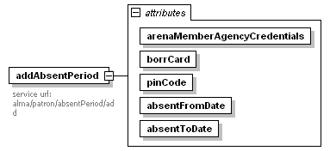
attributes
  Name | Type | Use | Default | Fixed
  arenaMemberAgencyCredentials |  | required
  borrCard |  | required
  pinCode |  | required
  absentFromDate |  | required
  absentToDate |  | required

addAbsentPeriodResponse

diagram | 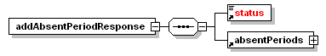
children | status absentPeriods

Add Fee

The addFee message is used for adding a fee. pinCode is optional in this message. feeType and feeStatus should be defined as D@as and D@at/D@ay trim values respectively before they are used in this message.

diagram | 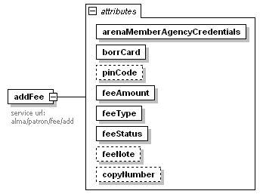
attributes
  Name | Type | Use | Default | Fixed
  arenaMemberAgencyCredentials |  | required
  borrCard |  | required
  pinCode |  | optional
  feeAmount |  | required
  feeType |  | required
  feeStatus |  | required
  feeNote |  | optional
  copyNumber |  | optional

addFeeResponse

diagram | 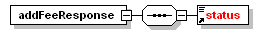
children | status

Change Absent Period

The changeAbsentPeriod is used for changing an existing absent period. Input contains the new absentFromDate and absentToDate plus the absentId for the existing absent period. The absentId can be fetched via the getPatronInformationExtended service.

diagram | 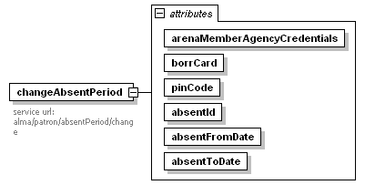
attributes
  Name | Type | Use | Default | Fixed
  arenaMemberAgencyCredentials |  | required
  borrCard |  | required
  pinCode |  | required
  absentId |  | required
  absentFromDate |  | required
  absentToDate |  | required

changeAbsentPeriodResponse

diagram | 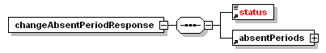
children | status absentPeriods

Change Patron Preferences

Change a patrons patronBranch. The current patronBranch can be fetched via the getPatronInformationExtended service. Note that patronBranch in this message is the code value fetched via getBranches service, not the actual code value from DDElibra.

diagram | 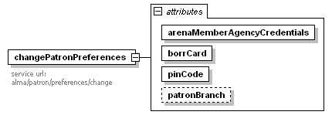
attributes
  Name | Type | Use | Default | Fixed
  arenaMemberAgencyCredentials |  | required
  borrCard |  | required
  pinCode |  | required
  patronBranch |  | optional

changePatronPreferencesResponse

diagram | 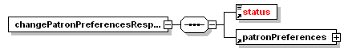
children | status patronPreferences

Change Pincode

Change a patrons pincode. Both the current pincode and the new pincode, pincodeChange, are mandatory.

diagram | 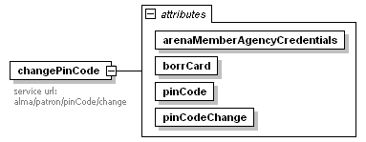
attributes
  Name | Type | Use | Default | Fixed
  arenaMemberAgencyCredentials |  | required
  borrCard |  | required
  pinCode |  | required
  pinCodeChange |  | required

changePinCodeResponse

diagram | 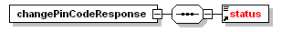
children | status

Get Patron Information Extended

Get extended information for a patron. The information from getPatronInformation service is contained in getPatronInformationExtended. A patrons block codes, absent periods and patron branch is furthermore contained in this message.

diagram | 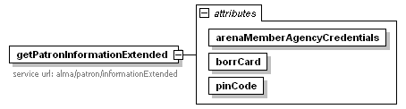
attributes
  Name | Type | Use | Default | Fixed
  arenaMemberAgencyCredentials |  | required
  borrCard |  | required
  pinCode |  | required

getPatronInformationResponse

diagram | 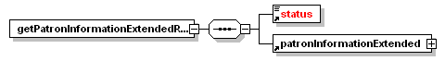
children | status patronInformationExtended

Remove Absent Period

The removeAbsentPeriod is used for removing an existing absent period. Input is the absentId for the existing absent period. The absentId can be fetched via getPatronInformationExtended service.

diagram | 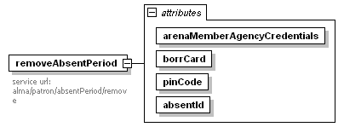
attributes
  Name | Type | Use | Default | Fixed
  arenaMemberAgencyCredentials |  | required
  borrCard |  | required
  pinCode |  | required
  absentId |  | required

addEmailAddressResponse

element removeAbsentPeriodResponse
diagram | 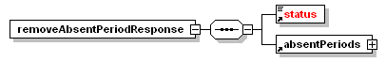
children | status absentPeriods

Element absentPeriod

An absentPeriod contains the absentFromDate, absentToDate and an absentId that can be used in the changeAbsentPeriod and removeAbsentPeriod services.

diagram | 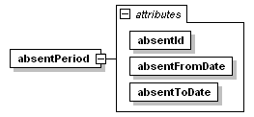
attributes
  Name | Type | Use | Default | Fixed
  absentId |  | required
  absentFromDate |  | required
  absentToDate |  | required

Element absentPeriods

AbsentPeriods is a list of absentPeriod elements. Currently the can be only one absentPeriod in the Absentperiods element.

diagram | 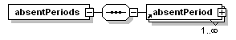
children | absentPeriod

Element patronBlock

patronBlock contains the block code value from DDElibra. The isSystemBlock attribute indicate whether the block code is a system block or a manuel block code.

diagram | 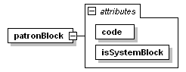
attributes
  Name | Type | Use | Default | Fixed
  code |  | required
  isSystemBlock | simpleOptionType | required

Element patronBlocks

patronBlock contains of patronBlock elements.

diagram | 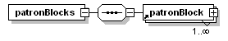
children | patronBlock

Element patronInformationExtended

The patronInformationExtended element contains all the information from the patronInformation element plus the patronBlocks, absentPeriods and patronPreferences elements.

diagram | 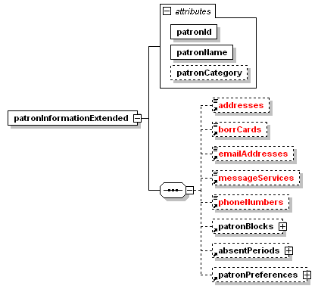
children | addresses borrCards emailAddresses messageServices phoneNumbers patronBlocks absentPeriods patronPreferences
attributes
  Name | Type | Use | Default | Fixed
  patronId |  | required
  patronName |  | required
  patronCategory |  | optional

Element patronPreferences

Contains currently the patronBranch attribute. Please note that the patronBranch should be decoded via the values returned in the getBranches service.

diagram | 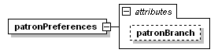
attributes
  Name | Type | Use | Default | Fixed
  patronBranch |  | optional

