
PROPOSAL
Website development
for OurCourses Ltd.

Cover Letter

Attn: Steve George, CEO, ‘OurCourses Ltd.’
From: Oleksandr Vorovskyi, student, WDD PACE University of Winnipeg
Re: Proposal, website development
Date: September 13, 2018

Dear Steve:
I appreciate the opportunity to respond to your request for the proposal. Please consider my offer to develop an extension for your website as requested. I believe these new features of the website will meet all your requirements and add value for your staff and customers. As well as it will allow to win a loyalty of customers, and to attract prospects in indirect way.
I possess all the skills, and have enough experience required for the development of a lightweight, modern looked, and easy to navigate website.
It would be the honor to cooperate with you during this project and future ones.
Please do not hesitate to contact me in any way to get answers to your possible questions. I look forward to your consideration.

Sincerely,
Oleksandr Vorovskyi

Table of Contents
Cover Letter 2
Background 4
Goals and Objectives 4
General requirements 4
Technical requirements 5
Business scenario 5
Target Audience 5
Timeline: Milestones and Deliverables 5
Phase I: Planning 5
Phase II: Design and Content 6
Phase III: Programming 6
Phase IV: Testing, Launch, Maintenance 6
Budget: Prices and Payment 6
Sitemap 7
Database 8
Screenshots 9
Example of list view (section ‘Events’) 9
Example of details view (section ‘People’) 10
Registration form 11
Static pages 12
‘About’ page 12
‘Contacts’ page 13
Mobile devices preview 13
Invoice 14

Background

'OurCourses' is a privately held educational company. Based on 20 years of experience, a wide variety of courses and programs across an array of disciplines are proposed to the market by the company. Located in the own building in the heart of the city, 'OurCourses' enriches students’ lives with the knowledge, skills and professional relationships they need to thrive in their preferred field.
The company allows students to complete their education as efficiently as possible while enjoying the benefits of flexible learning schedules, small class sizes, and the ability to complete some course material online. With intensive course materials and the highly reputable support, most students complete their programs within one year.
With quality education offered by practicing professionals, 'OurCourses' offers programming that is always at the cutting edge of industry standards. Programs are designed with student success in mind, with the objective of developing the skills valued by employers. Students develop quality relationships with industry peers throughout the length of the program, allowing them to start growing their professional networks from day one. By the time they complete their program, students are prepared for graduation with all the necessary tools for long-term success.
With its website the company follows the latest standards of web-development, along with improving the accessibility of websites, using technologies that allow reaching the widest possible audience.

Goals and Objectives

Following the company’s principle of ‘pushing an envelope whenever possible’, I propose to create a new feature for existing website – customer’s web-app. The app will provide real-time information on schedule, courses, groups and related information. It will allow helping all the customers (students, staff, instructors) to be aware of actual daily details.
Success will be measured through website usage statistics and the number of new online registrations.

General requirements
Website delivered should meet the following criteria:
- a modern look of the website;
- daily supplemented content made by non-trained administrator;
- intuitive and easy manageable navigation structure;
- unique but not complicated branding, enjoyable colours and layout;
- real-time schedule of events/classes;
- courses and recommended books description;
- online shop for recommended books;
- new customer registration form;
- three roles of users: anonymous, student/instructor, administrator.

Technical requirements
Website delivered should meet these technical requirements:
- valid code structure;
- dynamic content saved/retrieved to/from database;
- restricted (encrypted password protected) access for sensitive data;
- XSS & CSRF protection for data input;
- secure hosting, basic maintenance included.

Business scenario
Unauthenticated users should be able to see the actual schedule, description of courses available, information about the company (about and contacts), and registration form to fill and send.
Regular authenticated users (e.g., current students and instructors, additionally should get the possibility to check their own schedule (events and classes related to them) and edit personal details stored in the database. Also, the feature of the bookstore can be used to buy (add to cart and place an order) readings recommended for courses available.
Administrators (e.g., company’s staff) should be able to add, update and delete (mark for deletion) any kind of data related to any entity of the system.

Target Audience

Nowadays, most people in an active way are online via modern devices starting at teenage and almost until retirement. Same with the target audience. Prospect and current customers value their time and need the real-time information from anywhere.
We must cover people graduated from the high-school, and those who are getting a new profession, or just moved into the country. Prospect customers should be able to get descriptions of courses, as well as enrollment information. Existing customers are student and instructors, will use the app on daily basis to check their schedule, update personal information, or buy readings.

Timeline: Milestones and Deliverables

Phase I: Planning
Web development starts with collecting client’s requirements and expectations, so, it is will begin by interviews to understand all the needs: audience, goals, and desires. This stage has following deliverables:
- Proposal;
- Content Outline;
- Sitemap.
Estimated date: September 17, 2018

Phase II: Design and Content
This phase includes creating mockup of future site made in Adobe Photoshop. Two optional design concepts provided. Customer must choose a base one, tuning wishes are welcome. This stage has following deliverables:
- Website mockup (Adobe Photoshop format of file);
- Website content outline;
- Photos and other images (provided by customer, optimized for web by executor).
Estimated date: September 19, 2018

Phase III: Programming
Alive website requires bunch of code for front-end and back-end parts, as well as database structure and editor’s portal. These parts of work are web development itself. This stage has following deliverables:
- Website according to requirements (minor bugs are admitted);
- Database;
- Content management system.
Estimated date: September 26, 2018

Phase IV: Testing, Launch, Maintenance
The final phase where the website goes live. Thorough test to make the website free of bugs is performed here, as well as all the installation works. Feedback of customer and users are required to make the result perfect. This stage has following deliverables:
- Live bug-free website accessible from the Internet;
- Invoice to be paid.
Estimated date: September 28, 2018

Budget: Prices and Payment

Budget of project consists of following (timing is mentioned for informational purposes only):
# | Description | Days estimation | Hours estimation | Amount, CAD
1 | Meetings to interview and research. Defining the scope. Sitemap and content outline creating. | 2 | 16 | 1,600
2 | Design of websites concepts and mockups. Final decision on concept. | 2 | 16 | 1,600
3 | Programming, database and content management system installing. Beta-testing. | 5 | 40 | 4,000
4 | Testing. Launch. | 1 | 8 | 800
5 | Maintenance. Hosting. | 365 | N/A | 1
Total |  |  |  | 8,001
Price above is final, and includes all applicable taxes, plausible discounts, overheads, and unforeseen expenses. The total budget divided into two payment stages:
- Payment #1: Final design is accepted – CAD2,000;
- Payment #2: At the date of launch – CAD6,001.
Price for tasks beyond the scope of project will be calculated using blended rate - CAD120 before taxes per men hour.

Sitemap

Site consists of ten sections. List of accessible sections depends on user’s role: anonymous, regular user (student, instructor), or administrator. To get privileges users must sign-in with username and password.
The content of sections is not in the project scope and should be added by site administrator.
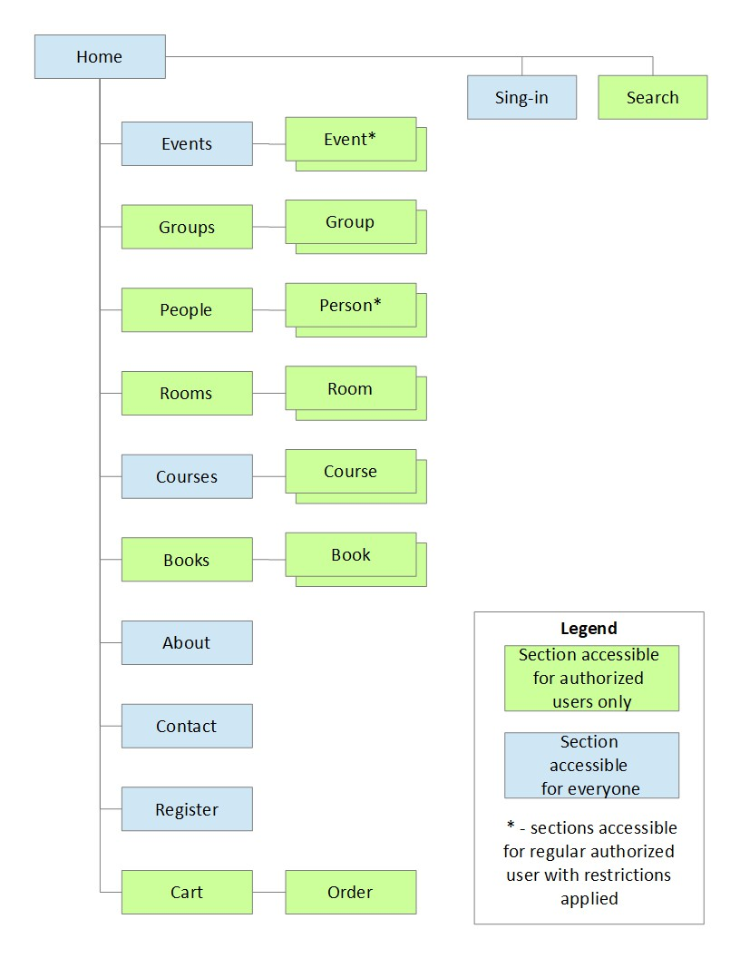

Database

Database supposed to be created by executor based on MySQL (MariaDB) the latest stable version. The content of database is to be added by site administrator upon the launch.
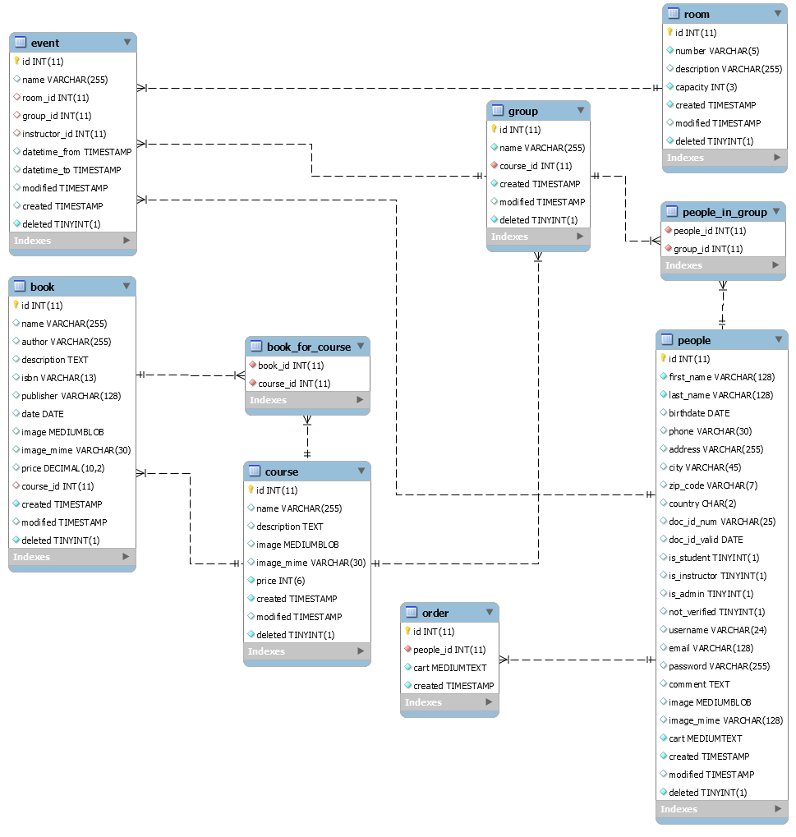

Screenshots

Example of list view (section ‘Events’)
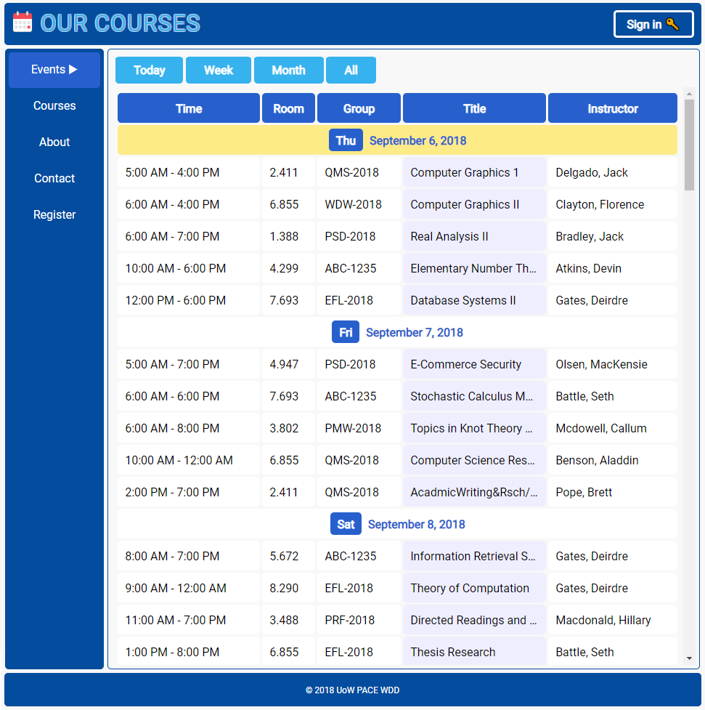

Example of details view (section ‘People’)
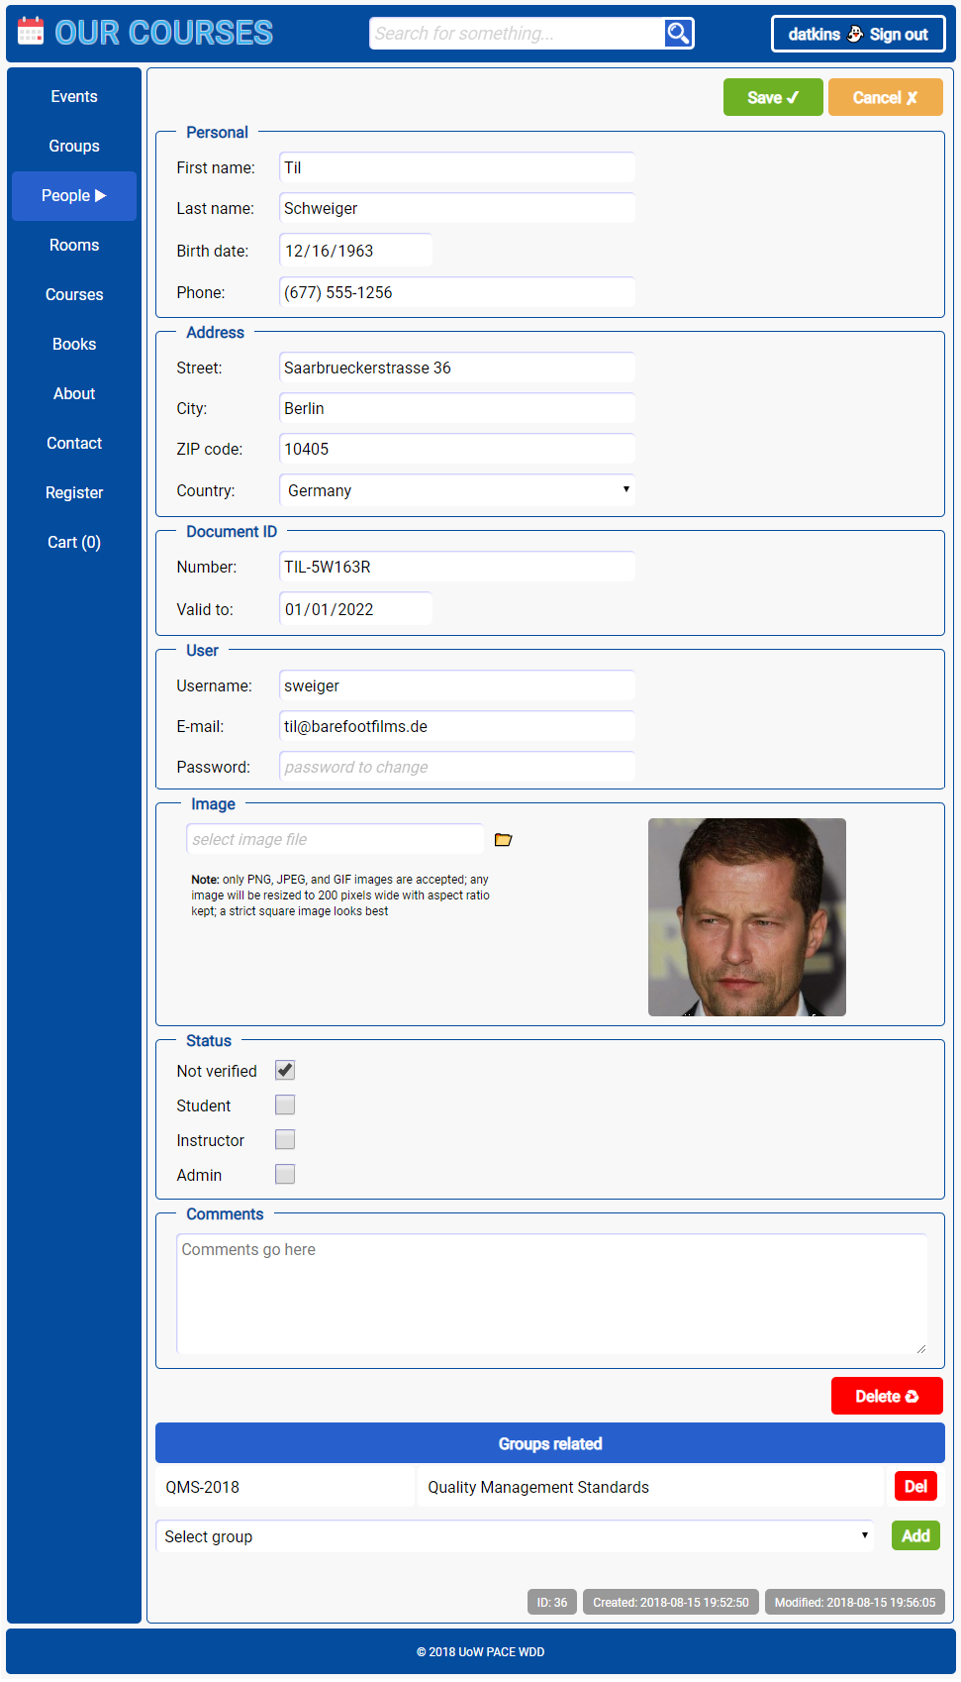

Registration form
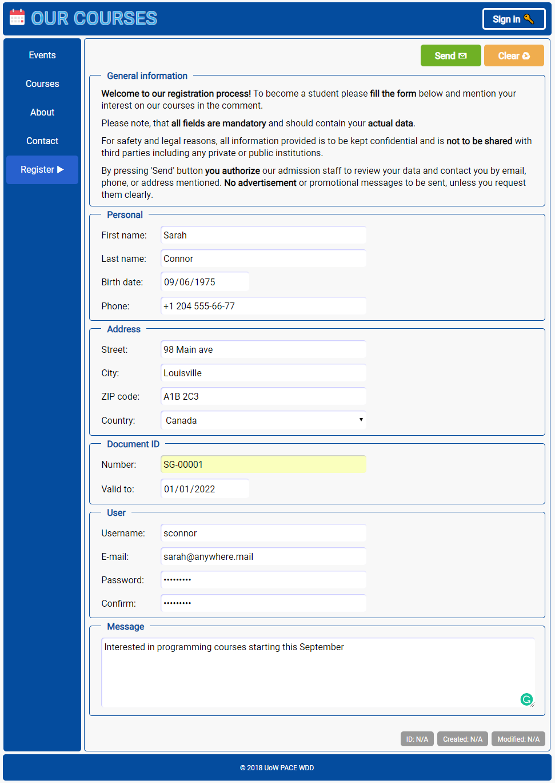

Static pages

‘About’ page


‘Contacts’ page
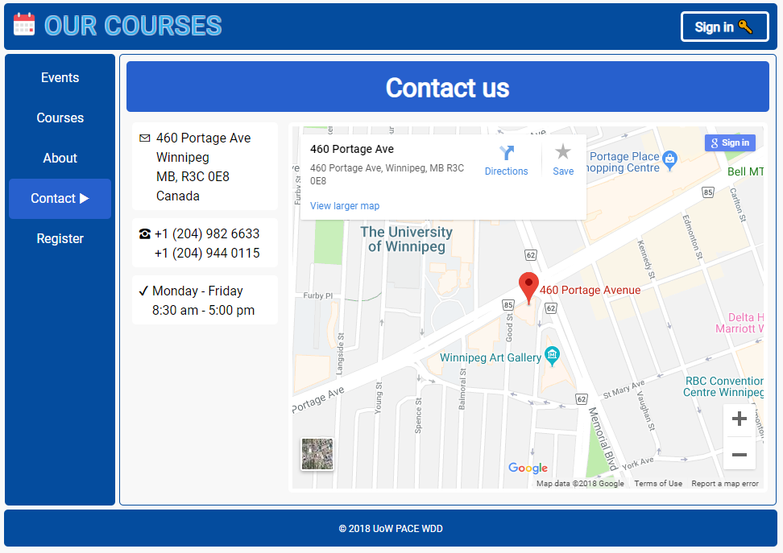

Mobile devices preview


Invoice

