**Machine Learning Group**

**Research Retreat 2017**

**Essential Information**



**When - Friday, 2nd June**



**Departure - 8:30am from Mappin Street**

**Destination - Cressbrook Hall (**[**http://www.cressbrookhall.co.uk**](http://www.cressbrookhall.co.uk)**)**



**Dinner at Packhorse Inn (**[**http://www.packhorselongstone.co.uk**](http://www.packhorselongstone.co.uk)**) from 6:30pm onwards to 9 pm.**





**Return - Mappin Street at approximately 10:00pm.**

**Programme**

|  |  |  |  |  |
| --- | --- | --- | --- | --- |
| **Time** | **Time Slot (mins)** | **Speaker** | **Affiliation** | **Title** |
| **9:30** | **30** | **Arrival, Coffee** | | |
| 10:00 | 10 | Eleni Vasilaki | Staff | Opening remarks: 5 Reasons why machine learning is better than human learning |
| 10:10 | 15 | Haiping Lu | Staff |  |
| 10:25 | 15 | Mauricio Alvarez | Staff |  |
| 10:40 | 10 | Fariba Yousefi | PhD |  |
| 10:50 | 10 | Alan Saul | PhD |  |
| 11:00 | 10 | Bei Wang | PhD |  |
| 11:10 | 10 | Avgoustinos (August) Vouros | PhD |  |
| 11:20 | 10 | Juan Jose Giraldo | PhD |  |
| 11:30 | 10 | Muhammad Arifur Rahman | PhD |  |
| 11:40 | 10 | Luisa Cutillo | Post-PhD? |  |
| 11:50 | 10 | Michael Smith | Post-PhD? |  |
| 12:00 | 20 | Amanda Sharkey | Staff |  |
| 12:20 | 40 | **Discussion** | | |
| **13:00** | **60** | **Lunch** | | |
| 14:00 | 15 | Mike Croucher | Staff |  |
| 14:15 | 10 | Will Funrass | R. Associate |  |
| 14:25 | 10 | Tanya Allard | R. Associate |  |
| 14:35 | 20 | Alessandra Tossi | Alumni |  |
| 14:55 | 20 | Neil Laurence | Staff/Amazon |  |
| 15:15 | 10 | Javier González | Amazon |  |
| 15:25 | 10 | Andreas Damianou | Amazon |  |
| 15:35 | 10 | Zhenwen Dai | Amazon |  |
| 15:45 | 30 | Shakir Mohamed | Guest |  |
| **16:15** | **45** | **Discussion** | | |
| **17:00** | **90-120** | **Free time**  **(Pub is approx. 45mins walking)** | | |
| **18:30 19:00** | **150-120** | **Diner**  **(Dinner will be served at 19:00)** | | |
| 21:00 – 22:00 | | Return to Mappin Street | | |

**Directions**

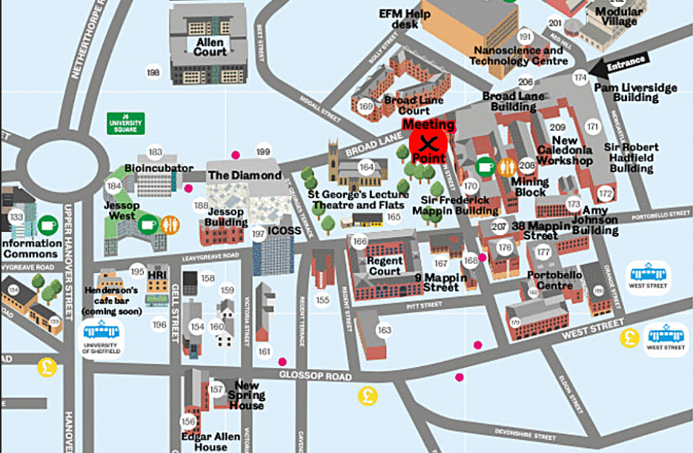

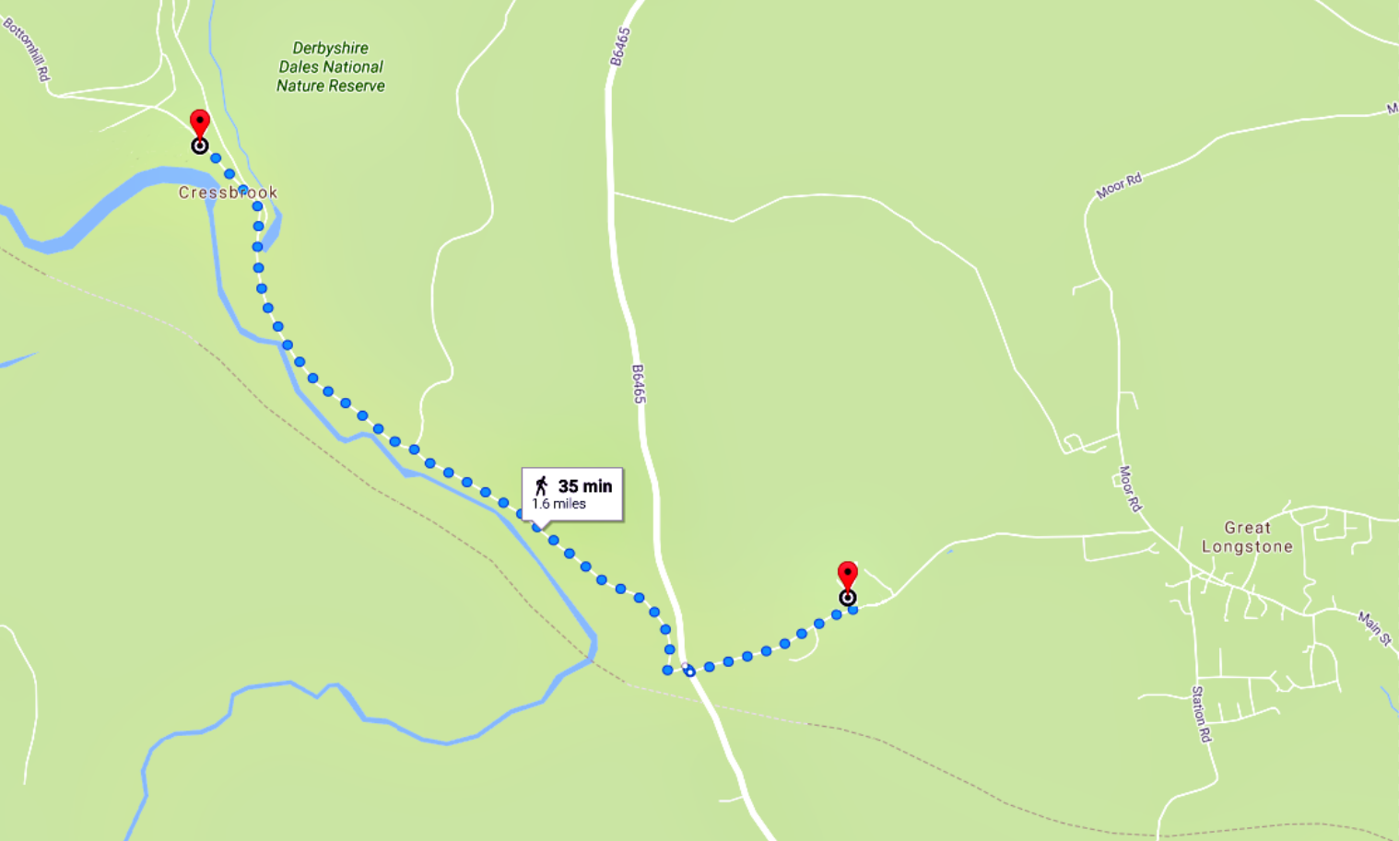

**Cressbrook**

**Hall**

**Packhorse**

**Inn**

**35 min**

**1.6 miles**

