**Machine Learning Group**

**Research Retreat 2017**

**Essential Information**



**Date - Friday, 2nd June**



**Departure - 8:30am from Mappin Street**

**Destination - Cressbrook Hall (**[**http://www.cressbrookhall.co.uk**](http://www.cressbrookhall.co.uk)**)**



**Dinner at Packhorse Inn (**[**http://www.packhorselongstone.co.uk**](http://www.packhorselongstone.co.uk)**) from 6:30pm until 9:00pm.**





**Return - Mappin Street at approximately 10:00pm.**

**Programme**

|  |  |  |
| --- | --- | --- |
| **Time** | **Time Slot (mins)** | **Speaker** |
| **8:30** | **Meeting at Mappin Street** | |
| **09:30** | **30** | **Arrival, Coffee** |
| 10:00 | 10 | Eleni Vasilaki |
| 10:10 | 15 | Haiping Lu |
| 10:25 | 10 | Mauricio Alvarez |
| 10:35 | 10 | Alan Saul |
| 10:45 | 10 | Bei Wang |
| 10:55 | 10 | Avgoustinos (August) Vouros |
| **11:05** | **30** | **Coffee Break** |
| 11:35 | 10 | Fariba Yousefi |
| 11:45 | 10 | Juan Jose Giraldo |
| 11:55 | 10 | Muhammad Arifur Rahman |
| 12:05 | 10 | Luisa Cutillo |
| 12:15 | 10 | Michael Smith |
| 12:25 | 20 | Amanda Sharkey |
| **12:45** | **75** | **Lunch Break & Discussion** |
| 14:00 | 15 | Mike Croucher |
| 14:15 | 10 | Will Furnass |
| 14:25 | 10 | Tania Allard |
| 14:35 | 20 | Neil Lawrence |
| 14:55 | 10 | Javier González |
| 15:05 | 10 | Zhenwen Dai |
| 15:15 | 10 | Andreas Damianou |
| **15:25** | **30** | **Coffee Break** |
| 15:55 | 20 | Alessandra Tosi |
| 16:15 | 35 | Shakir Mohamed |
| **16:50** | **30** | **Discussion** |
| 17:20 – 18:00 | | Free Time  (Pub is approx. 35mins by foot) |
| 18:30 – 21:00 | | Dinner at the Packhorse Inn  (dinner will be served at 19:00) |
| 21:00 – 22:00 | | Return to Mappin Street |

**Directions**

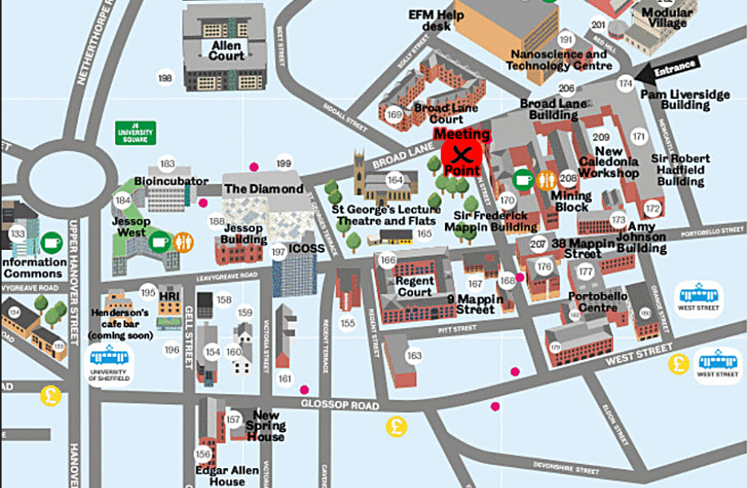

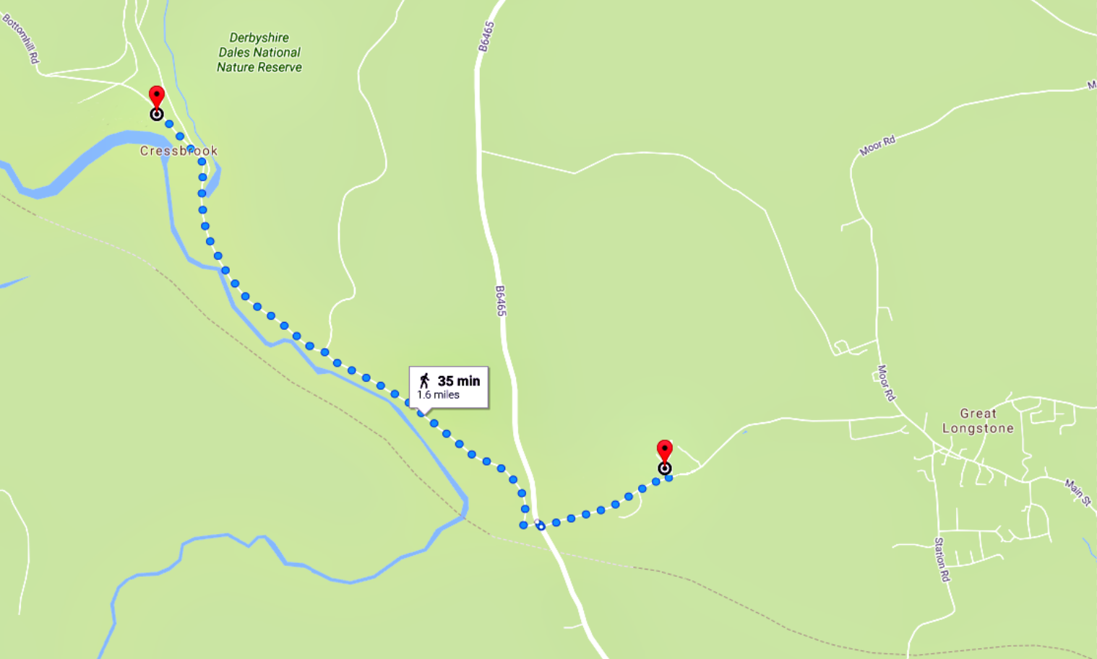

**Cressbrook**

**Hall**

**Packhorse**

**Inn**

**35 min**

**1.6 miles**

