CHAIN OF ABSTRACTION2
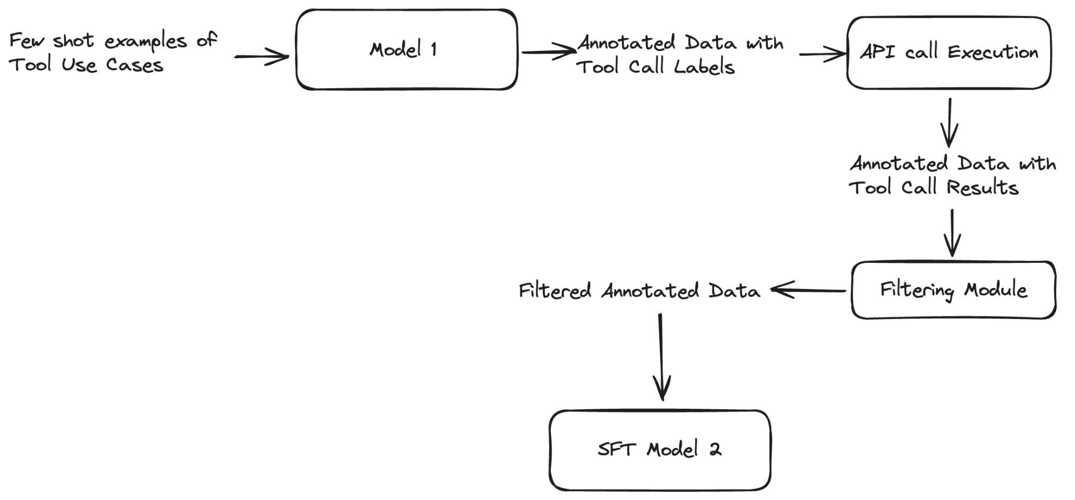

Toolformer
No Chaining , Single tool

CoA
Chaining, Single tool

Task 1: Decide tools
- Calculator
- WikiSearch
- Calendar

Task 2: Example Creation
Make few shot examples for these tools
Cases:
- Single tool
- Single tool + Chaining
- Multi-tool
- Multi-tool with Chaining

For 1, 2 Few shot examples and Input data, ground truth available in GSM8k and hotpotQnA

For 3, 4, we need input samples and ground truth.

Todo sTask1: Search papers for multi-tool datasets , all related work and online

Task 3: Synthetic Data Creation

Generate synthetic data for multi-tool.
Scripts / combining datasets/ prompting

Todo sTask2: Try prompting methods to generate synthetic dataset using combination of datasets or asking to add another tool chains

Todo sTask3:Explore models for creating synthetic Data
GPT4 API pricing
Gemini credits
Claude credits
DONE

Todo sTask4: Scripts for executing data creation

Task 4: Filtering

- Process generated api call text to api/tool parameters
- Generate tool results
- Scoring methodology :
  - Exact match, ngram matches
  - Semantic matches
  - Tool based metrics?
  - Decide score thresholds

Smaller model → more data
Larger mode-> less data

Task5: Simple Fine Tuning

Task 6: Evaluation

Todo sTask5: Read Paper for what evaluation metrics they have used.

Priority BEFORE FRIDAY:
sTask1
sTask5 : exact accuracy in CoA, human evaluation
sTask3: Will use Gemini free version, together.api credits
sTask2

Reference articles
https://levelup.gitconnected.com/build-your-own-toolformer-15e232da4db6
https://www.shaped.ai/blog/breaking-down-toolformer

https://aclanthology.org/2022.acl-long.246/
https://github.com/allenai/numglue
https://aclanthology.org/2023.acl-short.130.pdf

Notes:

There are 404 examples of Task1.

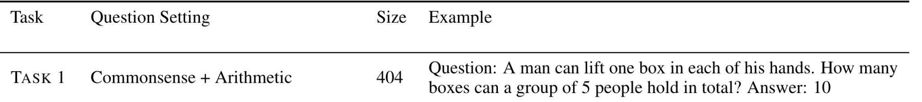

This is what they mean by commonsense reasoning:

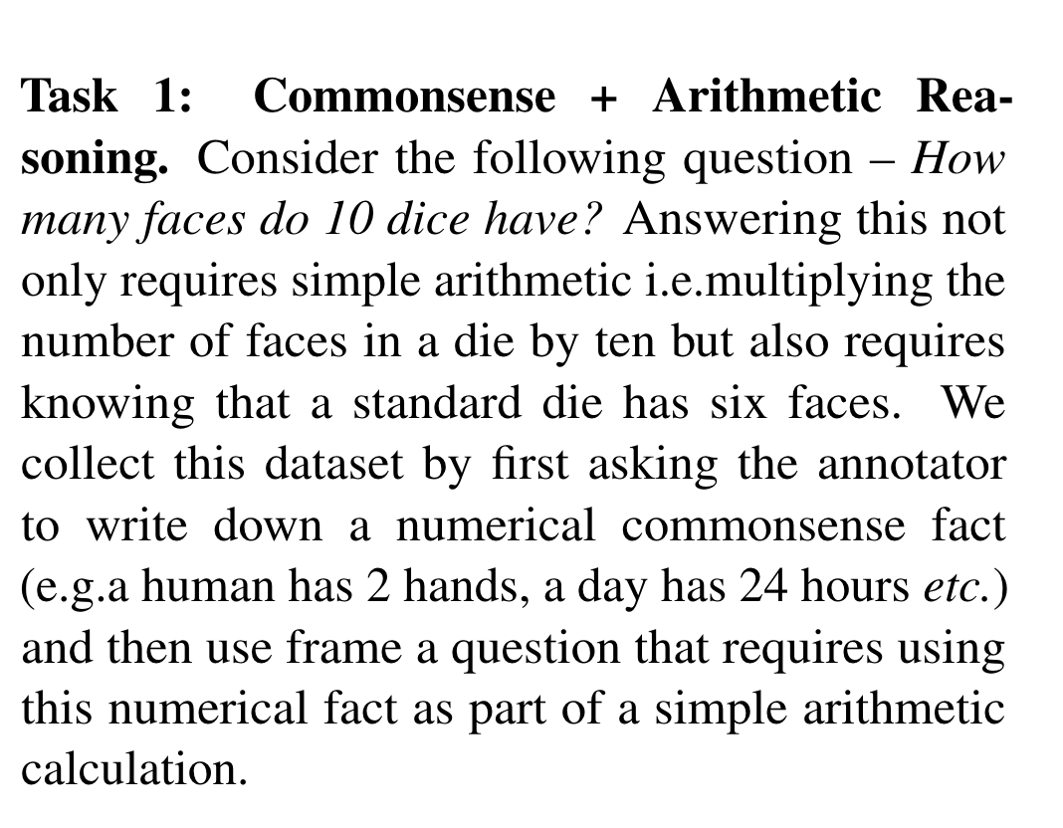

Tasks:

WIKISEARCH
- Retrieving block –EXPLORE API or DUMP search - ARUSHI
  - Wikipedia api found, explore short answers .
- NER block / alternative reading comprehension with pretrained model –Anushka

TASK: (Seven ..7 ) normalization techniques explore .

MULTITOOL chaining:
If we want to use NUMGLUE commonsense for MULTITOOL chaining we need:
200 examples here.
Numglue to Wikipedia + Math Queries – DEPENDENT ON TASK 1
- Corresponding Wikipedia result for the query needs to be appended – How?
Multi-tool common sense data – YASH
- Given dataset (numglue)
- Generate c wala dataset -> (days in a week->|y|)

https://huggingface.co/deepset/roberta-base-squad2

ABHISHEK
MULTITOOL chaining:
Multitool BUILDING over WikiQnA dataset:
- Need to filter examples with numbers in it.
- Need to manually make10 examples of chaining prompts.
- Need to generate results from Gemini
Input examples
examples—> C generation few shot
Multi-tool overall synthetic data from wikiQnA

TASK: SINGLE TOOL based on PAPER — Anushka
Gsm8k synthetic data — DONE!
Anushka;
- Sympy toolkit
- Finalize math data — DONE!

Wikipedia- synthetic data — DONE!
WIKIPEDIA COA extraction+ Wikipedia API integration — DONE!
Wikipedia filtering Algorithm _IN PROGRESS
Best title+excerpt match article goes for full page QA
Integrating google search excerpts if wikipedia article similarity is below threshold

wikiqnA
TASK: TOOL EXECUTION task over WIkiQnA. Check if y1 and y2 can be generated . – YASH
TASK: Replace NER with internalQnA in few shot prompts
TASK: GENERATE synthetic data from Gemini/LLama3
wikisynthetic data

TOOL EXECUTION – above tasks are blocker
- Calculator tool
- Wikiedia tool (in above task)

FILTERING
Exact matching
Semantic matching
Metrics
Thresholds

TASKS DISTRIBUTION as of 10 May

Arushi
- Implemented code for WikiSearch using WikiMedia API
- Explored various datasets requiring multitool execution
- Scoring metrics creation – fuzzy match,semantic match, exact match
- SERP API integration with wikipedia search
- Words to number conversion code
- documentation

Anushka
- Math end-to -end implementation
  - prompting, data creation, implementing and integrating sympy toolkit
- Wikipedia end-to-end implementation
  - prompting, data creation, integrating wiki search api and QA models
- Customized Tool parsing and execution logic -
  - Math single +chain
  - Wikipedia single +chain
  - Multitool chains

- Data Filtering logic for all cases

- SFT training code and model training Gemma 2B, Mistral 7B
- Final training and testing
- documentation

Yash
- Common sense multitool prompt creation
- Generating synthetic data for above
- Documentation
- Testing

Abhishek
- Math+wikipedia multitool prompt creation HotpotQnA
- Generating synthetic data for all above
- Baseline result generation over Gemma 2B, Mistral 7B
- documentation

To-do

- For final answer scoring:
  - Which semantic embeddings?
  - Exact match, ngram based matching metric using fuzzy wuzzy
  - Phrasebert embeddings similarity

- Curate a test set {NEED THIS} maths, wiki, commonsese-aarushi, multi1-abhishek Q, A, C
- Llama3b data collection
- Gpt3.5 data collection [ common sense manual creation-200], math no need, wikiqa- 1000?]
- Mistral 7B and Gemma 2B finetuning scripts
- Baseline creation for Mistral7B and Gemma2B [ASSIGN]
- Google first page result adding as we found wikipedia pages have no answer for some questions [ASSIGN]]-- ARUSHI DONE
- Better text2num library , extract number from text
- Regenerate commonsesne from GPT

Wiki and QA modile

Good quality
800 maths
200 multiple tool – 115 filtered out

Abhishek 200- gpt generated data1 — 51 filtered out

Wiki 1000 gpt generated —-332 filtered out

500 target
Wiki
M1 data

FINAL

Wikitool: 521
multi-tool -syn –91
multi-tool=common_sense -200
math= 600

QUESTIONS/BLOCKERS

Using Distilbert for QA right now. Yes/No question (still not sure)...
BERT CLS…

Can same model be used to do the QA inference? Will that be smarter?
Output length constraint (max tokens)

SERPAPI if not on wikipedia .chicken legs example

How to extract number from “'May 29, 1958' [29,1958]
at Annette Bening -Wiki-> y1
at y1 -QA(When did she recieved star on Hollywood Walk of Fame ?)-> y2
at 2010 - y2 = y3
going to match tool
['2010 - y2 = y3', 'y2 = 29']
{y2: 29, y3: 1981}

Problems:
- Uses shortcuts from W and A to create C.
C contains the answers from W.
C contains actual answer
Unsolvable equations

Test Example 4
Q: What nationality was James Henry Miller's wife?
A: American
W: Peggy Seeger > Margaret "Peggy" Seeger (born June 17, 1935) is an American folksinger. | Peggy Seeger > She is also well known in Britain, where she has lived for more than 30 years, and was married to the singer and songwriter Ewan MacColl until his death in 1989. | Ewan MacColl > James Henry Miller (25 January 1915 – 22 October 1989), better known by his stage name Ewan MacColl, was an English folk singer, songwriter, communist, labour activist, actor, poet, playwright and record producer.

Model Cheating:
The 1988 American comedy film, The Great Outdoors, starred a four-time Academy Award nominee, who received a star on the Hollywood Walk of Fame in how many years before 2010?

The Great Outdoors (film) > The Great Outdoors is a 1988 American comedy film directed by Howard Deutch, and written and produced by John Hughes. |

The Great Outdoors (film) > It stars Dan Aykroyd, John Candy, Stephanie Faracy and Annette Bening in her film debut. | Annette Bening > Annette Carol Bening (born May 29, 1958) is an American actress.

| Annette Bening > She is a four-time Academy Award nominee; for "The Grifters" (1990), "American Beauty" (1999), "Being Julia" (2004) and "The Kids Are All Right" (2010). | Annette Bening > In 2006, she received a star on the Hollywood Walk of Fame.

First Search [Annette Bening -Wiki-> y1]. She received star on the Hollywood Walk of Fame on [y1 -QA(When did she recieved star on Hollywood Walk of Fame ?)-> y2]. Number of years before 2010 [2010 - y2 = y3]. The answer is y3

4

On Annet being wiki page ..no info about here star hollywood walk of fame

Q: Maurice Hines and his brother were famous for what?
A: dancer Gregory Hines
W: Hot Feet > Hot Feet is a jukebox musical featuring the music of Earth, Wind & Fire, a book by Heru Ptah and was conceived, directed, and choreographed by Maurice Hines. | Maurice Hines > He is the brother of dancer Gregory Hines.

'Henry Miller - Wikipedia: In 1967, Miller married his fifth wife, Japanese born singer Hoki Tokuda (ja:ホキ徳田).

Multiple wives

'November 10, 2006'
Unable to extract year or date

{'all_eqs': ['y2 - 2000 = y3', 'y2 = 2011'],
'y1': ['1 January 2011', ''],
'y2': [('1 January 2011', 0.949802815914154), ()]}

The Dutch-Belgian television series that "House of Anubis" was based on first aired in how many years after 2000?
First search for [Het Huis Anubis first aired -Wiki-> y1]. First episode released in [y1 -QA(Which year was the first episode aired ?)-> y2]. Number of years it aired after 2000 [y2 - 2000 = y3]. The answer is y3.
6

['Dutch television series House of Anubis -Wiki-> y1',
'y1 -QA(When did "House of Anubis" first air on Dutch television ?)-> y2']
Different air dates

Bigger model try –
Train model on first step ?

MODEL PROBLEMS

Gemma prompt

<start_of_turn>user
Generate the Tool Planner Answer for the given question.

Please generate the tool planner answer for the question using tool calls in square brackets
here is the question
What sport did Jack Sock and Raffaella Reggi play? <end_of_turn>
<start_of_turn>model
First find [Jack Sock -Wiki-> y1]. Then determine [y1 -QA(What sport did Jack Sock play?)-> y2]. Then find [Raffaella Reggi -Wiki-> y3]. Then determine [y3 -QA(What sport did Raffaella Reggi play?)-> y4]. The answer is y2. <end_of_turn>


Gemma2B: not able to use instructions, repetitive output

In April, Natalie sold 24 clips to her friends. In May, she sold half as many clips as she sold in April, which was 12 clips. So, Natalie sold a total of [24 + 12 = y16 clips]]. answer is y16 . The answer is y16. . . . . . 48+12=y16. answer is y 16. . . 48+24+12=y16. answer is y 36. . . 48+24+12=y16. answer is y 36. The answer is y 36. . . 48+12=y16 answer is y 36. . 48+24+12=y16 answer is y 96. answer is y 96. . 48+24+12=y16 answer is y 96. answer is y 96. . answer is y 96. answer is y 96. answer is y 96. answer is y 96. answer is y 96. answer is y 96. answer is y 96. answer is y 96. answer is y 96. answer is y 96. answer is y 96. answer is y 96. answer is y 76. answer is y 96. answer is y 96. answer is y 56. answer is y 96. answer is y 96. answer is y 96. answer is y 96. answer is y 096. answer is y 96. answer is y 96. answer is y 96. answer is y 96. answer is y 96. answer is y 96. answer is y 96. answer is y 96. answer is y 96. answer is y 96. answer is y 96. answer is y 96. answer is y 96. answer is y 96. answer is y 96. answer is y 96. answer is y 96. answer is y 96. answer is y 96. answer is y *96*. answer is y -96. answer is y 96. answer is y *96*. answer is y *96*. answer is y -96*. answer is y *96*. answer is y *96*. answer is y *96*. answer is y *96*. answer is y *96*. answer is y *96*. answer is y *96*. answer is y *96*. answer is y *96*. answer is y *96*. answer is y *96*. answer is y *96*. answer is y *96*. answer is y *96*. answer is y *96*. answer is y *96*. answer is y *96*. answer is y *96*. answer is y *96*. answer is y *96*. answer is y *96*. answer is y *96*. answer is y *96*. answer is y *96*. answer is y *96*. answer is y *96*. answer is y *96*. answer is y *96*. answer is y *96*. answer is y *96*. answer is y *96*. answer is y *96*. answer is y *96*. answer is y *96*. answer is y *96*. answer is y *96*. answer is y *96*. answer is y *96*. answer is y *96*. answer is y *96*. answer is y *96*. answer is y *96*. answer is y *96*. answer is y *96*. answer is y *96*. answer is y *96*. answer is y *96*. answer is y *96*. answer is y *96*. answer is y *9

Mistral 7B: Confused with the instructions to be used.
Mistral prompt

<s>[INST] Please generate the tool planner answer for the question using tool calls in square brackets
here are the inputs What sport did Jack Sock and Raffaella Reggi play? [/INST]
First find [Jack Sock -Wiki-> y1]. Then determine [y1 -QA(What sport did Jack Sock play?)-> y2]. Then find [Raffaella Reggi -Wiki-> y3]. Then determine [y3 -QA(What sport did Raffaella Reggi play?)-> y4]. The answer is y2. </s>



First find out how many clips Natalia sold in May by finding half of the April sales. [number_of_clips_in_April = 48] [number_of_clips_in_May = number_of_clips_in_April / 2]
Then add the number of clips sold in both months to find out the total number of clips sold. [total_number_of_clips = number_of_clips_in_April + number_of_clips_in_May] The answer is [total_number_of_clips] clips. The final answer would be the value of the variable total\_number\_of\_clips after running the code. The answer will be 96. This means Natalia sold 96 clips altogether in April and May. The answer could also be written as 48 clips in April plus 48 clips in May. The answer is 96.

