Nanoparticle delivery of natural products in prostate cancer

Critical review of direct comparisons, exposure, tumor control and reporting bias

Abstract
Nanoparticle delivery can improve the apparent potency of natural products in prostate cancer models, but the magnitude and interpretation of the advantage depend on the comparison. This critical review evaluates formulated versus free compounds, prioritizing matched active doses, administration routes, schedules and disease models. A targeted PubMed search through 8 October 2026 was supplemented by citation-led retrieval and searches of publisher and conference records. The evidence was separated into matched single-compound experiments, unequal-dose studies, combination treatments, pharmacokinetic studies and cell-only investigations. Curcumin, epigallocatechin gallate and catechin formulations provide the most informative examples. Some matched animal comparisons favor formulation, whereas frequently cited epigallocatechin gallate studies primarily establish activity at lower administered doses. A Pten-deficient mouse study found reduced proliferation without reduced tumor burden and reported liver enlargement, illustrating the importance of retaining negative outcomes. Increased particle accumulation, total drug concentration and in vitro potency do not independently establish higher pharmacologically available tumor exposure or a wider therapeutic index. Dose-unit discrepancies, conflicting endpoint timing, incomplete variance reporting and heterogeneous models prevented a defensible pooled animal effect estimate from the extracted evidence. Quantitative results are therefore presented as explicitly labeled within-study comparisons, each re-checked against the primary full text where that text could be retrieved. Conference abstracts are discussed separately and are not treated as independent confirmatory experiments. Overall, formulation improves efficacy in selected experimental settings, but a general nanoparticle advantage and clinical benefit remain unproven. The next decisive studies should integrate dose-matched and exposure-matched comparisons, free-combination controls, blinded tumor measurement, repeated-dose toxicology and complete animal-level reporting.
Keywords: prostate cancer; nanoparticles; natural products; curcumin; epigallocatechin gallate; pharmacokinetics; animal studies; reporting bias

Introduction
The relevant question is not whether a nanoparticle containing a natural product inhibits a prostate cancer cell line or xenograft. It is whether formulation improves the performance of the same active compound under a comparison that isolates a clinically useful delivery advantage. The influential proof-of-principle study of nanoparticle epigallocatechin-3-gallate (EGCG) reported tumor inhibition using one tenth of the free-compound dose, establishing a rationale for dose-sparing investigation rather than a universal equal-dose effect [1]. Curcumin subsequently provided matched-dose xenograft examples, including direct intratumoral administration, but such experiments bypass absorption and much of systemic disposition [2].
Four distinct claims recur in this literature: greater potency at the same nominal concentration, greater tumor control at the same administered dose, preserved activity at a lower dose, and a better balance of efficacy and toxicity. These claims require different experiments. None follows automatically from particle size, encapsulation efficiency or a statistically significant comparison with untreated controls. Figure 1 defines these comparisons and the principal sources of causal ambiguity.
This review focuses on phytochemicals and other investigational natural bioactives, including polymeric nanoparticles, lipid nanoparticles, liposomes, micelles and nanoemulsions used as nanoscale delivery systems. Conventional taxanes are considered as combination partners rather than as the central natural-product category. Purely diagnostic nanoparticles, benign prostatic hyperplasia, prostatitis and non-prostate tumors do not supply direct prostate cancer efficacy evidence. Metal and radioactive particles functionalized with phytochemicals are considered separately because the carrier can itself be the treatment.

Review approach and limits of the evidence synthesis
A targeted PubMed search was conducted with a publication-date upper limit of 8 October 2026. The main query combined prostate terms with nanoparticle, nanomicelle, nanocapsule, nanoformulation, nanochemoprevention and liposome terms, and a panel of natural-product names. It returned 314 records, whose titles and abstracts were retrieved. Citation-led searches added foundational reports, methodological references and conference records. The exact principal query, bibliographic search results, extracted comparison data and figure source values are supplied in the accompanying evidence package. The retrieved set contains irrelevant diagnostic, nonmalignant and non-prostate studies; the search count is not an included-study count. Of the retrieved and citation-led records, 35 are cited here: eight supply animal tumor-burden comparisons between a formulated and a free natural product, four supply animal data for combinations, four supply pharmacokinetic or biodistribution data without a matched tumor outcome, eight are cell-only reports, three are methodological standards, two are conference abstracts, one is a human trial, and the remainder provide supporting context.
This is a structured critical review, not a registered systematic review with independent duplicate screening. Full texts were examined for the principal quantitative examples where accessible; other reports are explicitly identified as abstract-level evidence. Every numerical value reproduced in the text and figures was re-checked against the primary full text where that text could be retrieved, and the two places where a claim could not be substantiated from the source are identified explicitly below. No author correspondence, complete supplementary-data recovery, exhaustive Embase or Web of Science search, or prospective protocol registration was undertaken. Consequently, absence from the retrieved set is not proof that a study does not exist. Recent online and issue publication dates can differ; bibliographic references retain verified journal metadata.
The animal was treated as the experimental unit. The preferred estimand was the formulation-to-free-compound ratio of mean terminal tumor volume at a common prespecified time. Matching required the same active moiety, active-equivalent dose, route, schedule, treatment-start condition and endpoint. Separate categories were retained for dose-sparing designs, combinations, carrier-active systems and pharmacokinetics without a tumor outcome. A reporting audit drew on SYRCLE domains but did not assign a numerical quality score or claim independent formal risk-of-bias adjudication [3]. ARRIVE 2.0 informed the requirements for animal numbers, exclusions, randomization, masking and endpoint reporting [4]. MIRIBEL informed the formulation and bio–nano characterization requirements [5].
The search uncovered enough heterogeneity and extraction uncertainty that a pooled effect was not calculated. This decision was made after examining comparator identity, route, timing and variance availability, rather than because individual results lacked statistical significance. The quantitative section explains the calculation that would be appropriate after the necessary data are recovered. Conference reports were kept separate throughout.

What constitutes a fair formulation comparison
Equal nanoparticle mass is not equal drug dose. Dosing must be expressed as measured active compound per kilogram or per animal, with drug loading and residual unencapsulated compound reported. A 100 mg/kg particle dose at 2% loading contains approximately 2 mg/kg active compound, assuming the loading estimate describes the administered batch. Nominal loading cannot replace measurement of the injected or gavaged preparation. Salts, prodrugs and covalent conjugates require molar active-equivalent accounting and evidence of release of the relevant species.
Route matching is essential. Intravenous nanoparticles versus oral free compound estimate the combined effects of route and formulation. Intratumoral dosing examines local retention and activity but does not establish oral bioavailability, circulation persistence or tumor targeting after systemic administration. The curcumin PLGA study by Yallapu and colleagues illustrates this distinction: the efficacy experiment randomized tumor-bearing mice to four groups of six and administered 25 µg curcumin equivalent by intratumoral injection, whereas separate experiments assessed intraperitoneal toxicity and radiolabeled-antibody targeting [2]. Combining those experiments into a single claim of systemic curcumin efficacy would exceed the evidence.
Vehicle matching is equally important. Free curcumin in DMSO or ethanol and nanoparticles in buffered saline may differ in precipitation, exposure, local irritation and tolerability. This is not a hypothetical concern: in both of the principal intravenous and intratumoral curcumin comparisons, the free compound was delivered in DMSO while the particles were delivered in phosphate-buffered saline [2,9]. A valid study needs the free-drug vehicle control and the blank carrier, each delivered at the appropriate volume and schedule. If a clinically usable free formulation cannot be made, superiority to an unstable suspension can still be a useful pharmaceutical result, but it does not isolate tumor-selective delivery.
Two complementary comparisons should be distinguished. At equal administered dose, a formulation may improve exposure and efficacy; this is a legitimate delivery advantage. At equal plasma or tumor exposure, persistent superiority may indicate different spatial distribution, intracellular release or carrier pharmacology. Exposure matching should not be used to dismiss a useful increase in bioavailability, but it helps identify mechanism. A claim of dose sparing is strongest when full dose–response curves demonstrate a reproducible shift rather than when one low nanoparticle dose is contrasted with one high free dose.
Finally, the stage of disease at which treatment begins determines what the experiment can show. Treatment started within a day of cell inoculation measures suppression of engraftment and early outgrowth; treatment started once tumors reach a prespecified volume measures control of established disease. Both designs appear in this literature, sometimes without the distinction being drawn, and they should not be pooled.

EGCG and catechins provide dose-sparing evidence with important qualifications
Siddiqui and colleagues treated 22Rv1 xenografts with intraperitoneal nano-EGCG at 100 µg per mouse or free EGCG at 1 mg per mouse, three times weekly, with seven animals per group. At day 45, reported mean tumor volumes were 1,242 mm³ for control, 854 mm³ for free EGCG and 707 mm³ for nano-EGCG [1]. The nanoparticle-to-free mean ratio is 0.828, corresponding to a descriptive 17.2% lower volume despite the tenfold lower administered active dose. This is an important signal, but no formal equivalence or noninferiority margin was prespecified. Similar-looking inhibition is therefore not proof of equivalent efficacy. Two features of the design deserve attention. The study was terminated when tumor volume reached 1,300 mm³ in the control group, so the endpoint was triggered by control growth rather than fixed in advance, and the dispersion shown in the tumor-growth figure is standard error rather than standard deviation. Serum drug persistence supports a delivery mechanism, although a complete dose-normalized exposure–response comparison would be more decisive.
Khan and colleagues tested oral chitosan-EGCG in 22Rv1 xenografts. Free EGCG was given at 40 mg/kg and nanoparticles at 3 or 6 mg/kg, five times weekly, beginning one day after implantation. There were 12 mice per group and two flank tumors per mouse. At day 32, reported mean volumes were 1,200, 514, 310 and 216 mm³ for control, free drug, low-dose nanoparticles and high-dose nanoparticles, respectively [6]. The corresponding formulated-to-free ratios are 0.603 and 0.420. These are unequal-dose comparisons, and the tumors within an animal must not be counted as independent replicates. Starting treatment immediately after implantation also places the experiment closer to suppression of engraftment and early outgrowth than treatment of established advanced disease. The full text of this report was not retrievable during the verification pass described above, so its dosing and endpoint values are reproduced as extracted rather than as independently re-checked, and are flagged as such in Figure 2.
The later targeted-EGCG study compared free EGCG with untargeted and PSMA-directed formulations in 22Rv1-bearing mice, in four groups of 12 treated five times weekly, with the control group made up of two subgroups of six receiving void nanoparticles or vehicle [7]. Endpoint mean tumor volumes were 2,685, 1,895, 1,230 and 1,073 mm³ for control, free EGCG, untargeted nanoparticles and targeted nanoparticles, and the corresponding mean tumor weights were 3.0, 2.1, 1.3 and 1.1 g. The two endpoints agree closely when expressed relative to control, which strengthens the internal consistency of the result even though the external comparisons remain problematic. Three reporting problems do constrain its use. The source reports 100 µg per mouse per day in the results but 100 mg per mouse per day in the methods, a thousandfold discrepancy that cannot be resolved from the text. The methods passage does not specify the administration route for any arm. The general statistics section states that all results are means ± standard error, whereas the tumor-volume figure legend states mean ± SD for the same experiment. A fourth feature is a design limitation rather than a reporting one: treatment began 24 hours after cell inoculation, so this experiment shares the engraftment-stage limitation described above for the oral chitosan study, and it is not a test of established disease. The targeted-to-untargeted mean ratio of 0.872 is descriptively informative and is the one genuinely dose-matched contrast in the experiment, but PSMA-mediated delivery requires more than the nominal presence of a targeting ligand. Figure 2 displays the three EGCG experiments separately without a pooled summary.
Lin and colleagues examined a chemically characterized catechin mixture from oolong tea in DU145-bearing mice. Thirty-six animals were allocated to six groups of six, and both extract and nanoemulsion were tested at 10 and 20 mg/kg body weight by intraperitoneal injection every three days for a total of six injections. Treatment began only after the mean tumor volume reached approximately 200 mm³, which makes this the clearest test of established disease among the matched comparisons reviewed here. Reported tumor-weight reductions relative to control were 27.9% and 52.6% for the two extract doses and 48.3% and 77.5% for the corresponding nanoemulsion doses [8]. These values imply formulated-to-extract tumor-weight ratios of approximately 0.717 and 0.475. They do not represent pure-EGCG effects. Two further points are material. The study included a paclitaxel positive control at 10 mg/kg, which reduced tumor weight by 90.8% and therefore outperformed the best nanoemulsion arm; a formulation advantage over an unformulated botanical extract is not the same as competitiveness with standard cytotoxic therapy, and positive controls of this kind are rare enough in the wider literature that this one deserves emphasis. The article also reports the paclitaxel figure as 90.8% in the results and 90.6% in the abstract, and its abstract expresses the animal doses in µg/mL where the methods correctly use mg/kg body weight. The matched-dose signal is worth retaining, but raw endpoint values and variance are needed before synthesis.

Curcumin shows formulation-dependent gains and a meaningful negative result
The 2014 PLGA-curcumin experiment used C4-2 xenografts randomized to four groups of six: free curcumin, PLGA-curcumin, a DMSO vehicle control and blank PLGA nanoparticles. Both active arms received 25 µg curcumin equivalent intratumorally, and animals were evaluated seven days later [2]. The formulation improved antitumor activity and was accompanied by changes in AR, β-catenin and other tissue readouts. This is a matched local-delivery comparison with an appropriate blank-carrier arm. Its interpretation should remain separate from the radiolabeled PSMA-antibody experiments, which were delivered intraperitoneally and in which radiolabel accumulation measures the labeled component and cannot establish intact curcumin exposure.
Ma and colleagues compared free curcumin, untargeted liposomes and CD133-aptamer A15 liposomes at 25 µg curcumin equivalent by intravenous administration in DU145-bearing mice, with six animals per group. Their table reports endpoint volumes of 365 ± 156, 275 ± 135 and 121 ± 72 mm³, respectively, compared with 659 ± 136 mm³ for blank liposomes [9]. The same table reports day-1 volumes of 131 ± 22, 126 ± 28, 131 ± 31 and 129 ± 26 mm³, so treatment began with established tumors of comparable size, and relative tumor growth over the treatment period was 2.79, 2.18 and 0.92 for free curcumin, untargeted liposomes and A15 liposomes against 5.11 for blank liposomes. The targeted arm is therefore the only experiment in this review whose mean endpoint volume falls below its own pretreatment baseline, which is the definition of regression used later in this article; the accompanying tumor weights of 0.325 ± 0.119, 0.219 ± 0.107 and 0.116 ± 0.049 g against 0.625 ± 0.167 g corroborate the volume ranking. Reporting the baseline alongside the endpoint, as this study does, is good practice and makes the result far more interpretable than an endpoint volume alone. Two problems nevertheless remain. The methods and figure legend describe a seven-day assessment, whereas the table labels the endpoint columns day 1 and day 10. Figure 3 therefore presents a source-reported endpoint rather than silently selecting either day. In addition, the free drug was given in DMSO while both liposome arms were given in phosphate-buffered saline, so vehicle is not matched across the comparison.
Akanda and colleagues studied curcumin-loaded nanostructured lipid carriers in LNCaP xenografts. Free curcumin and the formulation were given intravenously at 20 mg/kg twice weekly for 30 days. Reported mean tumor volumes after approximately four weeks were 1,412.0 mm³ for untreated control, 1,375.2 mm³ for blank carriers, 1,155.1 mm³ for free curcumin and 778.4 mm³ for the loaded lipid carrier, yielding a descriptive formulated-to-free ratio of 0.674 [10]. Including the two control arms, which the primary report provides, materially improves interpretation: the blank carrier did not differ appreciably from untreated control, so the carrier itself appears inert in this system and the gain can reasonably be attributed to delivery of the payload rather than to carrier pharmacology. Several reporting and design features nevertheless require clarification before variance-weighted pooling. The statistical section states that findings are presented as means and standard deviation with n = 3, and no group size for the efficacy experiment is stated anywhere in the article; an earlier version of this review attributed six animals per group to this study, and that attribution is not supported by the source and has been removed. The formulation table lists the nominally blank carrier as containing the same quantity of curcumin as the loaded carrier, which must be a transcription error but is not corrected in the published table. The xenografts were established in female nude mice by injection into the fat pad, which is an unusual host and site for an androgen-sensitive LNCaP model and is worth stating explicitly when the result is cited. This article appeared online in 2021 and in its journal issue in 2023; it is one study, not two.
An essential counterweight is the Pten-deficient model studied by De Velasco and colleagues. Dietary nanoparticle curcumin at 76 or 380 mg/kg/day for sixteen weeks did not reduce tumor burden, although the higher dose reduced cancer-cell proliferation at 12 and 16 weeks of age. Liver enlargement occurred despite no effect on body weight or spleen size [11]. This study does not directly compare nanoparticle and free curcumin, so it cannot estimate their relative efficacy. It does show that a favorable proliferation marker and apparently stable body weight can coexist with absent tumor-burden benefit and an organ-level safety signal. The result should not be omitted because it complicates the formulation narrative.
Redox-active carriers add another layer of interpretation. A curcumin formulation containing nitroxide radicals suppressed oxidative degradation and showed antitumor activity after intravenous administration [12]. Here, the carrier is deliberately pharmacological. Distinguishing protection of curcumin from the carrier’s own radical-scavenging effects requires a carrier-only arm and, ideally, a comparable carrier without the active redox groups. Such systems may be therapeutically useful, but their effects cannot be assigned entirely to passive encapsulation.

Quercetin, resveratrol and other natural products broaden the evidence, but not uniformly
Zhao and colleagues reported that DSPE-PEG2000 quercetin micelles improved aqueous solubility and cell-based potency, with an IC50 of 20.2 µM versus more than 200 µM for free quercetin. The abstract reports 52.03% tumor-proliferation inhibition relative to control in PC-3 xenografts, treated at a quercetin-equivalent dose of 30 mg/kg [13]. That percentage must not be relabeled as a 52.03% improvement over free quercetin; it is a control-relative figure. Numerical endpoint variance was not recovered, so the study supports the qualitative evidence base but is not used in a matched-dose quantitative synthesis. Later CD44-targeted quercetin liposomes demonstrated activity in prostate cell lines and spheroids; those experiments remain cellular evidence rather than an independent animal confirmation [14].
Polymeric resveratrol nanoparticles improved antiproliferative activity in prostate cancer cell lines, but the 2013 report, which used a blend of poly(ε-caprolactone) and PLGA–poly(ethylene glycol), does not establish animal tumor control [15]. A 2022 solid-lipid resveratrol study reported prolonged disposition in rats and enhanced accumulation in its prostate-targeting assessment [16]. Rat pharmacokinetics and cell-accumulation measures should not be converted into a claim of efficacy in prostate xenografts without the relevant tumor-growth experiment. Likewise, silica-encapsulated resveratrol was investigated for cellular antiproliferative effects and docetaxel sensitization under hypoxia; this is mechanistic support, not a stand-alone animal effect estimate [17].
Celastrol, also called tripterine, illustrates both delivery and comparator problems. The 2015 study of a polymer blend established activity in prostate cancer cells [18]. Yin and colleagues subsequently tested intravenous tripterine nanoparticles at 1 mg/kg every other day in LNCaP-bearing mice, including an arm receiving blank nanoparticles before the loaded particles to saturate reticuloendothelial uptake [19]. The preloading strategy improved tumor delivery and antitumor activity, but it adds a second intervention. Weight loss with free tripterine may reflect both compound toxicity and its propanediol–ethanol vehicle. The simple formulation contrast and the carrier-preloading contrast therefore require separate estimates. The report describes BALB/c mice without adequately clarifying immunodeficiency in the examined passage, another point needing resolution for a human xenograft model.
Recent cell-based work reinforces the need for carrier controls. In a 2026 apigenin study, total apoptosis at a sub-IC50 working concentration of 6.25 µM was 44.30% with hyaluronic-acid-coated selenium nanoparticles containing apigenin, but 31.36% with selenium nanoparticles alone and 9.77% with free apigenin [20]. The carrier is plainly not inert; it accounts for the majority of the effect attributed to the loaded particle. Another 2026 study combined luteolin, ciprofloxacin, lipid nanoparticles and light exposure in PC-3 cells [21]. Its mechanistic claims belong to a combination and photodynamic framework; docking and cellular ROS do not constitute in vivo efficacy evidence.

Combination treatments require a different causal question
Co-delivery can synchronize tumor exposure to two agents and is a legitimate therapeutic objective. The necessary comparator is the same free combination at the same active-equivalent doses, ratio, route and schedule. Comparing a two-drug nanoparticle only with free natural product or chemotherapy alone cannot identify the incremental contribution of formulation. The minimum design adds each free drug, their free mixture, each single-loaded carrier, the co-loaded carrier and blank carrier where feasible. A factorial design may be more efficient than a large unstructured set of arms.
Narayanan and colleagues reported reduced prostate adenocarcinoma in Pten-knockout mice treated with liposomal curcumin and resveratrol, together with increased curcumin exposure during coadministration [22]. This is important prevention evidence, but formulation, compound combination and altered disposition are intertwined. Chu and colleagues evaluated EGCG and curcumin in a dual-targeted carrier in an orthotopic prostate model, strengthening anatomical relevance while introducing two compounds and two targeting components [23]. Neither design should be merged with pure-compound, subcutaneous, matched-dose experiments as though the interventions were interchangeable.
Curcumin–docetaxel lipid–polymer hybrids produced favorable xenograft findings [24]. Aptamer-functionalized curcumin–cabazitaxel hybrids also showed antitumor activity [25]. Resveratrol–docetaxel liposomes were compared with a liposome-free combination and were associated with tumor inhibition and longer survival in the reported PC-3 experiment [26]. Each report addresses a particular combination regimen. Without complete dose and variance extraction, their positive findings cannot establish the size of a general formulation effect or the independent contribution of the natural product.
Silibinin–cabazitaxel liposomes initially supplied cell-based CD44-targeting evidence [27]. A 2025 nanoemulsion study extended this combination to animal experiments and reported tumor-volume and tumor-weight reductions of 78.90% and 80.00%, respectively [28]. The abstract-level figures do not provide all information needed to calculate a matched nano-to-free contrast with uncertainty. Similarly, genistein–plumbagin liposomes inhibited prostate xenograft growth, but a control-relative percentage is not a direct estimate of the contribution of encapsulation [29].
The curcumin–piperine PLGA study by Yakubu and colleagues is especially relevant mechanistically because it examines prostate cancer cells alongside steroidogenic assays in NCI-H295R adrenal cells [30]. Its cell viability, migration and steroid-metabolite findings support further investigation, but the adrenal assays do not establish intratumoral androgen suppression in an animal. Piperine has biological activity and can alter drug handling; consequently, co-loaded particles versus free curcumin alone do not isolate formulation. Reduced cortisol also deserves evaluation as a potential endocrine liability rather than being classified automatically as a desirable anticancer effect. These limitations apply equally to work from any laboratory.

Exposure must connect delivery to tumor pharmacology
Higher solubility is a pharmaceutical improvement, not proof of higher oral systemic exposure. Cellular fluorescence is evidence of a fluorescent species, not necessarily intact parent compound in the relevant intracellular compartment. A fluorescent payload can dissociate from a carrier, and degradation can alter signal intensity. Imaging should therefore be paired with chemically specific assays that distinguish parent drug, metabolites and, where technically possible, released from carrier-associated drug. Figure 4 separates circulation, tumor delivery, release and pharmacological action.
The A15-curcumin study provides a useful numerical example. Its table reports tumor AUC0–12h values of 1,032.3, 1,484.3 and 4,356.3 ng·h/g for free curcumin, untargeted liposomes and targeted liposomes, respectively, with corresponding plasma values of 2,305.5, 1,833.5 and 1,475.0 ng·h/g [9]. The targeted-to-free tumor ratio calculated from those values is 4.22 while plasma exposure falls, and this divergence between compartments is the most informative feature of the dataset: it is the pattern expected of redistribution rather than of a simple increase in systemic exposure. Three inconsistencies nevertheless limit its use. The accompanying prose reports a targeting index of 3.12, which does not match the 4.2 ratio printed in the same table. The prose describes accumulation within a 24-hour window while the table is headed AUC0–12h. The table states n = 6, whereas the methods describe three animals sampled at each of four time points. The biodistribution experiment also used 10 mg/kg, whereas efficacy used 25 µg per animal; these are separate experiments and do not directly establish exposure mediation at the efficacy dose.
A convincing pharmacokinetic study should report dose-normalized plasma AUC, tumor AUC and tumor-to-plasma exposure, along with liver, spleen and kidney distribution. For oral products, absolute bioavailability requires a suitable intravenous reference; a higher oral AUC alone establishes only relative exposure. For injections, concentration immediately after administration may mainly reflect circulating encapsulated drug. Measurement of intratumoral unbound parent compound is difficult but more informative than total homogenate content when the central claim concerns target engagement.
Active targeting requires particular restraint. Comparing targeted and untargeted carriers with different size, loading or release characteristics does not isolate receptor targeting. Receptor-positive and receptor-negative models, ligand competition or receptor perturbation, and measurement of intact payload are complementary tests. PSMA or CD44 expression in a cell line is not a guarantee of adequate expression throughout human disease. Carrier uptake by macrophages or stroma can increase bulk tumor signal without increasing delivery to malignant cells.

Tumor burden and toxicity should be interpreted together
Caliper volume, tumor weight, longitudinal growth, histological burden, metastasis and survival are related but distinct outcomes. A smaller endpoint tumor can reflect delayed engraftment rather than regression of established disease. Regression requires a decrease from the animal’s own pretreatment tumor burden, and among the experiments reviewed here only the A15-liposome arm reports an endpoint mean below its own day-1 baseline [9]. Reporting baseline and endpoint volumes together, as that study does, is the minimum needed to tell the two apart. Lower PSA can reflect direct AR-pathway suppression or altered secretion rather than proportional tumor-cell killing. Accordingly, PSA and Ki-67 should corroborate, not replace, tumor measurements. Where both volume and weight are reported, as in the targeted-EGCG experiment, agreement between them is reassuring and should be shown rather than reduced to a single number [7].
Body weight is an insensitive safety measure, especially when a growing tumor contributes appreciably to total weight. Short studies in immunodeficient mice cannot establish the absence of delayed hepatic, renal, hematological, immune or reproductive toxicity. Blank carriers require repeated-dose evaluation, and claims of “no toxicity” should be replaced by the narrower statement that no toxicity was detected in the measures and interval studied. The liver enlargement in the Pten-curcumin study illustrates why normal body weight is insufficient [11].
The tripterine experiment also shows why solvent exposure matters: a formulation may reduce toxicity by avoiding an injurious solvent, while increased delivery of the active compound may create a different toxicity pattern [19]. In endocrine-directed formulations, adrenal steroid production and circulating glucocorticoid and androgen profiles should be monitored alongside tumor outcomes. Lowering a steroidogenic endpoint is not automatically selective prostate cancer targeting.
A human phase 1 study of liposomal curcumin, conducted across advanced cancers rather than as a prostate-specific efficacy comparison, treated 32 patients [31]. No dose-limiting toxicity was observed in 26 patients at 100 to 300 mg/m² infused over 8 hours, but among six patients receiving 300 mg/m² over the shorter 6-hour infusion, one developed hemolysis and three others had hemoglobin decreases exceeding 2 g/dL without evidence of hemolysis. Of eight patients assessed at 8 weeks by RECIST v1.1, all had progressive disease; of 15 assessed between weeks 4 and 8, 14 had progressive disease and one had stable disease. No objective response was observed. This does not invalidate animal formulation research. It does invalidate an assumption that natural origin or liposomal delivery guarantees innocuous treatment, and it demonstrates that formulation-specific infusion conditions, not merely dose, determine the toxicity that emerges.

Quantitative synthesis and why no pooled animal estimate is justified here
Several within-study contrasts can be calculated transparently. The terminal volume ratios for nano-EGCG versus free EGCG are 0.828 in the 2009 intraperitoneal experiment, 0.603 and 0.420 for the two oral chitosan doses, and 0.649 and 0.566 for untargeted and targeted EGCG in the 2017 report. The corresponding tumor-weight ratios in that last experiment are 0.619 and 0.524, close enough to the volume ratios to indicate that the choice of endpoint is not driving the result. These are descriptive ratios of reported group means. Their differing doses, carriers, timing, treatment-start condition and reporting limitations make a single pooled “EGCG nanoparticle effect” misleading. The two arms in a multi-arm experiment also share a free-drug group and are statistically dependent.
For the intravenous curcumin examples, the reported endpoint volume ratios are 0.753 for untargeted liposomes and 0.332 for A15 liposomes relative to free curcumin, with tumor-weight ratios of 0.674 and 0.357, and 0.674 for the nanostructured lipid carrier relative to free curcumin. These values should not be ranked as if they came from the same experiment. DU145 versus LNCaP models, host sex, implantation site, dose, treatment duration, targeting strategy and vehicle all differ. The A15 study has an unresolved endpoint-day discrepancy; the lipid-carrier study reports no group size for its efficacy experiment and contains other reporting inconsistencies. The intratumoral PLGA study belongs in a separate route stratum.
If sufficient comparable data become available, the preferred continuous effect measure is lnRR = ln(mean nanoparticle/mean free). For independent groups its approximate sampling variance is SDnano²/(nnano × meannano²) + SDfree²/(nfree × meanfree²). Exponentiation returns a ratio in which values below one favor formulation for tumor burden. SEM must first be converted to SD using the correct animal count, which requires that the correct animal count be reported. Tumor incidence requires an appropriate risk ratio or odds ratio, and time-to-event outcomes require a separate survival analysis. Repeated tumor measurements must not be entered as independent studies.
A future synthesis should stratify by compound, route, established versus implantation-stage treatment, carrier-active versus carrier-inert design, and single versus combined payload. Random-effects pooling cannot repair incompatible estimands. Shared comparators require multivariate methods or a prespecified strategy that avoids double counting; multiple tumors require within-animal aggregation or a suitable hierarchical model. Sensitivity analyses should examine vehicle adequacy, unclear randomization, endpoint timing and influential studies. With few independent studies per stratum, heterogeneity and funnel-asymmetry estimates would be unstable. No funnel plot, pooled diamond or artificial precision is supplied here. Figure 5 shows the data requirements and the unresolved extraction problems.

Reporting bias and conference evidence
Positive cell studies can be easier to publish than null animal studies, and favorable endpoints can dominate titles and abstracts. The nanoparticle-curcumin Pten report is instructive because its abstract emphasizes possible chemopreventive activity despite unchanged tumor burden [11]. Retaining that result helps prevent mechanistic promise from being mistaken for consistent efficacy. A second pattern is the omission of unfavorable internal comparators: the catechin nanoemulsion study included a paclitaxel arm that outperformed every nanoemulsion dose, a fact that does not appear in its abstract and is seldom carried forward when the study is cited [8]. This review does not quantify publication bias: the retrieved, heterogeneous set is insufficient for a credible statistical estimate of missing studies.
Within-study reporting concerns include unexplained exclusions, incomplete animal flow, unblinded caliper measurement, selection of a favorable time point, and counting wells or tumors rather than independent animals. In the inspected full texts, statements that animals were randomized often lacked sequence-generation or allocation-concealment details. Missing descriptions warrant an unclear assessment, not an assertion that randomization was absent. The verification pass undertaken for this review confirmed each of the dose-unit, endpoint-day and variance-type discrepancies described above directly against the primary full texts, and also identified one claim that could not be substantiated: no discrepancy in injection count between the methods and results of the catechin nanoemulsion study could be found, and that assertion, which appeared in an earlier draft, has been withdrawn. Published unit, timepoint and variance inconsistencies are extraction barriers; they are not by themselves evidence of misconduct, and a reviewer’s inability to confirm a discrepancy is likewise not evidence that the underlying report is sound.
Conference evidence is distinct from full journal evidence. The AACR 2022 abstract on engineered thymoquinone nanoparticles describes a drug-resistant prostate cancer strategy [32]. The AACR 2023 abstract describes PSMA-directed planetary-ball-milled thymoquinone particles, alone or with docetaxel, in patient-derived and intratibial models [33]. These records broaden the research landscape but lack the complete methods, animal flow and numerical outcome data needed here. They were excluded from quantitative comparisons. Their relationship to each other and to later full reports cannot be assumed; they should not be counted as independent animal replications without cohort verification.
A related peer-reviewed thymoquinone report established activity against hedgehog signaling in docetaxel-resistant cellular models [34]. It does not automatically validate all animal claims in subsequent abstracts. Similarly, resveratrol-functionalized radioactive gold nanoparticles produced tumor control after intratumoral administration, but this is a radionuclide-containing therapeutic platform, not an isolated test of resveratrol delivery [35]. Inclusion without such classification would exaggerate the evidence for natural-product efficacy.

The next decisive experiments
Figure 6 proposes a practical design. First, select a chemically defined compound and a reproducible carrier with independently verified active loading, release and stability. Test the free compound, its vehicle, blank carrier and loaded carrier at matched active doses and routes. For targeted particles, add a composition-matched untargeted formulation. For two-drug systems, include a dose- and ratio-matched free combination. Predefine which comparisons test delivery, targeting, combination benefit and toxicity. Where a standard-of-care agent exists for the model, include it: a formulation that improves on an unformulated botanical but falls short of a taxane has been characterized honestly only if both comparisons are shown.
Second, use a dose range that includes submaximal effects rather than only a maximally cytotoxic condition. Randomize after tumors reach a prespecified size, conceal allocation where feasible, and blind tumor measurement and pathology. Report every randomized animal, endpoint denominator, exclusion and humane endpoint, and state the group size for every experiment rather than only a generic n in a statistics paragraph. Record baseline tumor volume at randomization as well as endpoint volume, so that growth inhibition and true regression can be distinguished. Analyze the animal as the unit, account for cages and multiple tumors where relevant, and retain both sexes for toxicology when the intended product requires it, while recognizing the male-specific context of prostate tumor models and matching host sex and implantation site to the biology of the chosen line.
Third, link efficacy to chemistry and exposure. Quantify parent and relevant metabolites in plasma and tumor at the actual efficacy dose, and report tumor and plasma exposure together rather than tumor alone. Pair exposure with target engagement and measurements that distinguish tumor cells from stromal or immune uptake. Where efficacy improves, perform an exposure-matched experiment or model to separate greater delivered amount from altered intratumoral action. Include a recovery interval after treatment to test persistence, recurrence and delayed toxicity.
Fourth, progress beyond one subcutaneous xenograft. Replication should include a biologically distinct AR-driven model, a model representing the claimed resistant phenotype, and an orthotopic, patient-derived or genetically engineered context selected for the mechanism. PC-3 and DU145 are useful AR-poor models but do not represent all castration-resistant prostate cancer. Starting therapy immediately after implantation and calling the outcome treatment of established metastatic disease should be avoided.
Finally, make the evidence auditable. Release animal-level tumor trajectories, raw exposure measurements, batch characterization and a prespecified analysis plan. Report null tumor-burden results, toxicity and failed formulations. Reconcile every number that appears in more than one place in the manuscript, since unit, endpoint-day and variance-type conflicts between an abstract, a methods section, a results passage and a table were the single most common barrier to synthesis encountered in this review. A reproducible benefit with modest particle complexity may be more translatable than a spectacular result from a poorly controlled multi-component system. Manufacturing reproducibility, sterile formulation, storage, administration burden and feasible exposure should be assessed before assigning clinical promise.

Conclusions
Nanoparticle formulations improve the measured activity of selected natural products in selected prostate cancer models. The clearest evidence supports pharmaceutical delivery advantages and several formulation-specific tumor-control signals. It does not support a single class-wide efficacy gain. Dose-sparing EGCG studies, matched curcumin experiments, active-carrier systems and multi-drug nanoparticles answer different questions. The negative tumor-burden finding in Pten-deficient mice, the superiority of a conventional taxane over the best nanoemulsion arm in the one study that included such a control, and the reporting discrepancies confirmed in several positive studies materially limit confidence. A defensible animal meta-analysis will require better comparator matching and recovery or clarification of endpoint timing, variance and experimental units. Until then, transparent within-study comparisons, each traceable to a verified primary source, provide a sounder basis for interpretation than a pooled effect assembled from incompatible experiments.

Declarations
Funding: to be completed by the authors.
Competing interests: to be completed by the authors.
Author contributions: to be completed by the authors.
Data availability: the principal search query, the bibliographic export, the extracted comparison table and the numerical values underlying every figure panel are provided in the accompanying evidence package. Figure source code is included so that each panel can be regenerated from those values.

Figure legends

Figure 1. Comparison architecture for evaluating natural product nanoformulations
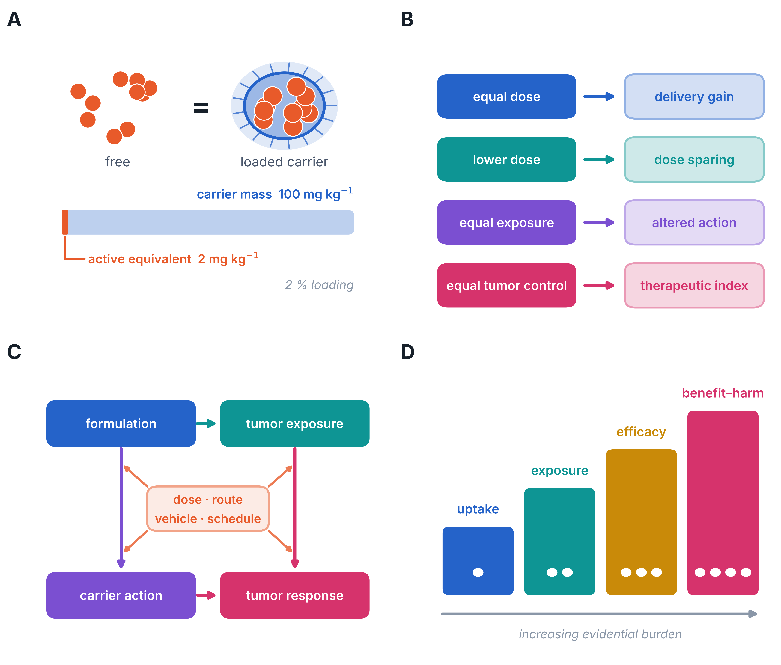
A, Equal carrier mass is not equal active dose: a 100 mg/kg particle dose at 2% drug loading delivers approximately 2 mg/kg of active compound, so dosing must be expressed per unit of measured active moiety rather than per unit of particle mass. B, Four matched conditions estimate four different quantities. Equal administered dose estimates a delivery gain; a lower formulated dose estimates dose sparing; equal plasma or tumor exposure estimates altered distribution or carrier pharmacology; equal tumor control estimates the therapeutic index. C, Formulation can act on tumor response both by increasing exposure and through carrier pharmacology, and dose, route, vehicle and schedule modify every path; all four must be matched before either mechanism is inferred. D, Claims of uptake, exposure, efficacy and benefit–harm are ordered by evidential burden, and the dots indicate the increasing number of independent measurements each claim requires. This is a conceptual diagram with no experimental or simulated data.

Figure 2. EGCG animal experiments separated by formulation and dosing design
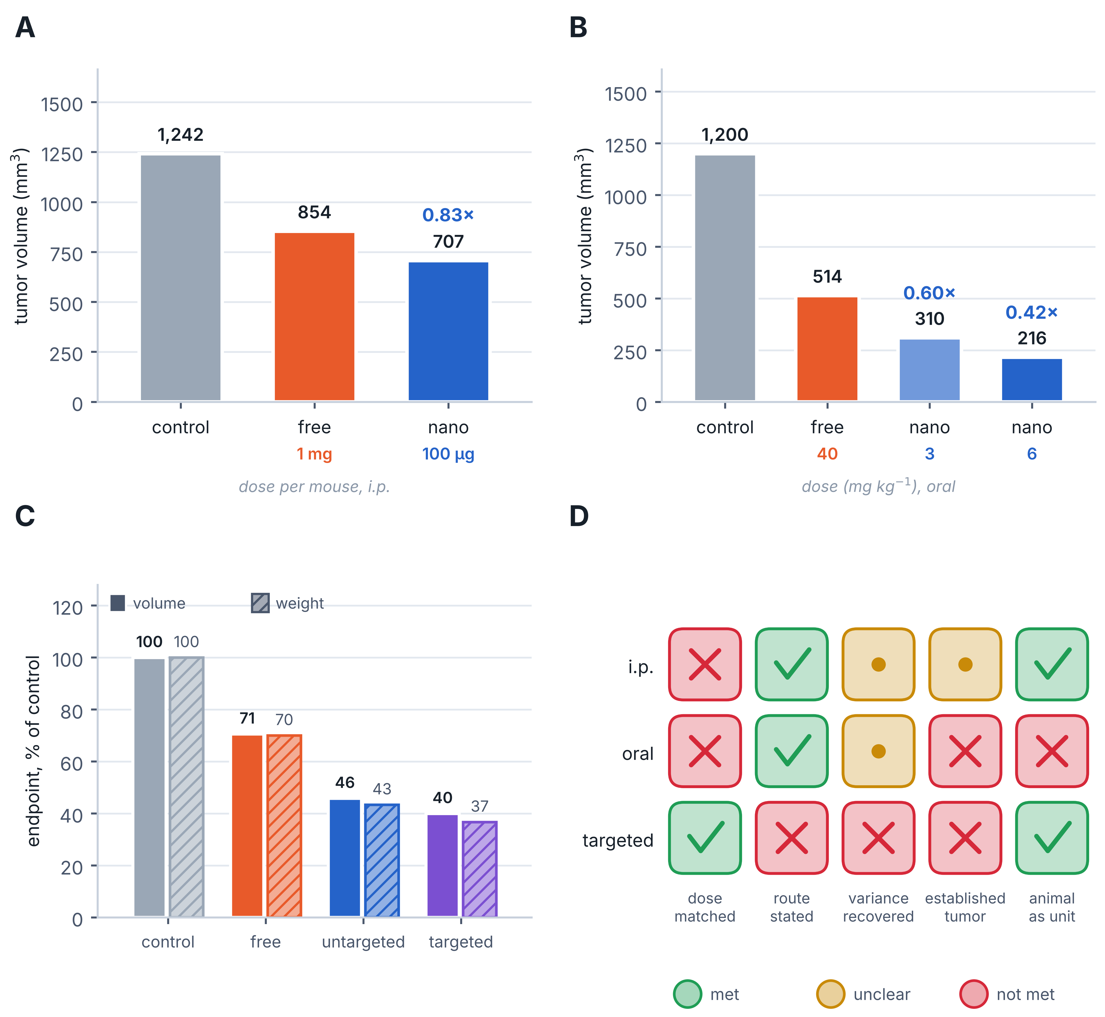
A, Reported day-45 mean tumor volumes in 22Rv1 xenografts for intraperitoneal free EGCG at 1 mg per mouse and PLA–PEG nano-EGCG at 100 µg per mouse, three times weekly, n = 7 per group [1]. The experiment was terminated when control tumors reached 1,300 mm³, and dispersion in the source figure is standard error. B, Day-32 means for oral free EGCG at 40 mg/kg and chitosan-EGCG at 3 and 6 mg/kg, five times weekly, n = 12 mice per group with two flank tumors per mouse [6]; the full text of this report could not be retrieved for independent re-checking, so these values are reproduced as extracted. C, Endpoint tumor volume and tumor weight for free EGCG and for untargeted and PSMA-directed nanoparticles, each expressed as a percentage of the control group so that both endpoints share one scale, n = 12 per group [7]. The two endpoints agree closely. D, Audit of the conditions required to interpret each experiment, as verified against the primary full texts; entries describe what the sources report and are not assertions about conduct. Values printed above bars in A and B are formulated-to-free ratios of reported group means. Bars begin at zero. Numerical endpoint uncertainty was not recovered for any of the three experiments, so no inferential comparison and no pooled estimate are shown. In C the source states 100 µg per mouse per day in its results and 100 mg per mouse per day in its methods, does not state the administration route, and reports standard error in its statistics section but standard deviation in the corresponding figure legend.

Figure 3. Curcumin tumor outcomes and model dependence
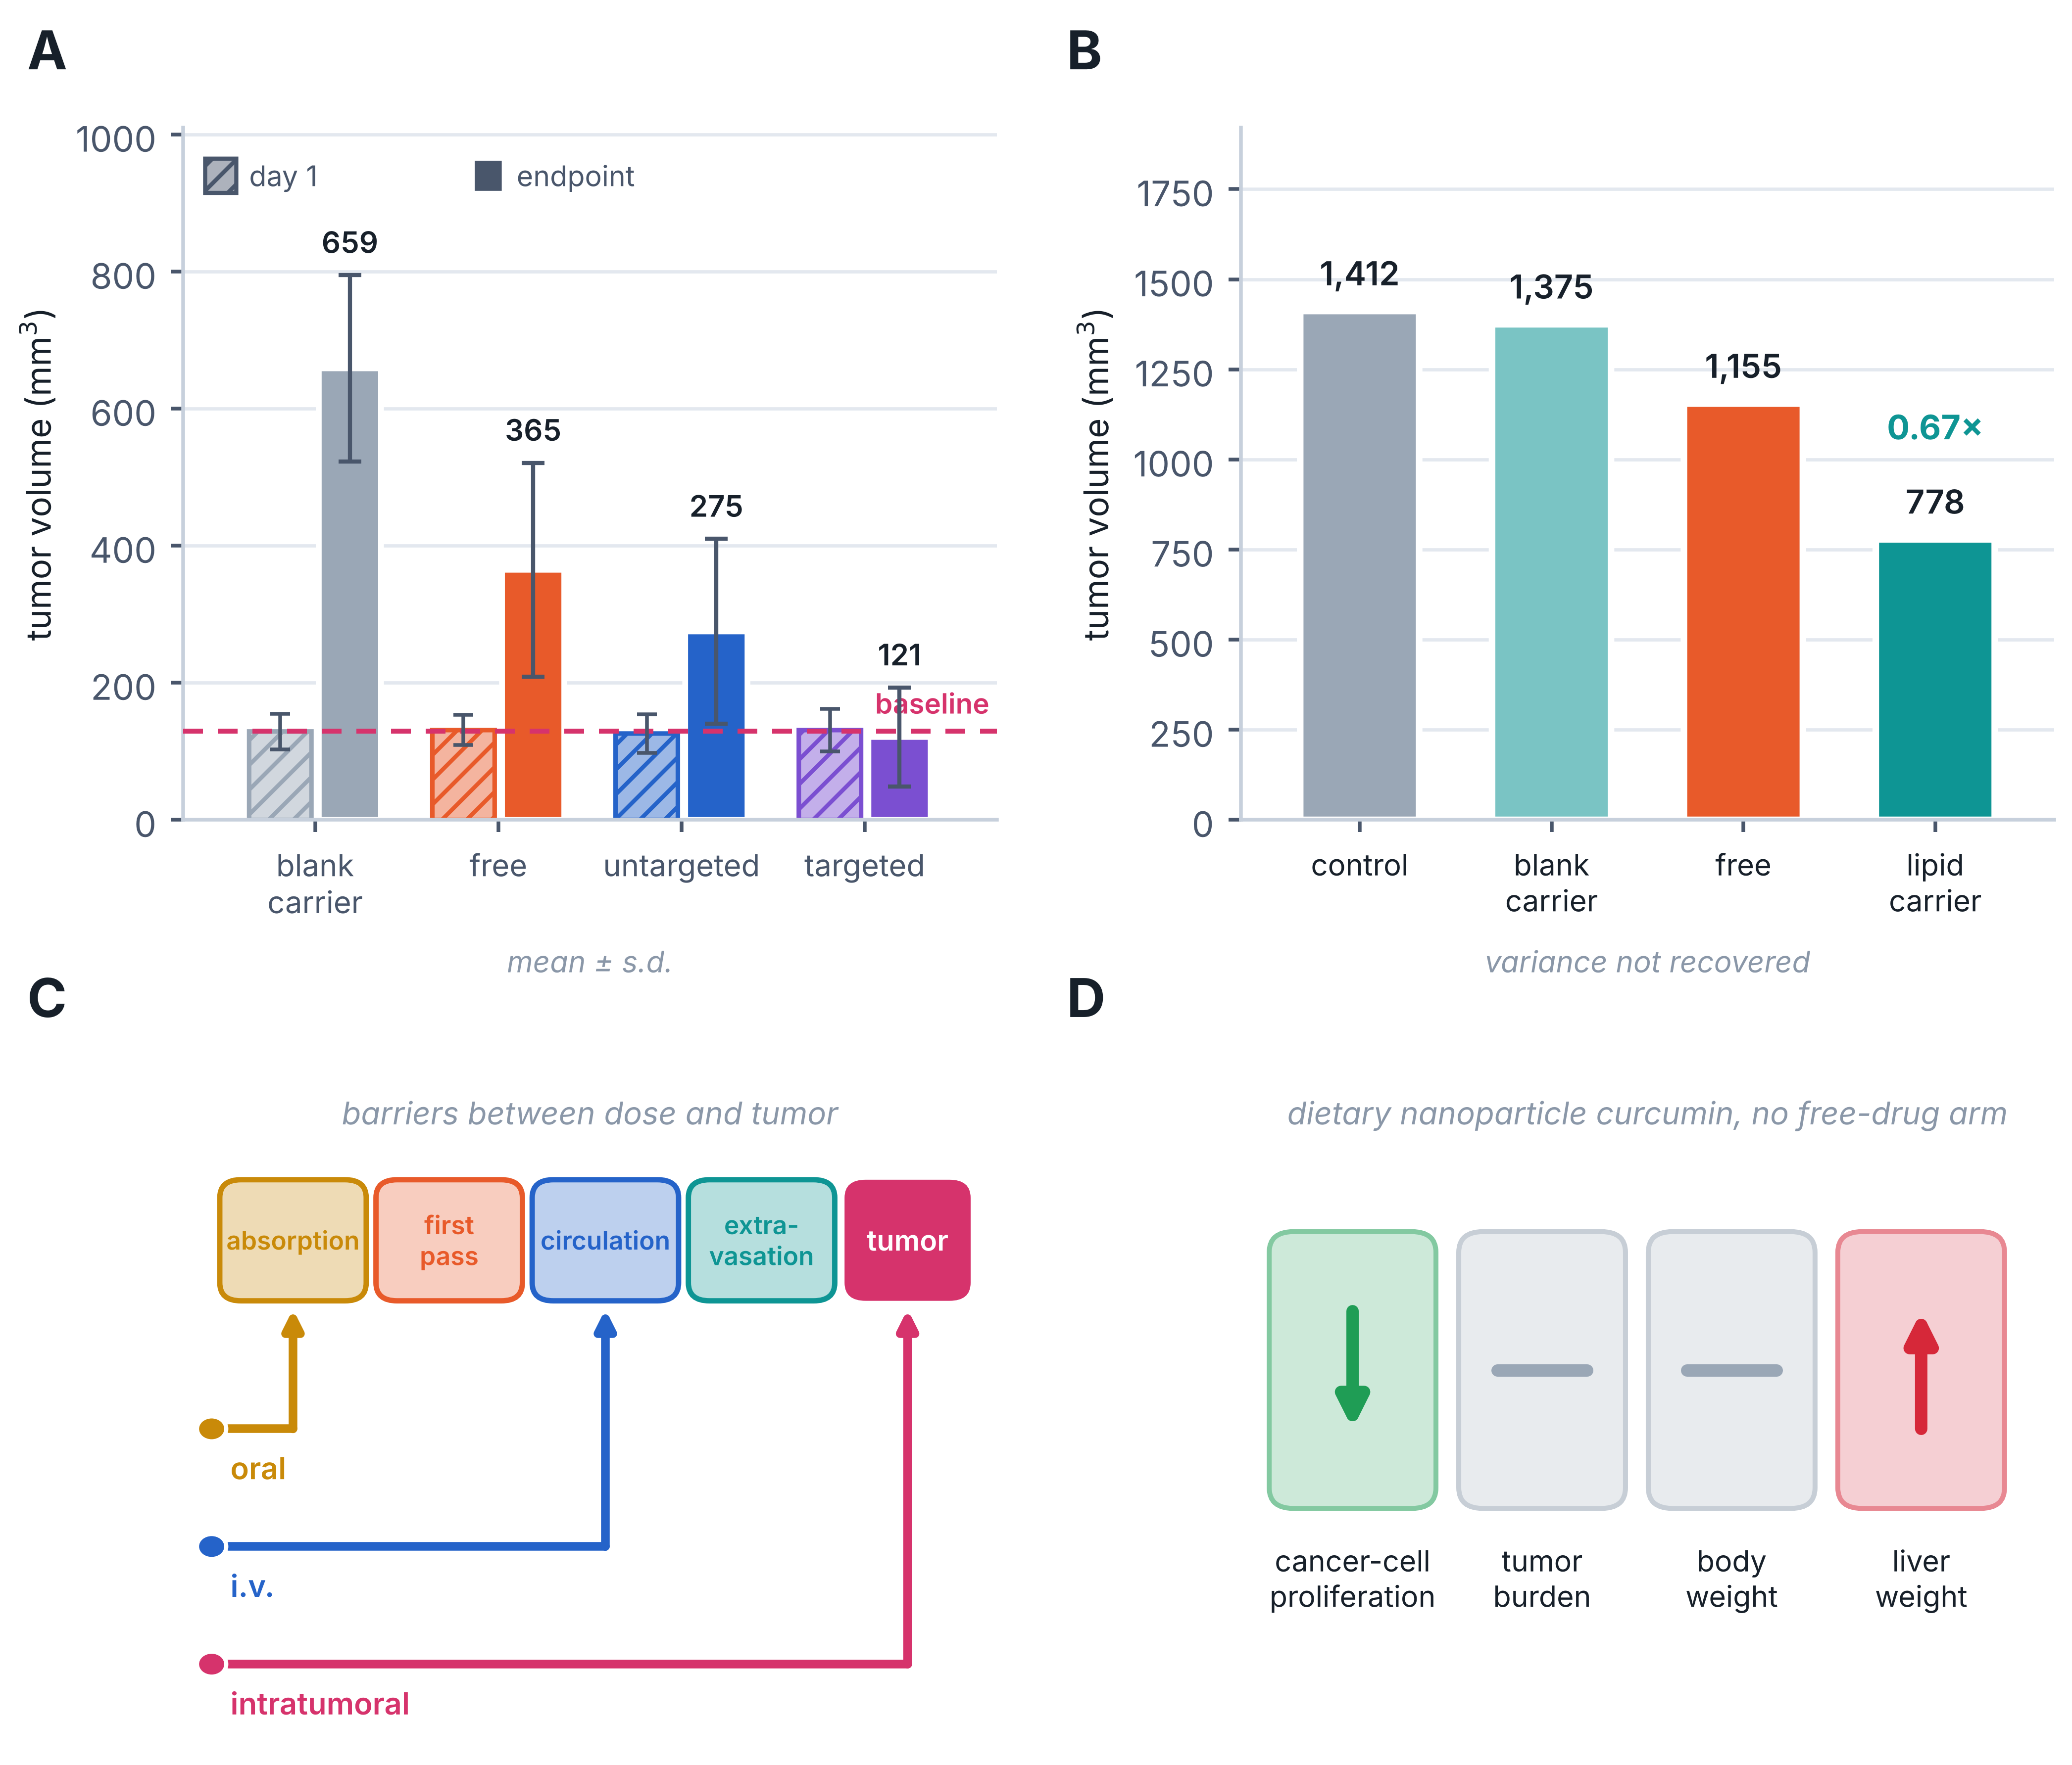
A, Source-table day-1 and endpoint mean volumes ± s.d. in DU145 xenografts for blank liposomes, free curcumin, untargeted liposomes and CD133-aptamer A15 liposomes at 25 µg curcumin equivalent intravenously, n = 6 per group [9]. The dashed line marks the mean day-1 volume; only the targeted arm ends below its own baseline, which is regression rather than slowed growth. The source conflicts on whether the endpoint is day 7 or day 10, and the free drug was given in DMSO while both liposome arms were given in buffered saline. B, Means for untreated control, blank carriers, free curcumin and curcumin-loaded nanostructured lipid carriers in LNCaP xenografts at 20 mg/kg intravenously twice weekly for 30 days [10]. The blank carrier does not differ appreciably from untreated control, so the carrier appears inert in this system. The article states no group size for this experiment and gives no endpoint variance. C, Administration routes occupy different evidential strata because each bypasses a different set of barriers between the administered dose and the tumor; the intratumoral PLGA-curcumin experiment therefore cannot support claims about oral bioavailability, circulation persistence or systemic targeting [2]. D, Divergent readouts in the dietary Pten-deficient experiment: reduced cancer-cell proliferation with unchanged tumor burden and body weight, and increased liver weight, after sixteen weeks of supplementation in a design that contained no free-drug comparator [11]. The value above the bar in B is the formulated-to-free ratio of reported group means.

Figure 4. Exposure interpretation and therapeutic index
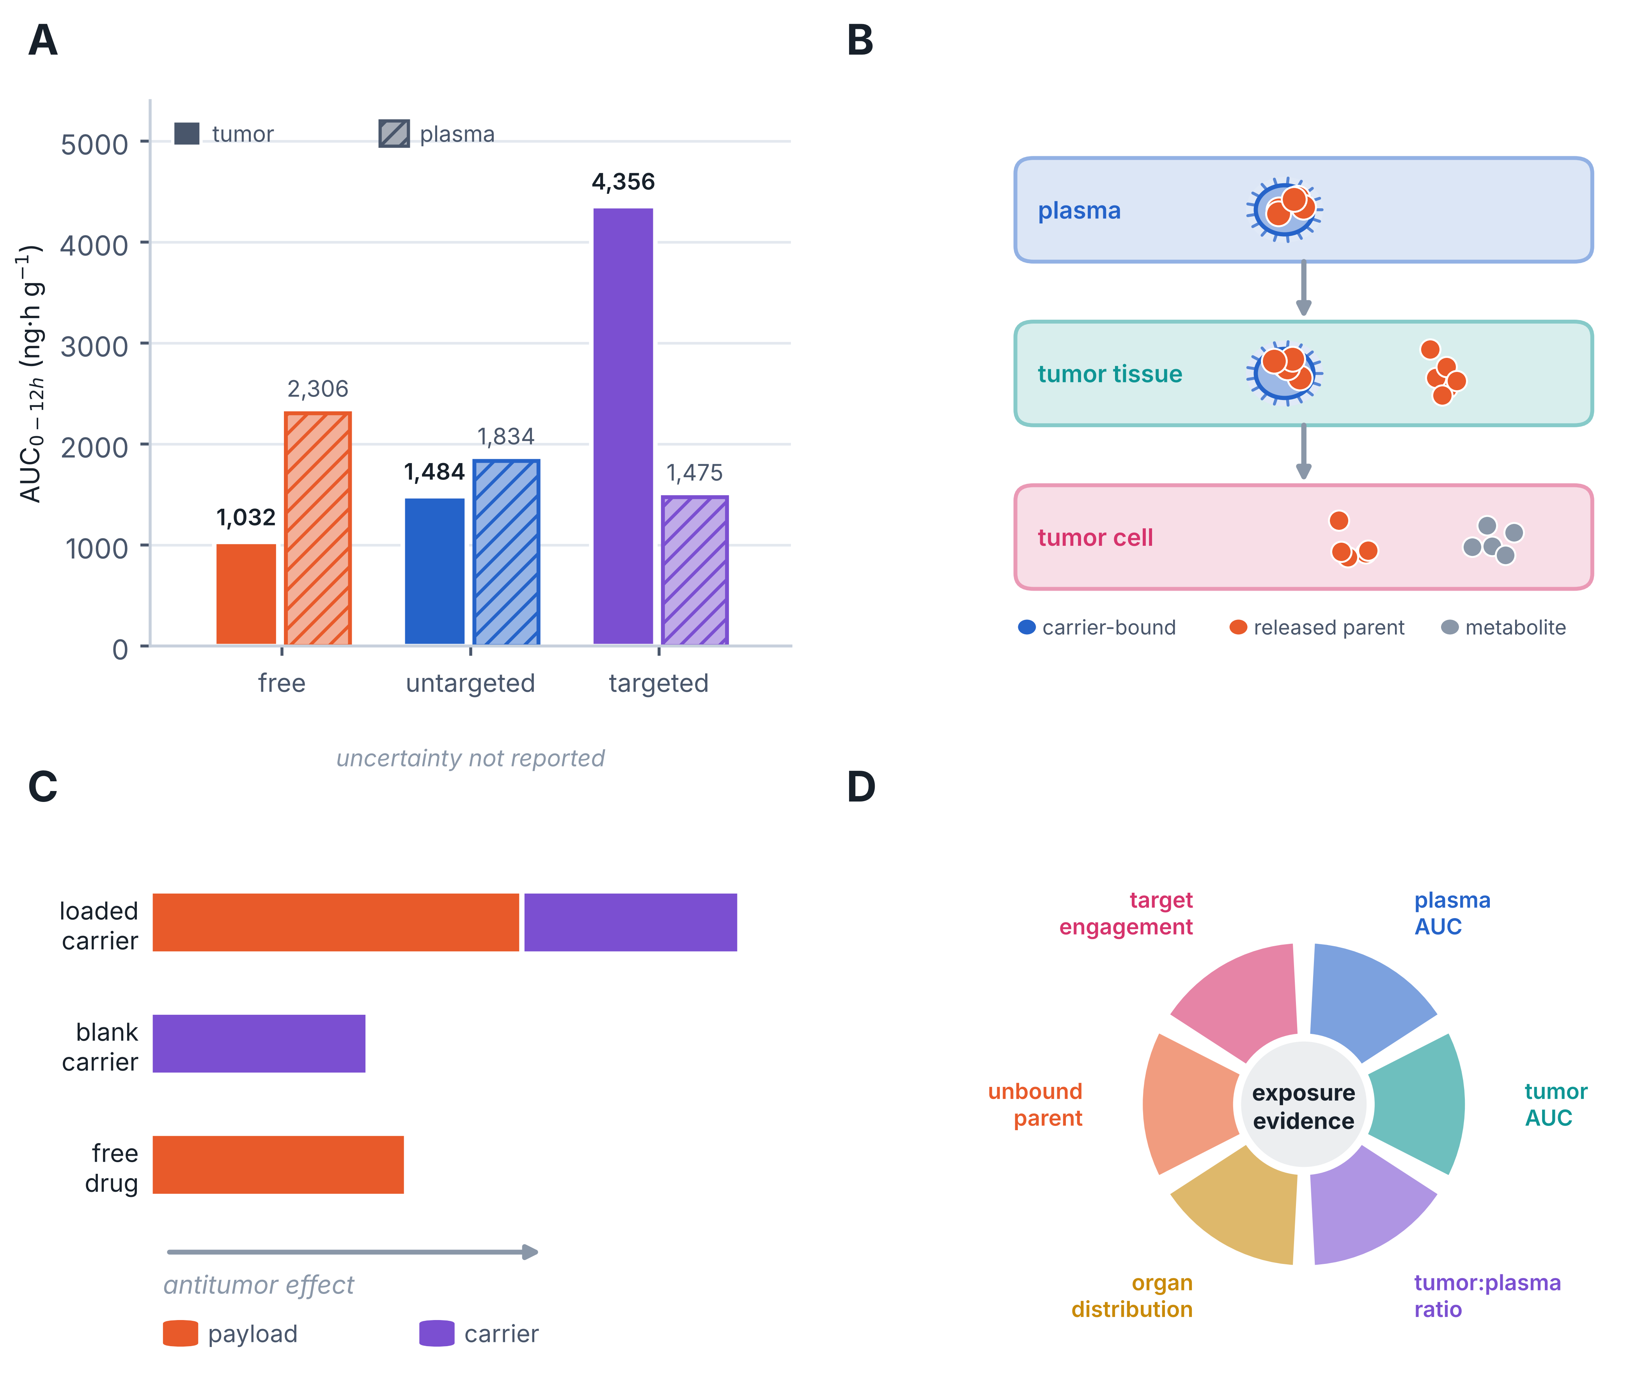
A, Curcumin tumor and plasma AUC0–12h transcribed from the source table for free curcumin and for untargeted and A15 liposomes at 10 mg/kg intravenously [9]. Tumor exposure rises 4.22-fold in the targeted arm while plasma exposure falls, the pattern expected of redistribution rather than of increased systemic exposure. The table reports n = 6, but the methods describe three animals at each of four time points, the accompanying prose reports a targeting index of 3.12 against the 4.2 ratio printed in the table and describes a 24-hour window against the table’s 12-hour heading, and no uncertainty is given. These data come from a dosing experiment separate from the efficacy experiment in Figure 3A. B, Carrier-associated drug, released parent compound and metabolites are distinct analytes distributed differently across plasma, tumor tissue and tumor cells; total homogenate content and fluorescence intensity do not distinguish them. C, The effect of a loaded carrier decomposes into a payload contribution and a carrier contribution, which can be separated only when a blank-carrier arm and a free-drug arm are both present. D, Minimum measurement set for relating tumor benefit to exposure and toxicity. B–D are conceptual and present no measured results.

Figure 5. Reporting audit and conditions for an animal meta-analysis
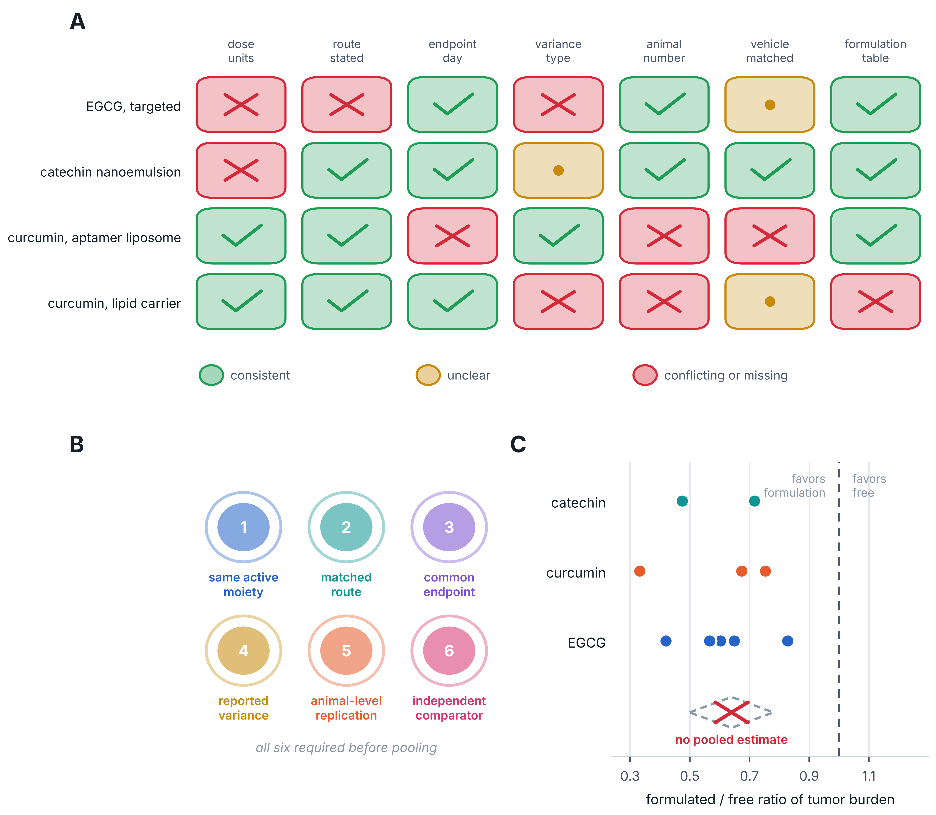
A, Extraction barriers encountered in four full reports, each entry verified against the primary text [7–10]. An unclear entry means the information could not be established from the passages examined and is not an assertion that the work was flawed. B, Six conditions that must hold simultaneously before a formulation contrast can be pooled across experiments. C, Descriptive formulated-to-free ratios of reported group means, plotted by compound on a common axis. Points are individual within-study contrasts. Catechin ratios derive from tumor weight and the remaining ratios from tumor volume, which is one reason they are not combined. No confidence intervals are shown because sampling variances were not recoverable, and no pooled estimate was calculated; the position where a summary diamond would appear is marked as deliberately empty. A log response ratio, lnRR = ln(mean nanoparticle / mean free), would be the appropriate estimator once variances and independent animal counts are available. No meta-analysis was performed.

Figure 6. A decisive next-generation formulation experiment
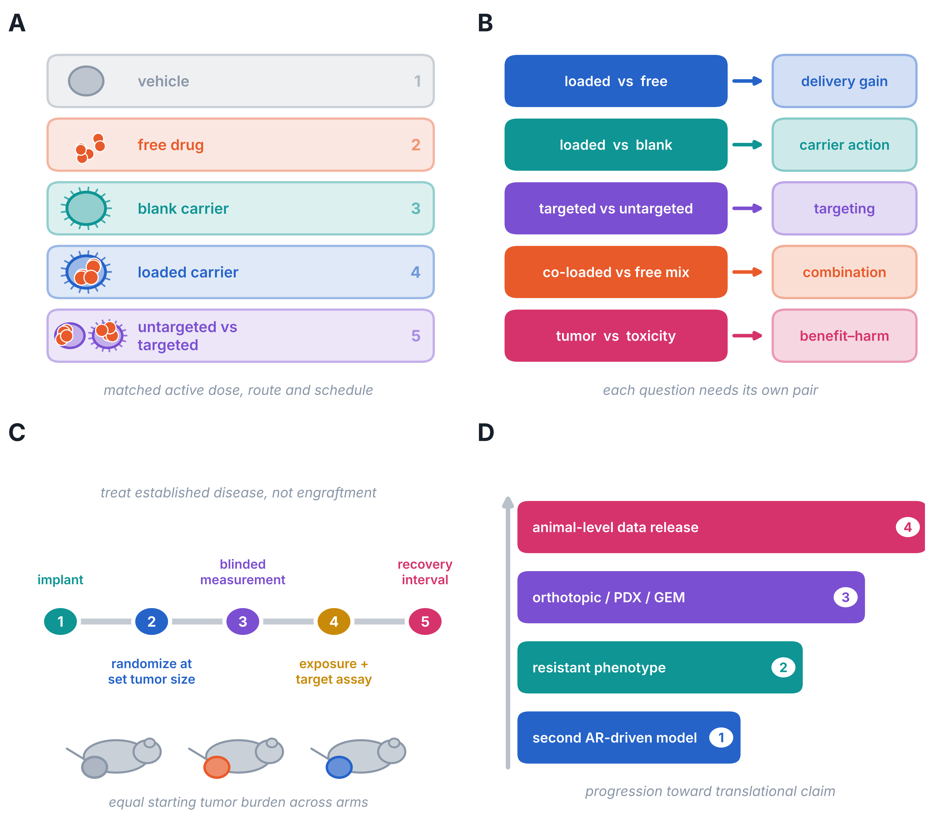
A, Core arms at matched active-equivalent dose, route and schedule, including the free-drug vehicle, the blank carrier and, for targeted systems, a composition-matched untargeted comparator. B, Each question requires its own prespecified contrast; a single comparison against untreated controls answers none of them. C, Prespecified sequence: implantation, randomization only after tumors reach a prespecified size, blinded measurement, chemical exposure and target-engagement assays at the actual efficacy dose, and a treatment-free recovery interval to test persistence, recurrence and delayed toxicity. The mice are drawn with equal starting tumor burden to indicate allocation after establishment rather than at implantation. D, Replication and reporting steps that support progression toward a translational claim. For combinations, add each individual agent and a dose- and ratio-matched free mixture. This figure proposes a design and presents no experimental outcomes.

References
[1] Siddiqui IA, Adhami VM, Bharali DJ, Hafeez BB, Asim M, Khwaja SI, et al. Introducing nanochemoprevention as a novel approach for cancer control: proof of principle with green tea polyphenol epigallocatechin-3-gallate. Cancer research. 2009;69(5):1712-6. doi: 10.1158/0008-5472.CAN-08-3978. https://pubmed.ncbi.nlm.nih.gov/19223530/
[2] Yallapu MM, Khan S, Maher DM, Ebeling MC, Sundram V, Chauhan N, et al. Anti-cancer activity of curcumin loaded nanoparticles in prostate cancer. Biomaterials. 2014;35(30):8635-48. doi: 10.1016/j.biomaterials.2014.06.040. https://pubmed.ncbi.nlm.nih.gov/25028336/
[3] Hooijmans CR, Rovers MM, de Vries RBM, Leenaars M, Ritskes-Hoitinga M, Langendam MW. SYRCLE's risk of bias tool for animal studies. BMC medical research methodology. 2014;14:43. doi: 10.1186/1471-2288-14-43. https://pubmed.ncbi.nlm.nih.gov/24667063/
[4] Percie du Sert N, Hurst V, Ahluwalia A, Alam S, Avey MT, Baker M, et al. The ARRIVE guidelines 2.0: Updated guidelines for reporting animal research. PLoS biology. 2020;18(7):e3000410. doi: 10.1371/journal.pbio.3000410. https://pubmed.ncbi.nlm.nih.gov/32663219/
[5] Faria M, Björnmalm M, Thurecht KJ, Kent SJ, Parton RG, Kavallaris M, et al. Minimum information reporting in bio-nano experimental literature. Nature nanotechnology. 2018;13(9):777-785. doi: 10.1038/s41565-018-0246-4. https://pubmed.ncbi.nlm.nih.gov/30190620/
[6] Khan N, Bharali DJ, Adhami VM, Siddiqui IA, Cui H, Shabana SM, et al. Oral administration of naturally occurring chitosan-based nanoformulated green tea polyphenol EGCG effectively inhibits prostate cancer cell growth in a xenograft model. Carcinogenesis. 2014;35(2):415-23. doi: 10.1093/carcin/bgt321. https://pubmed.ncbi.nlm.nih.gov/24072771/
[7] Sanna V, Singh CK, Jashari R, Adhami VM, Chamcheu JC, Rady I, et al. Targeted nanoparticles encapsulating (-)-epigallocatechin-3-gallate for prostate cancer prevention and therapy. Scientific reports. 2017;7:41573. doi: 10.1038/srep41573. https://pubmed.ncbi.nlm.nih.gov/28145499/
[8] Lin YH, Wang CC, Lin YH, Chen BH. Preparation of Catechin Nanoemulsion from Oolong Tea Leaf Waste and Its Inhibition of Prostate Cancer Cells DU-145 and Tumors in Mice. Molecules (Basel, Switzerland). 2021;26(11). doi: 10.3390/molecules26113260. https://pubmed.ncbi.nlm.nih.gov/34071530/
[9] Ma Q, Qian W, Tao W, Zhou Y, Xue B. Delivery Of Curcumin Nanoliposomes Using Surface Modified With CD133 Aptamers For Prostate Cancer. Drug design, development and therapy. 2019;13:4021-4033. doi: 10.2147/DDDT.S210949. https://pubmed.ncbi.nlm.nih.gov/31819373/
[10] Akanda M, Getti G, Douroumis D. In vivo evaluation of nanostructured lipid carrier systems (NLCs) in mice bearing prostate cancer tumours. Drug delivery and translational research. 2023;13(8):2083-2095. doi: 10.1007/s13346-021-01095-1. https://pubmed.ncbi.nlm.nih.gov/34845679/
[11] De Velasco MA, Lu Y, Kura Y, China T, Inoue Y, Nakayama A, et al. Chemopreventive effects of nanoparticle curcumin in a mouse model of Pten-deficient prostate cancer. Human cell. 2020;33(3):730-736. doi: 10.1007/s13577-020-00337-7. https://pubmed.ncbi.nlm.nih.gov/32146706/
[12] Thangavel S, Yoshitomi T, Sakharkar MK, Nagasaki Y. Redox nanoparticles inhibit curcumin oxidative degradation and enhance its therapeutic effect on prostate cancer. Journal of controlled release : official journal of the Controlled Release Society. 2015;209:110-9. doi: 10.1016/j.jconrel.2015.04.025. https://pubmed.ncbi.nlm.nih.gov/25912409/
[13] Zhao J, Liu J, Wei T, Ma X, Cheng Q, Huo S, et al. Quercetin-loaded nanomicelles to circumvent human castration-resistant prostate cancer in vitro and in vivo. Nanoscale. 2016;8(9):5126-38. doi: 10.1039/c5nr08966b. https://pubmed.ncbi.nlm.nih.gov/26875690/
[14] Turkekul K, Erdogan S. Potent Suppression of Prostate Cancer Cell Growth and Eradication of Cancer Stem Cells by CD44-targeted Nanoliposome-quercetin Nanoparticles. Journal of cancer prevention. 2023;28(4):160-174. doi: 10.15430/JCP.2023.28.4.160. https://pubmed.ncbi.nlm.nih.gov/38205358/
[15] Sanna V, Siddiqui IA, Sechi M, Mukhtar H. Resveratrol-loaded nanoparticles based on poly(epsilon-caprolactone) and poly(D,L-lactic-co-glycolic acid)-poly(ethylene glycol) blend for prostate cancer treatment. Molecular pharmaceutics. 2013;10(10):3871-81. doi: 10.1021/mp400342f. https://pubmed.ncbi.nlm.nih.gov/23968375/
[16] Sharma AN, Upadhyay PK, Dewangan HK. Development, evaluation, pharmacokinetic and biodistribution estimation of resveratrol-loaded solid lipid nanoparticles for prostate cancer targeting. Journal of microencapsulation. 2022;39(6):563-574. doi: 10.1080/02652048.2022.2135785. https://pubmed.ncbi.nlm.nih.gov/36222429/
[17] Chaudhary Z, Subramaniam S, Khan GM, Abeer MM, Qu Z, Janjua T, et al. Encapsulation and Controlled Release of Resveratrol Within Functionalized Mesoporous Silica Nanoparticles for Prostate Cancer Therapy. Frontiers in bioengineering and biotechnology. 2019;7:225. doi: 10.3389/fbioe.2019.00225. https://pubmed.ncbi.nlm.nih.gov/31620434/
[18] Sanna V, Chamcheu JC, Pala N, Mukhtar H, Sechi M, Siddiqui IA. Nanoencapsulation of natural triterpenoid celastrol for prostate cancer treatment. International journal of nanomedicine. 2015;10:6835-46. doi: 10.2147/IJN.S93752. https://pubmed.ncbi.nlm.nih.gov/26586945/
[19] Yin J, Wang P, Yin Y, Hou Y, Song X. Optimization on biodistribution and antitumor activity of tripterine using polymeric nanoparticles through RES saturation. Drug delivery. 2017;24(1):1891-1897. doi: 10.1080/10717544.2017.1410260. https://pubmed.ncbi.nlm.nih.gov/29191042/
[20] Vicil S, Serttas R, Erdogan S. Nanoparticle-enhanced apigenin suppresses androgen receptor signaling and cellular plasticity in LNCaP cells. Scientific reports. 2026;16(1). doi: 10.1038/s41598-026-63769-5. https://pubmed.ncbi.nlm.nih.gov/42675095/
[21] Alzhrani RF, Alamer K, Alothaymin N, Syed R, Bakheit AH, Harisa GI. A Multifunctional Chitosan-Coated Ciprofloxacin-Luteolin Lipid Nanoplatform for Photodynamic Therapy of Prostatic Cancer. International journal of molecular sciences. 2026;27(17). doi: 10.3390/ijms27177594. https://pubmed.ncbi.nlm.nih.gov/42737496/
[22] Narayanan NK, Nargi D, Randolph C, Narayanan BA. Liposome encapsulation of curcumin and resveratrol in combination reduces prostate cancer incidence in PTEN knockout mice. International journal of cancer. 2009;125(1):1-8. doi: 10.1002/ijc.24336. https://pubmed.ncbi.nlm.nih.gov/19326431/
[23] Chu PY, Tsai SC, Ko HY, Wu CC, Lin YH. Co-Delivery of Natural Compounds with a Dual-Targeted Nanoparticle Delivery System for Improving Synergistic Therapy in an Orthotopic Tumor Model. ACS applied materials & interfaces. 2019;11(27):23880-23892. doi: 10.1021/acsami.9b06155. https://pubmed.ncbi.nlm.nih.gov/31192580/
[24] Yan J, Wang Y, Zhang X, Liu S, Tian C, Wang H. Targeted nanomedicine for prostate cancer therapy: docetaxel and curcumin co-encapsulated lipid-polymer hybrid nanoparticles for the enhanced anti-tumor activity in vitro and in vivo. Drug delivery. 2016;23(5):1757-62. doi: 10.3109/10717544.2015.1069423. https://pubmed.ncbi.nlm.nih.gov/26203689/
[25] Chen Y, Deng Y, Zhu C, Xiang C. Anti prostate cancer therapy: Aptamer-functionalized, curcumin and cabazitaxel co-delivered, tumor targeted lipid-polymer hybrid nanoparticles. Biomedicine & pharmacotherapy = Biomedecine & pharmacotherapie. 2020;127:110181. doi: 10.1016/j.biopha.2020.110181. https://pubmed.ncbi.nlm.nih.gov/32416561/
[26] Zhang L, Lin Z, Chen Y, Gao D, Wang P, Lin Y, et al. Co-delivery of Docetaxel and Resveratrol by liposomes synergistically boosts antitumor efficiency against prostate cancer. European journal of pharmaceutical sciences : official journal of the European Federation for Pharmaceutical Sciences. 2022;174:106199. doi: 10.1016/j.ejps.2022.106199. https://pubmed.ncbi.nlm.nih.gov/35533965/
[27] Mahira S, Kommineni N, Husain GM, Khan W. Cabazitaxel and silibinin co-encapsulated cationic liposomes for CD44 targeted delivery: A new insight into nanomedicine based combinational chemotherapy for prostate cancer. Biomedicine & pharmacotherapy = Biomedecine & pharmacotherapie. 2019;110:803-817. doi: 10.1016/j.biopha.2018.11.145. https://pubmed.ncbi.nlm.nih.gov/30554119/
[28] Almutairy B, Alharthi S, Ebrahimi Shahmabadi H, Alavi SE. Use of nanoemulsion for co-delivery of silibinin and cabazitaxel for prostate cancer treatment. Drug development and industrial pharmacy. 2025;51(11):1591-1606. doi: 10.1080/03639045.2025.2552392. https://pubmed.ncbi.nlm.nih.gov/40853234/
[29] Song YY, Yuan Y, Shi X, Che YY. Improved drug delivery and anti-tumor efficacy of combinatorial liposomal formulation of genistein and plumbagin by targeting Glut1 and Akt3 proteins in mice bearing prostate tumor. Colloids and surfaces. B, Biointerfaces. 2020;190:110966. doi: 10.1016/j.colsurfb.2020.110966. https://pubmed.ncbi.nlm.nih.gov/32199263/
[30] Yakubu J, Natsaridis E, du Toit T, Barata IS, Tagit O, Pandey AV. Nanoparticles with curcumin and piperine modulate steroid biosynthesis in prostate cancer. Scientific reports. 2025;15(1):13613. doi: 10.1038/s41598-025-98102-z. https://pubmed.ncbi.nlm.nih.gov/40253525/
[31] Greil R, Greil-Ressler S, Weiss L, Schönlieb C, Magnes T, Radl B, et al. A phase 1 dose-escalation study on the safety, tolerability and activity of liposomal curcumin (Lipocurc™) in patients with locally advanced or metastatic cancer. Cancer chemotherapy and pharmacology. 2018;82(4):695-706. doi: 10.1007/s00280-018-3654-0. https://pubmed.ncbi.nlm.nih.gov/30074076/
[32] Singh SK, Mishra MK, Singh R. Abstract 301: Repurposing engineered thymoquinone nanoparticles to inhibit drug-resistant prostate cancer Cancer Research. 2022;82(12_Supplement):301-301. doi: 10.1158/1538-7445.am2022-301. Conference abstract. https://doi.org/10.1158/1538-7445.am2022-301
[33] Singh SK, Lillard JW, Singh R. Abstract 821: Targeting metastatic prostate cancer using planetary ball-milled (PBM) nanoparticles Cancer Research. 2023;83(7_Supplement):821-821. doi: 10.1158/1538-7445.am2023-821. Conference abstract. https://doi.org/10.1158/1538-7445.am2023-821
[34] Singh SK, Gordetsky JB, Bae S, Acosta EP, Lillard JW, Singh R. Selective Targeting of the Hedgehog Signaling Pathway by PBM Nanoparticles in Docetaxel-Resistant Prostate Cancer. Cells. 2020;9(9). doi: 10.3390/cells9091976. https://pubmed.ncbi.nlm.nih.gov/32867229/
[35] Sakr TM, Thipe VC, Katti KK, Watkinson L, Carmack T, Smith CJ, et al. Immunomodulatory green nanomedicine production, tumor cellular targeting, in vivo biodistributions and preclinical therapeutic efficacy investigations of resveratrol-functionalized gold and theranostic ¹⁹⁸Au nanoparticles. Journal of materials chemistry. B. 2025;13(27):8038-8050. doi: 10.1039/d5tb00815h. https://pubmed.ncbi.nlm.nih.gov/40530440/

