**Playtest Document**

Playtest Number One: Monday May 4th, 2015

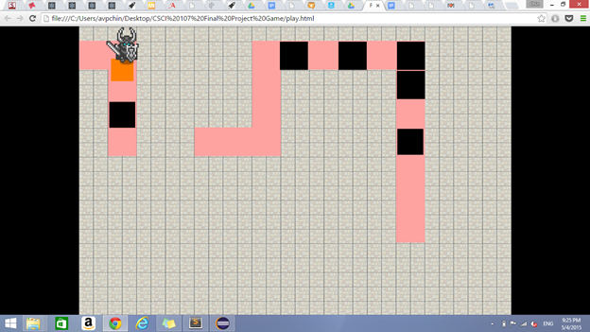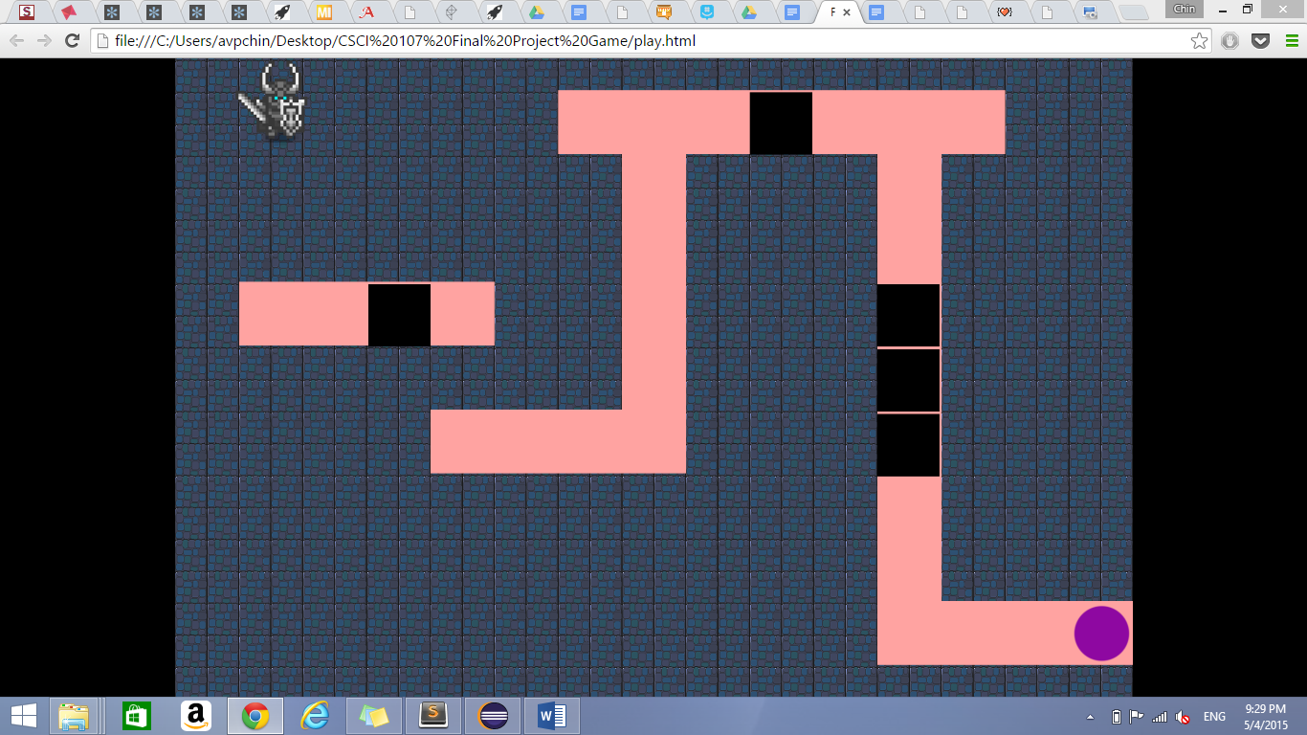

|  |  |
| --- | --- |
| Observations: | The overlapped box on the holes looks like it doesn’t completely overlap the hole, which is problematic because the player can’t tell if they can walk across. |
| Player Comments during gameplay: | The player can’t differentiate between the obstacles and the holes. The level was rather easy to finish after the player figured out the mechanics. |
| Player Feedback: | The player suggested that we use puzzles from Portal because our switching worlds mechanics reminds him about portal. |
| Suggested Adjustments to mechanics: | Code Suggestions: How to implement things better. Aesthetically the boxes should be overlapped well over the holes. The changing worlds button should not lag. We need interesting level designs. The game would be a memorizing game if we added enemies every time the player switched world’s because it would lose it puzzle-like quality,  Our focus right now should be making good puzzles. The idea is good but we need to brainstorm better and more interesting level designs. Colored boxes only working with certain colors of holes or doors. |
| Adjustments made to the game: | Changed the obstacle and holes interaction so that if the player places a box on a hole, the box is hidden when the hole changes color.. Before this, the box would still be there on some part of the hole. Mechanically, the hole was still covered so the player could cross to the other side of the path, but it was not displayed well visually. We also changed the color of the obstacle to make it more visible and to contrast it from the holes and the other objects on the screen.  We also fixed a bug that involves a player moving out of the platform area. |

Playtest Number Two: Wednesday, May 6th, 2015

|  |  |
| --- | --- |
| Observations: | The instructions were not clear and confused the player. The player was confused with what the objective of the game was, and it was difficult for the player to figure out what to do. Without clear instructions, the game is not very intuitive.  Player completed first two levels. |
| Player Comments during gameplay: | Player couldn’t tell if the squares could be placed on the colored circles/holes. He also was unclear about the objective of each level. He frequently mentioned that the game was difficult. |
| Player Feedback: | The game was fun and challenging. However, it could be greatly improved with better graphics since the placeholder graphics are boring and sometimes confusing. |
| Suggested Adjustments: | Improve graphics and instructions (which should have a visual element). Differentiate among the different types of holes while still making them look like holes to make gameplay more intuitive. |
| Adjustments made to the game: | Made a restart level function so that the player can restart the level if he or she dies. |

Playtest Number Three: Monday, May 11th, 2015

|  |  |
| --- | --- |
| Observations: | Player struggles and pauses to think before making decisions. Player successfully passes through three levels with very minimal help. |
| Player Comments during gameplay: | Nothing much. |
| Player Feedback: | He likes it. It’s cute art-style.  The puzzles are pretty adequate.  Sufficiently challenging but also simple. |
| Suggested Adjustments: | Make things more graphically obvious.  Animation - glowing effect to show that the holes are filled. |
| Adjustments made to the game: | Make a restart level function so that the player can restart the game when he/she’s stuck |

Playtest Number Four: Monday, May 11th, 2015

|  |  |
| --- | --- |
| Observations: | Player isn’t aware of certain paths that could be traversed but are not obvious.  Player completes first two levels and gets stuck at the third level. |
| Player Comments during gameplay: | - |
| Player Feedback: | The puzzles are good.  The game was thoroughly entertaining.  Some paths are not obvious. |
| Suggested Adjustments: | Adding storyline to explain the game mechanics.  Make certain paths obvious. |
| Adjustments made to the game: |  |

Playtest Number Five: Tuesday, May 12th, 2015

|  |  |
| --- | --- |
| Observations: | Player isn’t aware of certain paths that could be traversed but are not obvious. |
| Player Comments during gameplay: | - |
| Player Feedback: |  |
| Suggested Adjustments: | Maybe turn cube into sphere  Tile level 1 for light world should have better saturation  Make it more obvious that stars in special holes can be picked up again  Make 3 background pictures to simulate animation  Make it more obvious that the star can fit into the holes.  Add shadow to star to make it appear as if it’s on the ground |
| Adjustments made to the game: | Made a special effect to show the star enveloping the hole.  Added shadows to the star.  Increased saturation of tiles in level 1. |