Avradip
SREE CEMENT
library(quantmod)
library(fpp)
getSymbols("SREECEMENT.NS")
AP=SREECEMENT.NS
plot(AP$SREECEMENT.NS.Close,type="l")
chartseries(SREECEMENT.BO,type=”candlesticks”)
addEMA(5,col=”red”)
addEMA(20,col=”green”)
addEMA(50,col=”white”)
zoomchart(“2020-01-01”)
addRSI() #(14,68,66)
Sreecementrsi=RSI(sreecement$SREECEMENT.NS.Close,sreecementrsi)
Colnames(sreecementrsidf)
rsisignal =ifelse(sreecementrsidf$rsi>sreecementrsidf$signal,1,0)
plot(rsisignal,type=”I”)

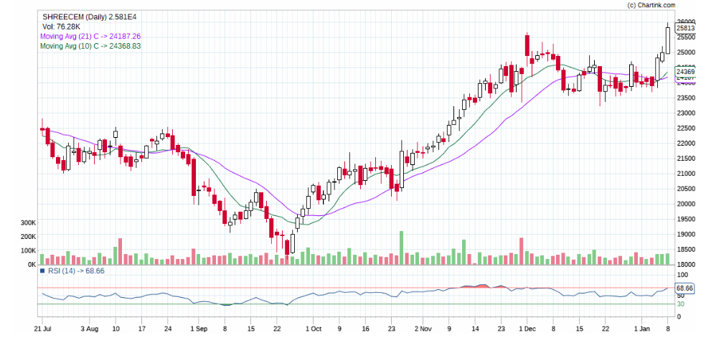

APclose=AP$SREECEMENT.NS.Close["2015-01-01::"]
APclose=na.omit(APclose)
plot(APclose,type="l")
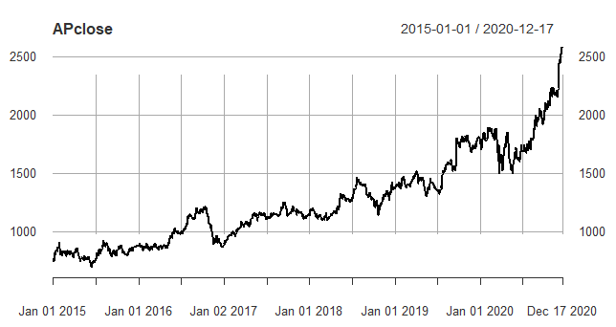
adf.test(APclose) # p-value = 0.9577
APclosediff=diff(APclose)
APclosediff=na.omit(APclosediff)
adf.test(APclosediff)
plot(APclosediff)
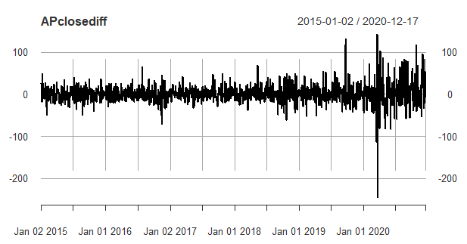
pp.test(APclosediff)
APclosediffts=ts(APclosediff,start=c(2015,1), frequency = 365)
plot(decompose(APclosediffts, type=c("multiplicative")))
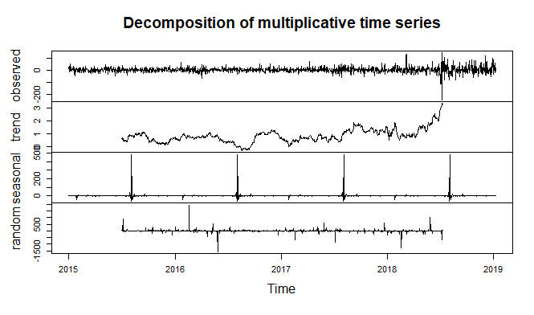
plot(decompose(APclosediffts,type=c("additive")))
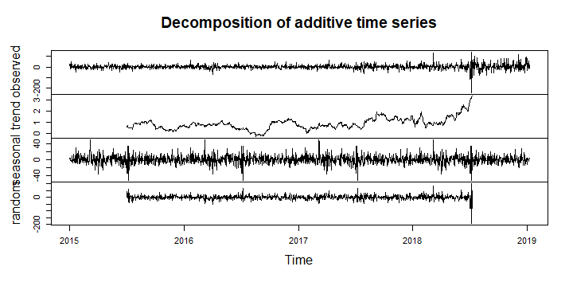
APsma=SMA(APclosediff,50)
plot(APclosediff,type="l")
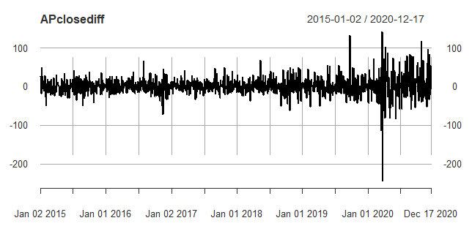
lines(APsma,col="red")
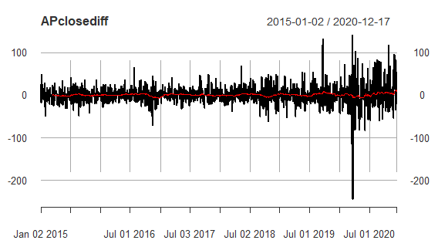

APets=ets(APclosediff)
summary(APets) # RMSE 22.55428
APetsforecast=forecast(APets,h=90)
plot(APetsforecast) # 90 Days forecast
# p-value = 1.175e-06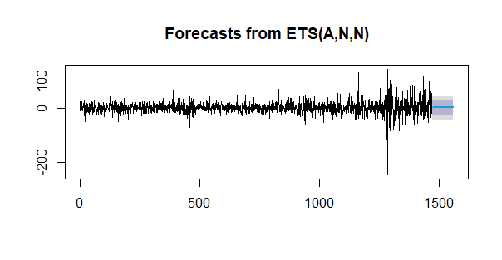
checkresiduals(APetsforecast)
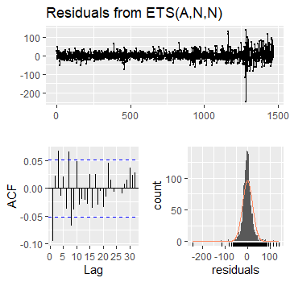
APholt=holt(APclosediff,h=90)
summary(APholt) # RMSE - 22.55428
plot(APholt)
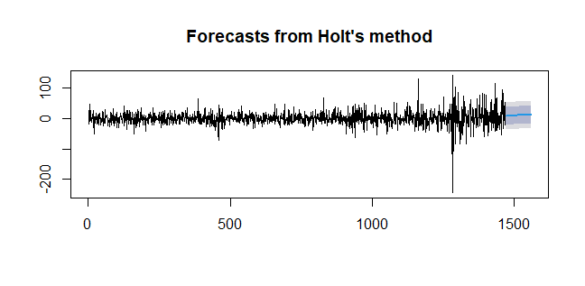
checkresiduals(APholt)
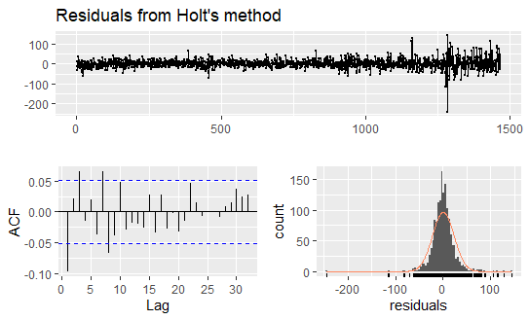
APsnaive=snaive(APclosediff,h=90) # p-value = 1.175e-06
summary(APsnaive)# RMSE - 22.71053
plot(APsnaive)
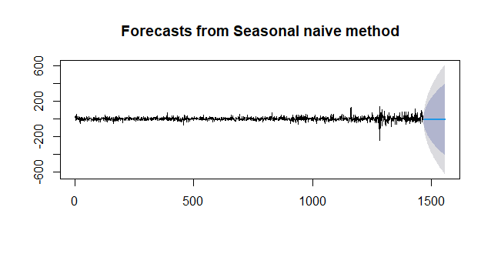
checkresiduals(APsnaive)
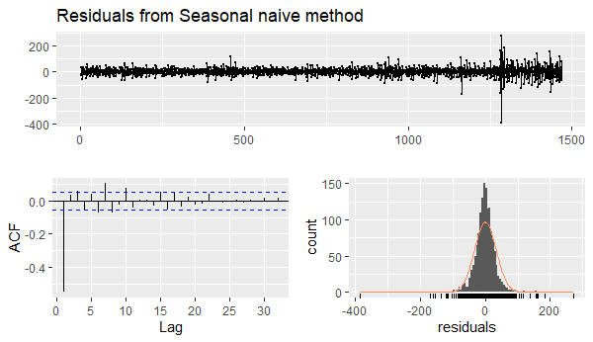

acf(APclosediff,lag.max = 30)# q=0
pacf(APclosediff,lag.max = 30)# p=6
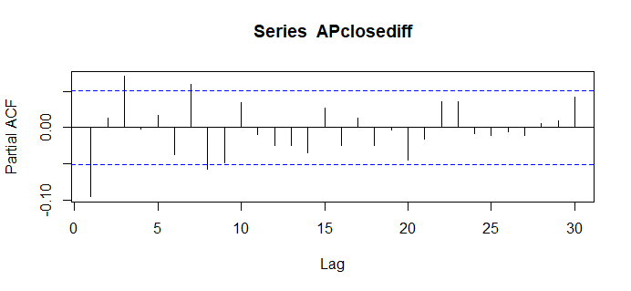
AParima=auto.arima(APclosediff)
summary(AParima)# RMSE - 33.39296
AParimaforecast=forecast(AParima,h=90)
plot(AParimaforecast)
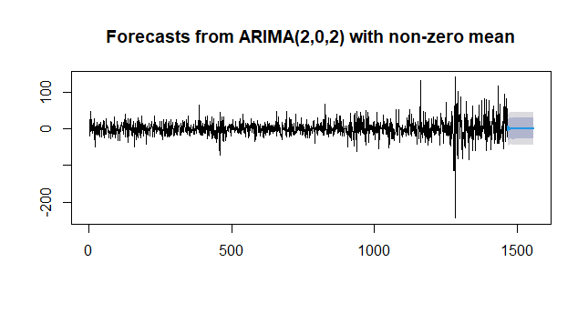
checkresiduals(AParimaforecast)
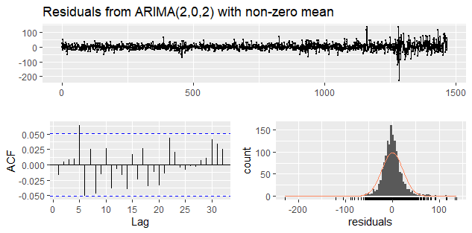

GODREJ INDUSTRIES
library(quantmod)
library(fpp)
getSymbols("GODREJINDUSTRIES.NS")
EM=GODREJINDUSTRIES.NS
plot(EM$GODREJINDUSTRIES.NS.Close,type="l")
chartseries(GODREJINDUSTRIES.BO,type=”candlesticks”)
addEMA(5,col=”red”)
addEMA(20,col=”green”)
addEMA(50,col=”white”)
zoomchart(“2020-01-08”)
addRSI() #(14,68,66)
godrejindustriesrsi=RSI(godrejindustries$GODREJINDUSTRIES.NS.Close, godrejindustries rsi)
Colnames(godrejindustriesrsidf)
rsisignal =ifelse(godrejindustriesrsidf$rsi>godrejindustriesrsidf$signal,1,0)
plot(rsisignal,type=”I”)

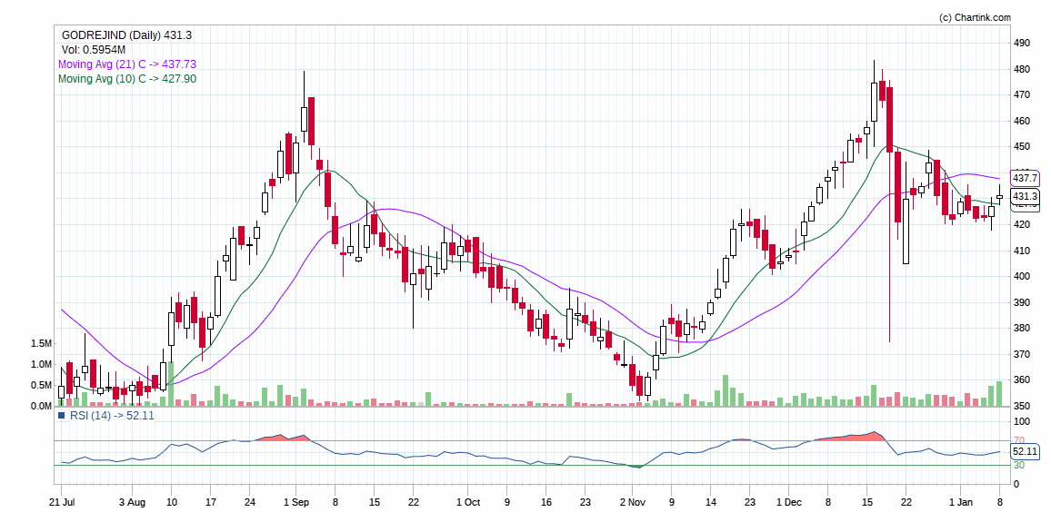

EMclose=EM$GODREJINDUSTRIES.NS.Close["2020-01-08::"]
EMclose=na.omit(EMclose)
plot(EMclose,type="l")

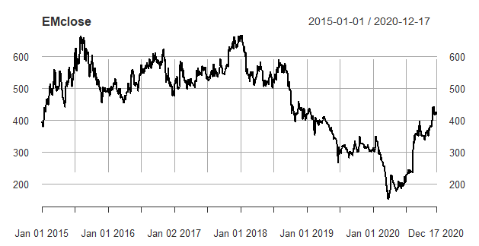

adf.test(EMclose) #p-value = 0.3759
EMclosediff=diff(EMclose)
EMclosediff=na.omit(EMclosediff)
adf.test(EMclosediff)
plot(EMclosediff)
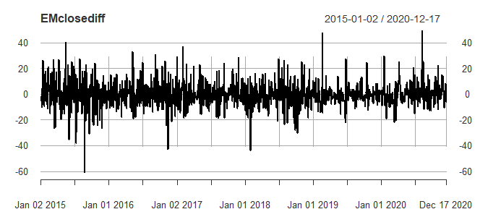

pp.test(EMclosediff)
EMclosediffts=ts(EMclosediff,start=c(2015,1), frequency = 365)
plot(decompose(EMclosediffts, type=c("multiplicative")))
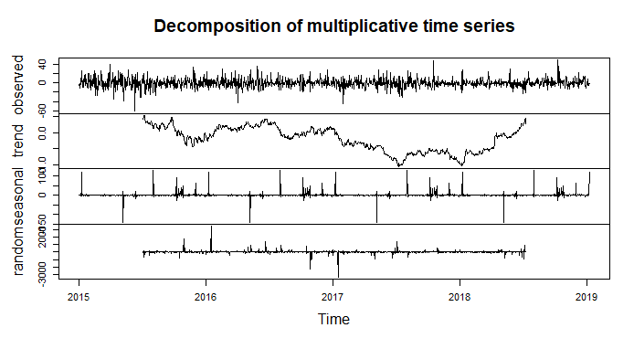
plot(decompose(EMclosediffts,type=c("additive")))
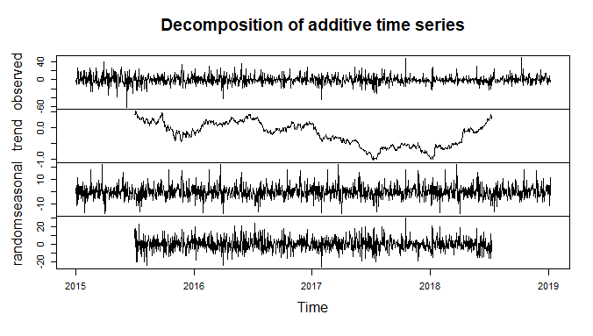
EMsma=SMA(EMclosediff,50)
plot(EMclosediff,type="l")
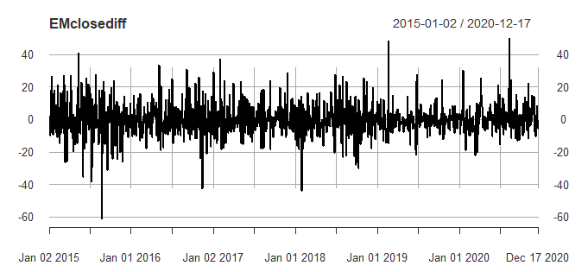
lines(EMsma,col="red")
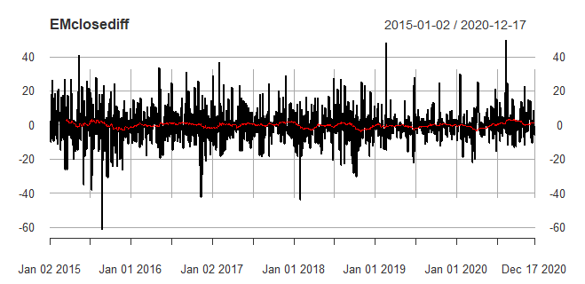

EMets=ets(EMclosediff)
summary(EMets) # RMSE 9.59749
EMetsforecast=forecast(EMets,h=90)
plot(EMetsforecast) # 90 Days forecast
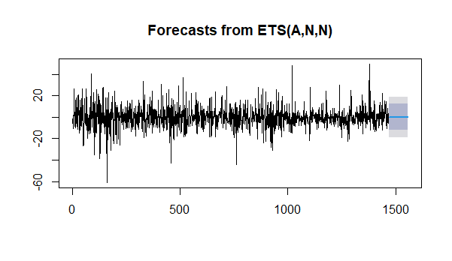
checkresiduals(EMetsforecast)
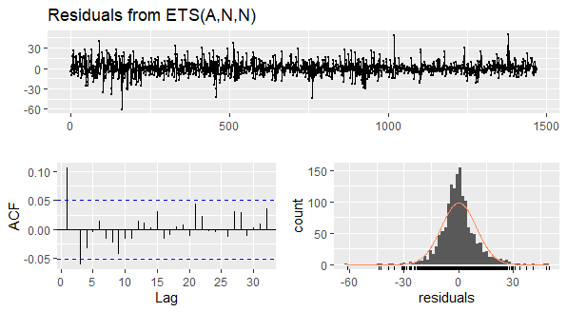

EMholt=holt(EMclosediff,h=90) #p-value = 0.0004085
summary(EMholt) # RMSE - 9.693987
plot(EMholt)
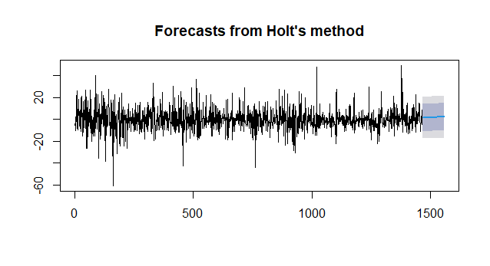checkresiduals(EMholt)
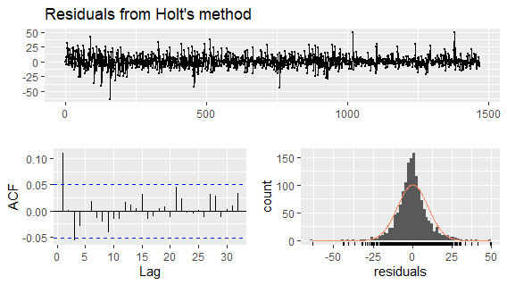
EMsnaive=snaive(EMclosediff,h=90) #p-value = 9.462e-05
summary(EMsnaive)# RMSE - 12.83204
plot(EMsnaive)
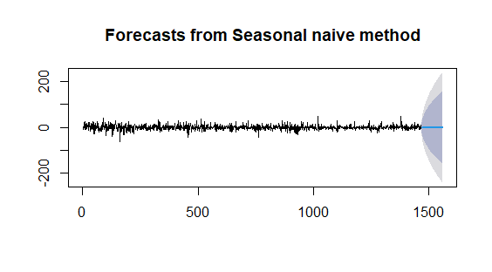
checkresiduals(EMsnaive)
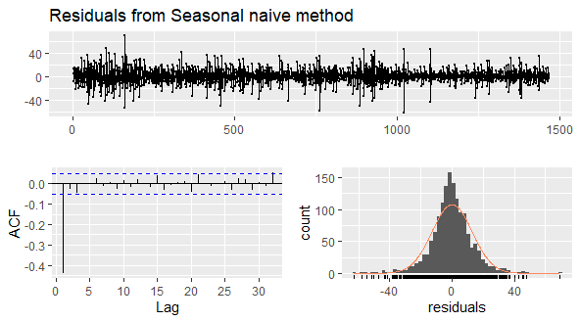
acf(EMclosediff,lag.max = 30)# q=0
pacf(EMclosediff,lag.max = 30)# p=6
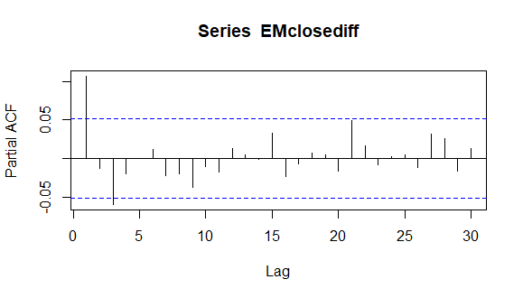
EMarima=auto.arima(EMclosediff)
summary(EMarima)# RMSE - 9.542208
EMarimaforecast=forecast(EMarima,h=90)
plot(EMarimaforecast)
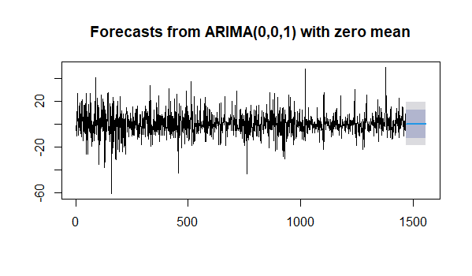
checkresiduals(EMarimaforecast)
# p-value = 0.3648
