**Class Diagrams for RNN and SVM Models**

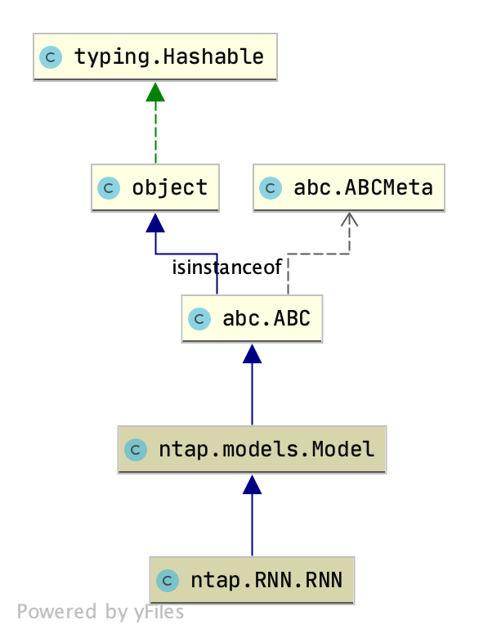

Figure Abstract Class Diagram for RNN

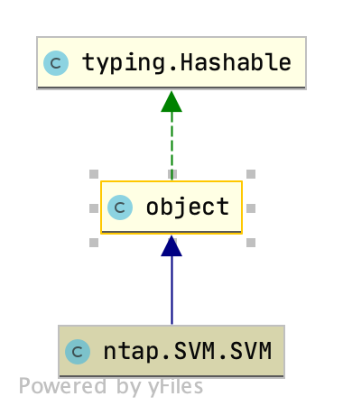

Figure Abstract Class Diagram for SVM

**Class Diagrams for RNN and SVM Models (Detailed)**

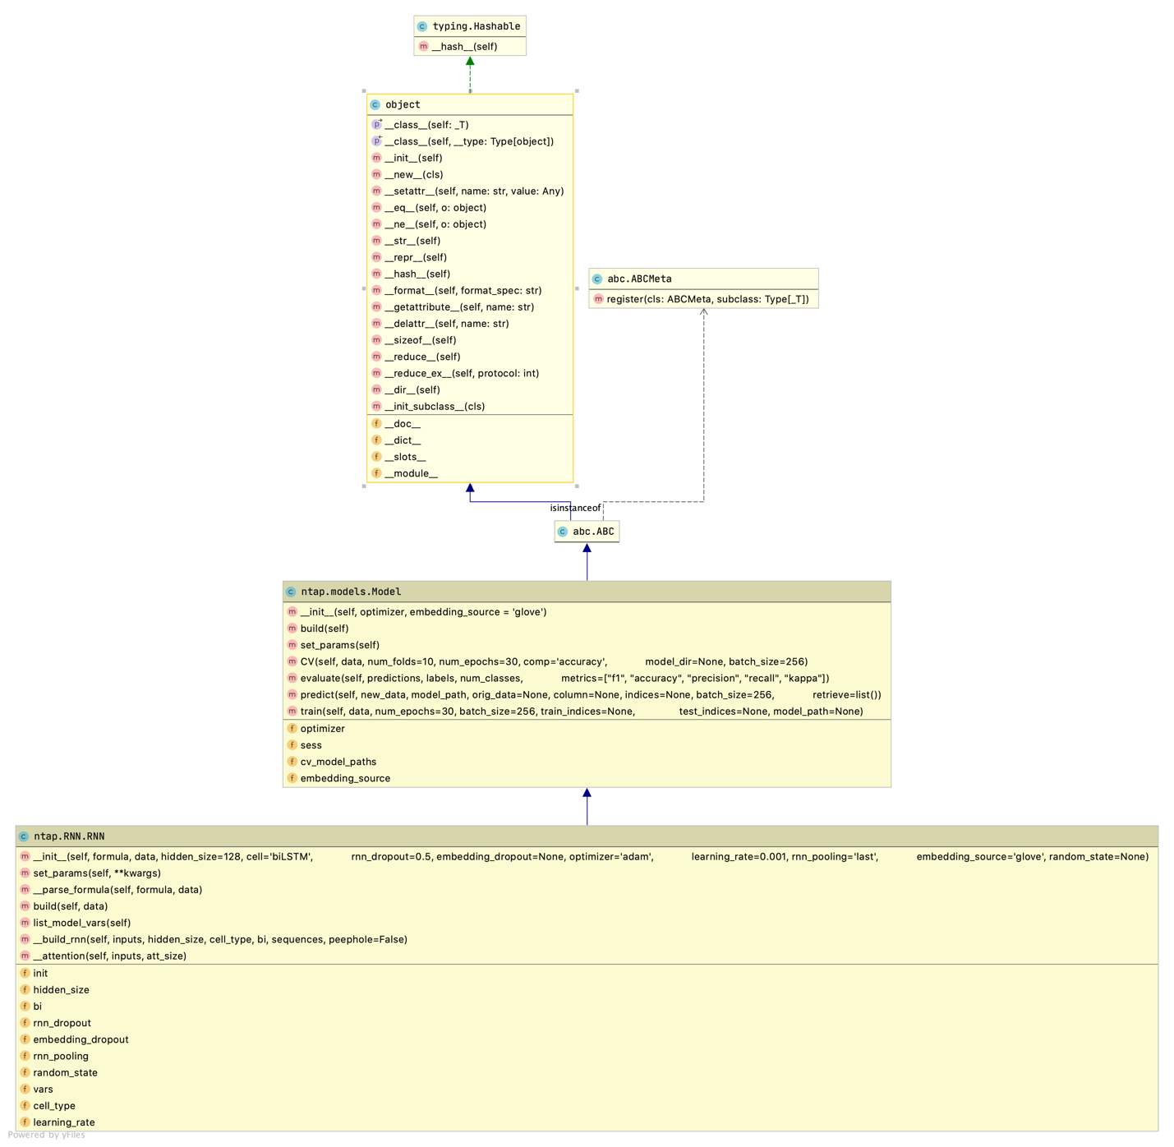

Figure Detailed Class diagram for RNN

Figure Detailed Class Diagram for SVM

**Class Diagram for NTAP**

Figure NTAP Class Diagram

**Detailed Class Diagram for NTAP**