Zamorin of Calicut - 1921 Malabar Rebellion - Colonial Period

The year 1915 - 1928 Kozhikode was ruled by Zamorin Manavikraman Kuttunni Raja. He was born in the year 1847 to Kutti Anujathi Thampuratti and Namboodirpad of Ullannor Mana. The Zamorin was a benefactor, liberal and a pious person.

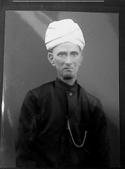
Maharaja Manavikraman Kuttunni Raja

When he took over the reign in the year 1915, the Zamorin's College was opened to all sections of the society, which shows his farsightedness and the value he attributed to education. This action paved the way for social upliftment and equal opportunity to all sections of the society.

As we are approaching the centenary of Malabar rebellion of 1921 it is necessary to revisit this historic events from a broader perspective. The khilafat movement which started against the british rule unfortunately took an ugly turn of religious fanatism, riot against hindu community of Eranad taluk coming under the province of Kozhikode Zamorin. Forceful conversions, acquisition of properties and vandalism of place of worship etc. under the name of khilafat were reported by many historians. The role of Zamorin who ruled Kozhikode during those difficult days is worth mentioning here.

The 1921 malabar rebellion started during his reign. This period could be remembered only with deep fear and distress. No one who have gone through those fearful days would be alive today.

Britishers ruled southern part of india with their headquarters at Madras by giving limited powers to the kings of the province. Within his limited powers Zamorin had done many good deeds to the people.

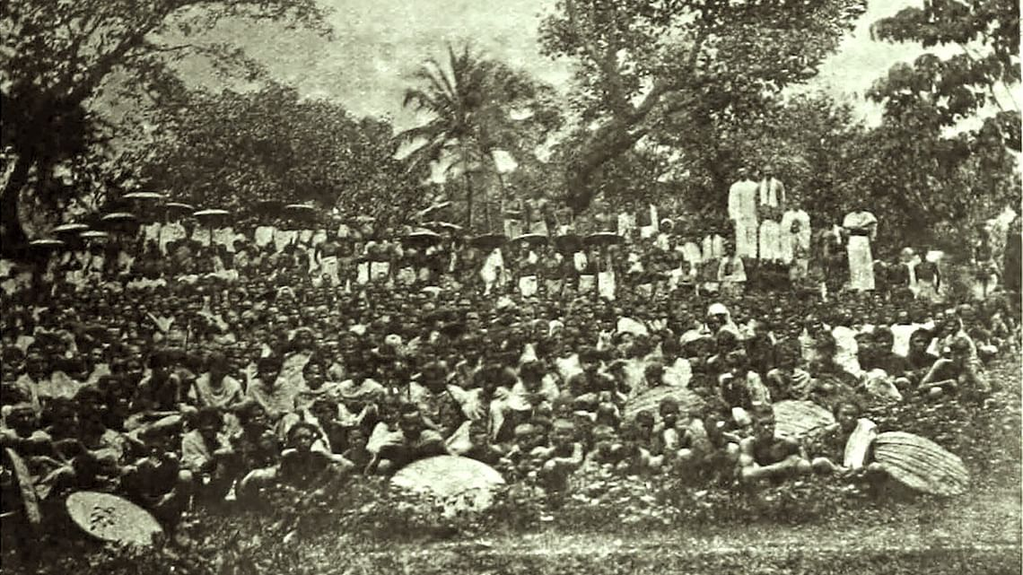
Refugees

The riot and looting at Eranad taluk resulted in large scale infulx of refugees to Kozhikode. Zamorin kept the Kovilakam (palace) doors open to thousands of refugees who fled from Ernad taluk during the riot giving them food & shelter for months. Apart from this, two more camps were opened in kozhikode town one at Puthiyara & the other at Mooriyad. During this period when malabar was going through its dark phase, these yeomen services made a mark in peoples mind for his care and kindness to the poor and needy.
.
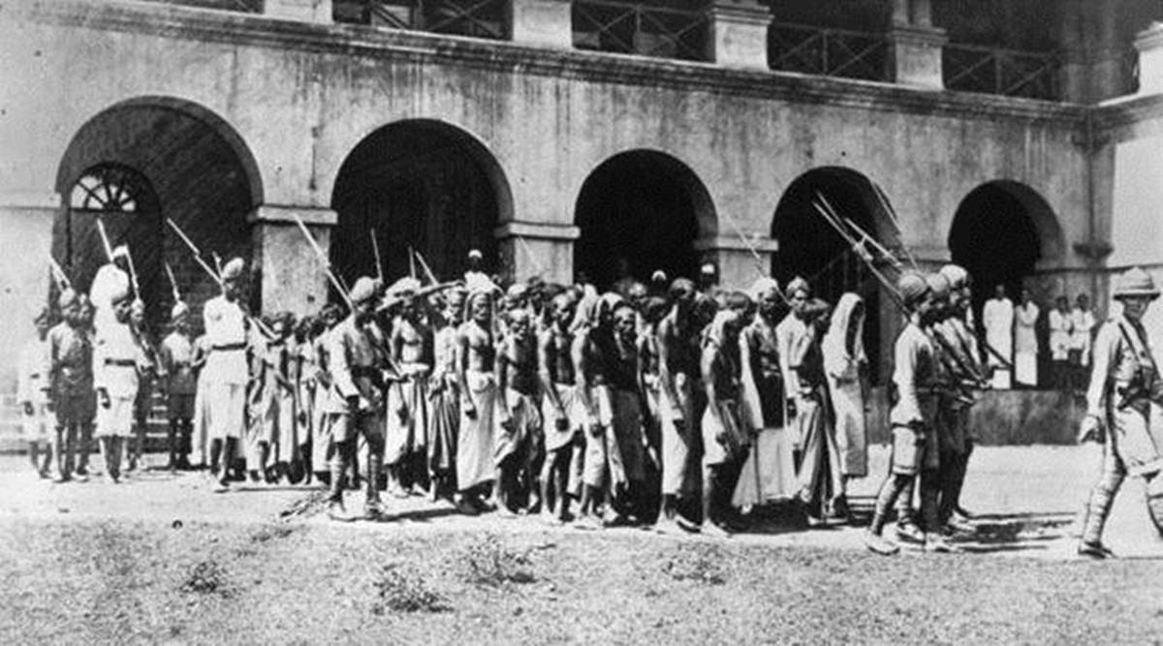
Rioters captured

Martial Law Ordinace was declared on 25.08.1921 by the then British Viceroy, Earl of Reading. Commander of Madras Military District, Major General J Burnett Stuart was ordered to restore peace in the region. Major Stuart and Commander E.T Humphrey initiated the military operations to bring back normalcy. They ordered the Dist. Supdt. Of Police, Richard Howards Hitchcock an iron fisted officer who was also the head of CID and a Civilian named Evans to suppress counter insurgency operation and crush the rioters. It was under their command the most horrendous incident of Wagon Tragedy happened at Tirur.

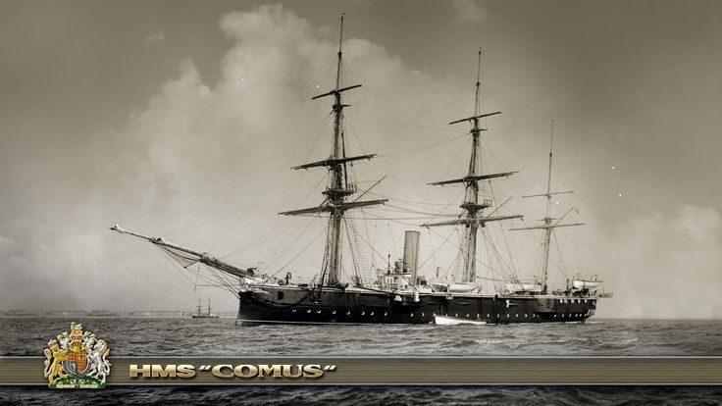
British Naval Ship HMS Comus carrying 90 soldiers from Colombo reached Kozhikode on 25.08.1921. On the same day they marched through the Market of Kozhikode (Valliangadi) and moved to the riot torn area of Malappuram. After 5 hours of fierce fighting, they could restore peace in Malappuram.

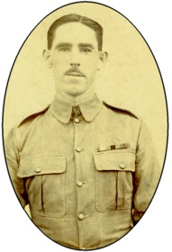
Captain McEnroy

Leinster Regiment was under Capt. Mc Enroy. His role was worth to be mentioned in bringing peace to the Eranad region of Malabar. This brave officer was known for his systematic, fearless moves and had the uncanny skill in co-ordinating many forces with astute precision. He won the heart of Hindu society. Many say that, if at all any Hindus left in Eranad it was just because of this brave officer and he got special mention in all the prominent historical books written on Malabar rebellion.
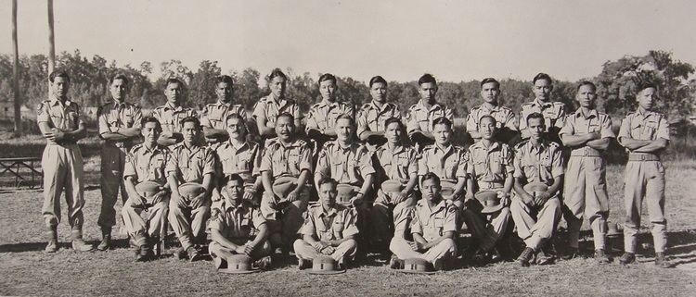
3/70th Burmese Rifles – Chen – Kachin Battalion

On 16.10.1921 Chen- Kachin Battalion, Gurka Regiment and Gharwali Regiment came to Malabar area. Capt. Mc Enroys Leinster Regiment joined hands with them and could restore peace in the region. And by December 1921 the refugees started moving back and by the end of January 1922 complete normalcy attained.

On 20.08.1922 a meeting of Hindu Religious Heads under the aegis of Collector Sir E.F Thomas was convened at the office of Zamorin's Estate, Mankavu for the reconversion of Hindus, who were forcefully converted to Islam during the rebellion. Thus enabling many to return to their faith.

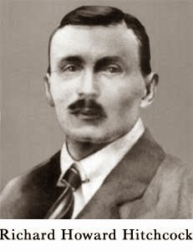
R.H Hitchcock the Dist.Superintendent of Police,Malabar, a person held the unenivable position of being the most hated and feared englishman in power, He was the British instrument, the person involved in collecting field and inside information as the head of CID and also partially responsible to suppress counter insurgency, which he did effectively.
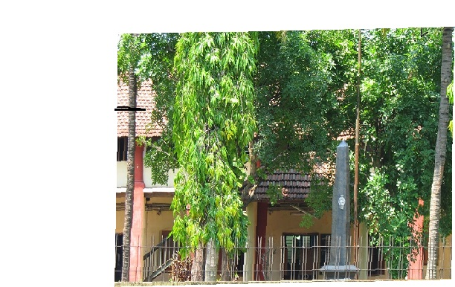
Hitchcock Memorial at Police Commissioners Office,Calicut

A memorial was erected at Mongam, in Malapuram District in the name of R.H. Hichcock, who was instumental for the making of Malabar Special Police. The police training college was renamed as Hitchcock Police School. But in 1936 due to public protest the Hitchcock memorial was taken from Mongam and the same was placed in Kozhikode Police Commissioners Office.

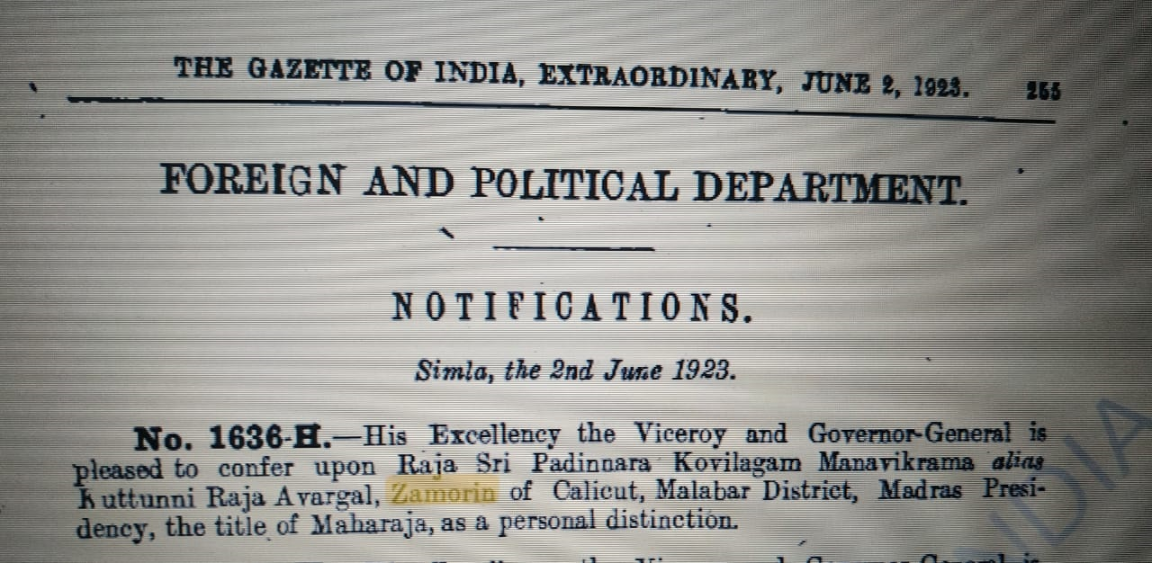
Gazette Notification of 1923
Conferred Maharaja title for his good samaritan work by the British Viceroy - Earl of Reading.

A British delegation headed by the Special Commissioner of Malabar Affairs - Sir Arthur Rowland Knapp visited Zamorin at his residence to honour him. He was accompanied by Commander Sir Edward Thomas Humphry, Malabar Dist Magistrate and Collector Sir E.F Thomas and Sir R.H.Ellis, ICS along with eminent lawyers of Madras Government.
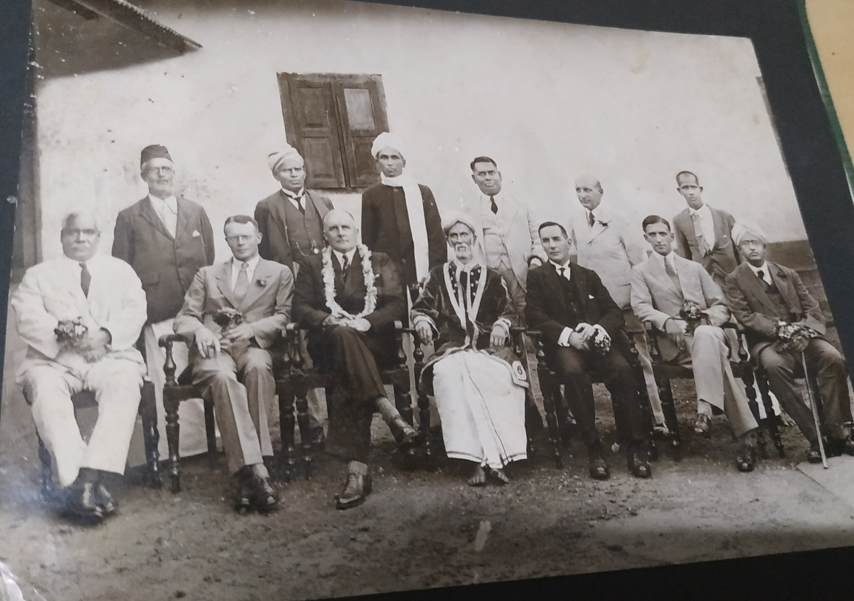
The simplicity of the Maharaja was evident from this picture, clad in simple dress bare footed.

Temples under Kovilakam

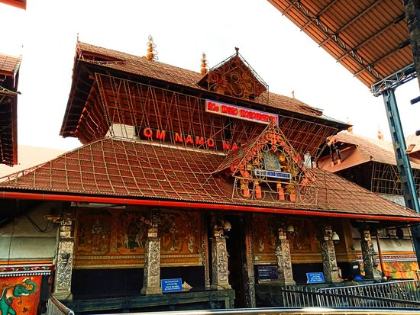
Guruvayur Sri Krishna Temple

Zamorin on becoming Mel-Etam of Guruvayur Temple, fought with the surviving Mallisseri Karanavar for getting upper hand in the managment of the Temple. This was an interesting feature in the administrative history of the temple. A temporary truce was however patched up when the Madras High Court declared that the uralma right was favourably vested with Zamorin & Mallisseri. This was later confirmed by the legislature and incorporated into law. Once again the quarrel between the two (1889) led to temporary suspension of Pujas and closure of the temple for a week. This resulted in a stalemate in the temple administration. The court assumed managment of Zamorins Estate immediately in 1916 and Sir Henry Cotton the then collector of Malabar was entrusted to manage the temple on behalf of Court of Wards. With the rendition of the estate in 1928 the Guruvayur Temple once again came under the Zamorin. The debt accumulated to the Temple during the court of wards rule had been paid from his privy purse. The Hindu Religious Endowment Board constituted by the HRE Act of 1926 deprived Mallisseri of their right to function as the hereditory trustee of the temple and entrusted the day to day management of the Temple solely to Zamorin. This won laurels among the royal family.

It was during his reign the famous Ekadasi Vilakku Pooja was started at the Guruvayur Srikrishna Temple. The first vilakku was of Sri. Parambot Achutha Menon, son in law of the Zamorin. For the past 100 years this Puja is offered to Lord Guruvayurappan by Parambot family without break.

Apart from historically important Guruvayur many temples are under Kovilakom. Some of them are Thriprangode Shiva Temple, Alathiyur Hanuman Temple, Thirunnavaya Nava Mukunda Temple, Varakkal Bhagavathi Temple, Kozhikode Thali Maha Deva Temple, Valayanad Devi Temple etc.

Being a social reformer, he strived for communal harmony too. He was instrumental of building a Mosque at Vattakinar – Beypore Road (Cemetery Mosque) which brought him wide appreciation among the muslim community in Kozhikode.

A new palace (Puthan Kovilakom) was built at Meenchanda during his reign. This place is now occupied by NSS Higher Secondary School and Government Arts and Science College.

‌On 20th July 1928 Maharaja Manavikraman Kuttunni Raja left to heavenly abode at Thiruvachira Kovilakom, Kozhikode. Vengalil Vilakkumadathil (Manakavu Thavazhy) Lakshmi Amma was his wife. The decsendants of this thavazhy is living at Vengalil, M.N.Road, Chalapuram, Kozhikode.

