Maish kumar me14resch11003.

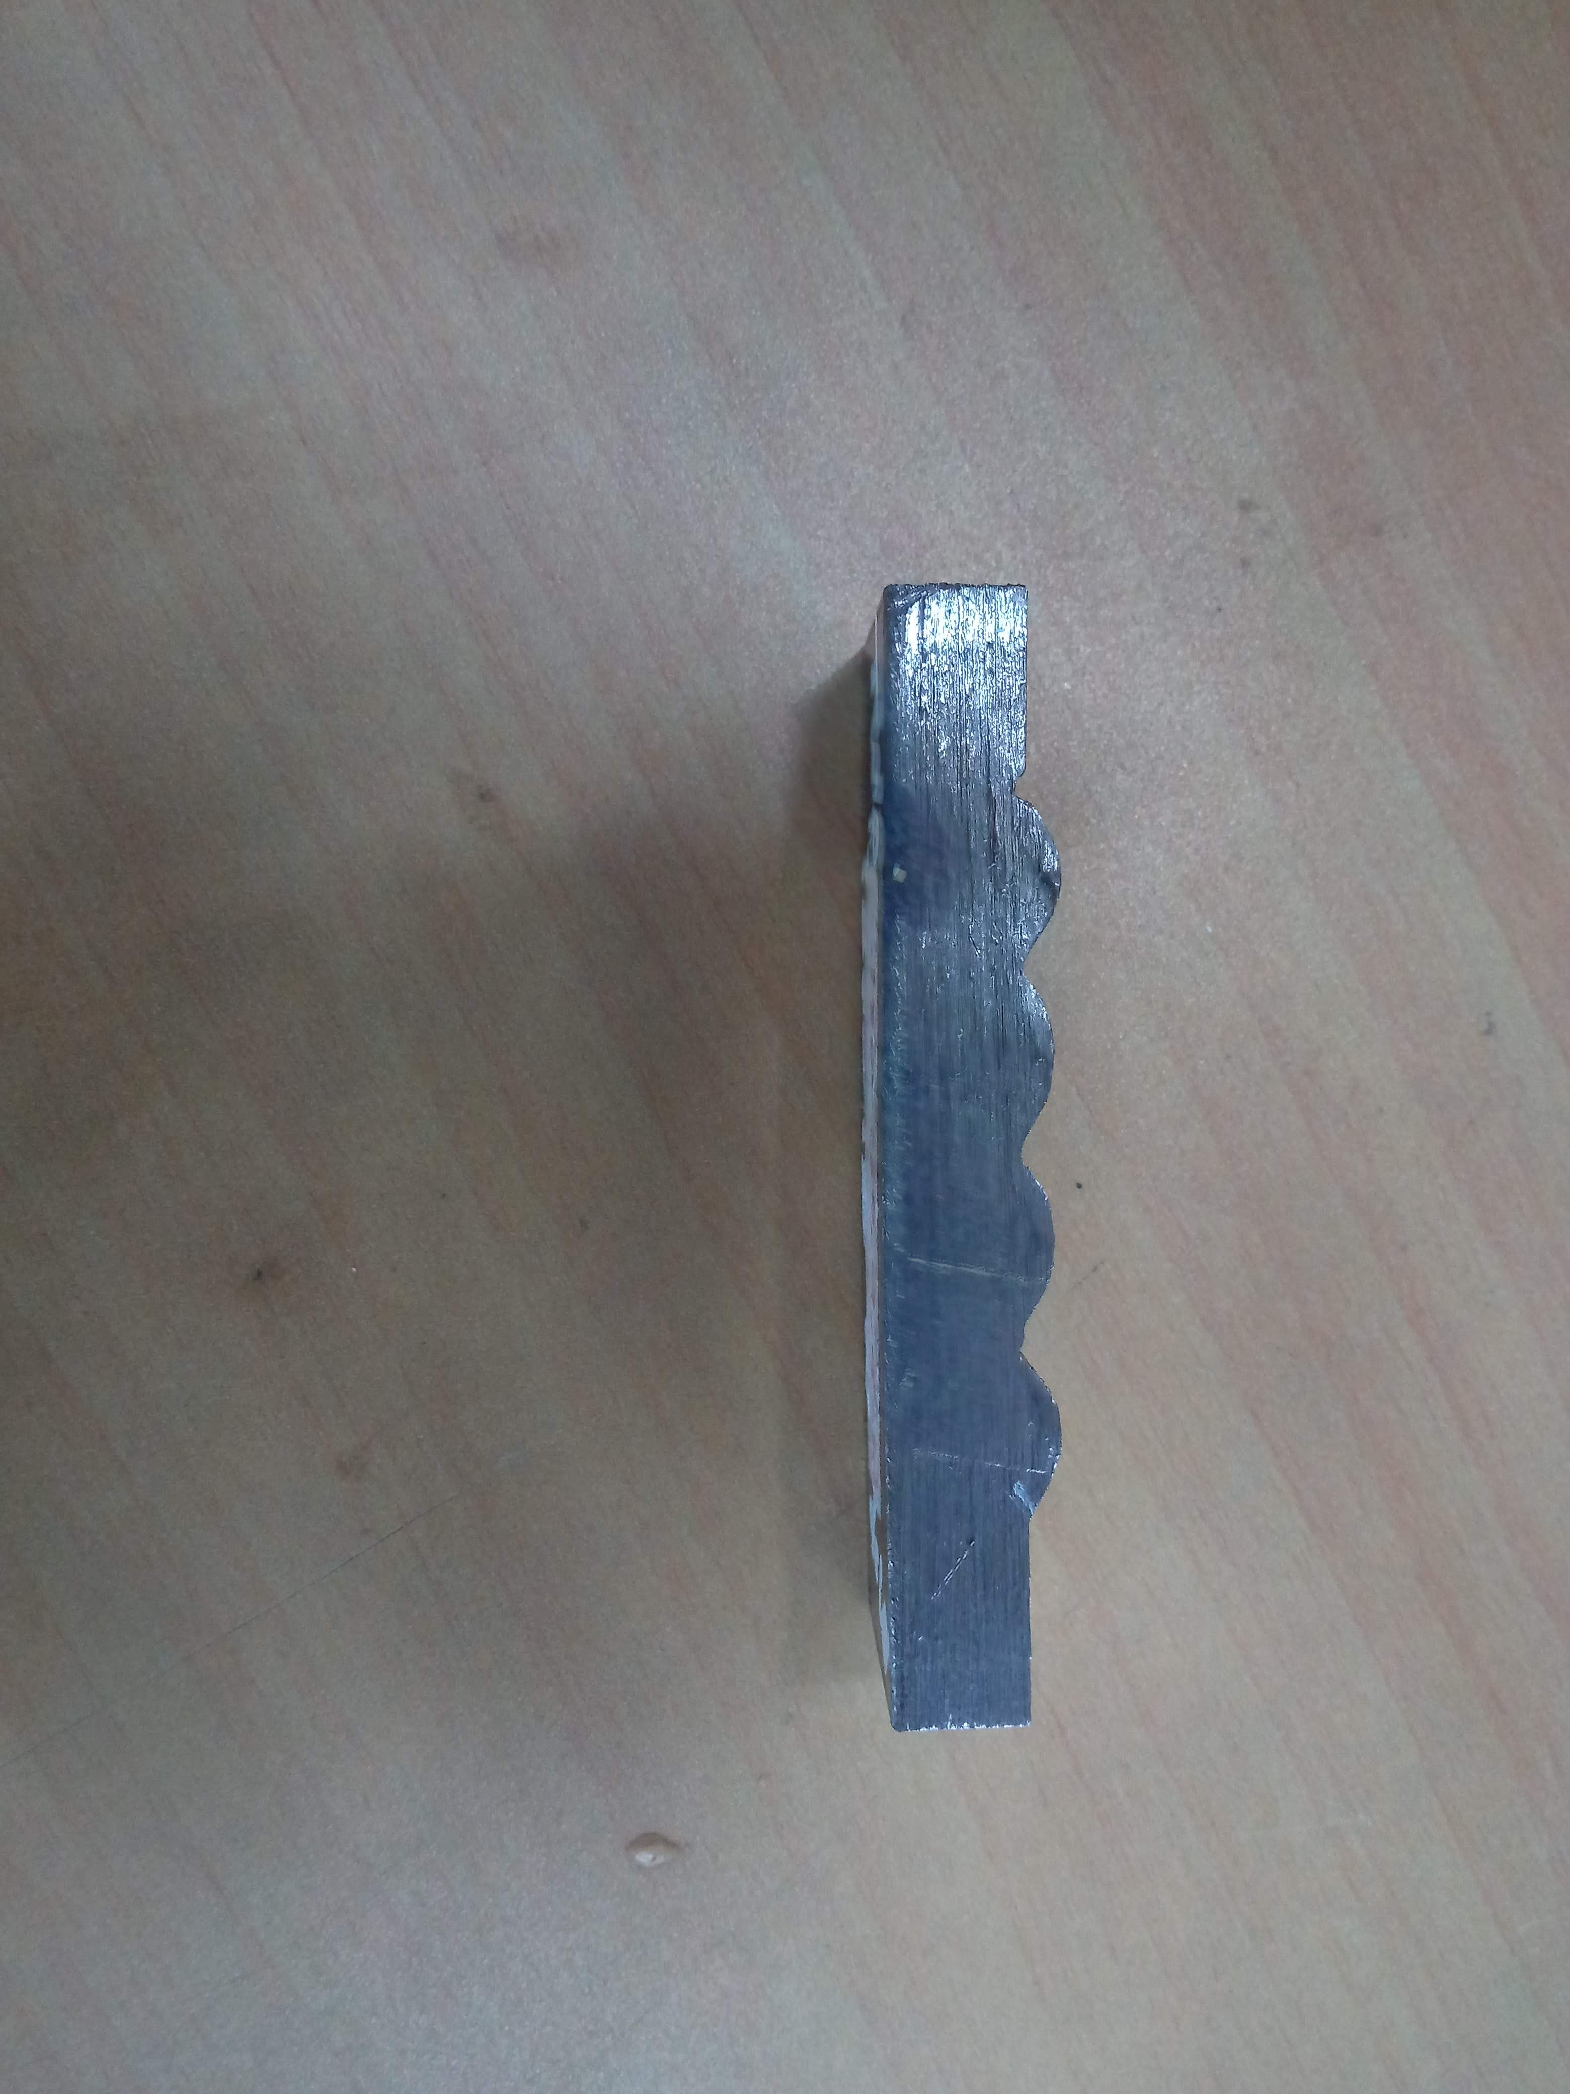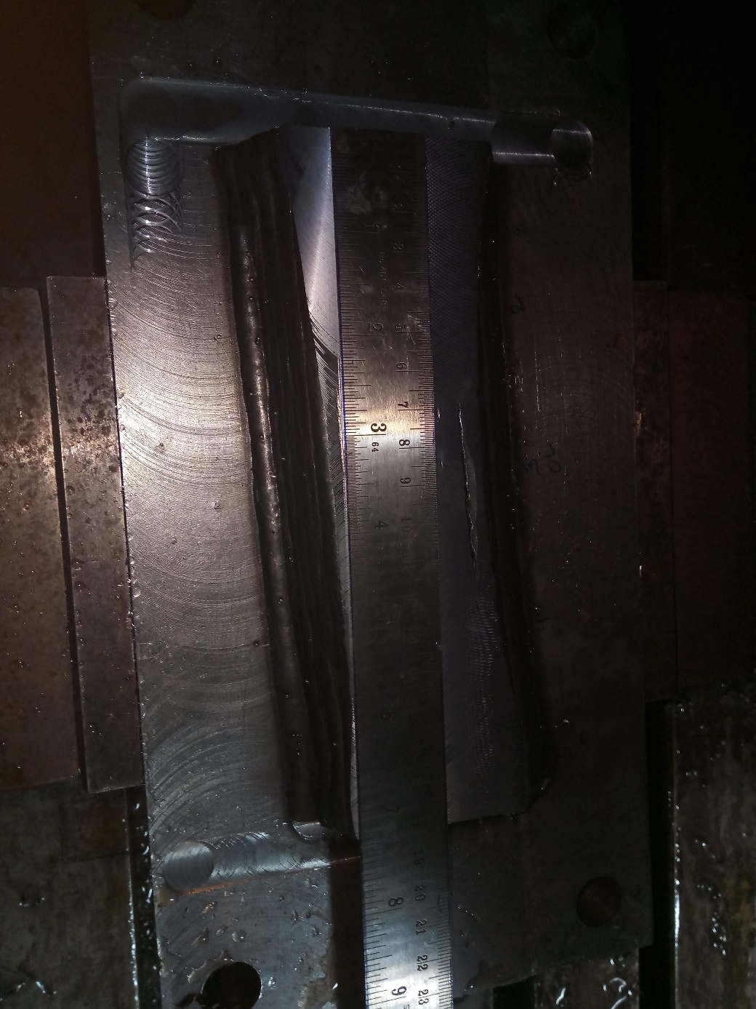

WAAM block (300\*150\* 25)

Bead on plate (74\*15\*15)