Fabrication of the sample as per dimensions in the figure below.

Material : EN8

No of samples : 1 each

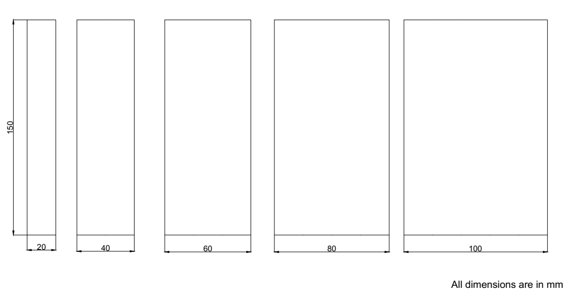

Sequence of operations:

1. Parting from the stock.
2. Face milling on either sides to 5mm thick.
3. Machining to the dimensions as per the diagram.
4. Heat treatment to 800oC and holding for 30 min.