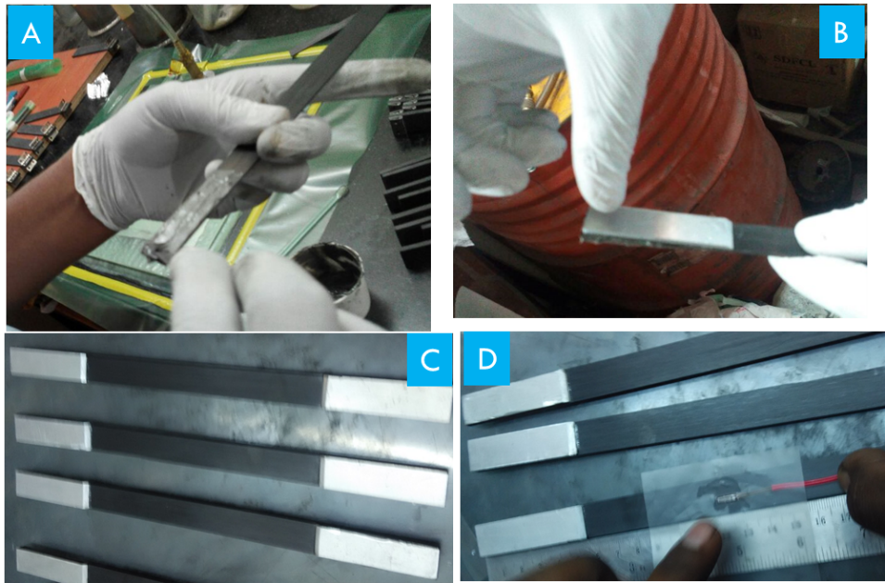

Specimen preparation for CFRP laminates testing.

Placing of end tabs