**Standard specimen dimensions:**

1. **Tensile test specimen.**

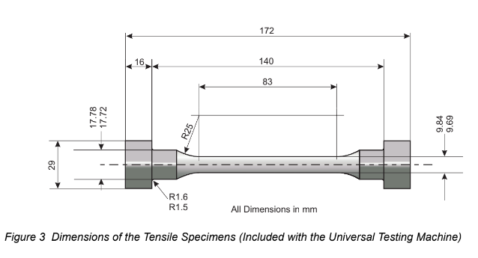

1. **Torsion Test Specimen.**

