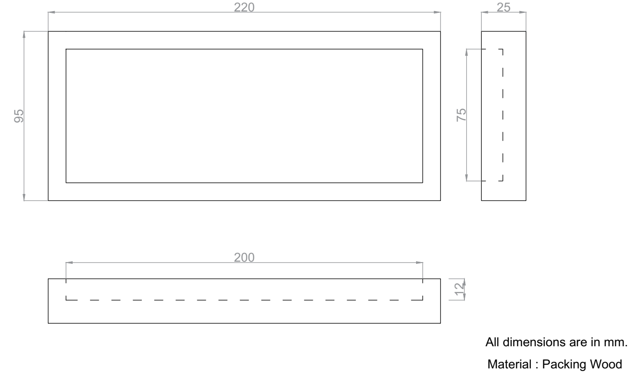

1. Fabrication of Wood block and parting off EN8 plates (2 No’s).