1. Wooden boxes -------- 8 quantity.

2. Knife edges (aluminum metal) ------------ 4 quantity.

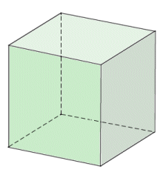

25cm length

20cm width

6cm height

Open Top

Closed Bottom