MANISH KUMAR

Me14resch11003@iith.ac.in

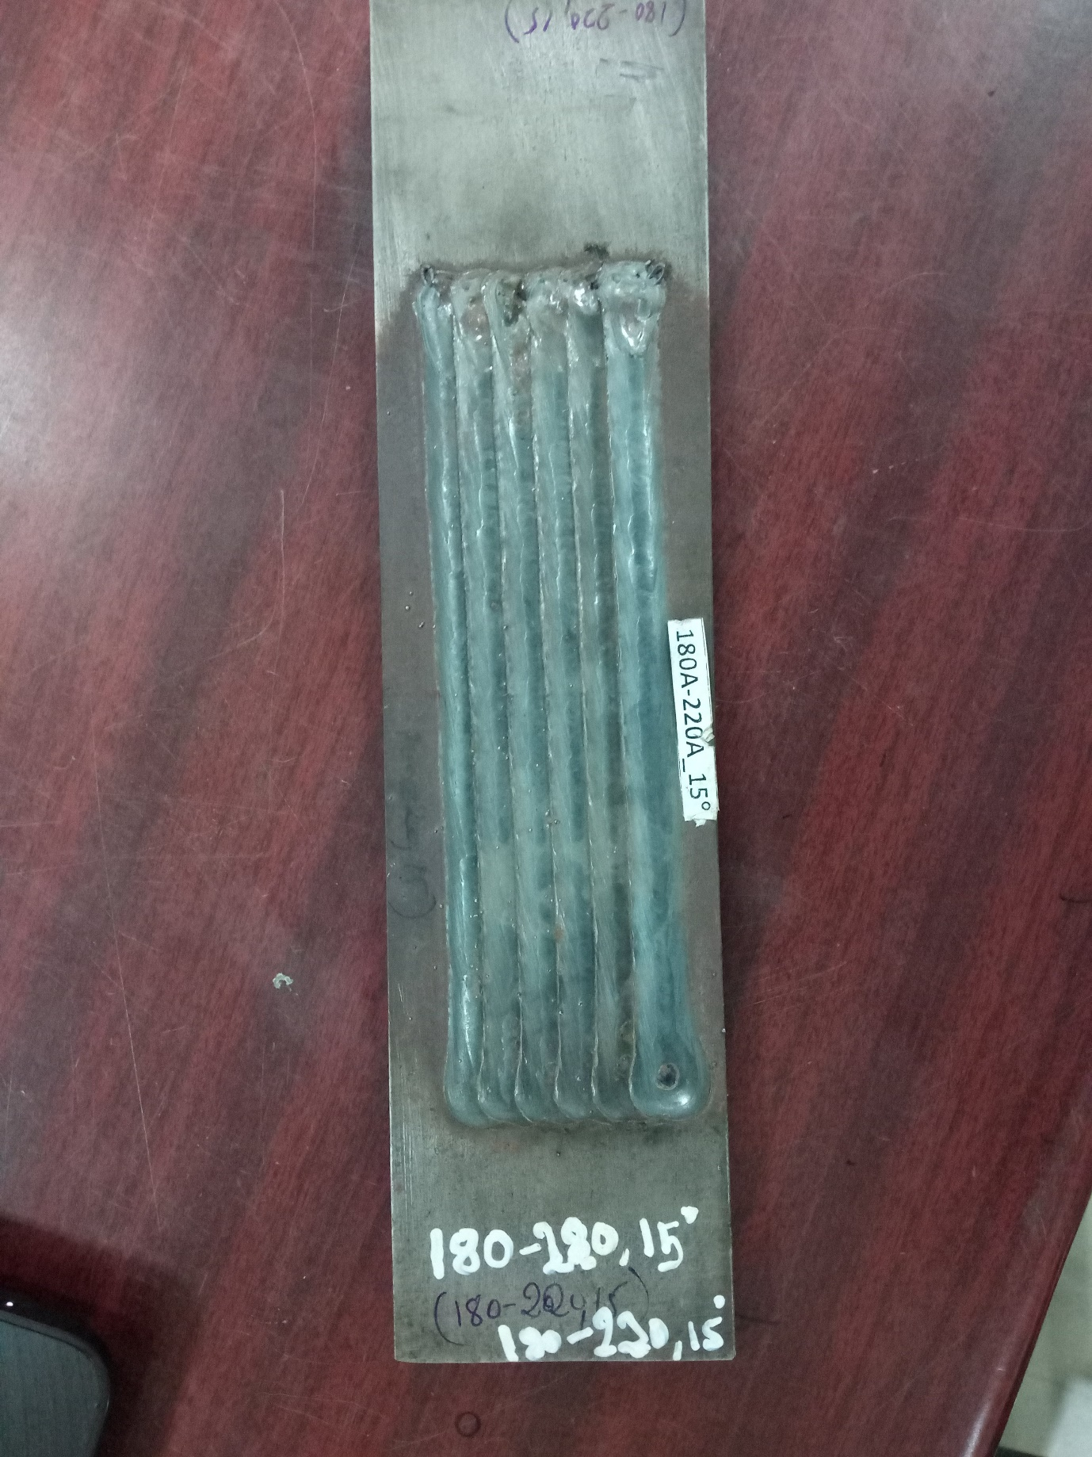

Overlapping of bead.

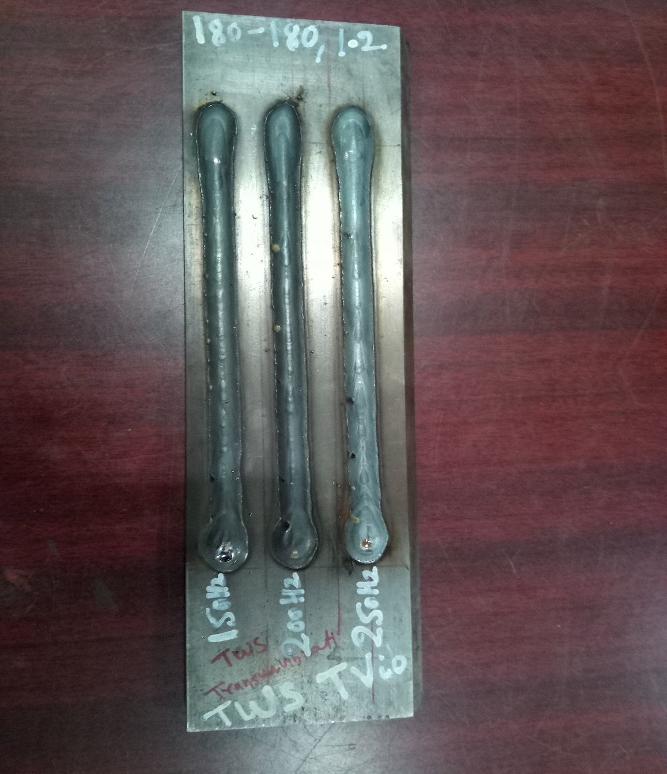

Bead on plate

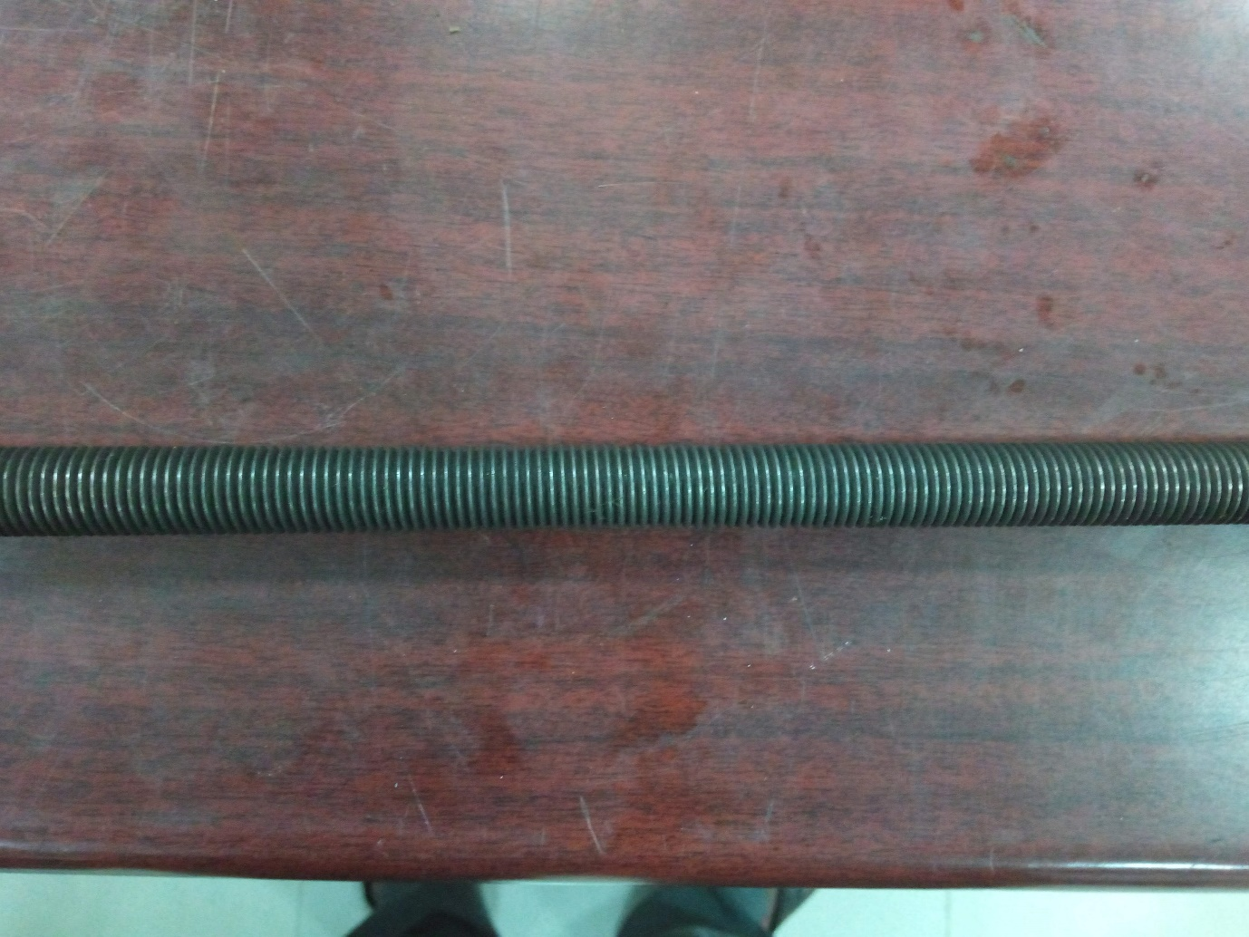

Thread rod of one meter.