Name ____________________________ Date _________________
Speed of a Toy Car

Background: How long does it take a car to move 150 centimeters? We all have a good idea that if it takes a smaller period of time to move 50centimeters, the car must be moving faster. But how do we measure the speed of a toy car. In your own car, it is easy because engineers have designed a speedometer that automatically tells you how fast your car is moving.

A common unit for speed is miles per hour. From this it is easy to figure out the formula that we have to use to calculate the speed of a toy car.

Miles is a unit to measure distance. Hour is a unit to measure time. The word PER stands for division.

So, if Miles Per Hour = Miles / Hour we can replace miles with distance and hour with time and we get the following formula:

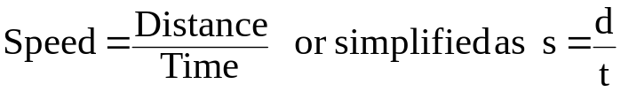

In this lab, you are going to determine the speed of a toy car.

Materials: Toy Car Ramp Tape Stopwatch Meter Stick

Predict: If you record the time it takes for the car to move 50 centimeters, then record the time it takes to move 150 centimeters, will there be a difference in the speed of the car between the two runs? Explain your prediction:

Procedure:
- Mark off the following distances on the floor with tape: 0 meters, 50 cm, 100 cm, and 150 cm.

- Set up your ramp so the bottom is at the 0 meter mark. Place the car at the top of the ramp. Release the car.

- When the front of the car reaches the 0 meter mark, start your timer. Then, stop the timer when the front of the car reaches the 50-cm mark. Record the time in the table on the back.

- Repeat this procedure for 2 more trials.

- Calculate the average time and record it in the table. (Add up time trials for that distance and divide by 3.)

- Calculate the average speed and record it in the table. (See speed formula above.)

- Repeat steps 1-6 for the 100-cm mark and 150-cm mark.

Distance traveled  (cm) | Time Trial 1  (s) | Time Trial 2  (s) | Time Trial 3  (s) | Average Time  (s) | Average Speed  (cm/s)
50

100

150

Variables:

Independent:

Dependent:

Controlled:

Questions: Answer in COMPLETE sentences!!
- Was there a significant difference in the speed of the car while it traveled 50 cm versus 150 cm? Explain why.

- What happens to the time of travel of the car if the distance that the car moves increases?

- As the car moves away from the starting point (0 cm) what happens to its speed?

- What is the reason for doing the experiment with multiple trials? Why not let the car run one time and record the time?

