Abstract

Brain Gate is a brain implant system developed by the bio-tech company Cyber kinetics in 2003 in conjunction with the Department of Neuroscience at Brown University. The device was designed to help those who have lost control of their limbs, or other bodily functions, such as patients with amyotrophic lateral sclerosis (ALS) or spinal cord injury. 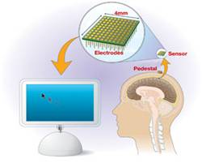

The Brain Gate is currently the subject of a pilot clinical trial being conducted under an Investigational Device Exemption (IDE) from the FDA. The system is designed to restore functionality for a limited, immobile group of severely motor-impaired individuals. It is expected that people using the Brain Gate System will employ a personal computer as the gateway to a range of self-directed activities. These activities may extend beyond typical computer functions (e.g., communication) to include the control of objects in the environment such as a telephone, a television and lights. 