**BIG DATA: How Big Data Analytics can unearth The Black Money of INDIA**

**ABSTRACT:**

This paper is about the role of big data in demonetization. Demonetization has been hailed as the necessary evil to weed out black money in the Indian economy. But to make it effective and to ensure that it is not repeated again, the government need to rely heavily upon modern technology such as **Big Data Analytics that** can be leveraged to unearth the trail of black money in this age of Demonetization. Big data is massive volume of structured and unstructured data that has come from heterogeneous, independent sources with distributed and regionalized control. Therefore it is going to play vital role in financial and banking services post demonetization because most of the bank transactions are done online. Big data analytics will examine the patterns of bank transactions to uncover the hidden fraudulent activities. The cash counting machine equipped with sensors will keep the track of unique number of notes will serve as a flood of data that will help to determine the fake currency. By this we can greatly reduce black money in INDIA.

Five ways in which big data analytics can trace black money in India:

* Currency notes have a country identifier, denomination, unique serial number, and a mechanism for counterfeit prevention.
* Cash counting and currency detection machines are used in banks and financial institutions.
* Big Data tools are ideal for huge and complex data sets something that wasn’t possible with traditional data-processing methods.
* Analytics tools can provide insights into monetary malpractices and detect currency corruption using the present infrastructure; thus, obviating the need to take drastic measures or purchase new technology or equipment.
* Analytics tools may be calibrated to factor in several other parameters such as the geographical location, serial numbers, individual account, etc.

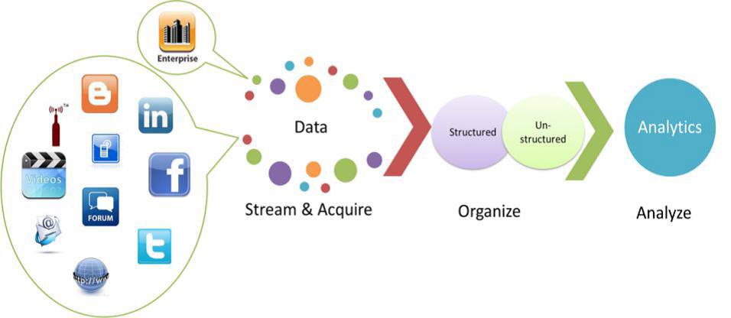

**Keywords:** Big Data Analytics, Black Money, Demonetisation, Fraudulent Activities, Data centralization.

Presented by,

K . Sahitya Durga(3rd CSE, GMRIT)

K . Sumanjali(3rd CSE, GMRIT)

K . Jeeshith Roy(3rd ECE, GMRIT)