**Idea/Approach Details**

**MINISTRY CATEGORY**: MINISTRY OF HEALTH AND FAMILY WELFARE

**PROBLEM STATEMENT:** To provide minimum services to all the android users mainly for elderly people.

**TEAM LEADER:** CH.LAHARIKA

**COLLEGE CODE**: MLID

**IDEA:**

Aged people who are living alone, especially those whose children are settled away from their parents’ are troubled by the growing everyday needs. Using this application, the elderly can book utility services , healthcare facilities or any other assistance they might need, can not only ease the lives of elderly living alone but can also lend satisfaction for their children as they will know that their parents are living comfortably with all services just a click away.

The main purpose of this project is to help the elderly people. The body of the application shows some utility services. Based on the requirement of the user any of the service can be selected which redirects to another page showing sub lists in that respective service. The services like health wellness, home maintenance, automobile services, are provided.

Whenever there is a need, the user can open the application and click on the service which shows two options.The user can make a call or even leave a message.The text field is also provided to give the respective address of the user.

**APPROACH DETAILS:**

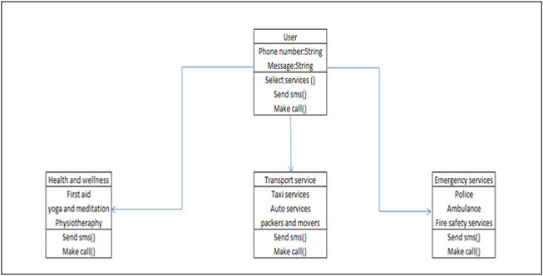

**FINAL OUTCOME:**

