**EUVL(Extreme UltravioletLithography)**

**Abstract**

**BY SHAIK SIMRAN**

**Extreme ultraviolet lithography** (also known as *EUV* or *EUVL*) is a [next-generation lithography](https://en.wikipedia.org/wiki/Next-generation_lithography) technology using an [extreme ultraviolet](https://en.wikipedia.org/wiki/Extreme_ultraviolet) (EUV) wavelength, currently expected to be 13.5 nm. EUV is currently being developed for high volume use by 2020.

[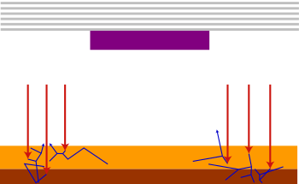](https://en.wikipedia.org/wiki/File:EUV_photoelectrons_and_secondaries_(vector).svg)

**Image formation mechanism in EUV lithography.** *Top:* EUV multilayer and absorber (purple) constituting mask pattern for imaging a line. *Bottom:* EUV radiation (red) reflected from the mask pattern is absorbed in the resist (yellow) and substrate (brown), producing photoelectrons and secondary electrons (blue). These electrons increase the extent of chemical reactions in the resist. A secondary electron pattern that is random in nature is superimposed on the optical image. The unwanted secondary electron exposure results in loss of resolution, observable line edge roughness and linewidth variation.

[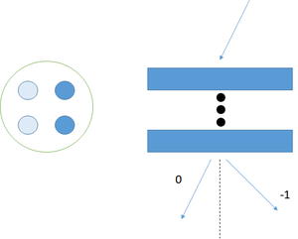](https://en.wikipedia.org/wiki/File:EUV_quadrupole_nontelecentricity.png)

**EUV non-telecentricity.** *Left*: Due to large multilayer reflection angle differences, one side of the illumination pupil results in more reflected light. *Right*: Consequently, illumination from one side will be dominant. This results in an optical path difference between diffraction orders with respect to defocus, leading to a tendency for the pattern to shift.

[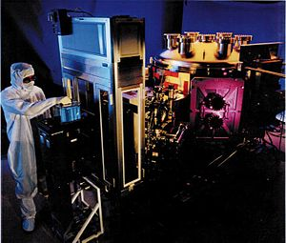](https://en.wikipedia.org/wiki/File:Extreme_ultraviolet_lithography_tool.jpg)

EUVL tool, Lawrence Livermore National Laboratory

Silicon has been the heart of the world's technology boom for nearly half a century. Each year, manufacturers bring out the next great computer chip that boosts computing power and allows our Personal Computers to do more than we imagined just a decade ago. The current technology used to make microprocessors, deep ultraviolet lithography will begin to reach its limit around 2005. At that time, chipmakers will have to look to other technologies to cram more transistors onto silicon to create powerful chips. Many are already looking at extreme-ultraviolet lithography (EUVL) as a way to extend the life of silicon at least until the end of the decade.

Akin to photography, lithography is used to print circuits onto microchips Extreme Ultraviolet Lithography (EUVL) will open a new chapter in semiconductor technology. In the race to provide the Next Generation Lithography (NGL) for faster, more efficient computer chips, EUV Lithography is the clear frontrunner. Here we discusses the basic concepts and current state of development of EUV lithography (EUVL), a relatively new form of lithography that uses extreme ultraviolet (EUV) radiation with a wavelength in the range of 10 to 14 nanometers (nm) to carry out projection imaging. EUVL is one technology vying to become the successor to optical lithography