**AUTOMATIC LOW COST OF SORTING AND PACKING OF COLOUR CRAYONS**

**Mr.** **L.Sangeethkumar 1,Mr.** **S.Sathishkumar,Mr.N.Vignesh3**

**UG Scholars,Department of Mechatronics Engineering,Kongu Engineering College,Erode-638060**

**ELAN ID:EN18IITH002491, EN18IITH004832, EN18IITH016523**

**TEAM ID: EN18IITHT0099**

**Emailid:sangeeth.log@gmail.com1,sathishshan1234@gmail.com2,vikivj.1997@gmail.com3**

**Introduction**

Since many years labour work has been playing an important role in Separating different colours and sorting of colour crayons ,and packing of colour crayons. Which incorporates many labours for packing of several colours. Now days, due to development in technology there have been a need to reduce the labour time. So, Automation in construction system is required.

**Objective**

To design and fabricate the automatic color sorting and packing machine for sorting and packing colour crayons.

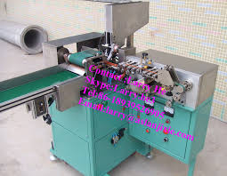

Fig 1. Conventional Crayon Sorter

**Technical details**

The main scope of the process is to automate the packing process.So, we proposed a system which can sort the colour crayon automatically by image processing . In this setup, we use digital camera for picturisation of the colour, once the colour has been captured then signal has been sent to the pneumatic cylinders using the arduino controller and then then pneumatic cylinders starts to expand and retract and pack them into different packets.Once the same colour is received then it is packed into the different packet.

The solid works model of the design is shown in fig 2.1 & fig 2.2

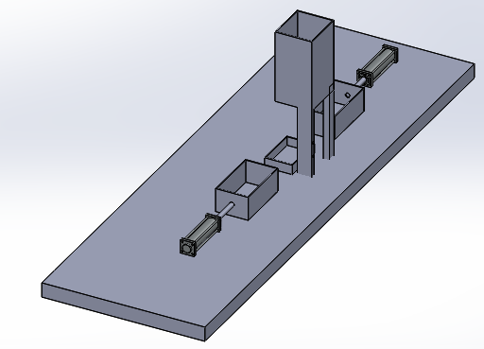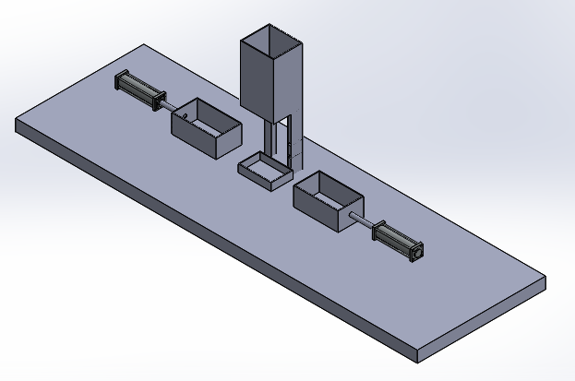

Fig 2.1 Top view of the setup Fig 2.2 Isometric View

**Advantages**

The advantages of the system are as follows:

1. It requires no effort to sort the colour crayons
2. It consumes less time for sorting.
3. It is cost efficient and cheaper.
4. Easy to sort the colour crayons

The real time photographic view of the project is shown in fig 4.

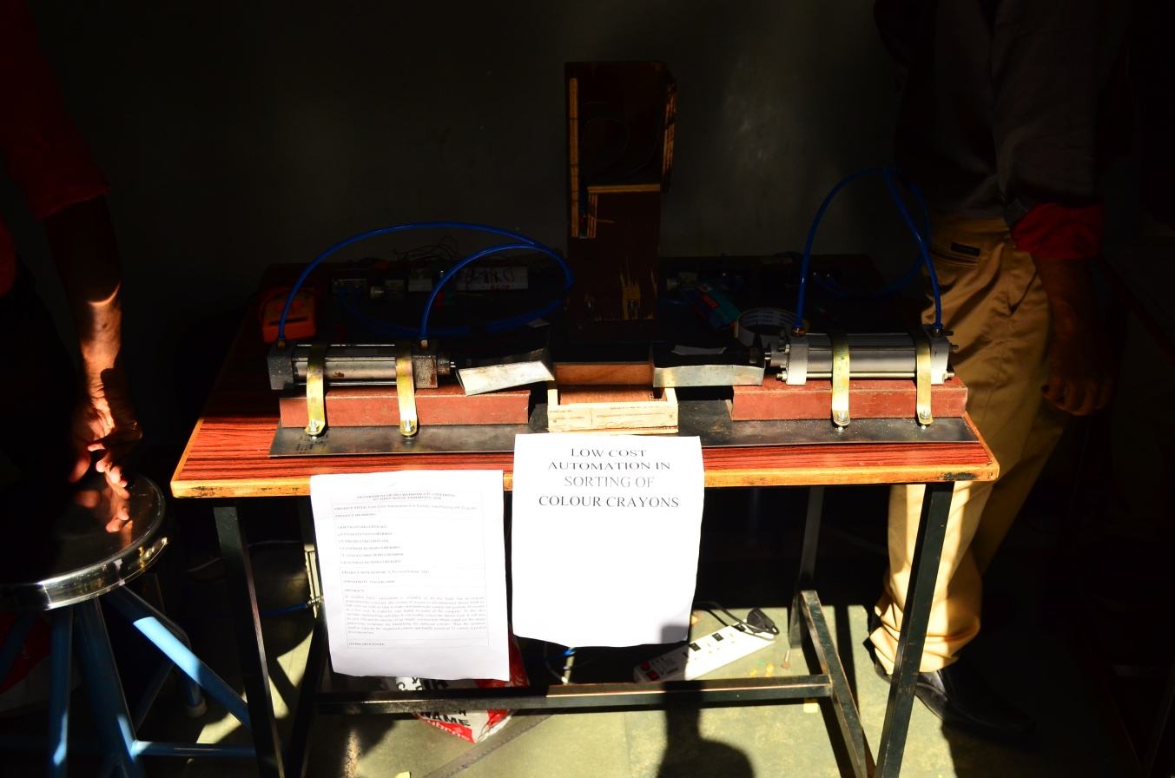

Fig4.Photographic view of the Developed Automatic colour sorting and packing machine

**Conclusion:**

Hence the automatic sorting of colour crayons has been fabricated and working of the sorting has been ensured. The colour crayons has been bent automatically using crayons accumulator without any trouble and the time taken for sorting of the colour crayons using the setup is also considerably low. It is convenient to sort the colour crayons using this setup without spending much effort.

As there is a lot of scope for the automated and low cost projects in the future our project is one of them. We can increase the efficiency of the process by using optimal machine vision camera. So this will be the Future idea and further improvement neeed for this project.This project will have a future scope with best results and working.