**LIFI TECHNOLOGY**

M.V. Shravanthi D. ShanthiPriya

CBIT CBIT

8125151089 9550814754 *shravanthi.musti@yahoo.com shantipriyamsd@gmail.com*

**ABSTRACT**

1. INTRODUCTION

Remember Wi-Fi? The wireless technology that’s made our lives so much more fun and way easy. In wireless communication, Wi-Fi is the most versatile and effective technology which uses radio waves for data transmission.

Well, as easy our lives have become thanks to Wi-Fi. Free Wi-Fi is fun, but a slow one? It’s your worst nightmare come true.

Meet The Revolutionary Wireless Technology that is 100 times faster than Wi-Fi – **THE LIFI TECHNOLOGY.**

**“[Light] has created us, has created life, and has created all the stuff of life. So it’s inherently safe to use. And wouldn’t it be great to use that for wireless communications?”**

WHAT IS LIFI?

Imagine a world, where every one of the billions of light bulbs in use today is a wireless hotspot.

Li-Fi stands for Light Fidelity. Li-Fi is a wireless optical networking technology that uses light emitting diodes (LEDs) for transmission of data.

Now, a teeny tiny fact – the visible light spectrum is 10,000 times larger than the

entire radio frequency spectrum. So, while Wi-Fi is close to achieving its full capacity, Li-Fi’s capacity is virtually untapped.

1. Wi-Fi Vs Li-Fi

Wi-Fi is facing many challenges in terms of **capacity, efficiency, availability** and most importantly **security.**

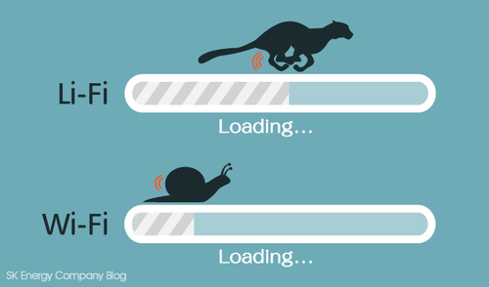

1. WORKING OF Li-Fi

Li-Fi technology uses visible light between the violet (800 THz) and red (400 THz). The principle of Li-Fi is based on sending data by amplitude modulation of the light source (LED) in a well defined way.

This invisible ON/OFF activity of LED enables data transmission using binary codes.

Logic 0 – LED is OFF

Logic 1 - LED is ON

1. MODULATION SCHEMES

 LiFi is cellular wireless networking (re)using lights. Li-Fi provides a number of unique and specific modulation formats. Multiple-antenna techniques constitute a key technology for modern wireless communications.

**Spatial Modulation (SM)** is a novel and recently proposed multiple-antenna transmission technique that can offer, with a very low system complexity, power and bandwidth efficient, improved data rates compared to Single-Input- Single-Output (SISO) systems, and robust error performance even in correlated channel environments.

As the data rate increases in Li-Fi networks, Multi carrier modulation (MCM) is preferred over SCM schemes such as PPM, OOK, and PAM.

One of the most common realisations of MCM is **orthogonal frequency division multiplexing (OFDM),** where parallel data streams are transmitted simultaneously.

1. OUR ATTEMPT

**SIGNAL TRANSMISSION THROUGH VISIBLE LIGHT COMMUNICATION:**

**3
CHAPTER 2
BLOCK DIAGRAM
Fig.2.1 Block Diagram
2.1 DESCRIPTION
The basic block diagram consist of
➢ Input from the Source...**

We implemented the basic Li-Fi based system to transmit a signal from one device to another through visible light.

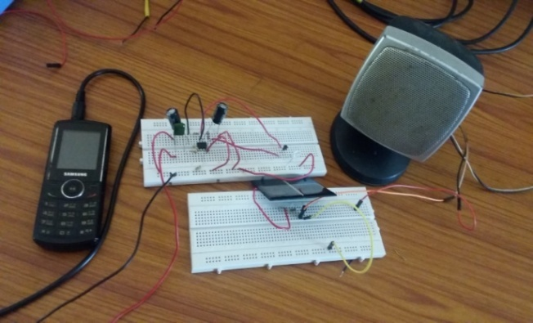

1. CONCLUSION

This way Li-Fi technology is attracting a greater deal of interest and will make our lives more technology driven in the near future.