“ UTILISATION OF TIDAL ENERGY,

UNDER WATER TURBINES ”

K.Lokesh

*Electrical and Electronics Department. ( M.R.E.C )*

*Medchal, Hyderabad, India*

[lokeshyadav3333@gmail.com](mailto:lokeshyadav3333@gmail.com)

***Abstract*—Tidal energy has a significant potential to play a role in the world’s future energy mix, as compared to other more established renewables like solar and wind. This paper presents a simple way to use tidal energy in generating electrical power and method of implementing it. The natural phenomenon behind the occurrence of these tides is clearly explained. It also relates to an apparatus and process for converting the energy contained in large ocean streams into profitable electric power, by using under water turbines, placed at accessible depth in the ocean. The turbines run at low operational cost and speed, producing continuous energy, without harming the marine life and environment, which in turn permits to reduce the dependency on conventional energy sources like oil, gas, and coal.**

***Index Terms*—Cables, Gearbox, Generator, Nacelle Tides, Turbines.**

1. INTRODUCTION

We live in a world of amazing technology, a world where anything is possible, the technology we rely on is advancing very quickly. Yet we still burn fossil fuels to power our lives. Everything we do uses energy, to power factories, our homes, to drive our vehicles, to live comfortable lives. The problem is the source of energy we use to do all these great things is exploding the planet and changing the climate, as the population increases the problem will get exponentially worse. So, the world needs an energy upgrade. There is a need to solve the worlds energy crisis. Under Water Ocean Turbines can be a solution and enough renewable energy source to free ourselves from outdated fossil fuels and nuclear power. This relates to an apparatus and method for generating electrical power, and more particularly, an apparatus and method for converting the energy contained in large ocean streams into usable electric power. we always knew there had to be a clean energy source that we could tap to re power the world, a renewable energy source with enough power to replace the fossil fuels and nuclear energy, the ocean could provide us that clean energy which we could ever use, and under water turbines are the right technology to capture that ocean energy. If energy independence is important, if more sustainable future is important to us, then tidal energy is the key.

The worlds ocean is constantly moving, joint flowing currents circle the globe, unlike solar and wind power, ocean currents are constantly flowing, they produce power 24 hours a day, guaranteed predictable 365 days a year. Under water turbines can capture massive underwater currents, the turbines are unique and it has ability to convert ocean energy to usable power with high efficiency, the ocean energy turbine is able to do this with its massive surface area. To minimise the impact on the ocean environment, these are designed to rotate at very low speed, making it much safer for the ocean environment. These are placed at accessible height, very near to the ocean bed.

Connecting large scale ocean turbines to the power grid, will allow people to utilise 100% renewable energy all of the time. It is a source of limitless clean energy, which reduces dependence on oil and nuclear power and can be a step to avoid unbalanced climate changes. The proposed topology permits to reduce further global environmental damage. This technology provides a low cost, low power and low complexity solution at a small ecological foot print. water 800times denser than air, contains 800 times the energy of AIR while in motion. Wave has the advantage of being more consistent and predictable than wind energy. Despite the advantages of the technology, wave energy has been slow to grow compared with other renewables, because it hasn’t received the same government funding yet. Nearly every other form of power technology, whether its nuclear, gas, solar or wind, has been either fully or nearly de-risked through the technology development phase by governments.

1. MAIN PARTS

* Turbines
* Gearbox
* Generator
* Cables
* Support

1. *Turbines*

Underwater turbine systems have been in operation since 2003 in areas of the Eastern Atlantic Ocean but they still haven’t hit the mainstream. The turbines used in tidal energy plants are special turbines which run at low operational speed, producing high torque. The major difference is that underwater turbines are designed to work with water flow from either the front or the back. This allows them to take advantage of the back and forth motion of tidal wave systems. The blades of the turbines only rotate at 10 to 30 rotations per minute. At this speed, there is no danger to aquatic life in the area.

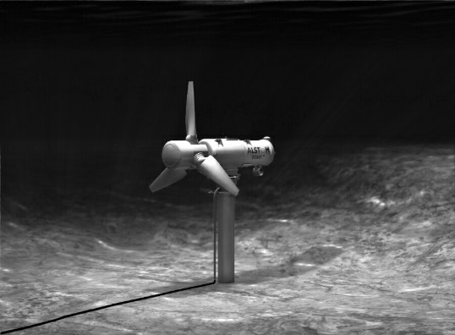

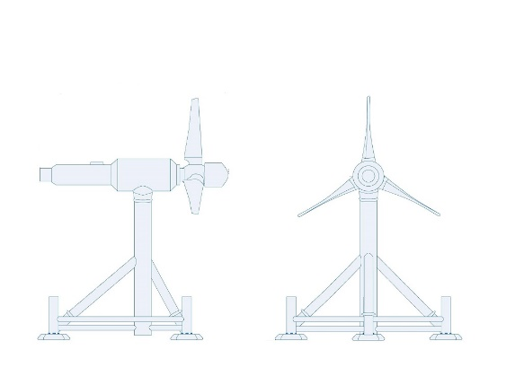

Figure 1. Under Water Turbine

1. *Gearbox*

The gearbox is a device used to convert the low rotational speed of the rotor shaft to the desired output speed of the generator shaft. By using the gearbox, it is capable to run the generator at rated speed, although the turbine speed is very low. The gearbox requires high torque input which is supplied by the turbine. Without the gearbox underwater turbines are worthless.

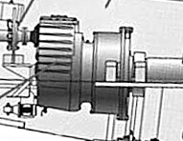

Figure 2. Gearbox

1. *Generator*

It is a commonly known device, which is used to convert mechanical energy of the turbine, into electrical energy. The rating of the generator is selected on the basis of turbine speed.

1. *Cables*

The power cables are used to transfer electrical power produced by underwater turbines, to the nearest costal area for analysis and distribution. Any leakage or damage of these cables results in to marine life, as these cables carry a minimum of 10kv of power, which is harmful. The cables are designed to withstand the harshest environmental conditions on earth, including salt water, solar effects, storm force winds and dynamic tidal wave motion. These factors place extreme loads on the connectors and cables. All Hydro Group cables and connectors are designed and manufactured for flexibility and environmental endurance.

1. *Supports*

The turbines are attached to the supports, which are grounded very strongly. The supports are like a vertical stack. They are designed to withstand the heavy adverse conditions inside the ocean, like strong tidal effects. The supports are also used as to raise the turbines to a particular height from the Ocean bed.

1. HOW ENTIRE SYSTEM WORKS
2. *Occurrence of tides*

The Tides changes for every 6 hours a day. Every day earth experience two high tides and two low tides. Studying of tides is tomb of human curiosity. The moon, sun, and earth are responsible for the occurrence of these tides. The gravitational pull of all these bodies interacting, creates a tide. But, the moon is more powerful for this phenomenon to occur, it exerts more power on these tides. As the oceans are fluid, the gravitational attraction of the moon causes the oceans to bulge out in the direction of the moon, which creates a high tide towards the direction of the moon. Another high tide occurs on the opposite side, since the Earth is also being pulled toward the moon and away from the water on the far side. Since the earth is rotating while this is happening, two high tides occur each day. And meanwhile in the halfway sides i.e. right angles to the high tides, two low tides are created simultaneously. The earth rotates few times faster than these water bulge. As the solid earth moves towards the water bulge, changing sea levels occur periodically, which in turn creates strong ocean currents and tides, which can be a source of renewable energy.

*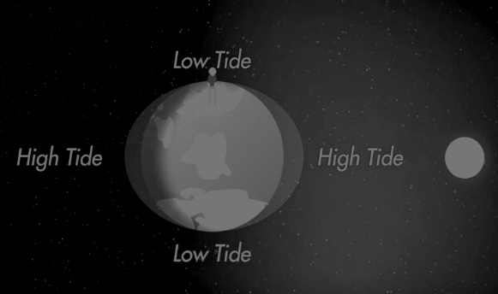*

Figure 3. Phenomena of tides

1. *Power generation*

As mentioned above, the tides occurred, thus creates high powerful ocean streams and currents inside the ocean, which has high energy. The energy created by these tides is always continuous and safe. This energy can be utilised for generation of electricity. The underwater turbines are placed in the ocean, near to the coastal areas, at areas where there is a strong effect of tides. The turbines rotate at a continuous speed, during the process of high and low tide formation.The turbines rotate at low speed, but produces high torque, without harming the marine environment where the turbines are placed. This high torque is used to run the generator at high rotational speed, by means of a gearbox connected in between the turbine shaft and the generator shaft. The Gearbox and all generating components are housed in nacelle. Gearbox is the crucial part or device in this whole process. The power generated from the generator is carried outside by means of strong cable conductors, which are strongly shielded outside to avoid any leakage or damage, due to harsh ocean environment. The damage of these cables leads to harmful effect on the marine life and animals. The cables travel all the way to the nearest power station, where the power is analysed and distributed for utilisation.

REFERENCES

1. Donal B. Murray; Paul Gallagher; Ben Duffy, and Vincent McCormack. “Energy storage solutions for offshore wave and tidal energy prototypes,” *Twelfth International Conference on Ecological Vehicles and Renewable Energies (EVER)*, pp. 1-8, 2017.
2. Chinweike Okoli, Roland Uhunmwangho, and Henry Nwogu “A simulation model for tidal energy extraction in Nigeria using tidal current turbine,” *IEEE PES PowerAfrica*, pp. 500-505, 2017.
3. A. Berian. “Compatability of Underwater Cables and Connectors,” *OCEANS '76*, pp. 197-205, 1976.
4. M. M. Nagib, Mahmoud M. Othman, Adel A. Naiem, and Y. G. Hegazy “Integrating tidal energy to solve dynamic economic load dispatch problem using IWO,” *2017 IEEE International Conference on Environment and Electrical Engineering and 2017 IEEE Industrial and Commercial Power Systems Europe*. pp. 1-6, 2017.