**A PAPER PRESENTATION ON**

***MAGNETIC LEVITATION VEHICLES***

**PRESENTED BY**



**A.Sivanagendra**

**[15KB1A0201]**

**III EEE**

**7093361321**

**sivanagendra98@gmail.com**

**DEPARTMENT OF ELECTRICAL AND ELECTRONICS ENGINEERING**

**N.B.K.R. INSTITUTE OF SCIENCE AND TECHNOLOGY**

**VIDYANAGAR**

**NELLORE (DISTRICT)**

# Abstract

This paper “**Driving without wheels, flying without wings**” deals with the present scenario of m**agnetic levitation** (maglev) with linear induction motor (LIM). The magnetically levitated train has no wheels, but floats-- or surfs-- on an electromagnetic wave, enabling rides at 330 miles per hour. There are two basic types of non-contact Maglev systems **Electro Dynamic Suspension (EDS)**, and **Electro Magnetic Suspension (EMS)**. EDS is commonly known as “**Repulsive Levitation**,” and EMS is commonly known as **"Attractive Levitation**." Each type of Maglev system requires propulsion as well as "levitation."

The various projects above use different techniques for propulsion, but they are all variations of the Linear Induction Motor (LIM) or Linear Synchronous Motor (LSM). The cost of making the guide way is a high percentage of the total investment for a maglev system. When the terrain becomes difficult Magley is best. Many of the tunnels, embankments, and cuttings necessary for roads and railroads are avoided because Maglev guide ways can be easily adapted to the topography.

Adaption of Maglev system is a bit costlier, but deploys electricity in electromagnets in an extraordinarily efficient manner. Maglev will set off a transportation and broader scientific explosion.

***LEVITATION SCHEMATIC***

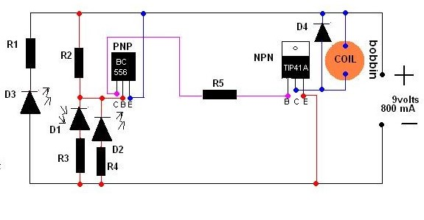

***LEVITATING TRAIN DIAGRAM***

